**Ohm's Law Verification Circuit with ESP32**

# **Introduction**

Understanding Ohm's Law is fundamental to electronics, and verifying its principles practically can enhance your comprehension. In this chapter, we will explore the implementation of an Ohm's Law verification circuit using the ESP32 microcontroller. This hands-on project will involve measuring voltage, current, and resistance to confirm the relationship expressed by Ohm's Law.

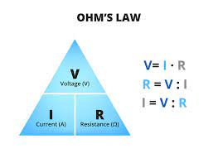

**Fig. 1 Ohm's Law**

# **Components Required**

* ESP32 development board
* Resistor for verification
* Breadboard and jumper wires
* Multimeter

# **Circuit Design**

* Connect the resistor to the breadboard.
* Connect one end of the resistor to a GPIO pin on the ESP32.
* Connect the other end of the resistor to the ground (GND) pin on the ESP32.
* Measure the voltage drop across the resistor using a multimeter.
* Measure the current flowing through the resistor using a multimeter.
* Use the ESP32 ADC to measure the voltage at the GPIO pin connected to the resistor.

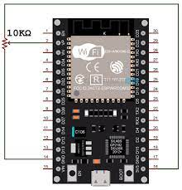

**Fig. 2 ESP32 With Resistor**

# **Arduino IDE Code**

Following is the Arduino code

const int resistorPin = A0; // Analog pin connected to the resistor

void setup() {

Serial.begin(115200);

}

void loop() {

int sensorValue = analogRead(resistorPin);

// Assuming a 10-bit ADC resolution (0-1023) and a reference voltage of 3.3V for ESP32

float voltage = sensorValue * (3.3 / 1023.0);

float current = voltage / resistorValue; // Ohm's Law: V = I * R

Serial.print("Voltage: ");

Serial.print(voltage);

Serial.print(" V, Current: ");

Serial.print(current);

Serial.println(" A");

delay(1000); // Delay for readability, adjust as needed

}

# **Procedure**

Upload the provided code to your ESP32 using the Arduino IDE.

Open the Serial Monitor to observe the voltage and current readings.

Adjust the resistor value and repeat the experiment to verify Ohm's Law.

# **Conclusion**

This practical project provides a hands-on experience in applying Ohm's Law using an ESP32 microcontroller. By actively measuring voltage, current, and resistance, you reinforce theoretical concepts and gain valuable insights into the practical application of fundamental electrical principles.