* Dialect
* What language will use ex: Mysql, oracle
* @Entity – use to create table in database
* @Table –use to change table name it will change only name not will be use in query
* Hibernate-Architecture
* Session-Factory : load configuration and keep in cache
* 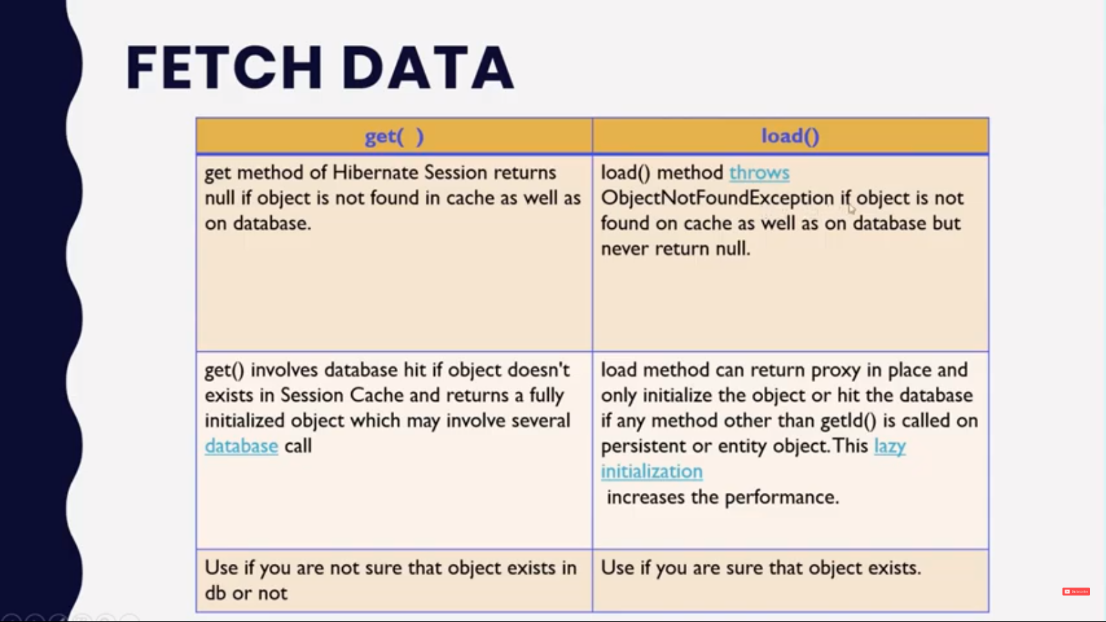

@Embeddable: to use other class property Ex variable in current class

@Lazyloading: when we use lazyloading mapped data won’t get automaticalyy we have to explicitly getter method to load mapped class data

@Eaggerloding: all data will be fetch at same time when you get current class data mapped class data automatically get fetch

