**Redux**: is use to manage state .it is predictable, centralized, debuggable, flexible

We can see change

**Store**: Redux store where we store all components state in central store.

**Action**: are used to tell what changes are going to be. Actions are dispatch.

Received by reducer.

{

‘type’:’Add_User’

‘Payload’:{‘name:’amir’,’email’}

}

**Payload**: payload is the information it holds data

Type is keyword it should be use as it is . payload keyword is optional and can be change

**Reducer**: is function used to manage state and store state in central state.

It accept two parameter (State, Action). Reducer is automatically called when an action is dispatch.

Reducer are responsible for particular state in stores

We create separate reducer and make them combine with the help of **combineReducers**

**CombineReducers** is called in store

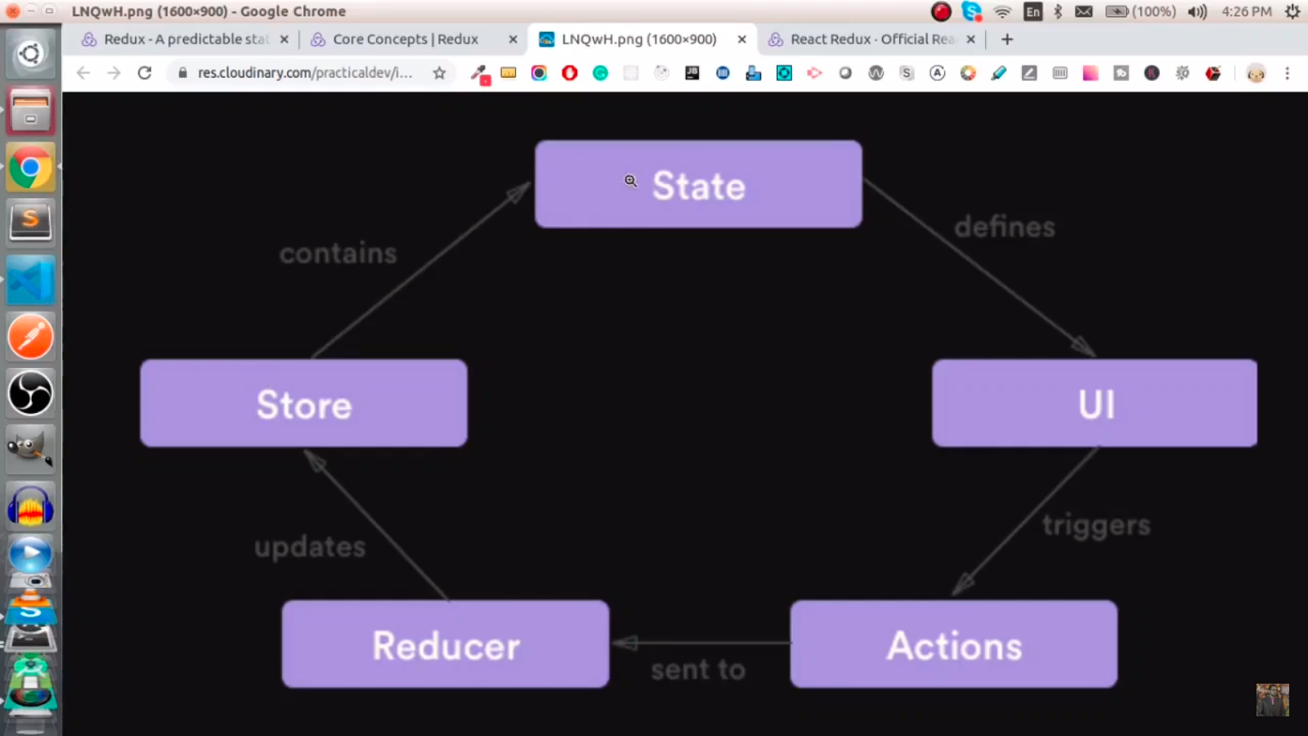

There is a package react-redux which is provided by **Redux** especially for react