Spring : spring is light weight because it does not use OS libraries it has no dependency on OS libraries . It uses only jdk libraries

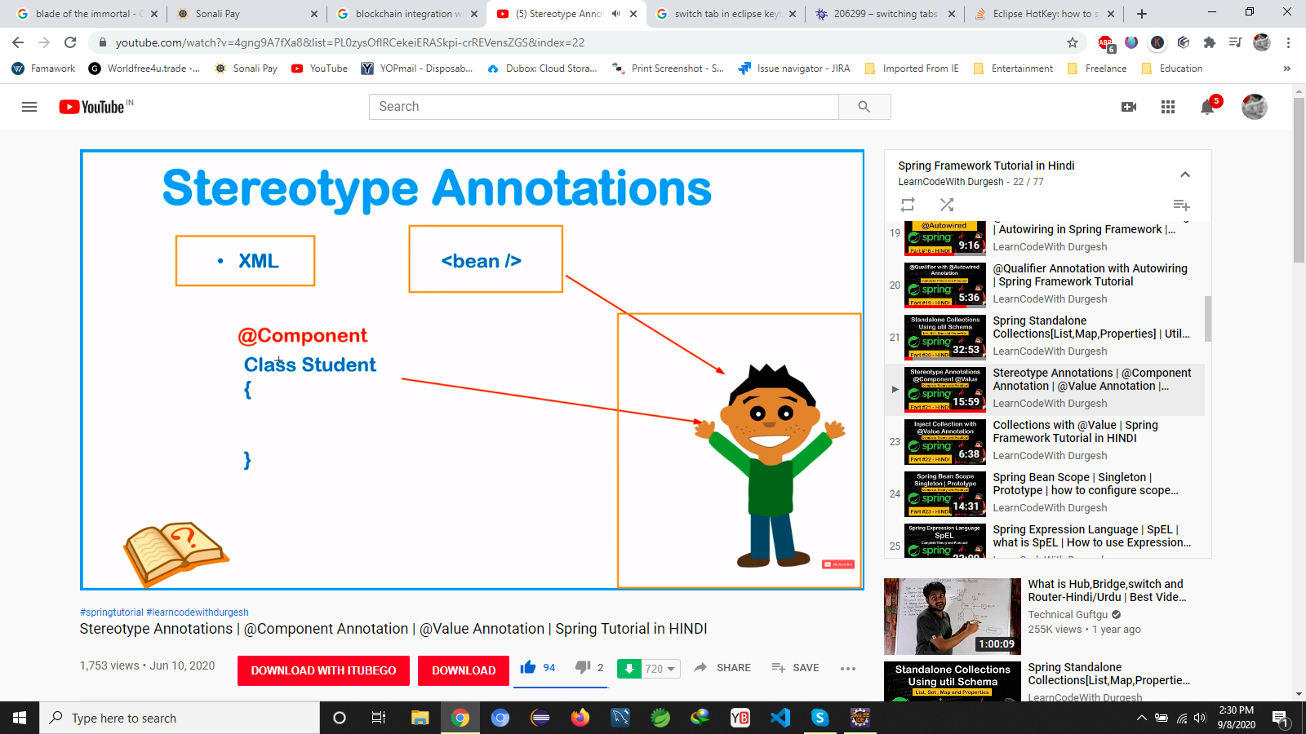

@component use for to create bean it is the alternate of <bean>

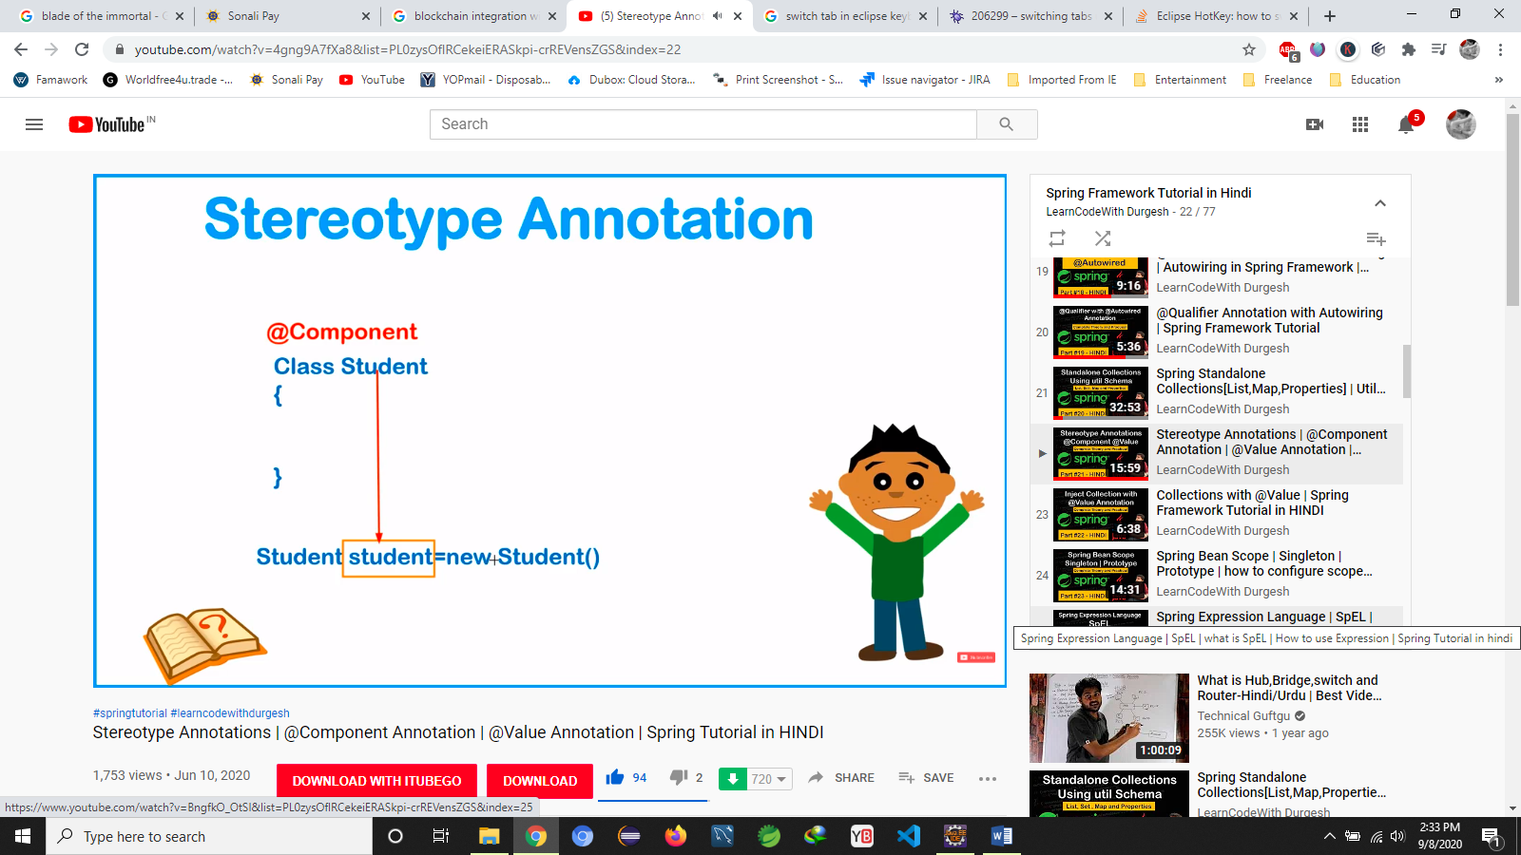

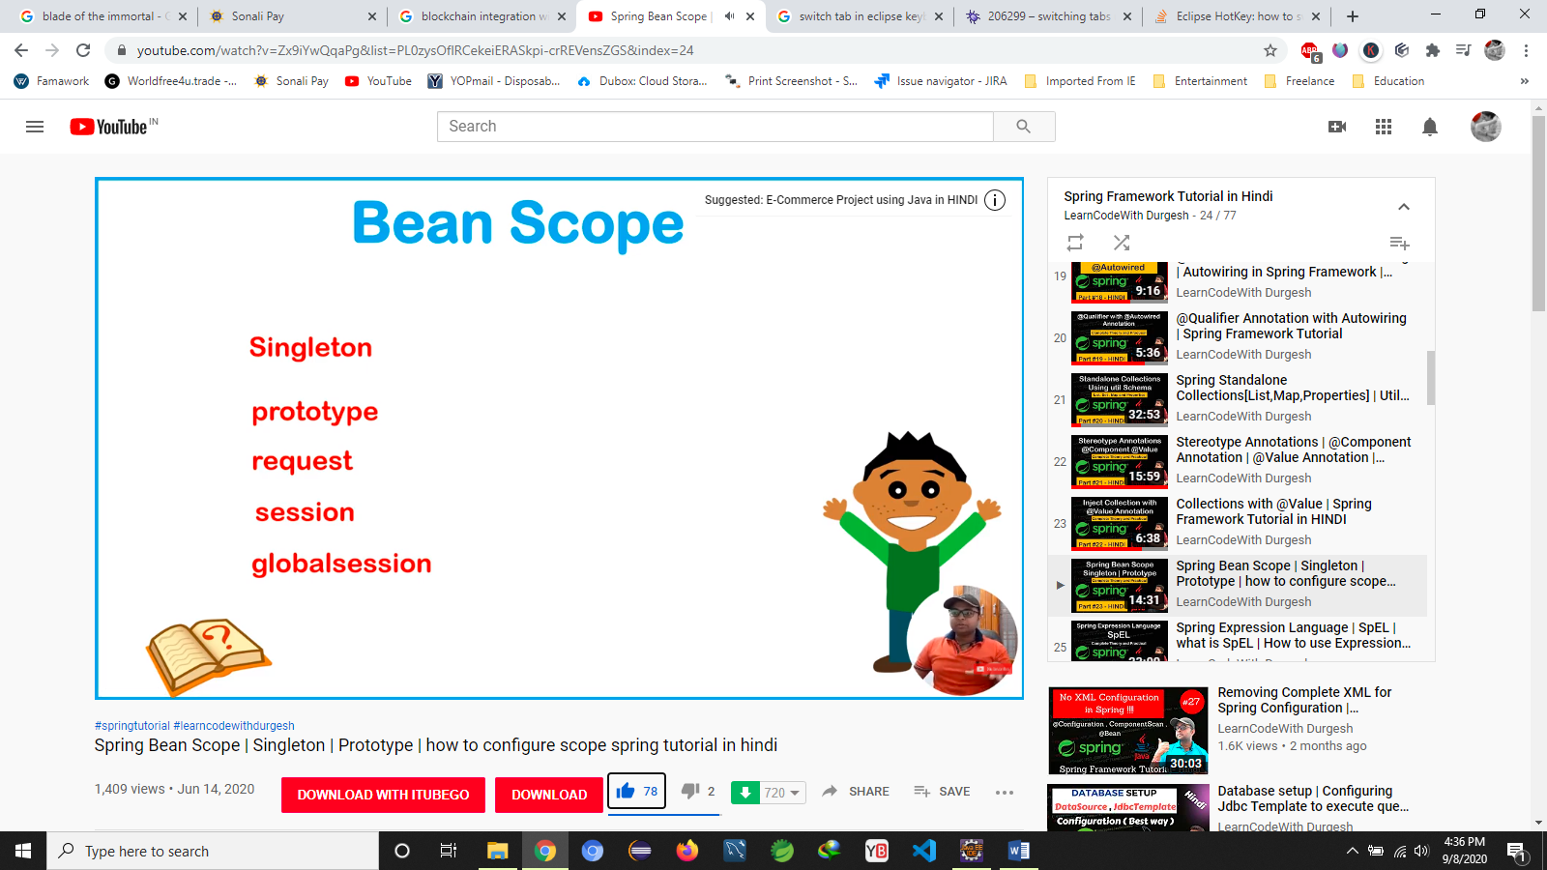

The job of @Controller is to create a Map of the model object and find a view but @RestController simply returns the object and object data is directly written into HTTP response as JSON or XML.