**Task 5 Documentation**

**Task 5: Setup vault through docker**

* **Create an application**
* **Add Username and Password**

**Step 1: Create dockerfile**

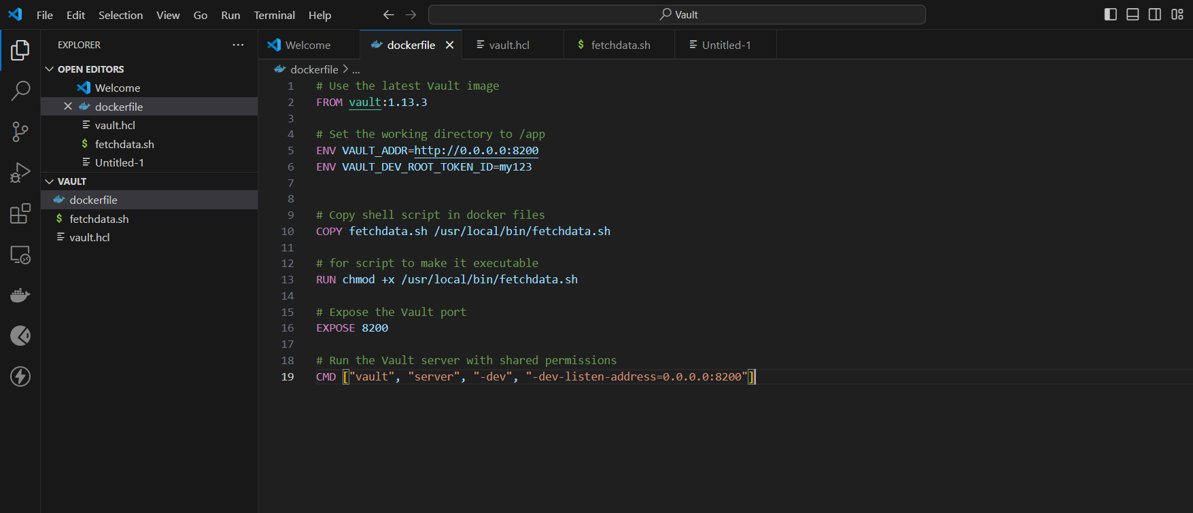

**2.Created shell script**

**Containing app data.**

**appname: ‘myapp’**

**id =’7’**

**password=’ms7’**

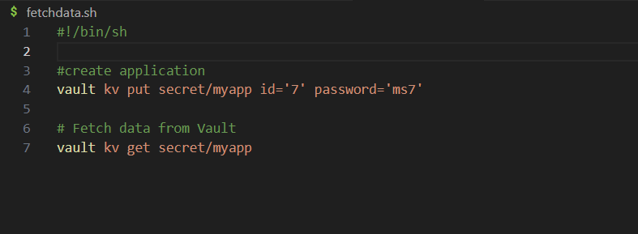

**3. build docker image and pull container**

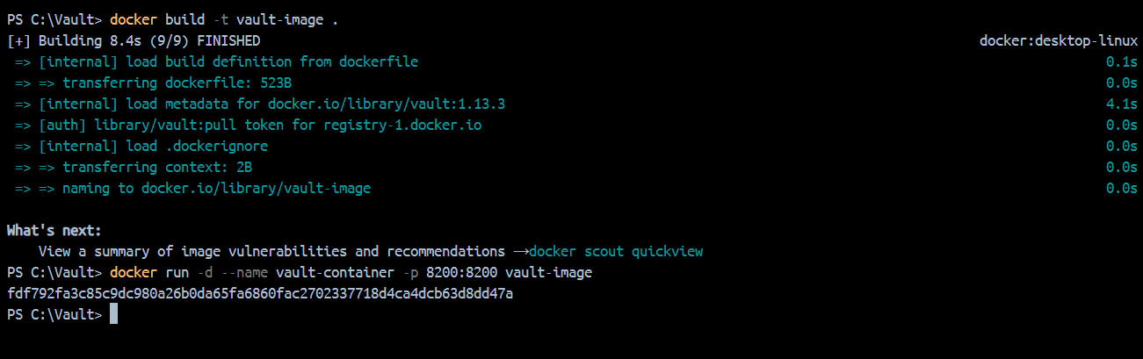

**4.Inside vault**

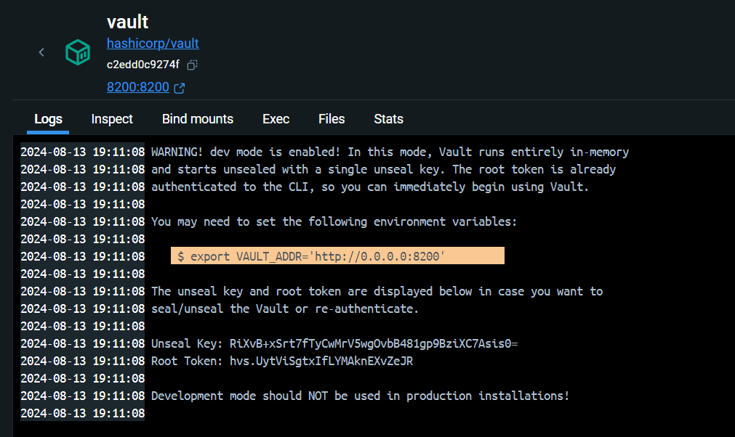

* **Take and copy that unseal key**
* **Open exec shell**
* **Run command:**
* **# vault operator unseal <unseal key>**

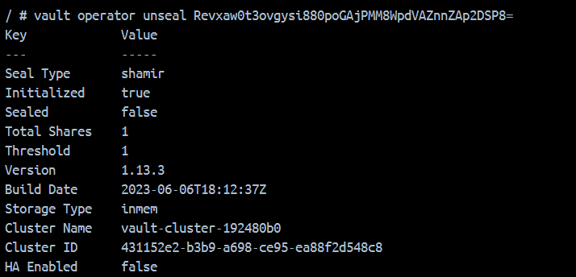

**5.** **Then login vault with your token id**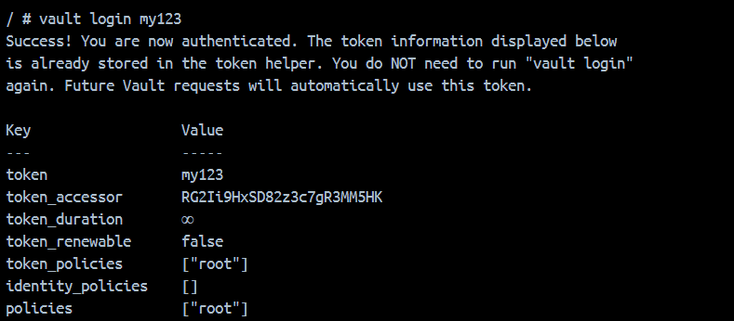

**6.**

* **Go to the bin**
* **Give permissions by using chmod to your shell script**

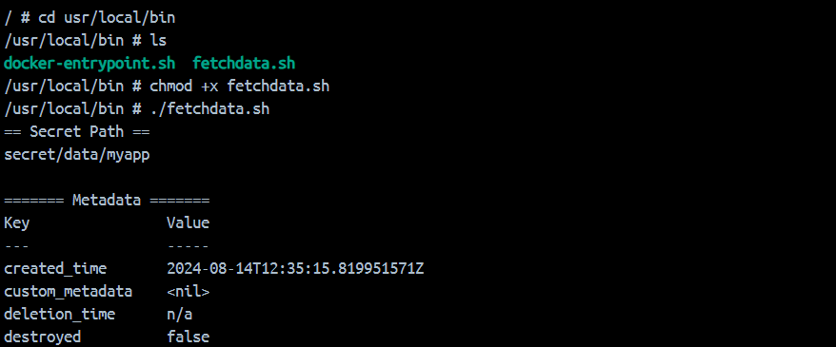

**7.**

**Now, we can see the data of shell file here**

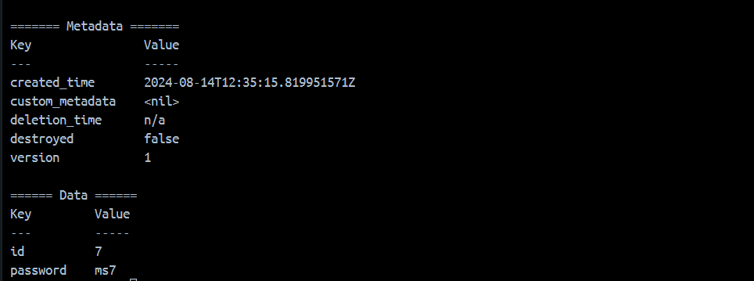

**8.**

**Now click port, url will open**

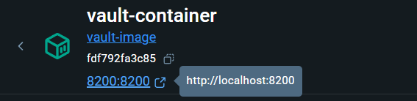

**9.**

**Sign in here with token-d that you saved before**

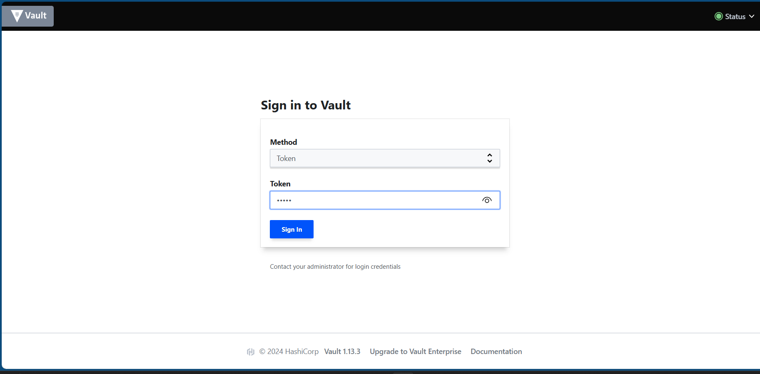

**10.**

**Here we can see secret file created which is key/value storage**

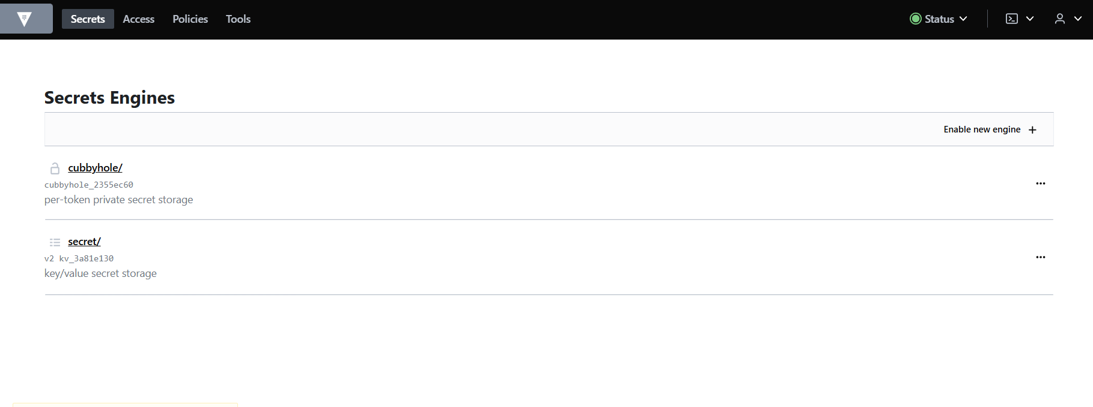

**11.**

**Inside secret key value storage you can see your app ‘myapp’**

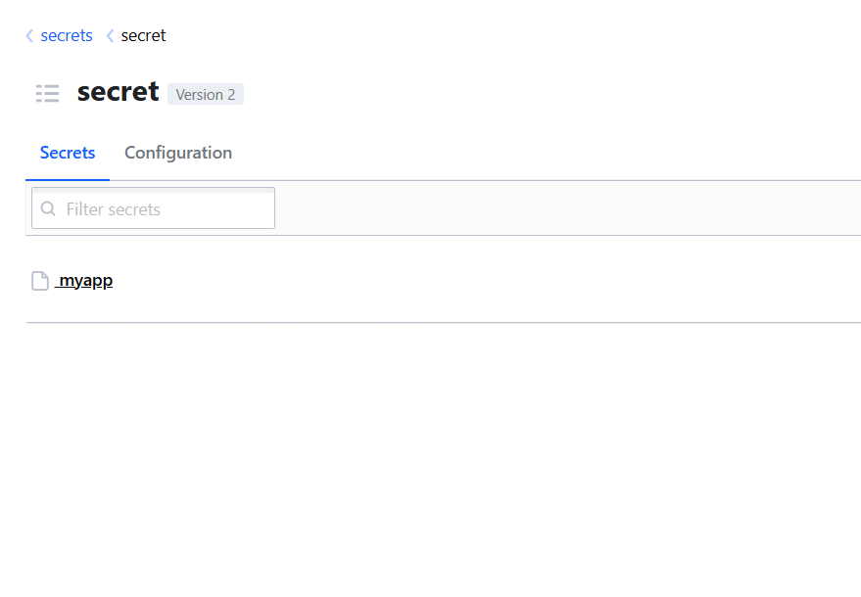

**12.**

**Here inside myapp, you can see your data of shell script**

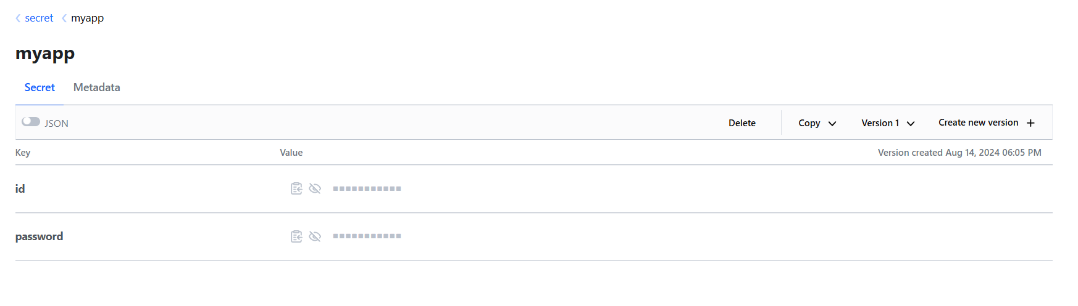

**--------------------------------------------Task 5 Completed-------------------------------------**