

Supporting documentation for:

Daily and sub-daily hydrometeorological and soil data (2013-2022) [COSMOS-UK]
Contents
1 Introduction 2
2 COSMOS-UK sites 3
3 Sub-hourly hydrometeorological and soil data 5
4 Daily hydrometeorological and soil data 12
5 Infilling 20
6 Completeness 21
7 Instrumentation 22
8 Changes to data 30
9 Author contributions 32
10 References 33

Introduction
This dataset contains daily and sub-daily time series of hydrometeorological and soil moisture data from 51 sites across the COSMOS-UK network from 2013 to the end of 2022.
The dataset consists of a total of 258 files:
- COSMOS-UK sites metadata
- Sub-hourly hydrometeorological and soil data (for each site)
- Sub-hourly hydrometeorological and soil data flags (for each site)
- Sub-hourly hydrometeorological and soil metadata
- Daily hydrometeorological and soil data, including VWC, potential evapotranspiration (PE) and snow water equivalent (SWE) (for each site)
- Daily hydrometeorological and soil data flags (for each site)
- Daily hydrometeorological and soil metadata
Full details of each of these files is given in the following sections.
For more information on the COSMOS-UK network as a whole, please visit the website https://cosmos.ceh.ac.uk/
This supporting document is based in part on the COSMOS-UK User Guide which is regularly updated and made available from the above referenced website.

COSMOS-UK sites

Filename
COSMOS-UK_SiteMetadata_2013-2022.csv

Description
- Figure 2-1 shows the locations of each site. Further details, including co-ordinates, soil type and land cover are provided in the site metadata file. Note, the following sites have been decommissioned: Wytham Woods on 01/10/2016, Redmere on 20/09/2018, Cochno on 16/11/2020 and Harwood Forest on 28/6/2022.
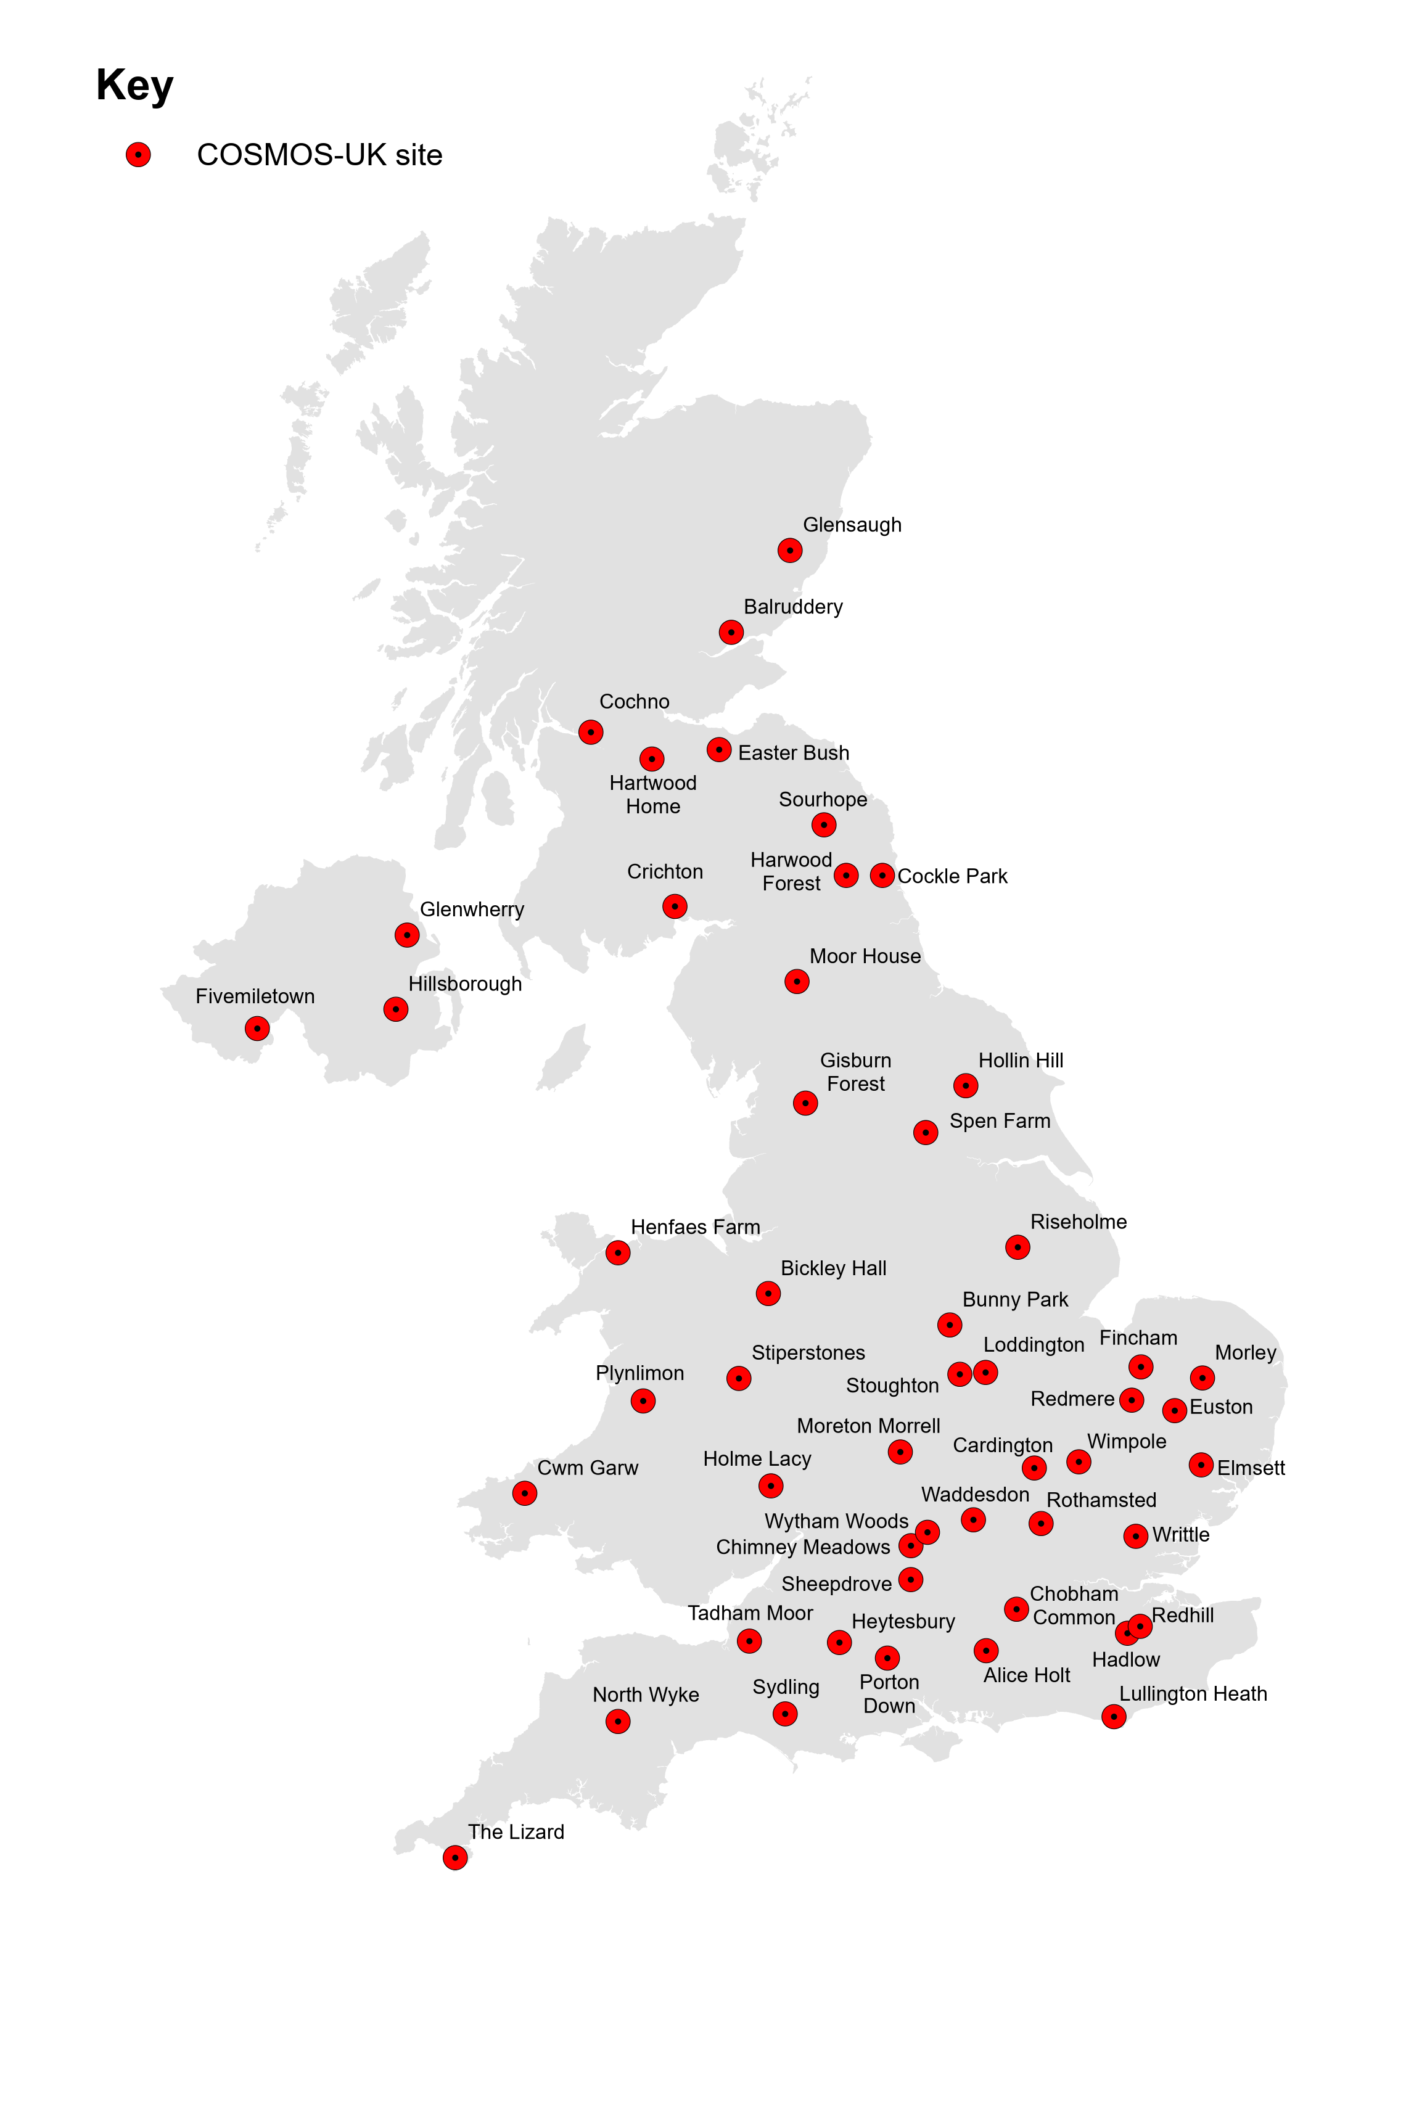
Figure 2-1 – COSMOS-UK site locations

File content
The content of COSMOS-UK site metadata file is outlined in the table below.
Table 2-1 - Details of columns within the file
Column name | Unit | Description
SITE_NAME | - | Full site name.
SITE_ID | - | Unique five character identifier for site.
START_DATE | - | Site’s start date in format YYYY-MM-DD.
END_DATE | - | For sites no longer active, the end date in format YYYY-MM-DD. This is left blank if site is still active.
EASTING | metres | Site coordinate. Coord ref system: OSGB36, EPSG SRID code: 27700.
NORTHING | metres | Site coordinate. Coord ref system: OSGB36, EPSG SRID code: 27700.
EAST_NORTH_EPSG | - | EPSG SRID code: 27700 provided for reference.
LATITUDE | degrees | Site coordinate. Coord ref system: WGS84, EPSG SRID code: 4326.
LONGITUDE | degrees | Site coordinate. Coord ref system: WGS84, EPSG SRID code: 4326.
LAT_LONG_EPSG | - | EPSG SRID code: 4326 provided for reference.
ALTITUDE | metres | Altitude of the site above sea level.
SOIL_TYPE | - | Informal soil type description derived from site inspection and soil sampling.*
LAND_COVER | - | Main land cover as observed at the site.
BULK_DENSITY | g cm⁻³ | Mass per unit volume derived from soil samples taken from the site.*
BULK_DENSITY_SD | g cm⁻³ | Standard deviation of bulk density across soil samples taken from site.*
SOIL_ORGANIC_CARBON | g / g | Organic carbon content within dry soil mass, derived from soil samples taken from the site.*
SOIL_ORGANIC_CARBON_SD | g / g | Standard deviation of soil organic carbon across soil samples taken from site.*
LATTICE_WATER | g / g | Lattice and bound water. Water integrated into mineral structures within the soil.*
LATTICE_WATER_SD | g / g | Standard deviation of lattice water across soil samples taken from site.*
*The soil sampling procedure is described in Evans et al. (2016).

Sub-hourly hydrometeorological and soil data

Data filename
COSMOS-UK_<SITE_ID>_HydroSoil_SH_2013-2022.csv

Metadata filename
COSMOS-UK_HydroSoil_SH_2013-2022_Metadata.csv

Description
A range of hydrometeorological and soil data at 30 minute resolution over the period October 2013-December 2022. Missing values are given as -9999. The <SITE_ID> given in the filename identifies the site from the COSMOS-UK network where the data was measured.

File content
The sub-hourly metadata file (Section 3.2) provided with the dataset contains details of the variables included in the sub-hourly data files. Table 3.1 is a descriptive supplement to this which can also be used to check the meaning of codes used in the metadata file.

See Section 6 for general completeness of the data.
Table 3-1 – Details of the variables recorded
Column name | Variable name | Unit | Aggregation | Infilled | Note
SITE_ID | Site | - | - | -
DATE_TIME | DateTime | - | - | - | GMT  Dates given in ISO 8601 format:  YYYY-MM-DDTHH:MM:SSZ.
LWIN | Incoming longwave radiation | Watts per square metre (${Wm}^{-2}$) | Mean over preceding time period | Yes
LWOUT | Outgoing longwave radiation | Watts per square metre (${Wm}^{-2}$) | Mean over preceding time period | Yes
SWIN | Incoming shortwave radiation | Watts per square metre (${Wm}^{-2}$) | Mean over preceding time period | Yes
SWOUT | Outgoing shortwave radiation | Watts per square metre (${Wm}^{-2}$) | Mean over preceding time period | Yes
RN | Net radiation | Watts per square metre (${Wm}^{-2}$) | Mean over preceding time period |  | Derived from:  (SWIN – SWOUT) + (LWIN – LWOUT)
PRECIP | Precipitation from Pluvio | Millimetres (mm) | Total over preceding time period
PRECIP_TIPPING | Precipitation from tipping bucket | Millimetres (mm) | Total over preceding time period
PRECIP_RAINE | Precipitation from RainE | Millimetres (mm) | Total over preceding time period
PA | Atmospheric Pressure | HectoPascals (hPa) | Mean over preceding time period | Yes
TA | Air Temperature | Degrees Celcius ($℃$) | Mean over preceding time period | Yes
WS | Wind speed | Metres per second (${ms}^{-1}$) | Mean over preceding time period | Yes | Absolute wind speed, not resultant wind speed of WD
WD | Wind direction | Degrees ($°$) | Mean over preceding time period | Yes
Q | Absolute Humidity | Grams per cubic metre ($gm^{-3}$) | Mean over preceding time period |  | Derived from TA and RH
RH | Relative Humidity | Percent (%) | Mean over preceding time period | Yes
SNOW_DEPTH | Snow depth | Millimetres (mm) | Value at timestamp |  | Data only given on snow days.
UX | X component of wind speed | Metres per second (${ms}^{-1}$) | Mean over preceding time period
UY | Y component of wind speed | Metres per second (${ms}^{-1}$) | Mean over preceding time period
UZ | Z component of wind speed | Metres per second (${ms}^{-1}$) | Mean over preceding time period
G1 | Heat flux 1 | Watts per square metre (${Wm}^{-2}$) | Mean over preceding time period | Yes
G2 | Heat flux 2 | Watts per square metre (${Wm}^{-2}$) | Mean over preceding time period | Yes
TDT1_TSOIL | Soil temperature | Degrees Celcius ($℃$) | Value at timestamp |  | Soil temperature from TDT sensor 1 and 2 at 10cm*
TDT2_TSOIL
TDT1_VWC | Soil moisture | Percent (%) | Value at timestamp |  | Volumetric water content from TDT sensor 1 and 2 at 10cm*
TDT2_VWC
TDT3_TSOIL | Soil temperature | Degrees Celcius ($℃$) | Value at timestamp |  | Soil temperature from TDT sensor 3 and 4 at 5cm*
TDT4_TSOIL
TDT3_VWC | Soil moisture | Percent (%) | Value at timestamp |  | Volumetric water content from TDT sensor 3 and 4 at 5cm*
TDT4_VWC
TDT5_TSOIL | Soil temperature | Degrees Celcius ($℃$) | Value at timestamp |  | Soil temperature from TDT sensor 5 and 6 at 15cm*
TDT6_TSOIL
TDT5_VWC | Soil moisture | Percent (%) | Value at timestamp |  | Volumetric water content from TDT sensor 5 and 6 at 15cm*
TDT6_VWC
TDT7_TSOIL | Soil temperature | Degrees Celcius ($℃$) | Value at timestamp |  | Soil temperature from TDT sensor 7 and 8 at 25cm*
TDT8_TSOIL
TDT7_VWC | Soil moisture | Percent (%) | Value at timestamp |  | Volumetric water content from TDT sensor 7 and 8 at 25cm*
TDT8_VWC
TDT9_TSOIL | Soil temperature | Degrees Celcius ($℃$) | Value at timestamp |  | Soil temperature from TDT sensor 9 and 10 at 50cm, except for Heytesbury site where sensors at 5cm*
TDT10_TSOIL
TDT9_VWC | Soil moisture | Percent (%) | Value at timestamp |  | Volumetric water content from TDT sensor 9 and 10 at 50cm, except for Heytesbury site where sensors at 5cm*
TDT10_VWC
STP_TSOIL2 | Soil temperature at depth 2cm | Degrees Celcius ($℃$) | Mean over preceding time period
STP_TSOIL5 | Soil temperature at depth 5cm | Degrees Celcius ($℃$) | Mean over preceding time period
STP_TSOIL10 | Soil temperature at depth 10cm | Degrees Celcius ($℃$) | Mean over preceding time period
STP_TSOIL20 | Soil temperature at depth 20cm | Degrees Celcius ($℃$) | Mean over preceding time period
STP_TSOIL50 | Soil temperature at depth 50cm | Degrees Celcius ($℃$) | Mean over preceding time period
* See Instrumentation for details on instrumentation.

Methodology
Data are measured by a range of instruments and then recorded by data loggers on site (see Section 7 for details on instrumentation). Some values are instantaneous measurements, taken every 30 minutes, others are aggregated over 30 minutes (either sum or mean) on the logger. The “Aggregation” column in table 3.1 details the aggregated method for each variable. Timestamps for all aggregated data refer to the end of the 30 minute period, i.e. a DATE_TIME of 12:30, refers to an aggregation of data from 12:00 to 12:30. These data are then telemetered to a central data system based at UKCEH Wallingford every hour.

Quality control
Data are subject to two stages of quality control (QC):
- QC tests automatically applied by a processing script. Data that fail these tests are flagged and removed. Each test is only applied to relevant variables. Details of the tests are given in table 3.2 and details on which variables are subject to which test are given in table 3.3.
- A daily visual inspection of all data on automatically generated plots.

Each automatic QC test comes with a unique flag value. This value is assigned to any data that fails a QC test, see table 3.2 for the flag values used for each test. If the same data fails multiple tests then the flag values are added together. The flag values are such that any combination added together will result in a unique final value, thus the exact tests a value fails can be traced back.
Data that fails QC are removed and the accumulated flag value is saved separately in the sub-hourly quality control flags dataset, with filename:
COSMOS-UK_<SITE_ID>_HydroSoil_SH_2013-2022_QC_Flags.csv
The QC flag files mirror the structure of their counterpart data file, except that all column names have “_QCFLAG” appended.
For example, if the value for PRECIP at site MOORH on 01-01-2019 00:30:00 was missing in the file (value is -9999), then the corresponding QC flag (in the PRECIP_QCFLAG column of the site’s QC file) would have a value larger than 0. Say that flag value was 72, then it can be deduced that data was removed because it failed the “low power” (8) and “out of range” (64) tests (see table 3.2).

Table 3-2 – Description of automatic quality control tests, and their flag values.
Test | Description | Flag value
Missing | No data received from logger. | 1
Zero data | Data equal to zero where this is not a possible value.  For certain variables missing data are marked using a zero. For variables where this is true any zero values are removed as these are assumed to be missing. | 2
Too few sample | Data with too few half hourly samples.  For variables that are a sum or average of numerous continuous readings in the preceding half hour period; if less than a third of these readings are missing the measurement is considered unreliable and data are removed. | 4
Low power | Data recorded where battery voltage is low.  Low battery power can mean measurements are missing or unreliable. If the battery pack voltage goes below 11V the associated data will be removed. | 8
Sensor fault | Data associated with a sensor that has a known fault. These are registered manually by the operations team. | 16
Diagnostic flag | Data that has been assigned a diagnostic flag by the instrument. | 32
Out of range | Data that are outside an acceptable range for that variable.  Each variable measured at each site has a minimum and maximum value set. If the measurement of this particular variable goes out of this range it will be removed. | 64
Secondary variable | Data dependant on another variable and the other variable is incorrect.  Some measurements are dependent on the measurements of another variable being reasonable. For example measurements of the components of radiation are not reliable when the body temperature (of the radiometer) measurement is out of the acceptable range. This test will remove values from the dependent variables if the main variable is not correct. | 128
Spike | Data that are greater than a threshold value smaller/larger than the neighbouring values.  If a value is greater than a certain threshold away from its neighbouring values this is removed. | 512
Error codes | Data where the logger programme has assigned an error code value due to a sensor/programme fault.  When there is a fault with the sensor for some variables the logger programme can record a value of 7999. | 1024

Table 3-3 – This table details the quality control tests that are run for each variable. See table 3.1 for descriptions of each parameter.
Parameter | Zero | Too few samples | Low power | Sensor fault | Diagnostic | Out of range | Secondary variable | Spike | Error codes
LWIN | x | x | x | x |  | x | x |  | x
LWOUT | x | x | x | x |  | x | x |  | x
SWIN | x | x | x | x |  | x | x |  | x
SWOUT | x | x | x | x |  | x | x |  | x
RN
PRECIP |  | x | x | x | x | x |  |  | x
PRECIP_TIPPING |  | x | x | x |  | x |  |  | x
PRECIP_RAINE |  | x | x | x |  | x |  |  | x
PA | x | x | x | x |  | x |  | x | x
TA |  | x | x | x |  | x |  |  | x
WS | x | x | x | x |  | x |  |  | x
WD |  | x | x | x |  | x |  |  | x
Q
RH | x | x | x | x |  | x |  |  | x
SNOW_DEPTH |  |  | x | x |  | x |  |  | x
UX |  |  | x | x |  | x |  |  | x
UY |  |  | x | x |  | x |  |  | x
UZ |  |  | x | x |  | x |  |  | x
G1 |  | x | x | x |  | x | x |  | x
G2 |  | x | x | x |  | x | x |  | x
TDT#_TSOIL |  |  | x | x |  | x |  |  | x
TDT#_VWC | x |  | x | x |  | x |  |  | x
STP_TSOIL2 |  | x | x | x |  | x |  |  | x
STP_TSOIL5 |  | x | x | x |  | x |  |  | x
STP_TSOIL10 |  | x | x | x |  | x |  |  | x
STP_TSOIL20 |  | x | x | x |  | x |  |  | x
STP_TSOIL50 |  | x | x | x |  | x |  |  | x

Note, Net radiation (RN) and absolute humidity (Q) are not run through any QC tests. This is because they are derived from values that have already been QC’d.

Data flags
Data flags are provided in a separate file:
COSMOS-UK_<SITE_ID>_HydroSoil_SH_2013-2022_Flags.csv
There are 4 possible flags:
Table 3-4 – Data flag values.
Flag | Description
M | Missing. Where data has been lost and not infilled.  Note, for snow parameters, e.g. SNOW_DEPTH, the values are only given on snow days. This means there is no data on non-snow days, but it is not considered missing and will not have the M flag.
U | Unchecked. Where data had had no quality control (QC).  Note, data that has been derived from QC’d data, e.g. net radiation, is not itself QC’d, however is still consider checked. The only truly unchecked data is the daily greenness proportion (GCC).
I | Infilled. Where missing data has been filled in directly using an infill method. See Section 5 for more details on infilling.
E | Estimated. Where the value contains some degree of uncertainty. This can be for one of two reasons:  1. The value was aggregated with less than a full set of data. For example, a daily mean temperature where some of the sub daily values were missing.  2. The value was aggregated or derived with some degree of infilled data. For example, if net radiation (RN) was calculated using an infilled SWIN value.
The data flag files mirror the structure of their counterpart data file, except that all column names have “_FLAG” appended. For example, if the value for TA_FLAG at site BUNNY on 01-01-2020 10:30:00 in the file…
COSMOS-UK_BUNNY_HydroSoil_SH_2013-2022_Flags.csv
…was “I”, this means the corresponding data value in the file…
COSMOS-UK_BUNNY_HydroSoil_SH_2013-2022.csv
…is an infilled value, not a raw measurement.
It is worth clarifying the difference between the QC flags, and the data flags.
- The QC flags explain why data was removed. They hold no information about the data present in the files. If a non-zero QC flag has a corresponding data value, this implies that value was infilled or estimated.
- The data flags however, are information about the data, mainly whether it is infilled or estimated. These are arguably more useful than the QC flags.

Daily hydrometeorological and soil data

Data Filename
COSMOS-UK_<SITE_ID>_HydroSoil_Daily_2013-2022.csv

Metadata filename
COSMOS-UK_HydroSoil_Daily_2013-2022_Metadata.csv

Description
Volumetric water content data, potential evapotranspiration and snow water equivalent are derived from hydrometeorological data and data from the cosmic-ray sensor at a daily resolution over the period October 2013-December 2022. Missing values are given as -9999. The <SITE_ID> given in the filename identifies the site from the COSMOS-UK network where the data was measured.

File content
The daily metadata file (Section 4.2) provided with the dataset contains details of the variables included in the daily data files. Table 4.1 is a descriptive supplement to this which can also be used to check the meaning of codes used in the metadata file.
Volumetric water content data are derived at all sites. See Section 6 for completeness of the VWC data.
Table 4-1 - Details of variables within the file.
Column name | Variable name | Unit | Aggregation | Infilled | Note
SITE_ID | Site | - | - | -
DATE_TIME | DateTime | - | - | - | Dates given in format:  YYYY-MM-DD
LWIN | Incoming longwave radiation | Megajoule per square metre and per day (${MJ m}^{-2} {day}^{-1}$) | Daily total
LWOUT | Outgoing longwave radiation | Megajoule per square metre and per day (${MJ m}^{-2} {day}^{-1}$) | Daily total
SWIN | Incoming shortwave radiation | Megajoule per square metre and per day (${MJ m}^{-2} {day}^{-1}$) | Daily total
SWOUT | Outgoing shortwave radiation | Megajoule per square metre and per day (${MJ m}^{-2} {day}^{-1}$) | Daily total
RN | Net radiation | Megajoule per square metre and per day (${MJ m}^{-2} {day}^{-1}$) | Daily total
PRECIP | Precipitation from Pluvio | Millimetres (mm) | Daily total
PRECIP_TIPPING | Precipitation from tipping bucket | Millimetres (mm) | Daily total
PRECIP_RAINE | Precipitation from RainE | Millimetres (mm) | Daily total
PA | Atmospheric Pressure | HectoPascals (hPa) | Daily mean
TA | Air Temperature | Degrees Celcius ($℃$) | Daily mean
WS | Wind speed | Metres per second (${ms}^{-1}$) | Daily mean
WD | Wind direction | Degrees ($°$) | Daily mean |  | Absolute direction mean. Does not account for WS.
Q | Absolute Humidity | Grams per cubic metre ($gm^{-3}$) | Daily mean
RH | Relative Humidity | Percent (%) | Daily mean
G1 | Heat flux 1 | Watts per square metre (${Wm}^{-2}$) | Daily mean
G2 | Heat flux 2 | Watts per square metre (${Wm}^{-2}$) | Daily mean
TDT1_TSOIL | Soil temperature | Degrees Celcius ($℃$) | Daily mean |  | Soil temperature from TDT sensor 1 and 2 at 10cm*
TDT2_TSOIL
TDT1_VWC | Soil moisture | Percent (%) | Daily mean |  | Volumetric water content from TDT sensor 1 and 2 at 10cm*
TDT2_VWC
TDT3_TSOIL | Soil temperature | Degrees Celcius ($℃$) | Daily mean |  | Soil temperature from TDT sensor 3 and 4 at 5cm*
TDT4_TSOIL
TDT3_VWC | Soil moisture | Percent (%) | Daily mean |  | Volumetric water content from TDT sensor 3 and 4 at 5cm*
TDT4_VWC
TDT5_TSOIL | Soil temperature | Degrees Celcius ($℃$) | Daily mean |  | Soil temperature from TDT sensor 5 and 6 at 15cm*
TDT6_TSOIL
TDT5_VWC | Soil moisture | Percent (%) | Daily mean |  | Volumetric water content from TDT sensor 5 and 6 at 15cm*
TDT6_VWC
TDT7_TSOIL | Soil temperature | Degrees Celcius ($℃$) | Daily mean |  | Soil temperature from TDT sensor 7 and 8 at 25cm*
TDT8_TSOIL
TDT7_VWC | Soil moisture | Percent (%) | Daily mean |  | Volumetric water content from TDT sensor 7 and 8 at 25cm*
TDT8_VWC
TDT9_TSOIL | Soil temperature | Degrees Celcius ($℃$) | Daily mean |  | Soil temperature from TDT sensor 9 and 10 at 50cm, except for Heytesbury site where sensors at 5cm*
TDT10_TSOIL
TDT9_VWC | Soil moisture | Percent (%) | Daily mean |  | Volumetric water content from TDT sensor 9 and 10 at 50cm, except for Heytesbury site where sensors at 5cm*
TDT10_VWC
STP_TSOIL2 | Soil temperature at depth 2cm | Degrees Celcius ($℃$) | Daily mean
STP_TSOIL5 | Soil temperature at depth 5cm | Degrees Celcius ($℃$) | Daily mean
STP_TSOIL10 | Soil temperature at depth 10cm | Degrees Celcius ($℃$) | Daily mean
STP_TSOIL20 | Soil temperature at depth 20cm | Degrees Celcius ($℃$) | Daily mean
STP_TSOIL50 | Soil temperature at depth 50cm | Degrees Celcius ($℃$) | Daily mean
COSMOS_VWC | Soil moisture / Volumetric water content | Percent (%) | Daily mean | Yes | See Methodologies for derivation
CTS_MOD_CORR | Corrected moderated counts | Count | Daily total |  | See Methodologies for derivation
D86_75m | Effective depth of CRNS (D86 at 75m) | Centimetres (cm) | Daily mean |  | See Methodologies for derivation
SNOW | Snow days | - | - |  | 1 if snow detected on day, 0 if not.  Derived from Albedo
SNOW_DEPTH | Snow depth | Millimetres (mm) | Daily mean |  | Data only given on snow days
SWE | Snow water equivalent | Millimetres (mm) | Value at midday (12:00) |  | See below for derivation
ALBEDO | Albedo | - | Mean between 10:00 and 14:00 |  | Derived from:  $$\frac{SWOUT}{SWIN}$$
PE | Potential evapotranspiration | Millimetres (mm) | Daily total |  | See Methodologies for derivation
GCC | Green colour content.  Proportion of green from a PhenoCam image | - | Daily max |  | Derived from:  $$\frac{Green}{Green+Red+Blue}$$  See Methodologies for more
* See Instrumentation for details on instrumentation.

Methodologies

COSMOS_VWC, CTS_MOD_CORR and D86_75m
Volumetric water content (VWC) measurements are achieved by monitoring the cosmic rays, the sub-atomic particles that originate from outer space, with a Cosmic-Ray Neutron Sensor (CRNS). See Section 7 for more details on the CRNS.
As the cosmic rays reach Earth’s atmosphere, they collide with atoms in the air and create a shower of secondary particles, which include high energy neutrons. As these neutrons head towards the Earth’s surface, they collide with other particles in the air and soil, losing energy with each collision. As it happens, hydrogen is the most effective element in terms of stopping power of these fast neutrons, therefore the amount of water within the soil (and air) correlates to the number of high energy (fast) neutrons picked up by the CRNS. This is the basis of the cosmic-ray soil moisture method. A sensor at the land surface will count more fast neutrons when there is little hydrogen (water) present and fewer fast neutrons when there is more hydrogen to remove the energy.
In order to derive an accurate VWC measurement from this, firstly correction factors are applied to the recorded neutron counts to account for variations in background cosmic ray intensity (as measured by a high altitude reference site at Jungfraujoch, Switzerland, http://www.nmdb.eu/station/jung/), and also site altitude, atmospheric pressure (PA) and absolute humidity (Q). PA and Q are taken from the quality controlled sub-hourly hydrometeorological and soil data described in Section 3. This adjusted number of counts is known as the ‘corrected counts’, given in the data as CTS_MOD_CORR .
There are currently three methods that can be used to derive water content from the corrected counts: (1) Site specific N₀ method, (2) universal calibration method, also known as hydrogen molar fraction (hmf) method, and (3) neutron transport modelling (e.g. MCNP, COSMIC, URANOS). These methods are described in Baatz et al. (2014) and Bogena et al. (2015). The first of these methods is the most straightforward to apply and as a consequence the most widely used. Baatz et al. (2014) conclude that all three methods estimate soil water content with acceptable errors when compared to estimates determined using soil sampling and laboratory analysis.
COSMOS-UK uses the first of these methods in which a reference soil water content is obtained from field calibration, see Franz (2012) and Zreda et al. (2012). This reference value is then used in combination with an equation relating corrected counts to soil water content (with parameters applicable for a generic silica soil matrix; see Desilets et al. (2010)), to calculate a site specific N₀ calibration coefficient. The COSMOS-UK procedure also follows the procedures in Zreda et al. (2012) and Franz et al. (2013) to account for the effects of lattice and bound water (structural water associated with clay minerals in the soil) and soil organic carbon (a minor constituent of mineral soils, but the major constituent of peat soils).
The above processing of neutron counts to derive volumetric water content has been described in Evans et al. (2016).
In 2018, following an investigation into spurious trends in the derived VWC data, an extra correction factor is applied to the counts recorded by the CRNS, to adjust for fluctuations in incoming cosmic rays. This factor is of the form
$$F_{i}=γ\left(\frac{I_{ref}}{I_{ref}'}-1\right)+1$$
in which ɣ is a scaling factor to adjust for geomagnetic effects and differences between the CRNS and the reference counter. Until 2018 the scaling factor was always set to unity and the correction factor reduces to
F_{i} = I_{ref} / I_{ref}’
Operationally, the 30 minute neutron count totals are telemetered from the sites, aggregated to hourly (by summing the two 30 min values) and corrected according to the above. Daily VWC data are generated by taking a daily average of the hourly corrected count data and applying the volumetric water content equation as outlined in Evans et al. (2016). D86 (measurement depth) data are calculated from this daily value using the method outlined in Köhli et al. (2015).

SWE and snow days
The neutron count rates detected by the CRNS are sensitive to presence of water held in a snow pack. Because of this, the VWC calculated during days with snow cover will typically be overestimated. However, the counts can be used to estimate the snow water equivalent (SWE).
For a given day, the presence or absence of snow cover is first established using the average value of the albedo between the times of 10:00 and 14:00 GMT. A period of snow cover is deemed to begin if average albedo exceeds a threshold of 50%, and end when it falls below 35%. These threshold values were chosen with the aim of only classifying a day as a snow day if a potentially detectable amount of snow is present (e.g. at least 2-3mm of SWE).
To estimate the SWE, the count rate from before the start of the snow event is used to estimate a count rate for snow-free conditions. Then the difference between the measured daily average count rate and the snow-free estimate are used to calculate the SWE. The method is described in full as Method 1 in Wallbank et al. (2020). The estimated count rate is then used to calculate snow free VWC.

PE
Potential evapotranspiration (PE) is derived from the sub-hourly hydrometeorological data described above (see Section 3), using the Penman-Monteith method, (FAO 56, 1998). The variables used to calculate this are: Net radiation (RN), heat flux (mean of G1 and G2), air temperature (TA), relative humidity (RH), wind speed (WS) and atmospheric pressure (PA). Daily PE are the sum of sub-hourly PE values >= 0, i.e. negative sub-hourly PE are ignored.

GCC
Each site is equipped with a PhenoCam, see Section 7. These take images of the site, and its surroundings, both north and south. The images are then processed by a script to determine the levels of red, green and blue (RGB) in them. The amount of each colour is given as a value between 0 and 255.
The main colour of interest is green, as this can be used as an indication of seasonal variation in the surrounding vegetation. Building on this, the proportion of green, compared to red and blue levels is calculated, as this normalises the “greenness” with varying light levels from time of day and weather conditions. This is the green colour content (GCC) data.
However, this is not done for the entire image. Instead, each site has its own mask that determines which section of the image is processed. The GCC data comes from masks that pick out the fields surrounding the site. For example:

This is a PhenoCam image from Cardington:
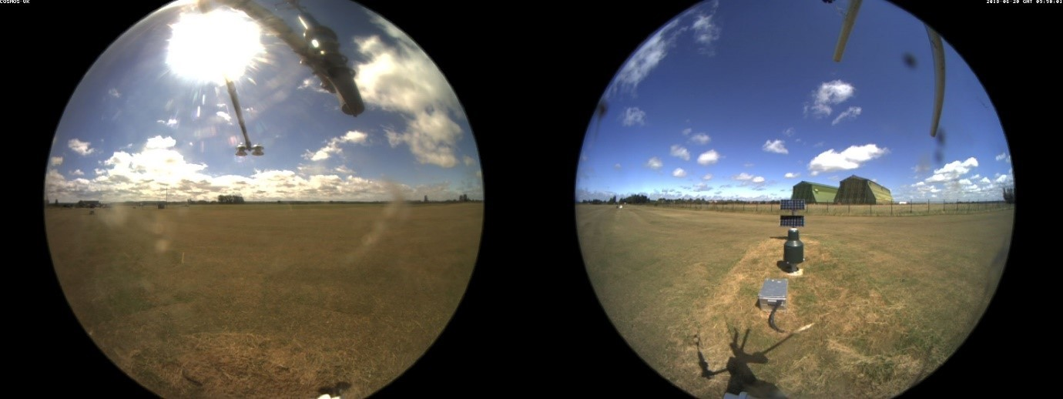
Before being processed for RGB data, it has a mask applied to it that just extracts the surrounding, north facing field:
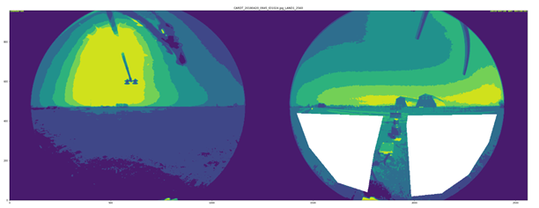

Or rather, only this gets processed:
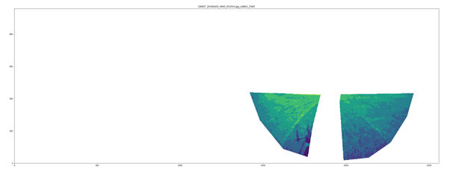

The PhenoCams take up to 5 images a day. The daily GCC is taken to be the image with the highest value of that day.
Please note, this dataset has not under gone any quality control.

Quality control
The daily values are not subjected to their own quality control. Instead they are all derived from sub-hourly values which have been quality controlled. See Section 3.6 for details on this.

Data flags
Data flags are provided in a separate file:
COSMOS-UK_<SITE_ID>_HydroSoil_Daily_2013-2022_Flags.csv
The data flag files mirror the structure of their counterpart data file, except that all column names have “_FLAG” appended. See section 3.7 for details.

Infilling
Infilling is the process of providing estimates of data values where there are gaps in the time series record. Simple infilling is carried out using interpolation methods. This is only applied to selected variables, and for gaps that are considered reasonable.
Interpolation uses data around the gap to estimate the values in between. It is very effective for small gaps, and on data that has low variability, for example temperature and pressure, but less so for variables with high variability, like precipitation. The variables chosen for infilling are listed in Tables 3.1 and 4.1, for sub-hourly and daily data respectively.
There two different types of interpolation used:
- Linear interpolation – this creates values that make a straight line across the gap.
- Order 2 Polynomial – this uses a larger window of data around the gap to create a smoother, curved line of points.
In order to determine which to use, the processing script answers three questions:
- Is the gap smaller (or equal) than 10 values?
- How many values are there around the gap?
If there is just 1 value each side, then only linear interpolation can be used. If possible, larger gaps will use more (up to 4) values each side to estimate a polynomial interpolation.
- Which interpolation method is the best?
Each combination of gap size, interpolation type, and values around the gap has an associated RMSE score that provides an estimate of which method works best.
To calculate RMSE scores for each method, 5000 artificial, independent, gaps are created with the chosen gap length and then infilled with the specific interpolation. With the results the RMSE is calculated between the estimates and the real values. This is done for every variable that is chosen to be infilled.

Completeness
The following table outlines the percentage completeness of data over the period October 2013 - December 2022. The ‘Met’ and ‘Soil’ columns combine groups of measured variables and give the overall completeness. ‘VWC’ is completeness of the derived volumetric water content data from the Cosmic-Ray Neutron Sensor.
Met = Precipitation, humidity, air temperature, atmospheric pressure, short and long wave radiation and wind speed and direction.
Soil = Soil heat flux, soil temperature, and volumetric water content measured by TDT sensors.

Table 6-1 - Completeness of data for each site, for combined sets of variables
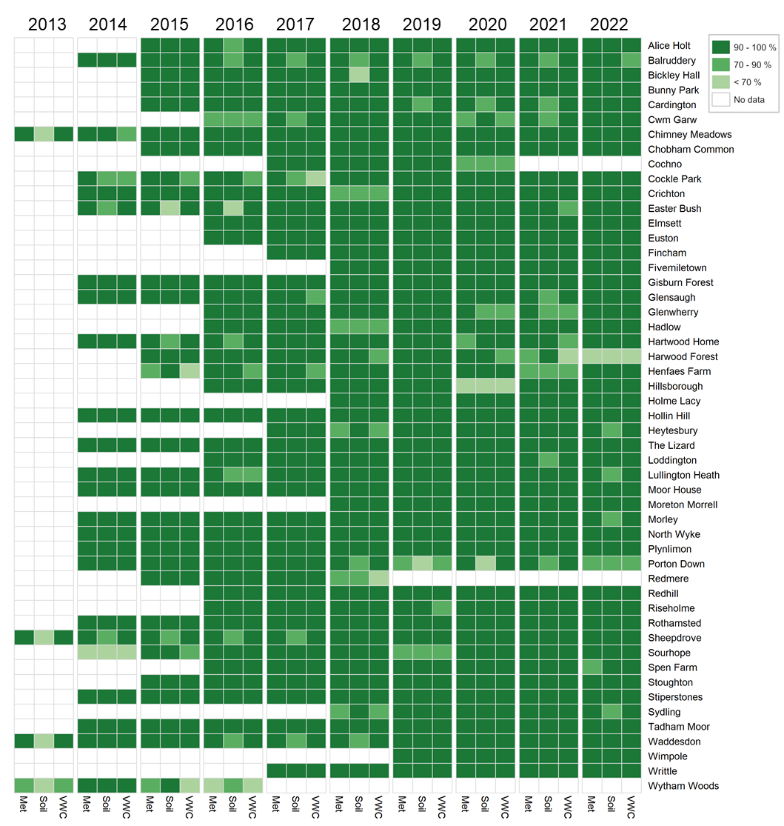

Instrumentation
Instruments used by the COSMOS-UK network are listed in 7.1. Note that instrumentation has changed with time and that not all instruments are installed at all sites (see 7.2).
This information is provided for reference only and implies no endorsement of the specific instrument or supplier by UKCEH.

Instruments used by COSMOS-UK
Cosmic-Ray Neutron Sensor (CRNS)  The sensor counts fast neutrons which can be converted to soil moisture after field calibration. Data processing accounts for variations in atmospheric pressure, humidity, and the intensity of incoming cosmic rays.  The measurement volume of the sensor is many tens of meters horizontally (possibly up to 200m) although measurement is inversely related to distance from the sensor. The effective depth varies with soil moisture but is typically in the range 15-40cm. Köhli et al. (2015) provide a recent discussion of the sensor footprint.  Model: Hydroinnova CRS-2000/B and CRS-1000/B  http://hydroinnova.com/ps_soil.html#overview | 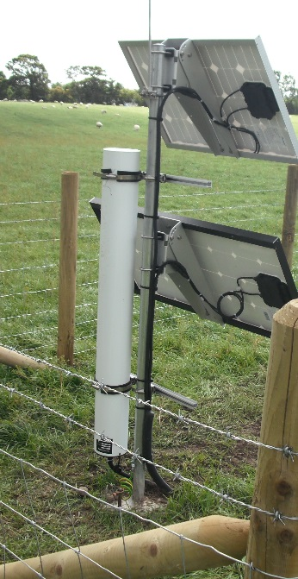
Rain gauge  Provides data on the amount and intensity of solid and liquid precipitation. On-board processing algorithms account for spurious changes due to temperature or wind speed.  Model: OTT Pluvio¹  https://www.ott.com/products/meteorological-sensors-26/ott-pluvio2-weighing-rain-gauge-963/ | 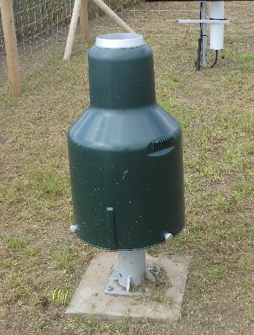
Tipping bucket rain (TBR) gauge  Provides data on the amount of liquid precipitation at 0.2 mm resolution. Aerodynamically shaped to reduced wind-induced under-catch. Any solid precipitation collected in the funnel will be measured as it melts.  Model: EML SBS 500  http://www.emltd.net/sbs.html | 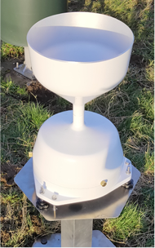
Tipping weighing rain gauge (RainE)  Provides data on precipitation amount and intensity. Combines a tipping bucket with a weighing system and self-emptying collecting vessel.  Model: Lambrecht Rain[e]  https://www.lambrecht.net/en/products/precipitation/weighing-precipitation-sensor-rain-e | 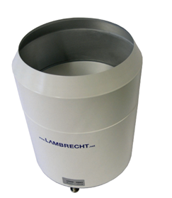
Point soil moisture sensor  Soil moisture sensors at various depths use the TDT (time domain transmissometry) technique and provide absolute volumetric water content and soil temperature.  Note that the soil moisture data are not calibrated to the site specific soil type, but rely on generic calibration information.  The sampling volume is a region around the waveguide which has a total length of 30cm. Blonquist et al. (2005) suggest that the sampling volume is no greater than 15 cm (half length of wave guide) x 6 cm(horizontal) x3 cm(vertical).  Model: Acclima Digital TDT Soil Moisture Sensor  https://acclima.com/products.html | 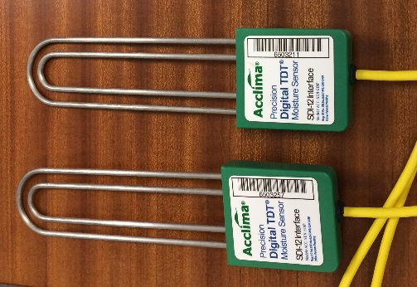
Soil heat flux plate  Two heat flux plates at each site provide the soil heat flux at a depth of 0.03 m. These plates have a self-calibrating feature to maximise measurement accuracy; the in situ calibration is performed once a day.  Model: Hukseflux HFP01SC self-calibrating heat flux plate  https://www.hukseflux.com/products/heat-flux-sensors/heat-flux-meters/hfp01-heat-flux-sensor | 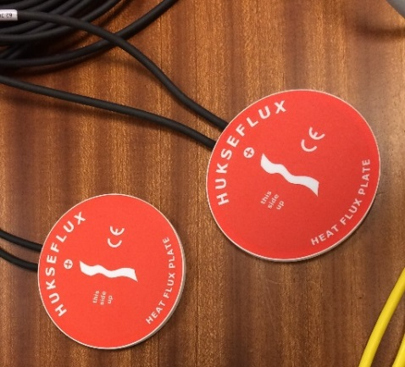
Soil temperature sensor  The near-surface soil temperature is measured at five depths (0.02, 0.05, 0.10, 0.20 and 0.50 m) using a profile of thermocouples.  Model: Hukseflux STP01  https://www.hukseflux.com/products/heat-flux-sensors/soil-temperature-sensors/stp01-soil-temperature-sensor | 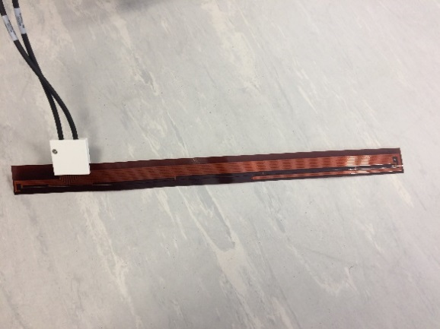
Radiometer  A four-component radiometer measures the individual radiation components using upward and downward facing pyranometers (for the shortwave components) and pyrgeometers (for the longwave components). The net radiation is calculated as the sum of the incoming minus the outgoing components and is usually the dominant term in the surface energy balance. In the photo the radiometer is at the right-hand end of the horizontal support.  Model: Hukseflux NR01 four-component radiometer.  https://www.campbellsci.com/nr01 | 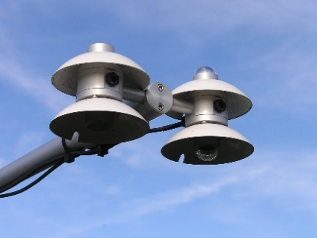
Automatic weather station  Air temperature and relative humidity are measured by a probe situated within a naturally aspirated radiation shield; barometric pressure is also measured.  Model: Rotronic HC2A-S3 within the Gill MetPak Pro Base Station  http://www.gillinstruments.com/products/anemometer/metpak-pro-weather-station.html | 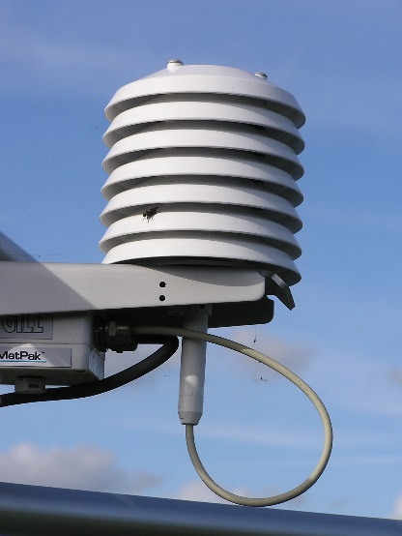
Barometric pressure sensor  A barometric pressure sensor which incorporates a Barocap® silicon capacitive pressure sensor encased in a plastic shell with an intake valve for pressure equalisation. Measures barometric pressure equivalent to an elevation range from below sea level to 4.5km.  Model: Vaisala PTB110 Barometric Pressure Sensor.  https://www.vaisala.com/en/products/instruments-sensors-and-other-measurement-devices/instruments-industrial-measurements/ptb110 | 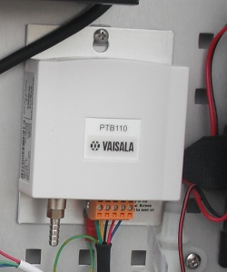
Temperature and humidity sensor  Humidity and air temperature are measured by a capacitive thin film HUMICAP© polymer sensor and resistive platinum sensor (Pt100) respectively. Both the humidity and temperature sensors are located at the tip of the probe protected by a removable filter.  Model: Vaisala HUMICAP HMP155A Humidity and Temperature Probe.  https://www.vaisala.com/en/products/instruments-sensors-and-other-measurement-devices/weather-stations-and-sensors/hmp155 | 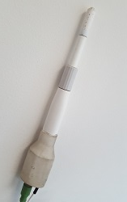
3D sonic anemometer  Monitors wind speeds of 0-50m/s (0-100mph), and wind direction.  Model: Gill WindMaster 3D Sonic Anemometer  http://www.gillinstruments.com/products/anemometer/windmaster.htm | 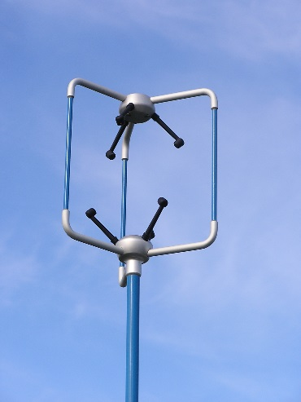
Integrated 2D sonic anemometer  High accuracy wind speed and direction integrated with automatic weather station  Model: Gill Integrated WindSonic  http://gillinstruments.com/products/anemometer/weather-station-range.htm | 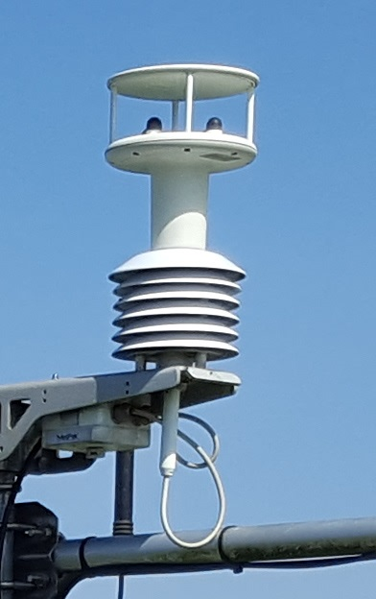
PhenoCam  A pair of cameras with almost 360° field of view provides visual information about the land cover, (e.g. when crops are harvested, greenness of vegetation - hence the name which is a contraction of “phenology camera”). It can also provide information on cloud cover, snow cover, surface ponding and atmospheric visibility.  Model: Motobotix S14 IP camera with hemispheric lenses  https://www.mobotix.com/ |  | 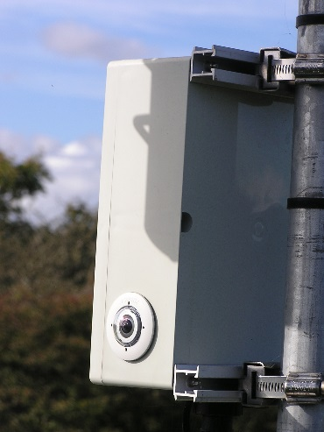
Snow depth sensor
Sonic rangefinder designed specifically to measure snow depth.

Model: Campbell Scientific SR50A
https://www.campbellsci.ca/sr50a
SnowFox
The sensor records the intensity of downward-directed secondary cosmic-rays that penetrate the snow pack. This intensity is proportional to the mass of snow traversed by cosmic-rays, and is related to soil water equivalent (SWE) through a calibration function.

Model: Hydroinnova SnowFox
http://www.hydroinnova.com/_downloads/snowfox_v1.pdf
Micrologger  Consists of measurement and control electronics, communication ports.  Model: Campbell Scientific CR3000  https://www.campbellsci.com/cr3000 | 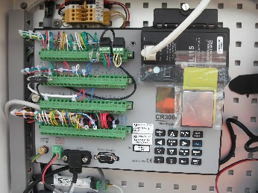

Instruments installed at COSMOS-UK sites
All the instruments within the network are outlined in section 7.1. However, there is some variation across sites. This section outlines the differences in site setups and any changes over time.
Table 7-1 describes different setup features that can be present at each COSMOS-UK site. Table 7-2 then outlines specifically which setup features each COSMOS-UK site has.
Table 7-1 – Types of site setups, installations and changes.
SITE SETUP FEATURE | DESCRIPTION
SNOW SITE | Site with snow sensors installed; Snow depth sensor and SnowFox.
FULL TDT ARRAY | All sites have 2 TDT sensors installed at 10cm depth. A selection also have a further 8 TDT sensors (10 in total) installed at various depths. These are the “full TDT array” sites
ANEMOMETER | Most sites have the 3D sonic anemometer, meaning they have the UX, UY and UZ wind component data, while some have the 2D sonic anemometer.
TIPPING BUCKET | Some sites have had a tipping bucket rain gauge installed. The TIPPING BUCKET column in Table 7-2 gives the date of installation. If no date is given then this sensor is not installed.
RAINE | Some sites have had a RainE tipping weighing rain gauge installed. The RAINE column in Table 7-2 gives the date of installation. If no date is given then this sensor is not installed.
AWS and SWS | Temperature, pressure and humidity are either measured by the all-in-one automatic weather station (AWS), or by the temperature and humidity sensor, and barometric pressure sensor, i.e. separate weather sensors (SWS).  The preferred option in the network is SWS, therefore most of the sites with an AWS initially installed have been swapped.  Table 7-2 states if the site currently has the AWS or SWS, and the date if it was swapped from AWS to SWS.

Table 7-2 – Details of site setup.
SITE NAME | SNOW SITE | FULL TDT ARRAY | ANEMOMETER | TIPPING BUCKET | RAINE | AWS | SWS | AWS TO SWS
Alice Holt¹ |  |  | 2D |  |  | x
Balruddery |  |  | 3D |  |  |  | x | 29/06/2022
Bickley Hall |  |  | 3D |  | 14/02/2022 |  | x | 14/02/2022
Bunny Park |  |  | 3D |  | 25/02/2022 |  | x | 26/04/2022
Cardington |  |  | 3D |  | 14/07/2022 |  | x | 15/03/2022
Chimney Meadows |  | x | 2D | 12/02/2020 | 07/09/2022 |  | x | 12/02/2020
Chobham Common |  | x | 3D |  | 09/08/2022 |  | x | 09/08/2022
Cochno | x |  | 3D |  |  |  | x
Cockle Park |  | x | 3D |  |  |  | x | 14/06/2022
Crichton |  |  | 3D |  |  |  | x | 15/06/2022
Cwm Garw | x |  | 3D |  |  |  | x
Easter Bush | x |  | 3D |  |  |  | x | 17/08/2022
Elmsett |  | x | 3D |  |  |  | x
Euston |  | x | 3D |  |  |  | x
Fincham |  | x | 3D |  | 24/02/2022 |  | x
Fivemiletown |  | x | 3D |  |  |  | x
Gisburn Forest | x |  | 3D |  |  |  | x | 05/05/2022
Glensaugh | x |  | 3D |  |  |  | x | 30/06/2022
Glenwherry |  | x | 3D |  |  |  | x
Hadlow |  | x | 3D |  |  |  | x
Hartwood Home |  |  | 3D |  |  |  | x | 16/08/2022
Harwood Forest¹ |  |  | 2D |  |  | x
Henfaes Farm |  |  | 3D |  |  |  | x | 04/08/2022
Heytesbury |  | x | 3D |  |  |  | x
Hillsborough |  | x | 3D |  |  |  | x
Hollin Hill |  |  | 3D |  | 27/06/2022 |  | x | 03/05/2022
Holme Lacy |  | x | 3D |  | 24/05/2022 |  | x
The Lizard |  |  | 3D |  |  |  | x | 21/02/2022
Loddington |  | x | 3D |  | 25/02/2022 |  | x
Lullington Heath |  |  | 3D |  | 23/08/2022 |  | x | 23/08/2022
Moor House | x |  | 3D |  |  |  | x | 16/06/2022
Morley |  | x | 3D |  |  |  | x | 18/05/2022
Moreton Morrell |  |  | 3D |  | 08/09/2022 |  | x
North Wyke |  |  | 3D |  |  |  | x | 11/05/2022
Plynlimon | x |  | 3D |  |  |  | x | 03/08/2022
Porton Down |  |  | 3D |  |  |  | x | 08/11/2022
Redhill |  |  | 3D |  |  |  | x | 24/08/2022
Redmere |  |  | 3D |  |  | x
Riseholme |  | x | 3D |  |  |  | x
Rothamsted |  |  | 3D |  | 10/08/2022 |  | x | 10/08/2022
Sheepdrove |  | x | 2D | 11/02/2020 | 13/09/2022 |  | x | 11/02/2020
Sourhope | x |  | 3D |  |  |  | x | 18/08/2022
Spen Farm |  | x | 3D |  |  |  | x
Stiperstones |  |  | 3D |  |  |  | x | 25/05/2022
Stoughton |  |  | 3D |  | 09/03/2022 |  | x | 09/03/2022
Sydling |  | x | 3D |  | 07/06/2022 |  | x
Tadham Moor |  |  | 3D |  |  |  | x | 12/05/2022
Waddesdon |  | x | 2D | 13/02/2020 |  |  | x | 13/02/2020
Wimpole |  | x | 3D |  |  |  | x
Writtle |  | x | 3D |  |  |  | x
Wytham Woods¹ |  |  | 2D |  |  | x

__________________________
¹ These sites were installed at pre-existing flux observation towers. Here meteorological sensors are located at the top of the tower above the vegetation canopy, whilst other equipment is installed at ground level. The digital weighing rain gauge (Pluvio) receives rainfall collected at the top of the tower via a funnel and tube, and therefore does not accurately measure precipitation intensity. Precipitation accumulation data measured by the Pluvio at these sites are corrected for the smaller aperture area of the funnel.

Changes to data
Data processes are under constant review. Where improvements are made, the full time series is reprocessed. The following table lists these major changes.

Table 8-1 - History of major changes to data
Date | Change | Details
Feb 2023 | COSMOS VWC reprocessed at Hollin Hill | The pressure sensor installed between May 2021 and April 2022, was found to be incorrectly calibrated leading to low VWC values. A correction factor has been applied.
Feb 2023 | All 00:30 and 01:00 heat flux values (G1 and G2) now being removed. | Due to residual heat from midnight calibrations, small spike in the data were regularly seen. The gaps are subsequently infilled using interpolation.
Feb 2022 | Infilling applied | Temperature, relative humidity, pressure, heat fluxes, radiation (short/long wave in/out), wind speed and direction, and daily VWC now infilled with interpolation for gaps smaller than 10 data points.  Either linear or polynomial interpolation is used, depending on which is best suited to the condition of the gap (e.g. available data around the gap).
Jun 2021 | VWC calibration values updated | New Gamma values calculated up to 01/04/2021, along with calibration values affected; REF_CTS_MOD_CORR, N0_MOD, N_MIN and N_MAX.  Bulk density recalculated now based on a weighted average of soil samples.
Jan 2021 | D86_75m updated | Correction to the calculation of effective depth of CRNS.
Jul 2020 | VWC calibration values updated | As the amount of data available grows, calibration values required for calculating VWC can be reviewed and in some cases, updated.
Jul 2020 | CRNS counts infilled from temporarily installed secondary tube | Where a site has had two CRNSs, any missing data from primary tube now infilled from the secondary, after correction factor applied.
Jul 2020 | NMDB data infilled | Missing NMDB data from Jungfraujoch now infilled from other sites, after correction factor applied
Jul 2020 | 30 min precipitation updated | The way 30 minute precipitation was calculated changed.
Apr 2020 | PE updated | Revision of implemented method plus a switch to calculate 30 min values and aggregate these to hourly and daily. Previously just daily calculated.
Dec 2019 | SWE added | Snow days calculated from albedo, and method added to estimate counts and snow water equivalence (SWE) on these days. Wallbank et al. (2020).
Dec 2019 | Daily albedo added | Calculated from SWIN and SWOUT for mid-day hours

Author contributions
S. Stanley is the primary author of this document and first point of contact for these data.
H.M. Cooper, M. Fry, R. Smith, O. Swain and H.C. Ward have managed the data; V. Antoniou, J.R. Blake, H.M. Cooper, M. Fry have compiled site metadata; A. Askquith-Ellis, J.R. Blake, M. Brooks, N. Cowan, J.G. Evans, D. Harvey, T. Howson, R. Morrison, F. O'Callaghan, D. Rylett, P.M. Scarlett, M. Clarke, A. Cumming, S. Teagle, J.L. Thornton, E.J. Trill, H.C. Ward and J.B. Winterbourn have contributed to the system design, instrument setup, calibration and technical maintenance of the network; P. Farrand, W.D. Lord and A.C. Warwick have had responsibility for field engineering; L.A. Ball, J.R. Blake, J.G. Evans and R. Morrison were responsible for site selection and negotiation; L.A. Ball, E.S. Bennett, D.B. Boorman, J.G. Evans and H. Houghton-Carr have project managed COSMOS-UK; J.R. Blake, D.B. Boorman, H.M. Cooper, J.G. Evans, D. Khamis, R. Morrison, G. V. Nash, M. Szczykulska and H.C. Ward contributed to derived data processing algorithms, data presentation, analysis and interpretation.

References
Baatz, R., H. R. Bogena, H.-J. Hendricks Franssen, J. A. Huisman, W. Qu, C. Montzka, and H. Vereecken, 2014, Calibration of a catchment scale cosmic-ray probe network: A comparison of three parameterization methods, J. Hydrol., 516, 231–244, doi:10.1016/ j.jhydrol.2014.02.026.
Blonquist, J.M., Jones, S.B., Robinson, D.A., 2005, A time domain transmission sensor with TDR performance characteristics. Journal of Hydrology 314, 235-245.
Bogena, H. R., Huisman, J. A., Güntner, A., Hübner, C., Kusche, J., Jonard, F., Vey, S. and Vereecken, H., 2015, Emerging methods for noninvasive sensing of soil moisture dynamics from field to catchment scale: a review. WIREs Water, 2: 635–647. doi:10.1002/wat2.1097
Desilets D, Zreda M, Ferré TPA., 2010, Nature’s neutron probe: land surface hydrology at an elusive scale with cosmic rays. Water Resources Research 46: W11505. DOI:10.1029/2009WR008726
Evans J. G., Ward H. C., Blake J. R., Hewitt E. J., Morrison R., Fry M., Ball L. A., Doughty L. C., Libre J. W., Hitt O. E., Rylett D., Ellis R. J., Warwick A. C., Brooks M., Parkes M. A., Wright G. M. H., Singer A. C., Boorman D. B. and Jenkins A. (2016). Soil water content in southern England derived from a cosmic-ray soil moisture observing system – COSMOS-UK, Hydrol. Process., 30: 4987–4999. https://doi.org/10.1002/hyp.10929
FAO, 1998. Crop evapotranspiration: Guidelines for computing crop water requirements. FAO Irrigation and drainage paper 56.
Franz TE., 2012, Installation and calibration of the cosmic-ray solar moisture probe. pp: 12.
Franz TE, Zreda M, Rosolem R, Ferre TPA., 2013, A universal calibration function for determination of soil moisture with cosmic-ray neutrons. Hydrology and Earth System Sciences 17: 453–460. DOI:10.5194/hess- 17-453-2013
Köhli, M., M. Schron, M. Zreda, U. Schmidt, P. Dietrich and S. Zacharias (2015). Footprint characteristics revised for field-scale soil moisture monitoring with cosmic-ray neutrons, Water Resour. Res., 51(7), 5772–5790, https://doi.org/10.1002/2015WR017169
Rowland, C.S., Morton, R.D., Carrasco, L., McShane, G., O'Neil, A.W., Wood, C.M. (2017). Land Cover Map 2015 NERC Environmental Information Data Centre.
Wallbank J. R., Cole S. J., Moore R. J., Anderson S. R., Mellor E. J., 2020, Deriving snow water equivalent using cosmic-ray neutron sensors from the COSMOS-UK network. In preparation.
Zreda M, Shuttleworth W, Zeng X, Zweck C, Desilets D, Franz T, Rosolem R., 2012, COSMOS: the cosmic-ray soil moisture observing system. Hydrology and Earth System Sciences 16: 4079–4099.

