Address |  | Hacıosman neighborhood. PTT Evleri street  KYK Bahçeköy Yurdu Sarıyer/İstanbul |  |  |  | 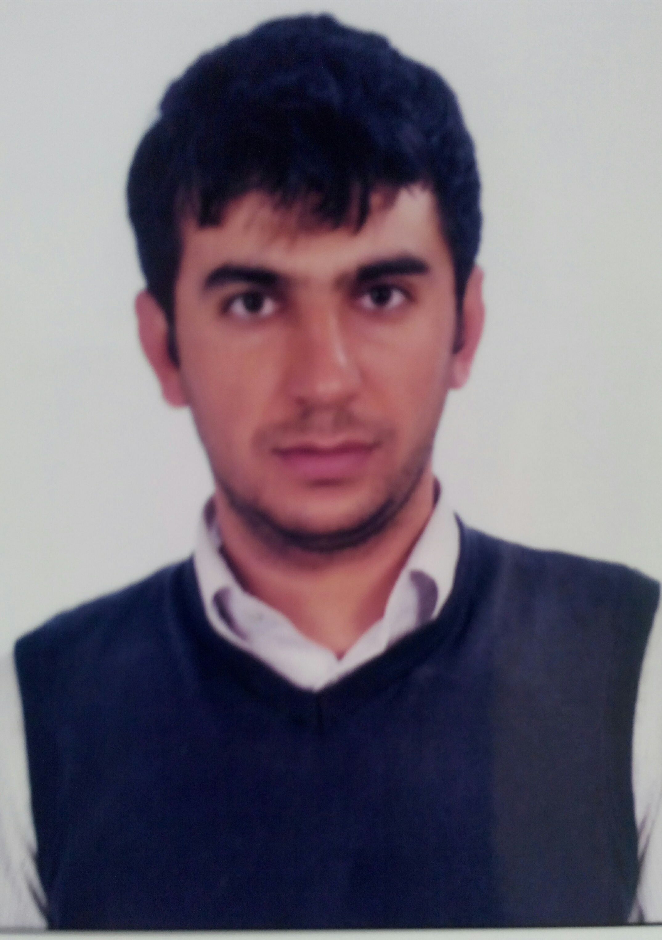
Phone |  | +905531434544 |  |  |  | İsmet ARTUÇ
Email: |  | ismetartuc@hotmail.com |  |  |  | 03.09.1992  (Turkey, Şırnak)
Education : |  | İTÜ Mathematical Engineering
Degree |  | Department |  | Institute |  |  | Date
High School |  | Science |  | TED Karabük Koleji  (full scholarship) |  |  | 2008-12
License |  | Mathematical Engineering |  | ITU (3. Class) |  |  | 2012---
Technical Skills:
• C#.Net good
- T-SQL good
• MySQL moderate
- C Programming Language good
- PHP moderate
- Java moderate
- Photoshop good
- SolidWorks good

Jobs:
2015 | MATO Confection | Web Designer
2014 | IMONA | Internship
2013-2014 | İTÜ (C programing Language) | Student Assistant

Achievements:
- Karabuk Verem Haftası Kompozisyon Yarışması championship
- TED- USA Embassy Innovation Compotation championship
- Özyeğin University exchange contest (7.)
- TÜBİTAK BİLGEM Cryptology Seminar Organization

Clubs:
- İTÜ Zeka ve Yetenek Klubü (Vice-chairman )
- İTÜ SAVTEK(Savunma Teknolojileri Klübü) (R & D Manager)

Certificates and Workshops:
2014 | Project Managment | Özyeğin Universty
2011 | Cyberbullying | TED

Language:
 | Speaking (-/5) | Listening (-/5) | Writing (-/5)
Turkish | 5 | 5 | 5
English | 3 | 4 | 4
German | 3 | 3 | 3

Hobbies:
  - nonsmoker
  - Table tennis
  - Cycling
  - Movies
  - Novels (Classics)
  - Strategy Games
Interested Fields  & Departments | - Software Development  - Database Management  - Cryptology

