Database Analysis Worksheet

# Step 1: Identify Entities, Attributes, and Primary Keys

|  |  |  |  |  |
| --- | --- | --- | --- | --- |
| Entity |  | Attributes |  | Primary Key |
| Doctors |  | **ID,** email, password |  | ID |
| Patients |  | **ID,** first_name, last_name, height (cm), weight (kg), blood type, gender, ethnicity |  | ID |
|  |  |  |  |  |

# Step 2: Define Relationships Between the Entities

|  |  |  |  |
| --- | --- | --- | --- |
| Entity 1 | Entity 2 | How Related?  (2 sentences) | Relationship Type (1:1, 1:N, M:N) |
| Doctors | Patients | A doctor can have many patients.  A patient can go to multiple doctors. | M:N |

# Step 3: Draw your Entity-Relationship Diagram (Hand-drawn is okay!!!)

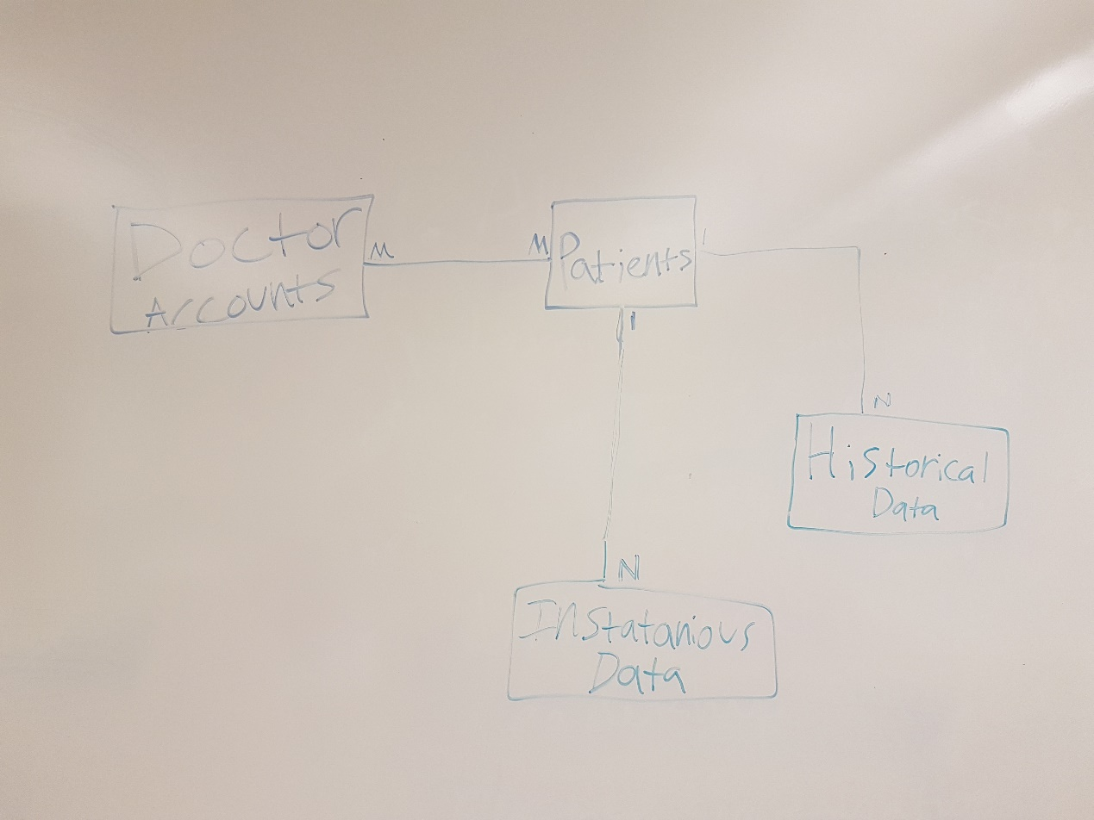

# Step 4: Specify Tables, Fields, and Data Types

Fill out a chart for each table to be included in the database.

Name of 1st Table: **doctors**

|  |  |
| --- | --- |
| Field Name | Data Type |
| ID** | integer (auto-increment) |
| email | string(9) |
| password | string(28) (ISO 8601) |

Name of 2nd Table: **patients**

|  |  |
| --- | --- |
| Field Name | Data Type |
| ID** | Integer (auto increment) |
| first_name | Text not null |
| last_name | Text not null |
| height (cm) | Integer |
| weight (kg) | Integer |
| blood type | Text |
| gender | Text |
| ethnicity | Text |

Name of 3rd Table: **doctors_patients**

|  |  |
| --- | --- |
| Field Name | Data Type |
| doc_id** (fk) | integer |
| pat_id** (fk) | integer |