**LAPORAN**

**PRAKTIKUM MOBILE PROGRAMMING**

**MODUL 4**

**ANDROID WIDGET**

**DISUSUN OLEH :**

MUHAMMAD RAMDHANI 3411181023

DSE A



**PROGRAM STUDI/JURUSAN INFORMATIKA**

**FAKULTAS SAINS DAN INFORMATIKA**

**UNIVERSITAS JENDERAL ACHMAD YANI**

**TAHUN 2021**

**DAFTAR ISI**

BAB I 3

HASIL PRAKTIKUM 3

1.1 Latihan 1 : Tombol dan Onclick 3

1.2 Latihan 2 : Radio dan CheckBox 6

1.3 Latihan 3 : WebView 9

BAB III 12

KESIMPULAN 12

# BAB I

# HASIL PRAKTIKUM

## 1.1 Latihan 1 : Tombol dan Onclick

A. Source Code

|  |
| --- |
| **ActivityMain.xml** |
| <?xml version="1.0" encoding="utf-8"?> <LinearLayout  xmlns:android="http://schemas.android.com/apk/res/android"  xmlns:app="http://schemas.android.com/apk/res-auto"  xmlns:tools="http://schemas.android.com/tools"  android:layout_width="match_parent"  android:layout_height="match_parent"  android:orientation="vertical"  tools:context=".MainActivity">   <EditText  android:layout_width="match_parent"  android:layout_height="wrap_content"  android:id="@+id/username"  />  <Button  android:layout_width="wrap_content"  android:layout_height="wrap_content"  android:gravity="center"  android:text="Call"  android:id="@+id/btnCall"  />  <TextView  android:layout_width="match_parent"  android:layout_height="wrap_content"  android:gravity="center"  android:id="@+id/output"  />  </LinearLayout> |

|  |
| --- |
| **MainActivity.java** |
| package com.example.latihan1;  import androidx.appcompat.app.AppCompatActivity;  import android.os.Bundle; import android.view.View; import android.widget.Button; import android.widget.EditText; import android.widget.TextView;  public class MainActivity extends AppCompatActivity {  Button btn;  EditText user;  TextView output;   @Override  protected void onCreate(Bundle savedInstanceState) {  super.onCreate(savedInstanceState);  setContentView(R.layout.*activity_main*);  btn = (Button) findViewById(R.id.*btnCall*);  user = (EditText) findViewById(R.id.*username*);  output = (TextView) findViewById(R.id.*output*);   btn.setOnClickListener(new View.OnClickListener() {  @Override  public void onClick(View v) {  String teks;  teks = "Welcome"+user.getText().toString()+"!";  output.setText(teks);  }  });  } } |

B. Screenshoot

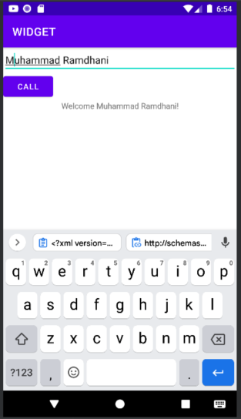

C. Analisis

Merupakan contoh penggunaan OnClickListener, OnClickListener digunakan untuk membaca klik atau touch yang dilakukan user pada Button, dan memasukkan fungsi yang akan dijalankan di dalam function onClick.

1.2 Latihan 2 : Radio dan CheckBox

A. Source Code

|  |
| --- |
| **ActivityMain.XML** |
| <?xml version="1.0" encoding="utf-8"?> <LinearLayout  xmlns:android="http://schemas.android.com/apk/res/android"  xmlns:app="http://schemas.android.com/apk/res-auto"  xmlns:tools="http://schemas.android.com/tools"  android:layout_width="match_parent"  android:layout_height="match_parent"  android:orientation="vertical"  tools:context=".MainActivity">   <RadioGroup  android:id="@+id/rradGroupCoffeeType"  android:layout_width="fill_parent"  android:layout_height="wrap_content"  android:orientation="vertical">  <TextView  android:id="@+id/labelCoffeeType"  android:layout_width="fill_parent"  android:layout_height="wrap_content"  android:background="#ff993300"  android:text="Jenis kopi"  android:textStyle="bold"  />  <RadioButton  android:id="@+id/radDecaf"  android:layout_width="fill_parent"  android:layout_height="wrap_content"  android:text="Decaf">  </RadioButton>  <RadioButton  android:id="@+id/radExpresso"  android:layout_width="wrap_content"  android:layout_height="wrap_content"  android:text="Expresso">  </RadioButton>  <RadioButton  android:id="@+id/radColombian"  android:layout_width="wrap_content"  android:layout_height="wrap_content"  android:text="Colombian">  </RadioButton>  </RadioGroup>   <TextView  android:id="@+id/labelCoffee"  android:layout_width="fill_parent"  android:layout_height="wrap_content"  android:background="#ff993300"  android:text="Tambah Topping ?"  android:textStyle="bold"></TextView>   <CheckBox  android:id="@+id/chkCream"  android:layout_width="wrap_content"  android:layout_height="wrap_content"  android:text="Cream"  android:textStyle="bold"></CheckBox>   <CheckBox  android:id="@+id/chkSugar"  android:layout_width="wrap_content"  android:layout_height="wrap_content"  android:text="Sugar"  android:textStyle="bold"></CheckBox>   <Button  android:id="@+id/btnOrder"  android:layout_width="72dp"  android:layout_height="wrap_content"  android:text="Order"  android:textStyle="bold"></Button>  </LinearLayout> |
| **MainActivity.java** |
| package com.example.latihan2;  import androidx.appcompat.app.AppCompatActivity;  import android.os.Bundle; import android.view.View; import android.widget.Button; import android.widget.CheckBox; import android.widget.RadioButton; import android.widget.RadioGroup; import android.widget.Toast;  public class MainActivity extends AppCompatActivity {  CheckBox chkCream;  CheckBox chkSugar;  Button btnOrder;  RadioGroup radCoffeeType;  RadioButton radExpresso;  RadioButton radDecaf;  RadioButton radColombian;    @Override  protected void onCreate(Bundle savedInstanceState) {  super.onCreate(savedInstanceState);  setContentView(R.layout.*activity_main*);   chkCream = (CheckBox) findViewById(R.id.*chkCream*);  chkSugar = (CheckBox) findViewById(R.id.*chkSugar*);  btnOrder = (Button) findViewById(R.id.*btnOrder*);  radCoffeeType = (RadioGroup) findViewById(R.id.*rradGroupCoffeeType*);  radDecaf = (RadioButton) findViewById(R.id.*radDecaf*);  radExpresso = (RadioButton) findViewById(R.id.*radExpresso*);  radColombian = (RadioButton) findViewById(R.id.*radColombian*);  btnOrder.setOnClickListener(new View.OnClickListener() {  @Override  public void onClick(View view) {  String msg = "Coffee ";  if (chkCream.isChecked())  msg += " & cream ";  if (chkSugar.isChecked())  msg += " & sugar";   int radioId = radCoffeeType.getCheckedRadioButtonId();  if (radColombian.getId() == radioId)  msg = "Columbian " + msg;  if (radExpresso.isChecked())  msg = "Expresso" + msg;  Toast.*makeText*(getApplicationContext(), msg,  Toast.*LENGTH_SHORT*).show();  }  });   } } |

B. Screenshoot

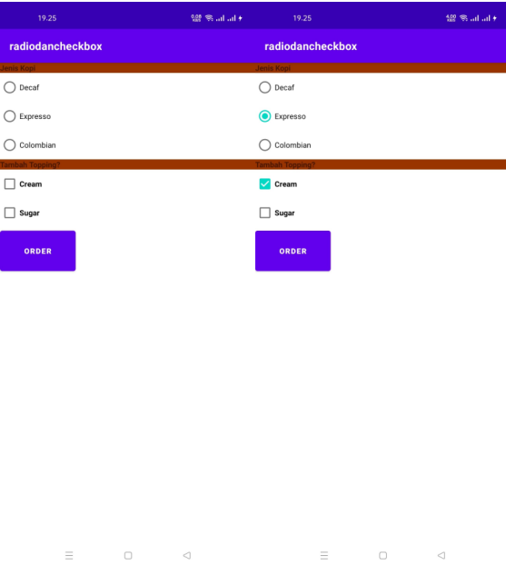

C. Analisis

Radio button adalah elemen graphical user interface ( GUI ) yang memungkinkan pengguna untuk memilih single item dari daftar opsi yang ditampilkan. Check box merupakan komponen desain yang biasanya ditampilkan dalam bentuk box kecil. check box juga digunakan sebagai komponen yang memungkinkan pengguna untu

1.3 Latihan 3 : WebView

A. Source Code

|  |
| --- |
| **ActivityMain.xml** |
| <?xml version="1.0" encoding="utf-8"?> <RelativeLayout  xmlns:android="http://schemas.android.com/apk/res/android"  xmlns:app="http://schemas.android.com/apk/res-auto"  xmlns:tools="http://schemas.android.com/tools"  android:layout_width="match_parent"  android:layout_height="match_parent"  tools:context=".MainActivity">   <WebView  android:layout_width="match_parent"  android:layout_height="match_parent"  android:layout_alignParentTop="true"  android:layout_alignParentLeft="true"  android:layout_alignParentStart="true"  android:id="@+id/webView"/>   <ProgressBar  style="?android:attr/progressBarStyle"  android:layout_width="wrap_content"  android:layout_height="wrap_content"  android:layout_centerHorizontal="true"  android:layout_marginTop="110dp"  android:id="@+id/progressBar2"  /> </RelativeLayout> |
| **AndroidManifest.xml** |
| <?xml version="1.0" encoding="utf-8"?> <manifest xmlns:android="http://schemas.android.com/apk/res/android"  package="com.example.fourthapps">  <uses-permission android:name="android.permission.INTERNET" />   <application  android:allowBackup="true"  android:icon="@mipmap/ic_launcher"  android:label="@string/app_name"  android:roundIcon="@mipmap/ic_launcher_round"  android:supportsRtl="true"  android:theme="@style/Theme.FourthApps">  <activity android:name=".MainActivity">  <intent-filter>  <action android:name="android.intent.action.MAIN" />   <category android:name="android.intent.category.LAUNCHER" />  </intent-filter>  </activity>  </application>  </manifest> |
| **MainActivity.java** |
| package com.example.fourthapps;  import androidx.appcompat.app.AppCompatActivity;  import android.graphics.Bitmap; import android.os.Bundle; import android.view.KeyEvent; import android.view.View; import android.webkit.WebView; import android.webkit.WebViewClient; import android.widget.ProgressBar;  public class MainActivity extends AppCompatActivity {  WebView webView;  ProgressBar bar;  @Override  protected void onCreate(Bundle savedInstanceState) {  super.onCreate(savedInstanceState);  setContentView(R.layout.*activity_main*);  webView = (WebView)findViewById(R.id.*webView*);  bar = (ProgressBar) findViewById(R.id.*progressBar2*);  webView.setWebViewClient(new MyWebClient());  webView.getSettings().setJavaScriptEnabled(true);  webView.loadUrl("https://sinau.unjani.ac.id/");  }  public class MyWebClient extends WebViewClient {   public void onPageFinished(WebView view, String url, Bitmap  favicon){  super.onPageFinished(view, url);  bar.setVisibility(View.*GONE*);  }  @Override  public void onPageStarted(WebView view, String url, Bitmap favicon){  super.onPageStarted(view, url, favicon);  }  @Override  public boolean shouldOverrideUrlLoading(WebView view, String url){  view.loadUrl(url);  return super.shouldOverrideUrlLoading(view, url);  }  }  @Override  public boolean onKeyDown(int keyCode, KeyEvent event){  if ((keyCode==KeyEvent.*KEYCODE_BACK*) && webView.canGoBack()){  webView.goBack();  return true;  }  return super.onKeyDown(keyCode, event);  } } |

B. Screenshoot

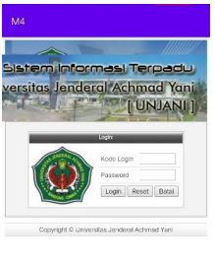

C. Analisis

WebView adalah ekstensi class View Android yang memungkinkan untuk menampilkan halaman web sebagai bagian dari tata letak aktivitas. Class ini tidak menyertakan fitur apa pun dari browser web yang dikembangkan sepenuhnya, seperti kontrol navigasi atau kolom URL.

# BAB III

# KESIMPULAN

Pada praktikum kali ini kita belajar di Android Studio yaitu memahami dan mengimplementasikan cara bagaimana membuat Tombol/OnClick, Radio/CheckBox dan WebView.