Hexagon Conway’s Game of Life Simulator

1. class cell

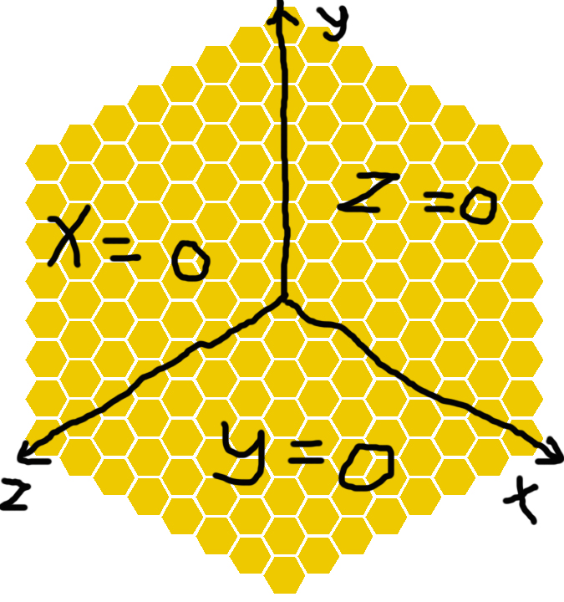

Each cell should contain its own coordinate. The coordinate is defined as a vector (x, y, z). x, y, z are nonnegative integers which hold the equation x\*y\*z = 0.