|  |
| --- |
| Software Requirements Specification |
| Event Management System |
| Blithe Fan, CY Lim, Loo Yee, Matthew Boroczky, Michael Kong, Sandon Joubert, Toby He |

Table of Contents

1. Introduction 4

Glossary - Definitions, Acronyms and Abbreviations 4

Purpose 5

Scope 5

Overview 6

References 6

2. Overall Description 6

2.1 Product perspective 6

*System Interface* 6

*User interfaces* 7

*Hardware interfaces* 7

*Memory Constraints* 7

*Operations* 7

User Characteristics 8

Product Functions 9

Constraints 10

Assumptions and dependencies 10

3. Specific Requirements 11

Requirement Dependencies 12

Dependency table 12

Dependency graph 19

Functional Requirements 25

User Management Subsystem 25

Paper Management Subsystem 39

Paper Review Subsystem 46

Event Creation Subsystem 60

Venue Creation Subsystem 61

Conference Logistics Subsystem 72

Ticketing and Payment 80

Analytics Subsystem 89

In-House Subsystem 96

Non-Functional Requirements 100

Software Requirements Specification

# Introduction

## Glossary - Definitions, Acronyms and Abbreviations

**Manager / Organiser** - Individuals at the top of the hierarchy within the event. They have the ability to change all details about the event

**Conference** - a formal meeting for discussion. When considering Conferences the system is not limited to small academic conferences. It should support the management of large conferences such as Apple’s WWDC conference in which thousands attend (~ 5000)

**Event** – An event is similar to a conference but can generally be much larger. Typically events also have multiple presentations.

**Presentation** - Presentations are held within conferences or events. One event/conference must have one or more presentations

**Author** – Refers to an author of a paper. Also refers to event speakers since authors are potential speakers.

**System** – Refers to the Event Organiser and its subsystems.

**User** – Refers to any user of the system.

**COI** – Conflict of Interest

**Drawing Board** - The graphical user interface provided to managers to enable then to draw seats , types of seat, accessory items and position object. This may also be used in the context of visitors/guests having the ability to select seats.

## Purpose

The purpose of this document is to describe the external behaviour of the Event Organiser. In this document, a detailed overview of the software’s parameters and goals are presented. Optional functions, that may be implemented later, are also described. Also described within this document are non-functional requirements that are necessary in providing a complete and thorough description of all system requirements.

The software development team and the potential users are the main audience of this document.

## Scope

The software system to be produced is a web based event organiser system. This system is aimed at 4 groups of users: event organisers, event attendees, paper authors and paper reviewers. The entire system will be under the control of the system administrator whose role is to maintain all services and users related to the system.

There are 9 main subsystems that comprise the Event Organiser:

* User Management Subsystem that manages user profiles and access rights.
* Paper Management Subsystem that manages paper submissions, deadlines, sorting, filtering and storage.
* Paper Review Subsystem that manages reviewer requests, provides features for review procedures and protocols, and tracks reviews of papers.
* Event Creation Subsystem that allows the creation of events, choosing of venues and setting of ticket prices.
* Venue Creation Subsystem that allows venue building via a “room builder” feature.
* Event Logistics Subsystem that manages the various resources such as microphones and projectors during an event, and allow users to specify meal preferences.
* Ticketing and Payment Subsystem that allows users to purchase tickets.
* Analytics and Tracking Subsystem that tracks various aspects of the system such as the demographics of the event attendees and produces financial reports of events.
* In-house Event Subsystem that contains timetables of events, provides venue maps, facilitates check-in and sends post-event questionnaires to event attendees.

Although the system makes event organizing and booking convenient for all users, there are some limitations of the system:

* Usage is limited to newer browsers that support HTML5 specifications
* Only mobile devices that are running iOS7 and above can run the mobile application of the Event Organiser

## 

## Overview

The remainder of this document is composed of two main sections:

Section 2: Overall Description: Description of the general factors that affect the system and provide high level requirements of the system.

Section 3: Specific Requirements: Description of all software requirements the system must have to meet the requirements and necessities of the client.

## References

– NIL –

# Overall Description

## 2.1 Product perspective

All current activities under the present system are done manually. Processes that are executed manually, such as the collection and organization of event attendee particulars, are inefficient. To perform such tasks, considerable amounts of time and manpower are required.

This inefficiency in performing such tasks creates the need to build an Event Organiser system to increase efficiency, productivity and convenience for the event organisers, event attendees, paper authors and paper reviewers. The system will make processes that are currently inefficient, quicker and more convenient.

### *System Interface*

The Event Organiser system will be built for web and mobile. It will be deployed on the Internet so that users can simultaneously access the system from any personal computer or mobile device that supports Internet services.

Servers on which the Event Organiser is deployed are connected to the Internet to allow client machines to access the Event Organiser system to utilize the various features provided by the system. The servers will receive and process client requests, retrieve, store and compute data from database servers, and send data back to clients.

### *User interfaces*

The user interface (UI) for the Event Organiser system is based on graphical user interfaces. The UI can be accessed from any personal computer or mobile device that supports Internet services. All users will access a similar UI with differences depending on the users’ profile privileges. Users can only view the UI after logging into the system.

Access to the database and the servers will be performed through the UI provided by the web hosting company.

### *Hardware interfaces*

Server modules must be able to execute on the servers. Web modules must be able to execute on Google Chrome and Mozilla Firefox on personal computers. Mobile modules must be able to execute on iOS7 and above.

### *Memory Constraints*

The web server machines must have a minimum of 5GB of storage and the database server machines must have a minimum of 20GB of storage. The personal computers must have a minimum of 500MB of free space.

### *Operations*

The Event Organiser system should be easy for all users to use. No specific information or technical skills are required to use the system.

Access to the web server should be familiar to the system administrator such that they do not require any additional information or technical skills.

The database of the system and access to it should be familiar to the system administrator such that they do not require any additional information or technical skills.

Backup and recovery operations must be specified in case of database corruption, power outage or any other incidents which may disrupt the system.

## User Characteristics

The Event Organiser consists of 3 different types of users with a possible 7 states of users.

The 3 different types of users found in the system that are:

* **Public Visitor** - A public viewer is any user who enters the website and has the ability to view events, times, seat selection and etc. These forms of users are not stored in the database
* **Guests** - Guests are the default user of the system. Upon purchasing a ticket or creating an account the user becomes a guest. Guests inherits the ability to view the website as a Visitor does.
* **Administrators**  - Users who will be running the system and providing you as the customer with the service of using our system (SaaS - Software as a Service). These individuals have write privileges on everything and maintain the system.

Below are the different states a Guest can have within the system:

* States Specific to a conference a Conference:
  + **Authors** - Users who submit papers into the system for reviewing. They should have some knowledge of online submissions and online communication.
  + **Reviewers** - Users who are eligible to review papers based on their expertise and knowledge. They should be knowledgeable in their individual fields because they might be selected to be part of a program committee to review papers.
  + **Chair** - Higher privileged Reviewers. They should know the processes that encompass paper reviewing so that the integrity of paper reviewing process is maintained. They have the ability to moderate conversation between Authors and Reviewers and have the final review on the paper
* States for Conferences and Events:
  + Event **Attendees** - Users who will purchase tickets to events. Their knowledge of online systems can be extremely varied from novice users to expert users.
  + Event **Organisers**/**Managers** - Users who will create, manage and monitor events. They should have knowledge of how event organization and event logistics.
  + **Presenters** - Users who either represent Authors that are unable to attend the event or one or more of the authors themself. In general they should have a close association with the Author and the paper that they were selected for.
  + **Security** Personnel _ Users who will be maintaining the security at an event. They should have basic knowledge of Internet-enabled mobile devices and the features of the Event Organiser that are specific to their role.

*Disclaimer: The below functionalities are just a small snippet of some of the functionalities our system provides. For an in depth view please see the Functional Requirements section.*

## Product Functions

The main functions of the Event Organiser are listed below and categorized based on different types of users.

For Event Organisers/Managers, the Event Organiser system would provide the functionalities to:

* create and manage events
* monitor and manage submission of papers
* select a conference Chair from a pool of Reviewers
* manage and monitor a program committee

For Event Attendees, the Event Organiser system would provide the functionalities to:

* select seats
* purchase tickets
* view event timetable
* connect with other attendees that have the same interests
* receive notifications via email or mobile notifications

For Authors, the Event Organiser system would provide the functionalities to:

* upload and submit papers in PDF or LaTeX formats
* receive reviews on their papers
* elect a Presenter if their paper is selected and they are not able to attend the event

For Chair, the Event Organiser system would provide the functionalities to:

* elect and manage a program committee from a pool of Reviewers
* mediate a conversation between an Author and a Reviewer
* manage Reviewer access to papers with conflicts of interests
* assign papers to Reviewers based on Reviewer preferences

For Reviewers, the Event Organiser system would provide the functionalities to:

* review a given paper
* reject proposal to review a paper
* converse with an Author about their paper
* select preferences

For Presenters, the Event Organiser system would provide the functionalities to:

* upload their credentials
* act as a representative as the Author for an event
* accept or reject the offer to be a presenter for an Author

For Security Personnel, the Event Organiser system would provide the functionalities to:

* receive requests for assistance
* communicate with other Security Personnel

The functionalities listed here are centered on the business needs and requirements of the client that has requested this system. In a further section of this document, these functionalities will be subdivided into smaller parts and be covered in more detail. The functionalities that make up the Event Organiser system are aimed to make tasks and transactions simpler and more convenient.

## Constraints

The system should obey and satisfy the following constraints:

* Authentication: The system should only allow users to login when the correct email and password are entered.
* Access Control: The appropriate access rights should be given to the various users of the system. (E.g.: Event attendees should not be allowed to edit event details)
* Backup and recovery: System files should be easily recoverable through back up in the event of data corruption or data loss.
* The system must have all Core and Main requirements implemented by June 2016.

## Assumptions and dependencies

1. All potential users must have an existing email address.
2. All potential users must have access to the Internet.
3. All potential users must have a device containing an HTML5 and JavaScript enabled web browser.
4. If users wish to access additional on-the-day features, which is recommended, they must have an apple device with access to the internet and have downloaded our application from the Apple app store.

# Specific Requirements

Each requirement (either functional or non-functional requirements) of Event Management System is ranked based on its level of priority:

1. Core: these requirements are the core functionalities of Event Management System. Without these requirements there will not be a functional Event or Conference Management system.
2. Main: these requirements are the important functionalities of Event Management System and should be implemented when all the Core requirements have been finished
3. Stretch: these requirements are the necessary functionalities of Event Management System and should be covered when Core and Main requirements have implemented
4. Dream: these requirements are the enhanced functionalities of Event Management System and should be considered only when all Core, Main and Stretch requirements are completed

## Requirement Dependencies

### Dependency table

|  |  |  |  |  |  |
| --- | --- | --- | --- | --- | --- |
| ID | Requirement | Platform | Type | Priority | Dependencies |
| F_U1 | Create Profiles | Web | Functional | Core |  |
| F_U2 | Remove Profile | Web | Functional | Core | F_U1 |
| F_U3 | Profile Details | Web | Functional | Core | F_U1 |
| F_U4 | Update Profile | Web | Functional | Core | F_U3 |
| F_U5 | Unique ID and Password | Web | Functional | Core | F_U3 |
| F_U6 | Change Password | Web | Functional | Core | F_U5 |
| F_U7 | Upgrade Account | Web | Functional | Core | F_U3 |
| F_U8 | Password Encryption | Web, IOS | Functional | Main |  |
| F_U9 | Create a Conference | Web | Functional | Core |  |
| F_U10 | Enable Paper Submission for Event | Web | Functional | Main |  |
| F_U11 | Email Created | Web | Functional | Main |  |
| F_U12 | Email Reminder of Event | Web | Functional | Main |  |
| F_U13 | View Presenter and Presentation Times | Web, IOS | Functional | Stretch |  |
| F_U14 | Multi-lingual support | Web | Functional | Dream |  |
| F_U15 | Default Mandarin Support | Web, IOS | Functional | Dream |  |
| F_U16 | Database Type | Web | Functional | Dream |  |
| F_U17 | Facebook Integration | Web, IOS | Functional | Stretch |  |
| F_U18 | Login via Facebook | Web, IOS | Functional | Stretch |  |
| F_U19 | Invite to Event via Facebook | Web, IOs | Functional | Stretch | F_U18 |
| F_U20 | Linkedin Integration | Web, IOS | Functional | Stretch | F_U19 |
| F_U21 | Invite to Event via Linkedin | Web, IOS | Functional | Stretch |  |
| F_U22 | Invite to Event via Contacts | IOS | Functional | Stretch | F_U21 |
| F_PM1 | Upload PDF Documents | Web | Functional | Core |  |
| F_PM2 | Upload LaTex Documents | Web | Functional | Main |  |
| F_PM3 | Upload Word Documents , | Web | Functional | Main |  |
| F_PM4 | Upload ZIP Files | Web | Functional | Main |  |
| F_PM5 | Submit Paper | Web | Functional | Core | F_PM1 |
| F_PM6 | Modify Submission | Web | Functional | Core | F_PM5 |
| F_PM7 | Match Accounts to Paper Contribution | Web | Functional | Main | F_PM5 |
| F_PM8 | Allow Automatic Detection of Paper Contribution | Web | Functional | Stretch | F_PM1 |
| F_PM9 | Restrict Upload Types | Web | Functional | Main | F_PM1 |
| F_PM10 | Setup Categories and Subcategories | Web | Functional | Main |  |
| F_PM11 | Automatic Detection of Paper Abstract | Web | Functional | Stretch | F_PM1 |
| F_PM12 | Set Limit on File Size | Web | Functional | Stretch | F_PM1 |
|  |  |  |  |  |  |
| F_PR1 | Assign Papers to Reviewers | Web | Functional | Core | F_U1 |
| F_PR2 | Multiple Papers to Reviewers | Web | Functional | Core | F_U1 |
| F_PR3 | Delete Reviewer | Web | Functional | Core | F_U4 |
| F_PR4 | Distribute Papers to Reviewers | Web | Functional | Core | F_U7 |
| F_PR5 | Blind Review | Web | Functional | Core | F_PR4 |
| F_PR6 | Double Blind Review | Web | Functional | Main | F_PR5 |
| F_PR7 | Scaling of Reviews based on Reviewer Competence | Web | Functional | Main | F_PR5 |
| F_PR8 | Accept Reject Paper Review | Web | Functional | Main | F_PR5 |
| F_PR9 | Automatically Flag Reviews with a difference | Web | Functional | Main | F_PR5 |
| F_PR10 | Communicate between Author and Reviewer Moderated by Chair | Web | Functional | Main | F_U7 |
| F_PR11 | Select Reviewer Preferences | Web | Functional | Core | F_U7 |
| F_PR12 | Send Request to Review Paper | Web | Functional | Core | F_U7 |
| F_PR13 | Accept/Reject Assigned Paper Request | Web | Functional | Core | F_PR12 |
| F_PR14 | View the Reviewer List | Web, IOS | Functional | Core |  |
| F_PR15 | Add Reviewer to Reviewer List | Web | Functional | Core | F_PR14 |
| F_PR16 | Check COI Manually | Web | Functional | Core |  |
| F_PR17 | Check COI through Facebook and Linkedin | Web | Functional | Stretch | F_U17, F_U20 |
| F_PR18 | Customise Flag Value of Review | Web | Functional | Main |  |
| F_PR19 | Automatically Suggest Reviewers Based on Linkedin Skills | Web | Functional | Dream | F_U20 |
| F_PR20 | Send Paper Link to a Friend for Review | Web | Functional | Stretch |  |
| F_PR21 | Comment on Papers | Web | Functional | Core | F_U7 |
| F_PR22 | Create Best Paper Award | Web | Functional | Main | F_PM10 |
| F_PR23 | Set Minimum and Maximum number of Reviews per Paper | Web | Functional | Main |  |
| F_PR24 | Set Maximum number of Papers each Reviewer can Review | Web | Functional | Main |  |
| F_PR25 | Accept/Reject Review of Paper | Web | Functional | Core |  |
| F_PR26 | Multiple Reviewers for a paper | Web | Functional | Main | F_U1 |
| F_E1 | Create an Event | Web | Functional |  | F_U7 |
| F_E2 | Upload Poster | Web | Functional |  |  |
| F_V1 | Build a Conference Room | Web, IOS | Functional | Dream | ~F_V15 |
| F_V2 | Drag and Drop for Utilities | Web, IOS | Functional | Dream | F_V1 |
| F_V3 | Drag and Drop for Seat Location | Web, IOS | Functional | Dream | F_V1 |
| F_V4 | Select Number of Seats in X and Y Axis | Web | Functional | Dream | F_V1 |
| F_V5 | Fan-Out option for Seats | Web | Functional | Dream | F_V1 |
| F_V6 | Display Unavailable Seats | Web, IOS | Functional | Dream | F_V1 |
| F_V7 | Seat Types | Web, IOS | Functional | Main |  |
| F_V8 | Seat Classes | Web, IOS | Functional | Main |  |
| F_V9 | Selecting Seats for Types | Web, IOS | Functional | Main | F_V7 |
| F_V10 | Selecting Seats for Classes | Web, IOS | Functional | Main | F_V8 |
| F_V11 | Automatic Legend Generation | Web, IOS | Functional | Dream | F_V9, F_V10 |
| F_V12 | Seating Release Conditions | Web, IOS | Functional | Dream | F_V8 |
| F_V13 | Ability to Draw Venue with Line Tools | Web, IOS | Functional | Dream | F_V1 |
| F_V14 | Ability to Add Labels | Web, IOS | Functional | Dream | F_V1 |
| F_V15 | 3D Venue Builder | Web | Functional | Dream* |  |
| F_V16 | Virtual Walk through | Web | Functional | Dream* | F_V15 |
| F_V17 | Selecting, Moving and Modifying Objects | Web, IOS | Functional | Dream | F_V2, F_V3 |
| F_V18 | Booking Accommodation for Guests | Web | Functional | Stretch |  |
| F_V19 | Pricing options for Accommodation | Web | Functional | Stretch |  |
| F_V20 | Upload Birds-Eye-View Image of Venue | Web, IOS | Functional | Stretch |  |
| F_L1 | Book Accommodation for Guests | Web | Functional | Stretch |  |
| F_L2 | Room Selection for Speakers | Web | Functional | Main | F_U16 |
| F_L3 | Create a presentation | Web | Functional | Core |  |
| F_L4 | Determine Available Rooms for Presenters | Web | Functional | Main | F_U16 |
| F_L5 | Filter Criteria for Room Booking | Web | Functional | Stretch | F_U16 |
| F_L6 | Timetable Generation | Web | Functional | Main | F_L2 |
| F_L7 | User Specific Meal Preferences | IOS, Web | Functional | Stretch |  |
| F_L8 | Video Conference Capabilities | Web | Functional | Dream |  |
| F_L9 | Ability to have Private or Public Events | Web | Functional | Main | F_E1 |
| F_L10 | Ability to have Private or Public Presentations/Performances | Web | Functional | Stretch | F_E1 |
| F_L11 | Automatically generate Visa Letters | Web | Functional | Stretch |  |
| F_L12 | Ability to have a presenter that is not an author of a paper | Web | Functional | Main |  |
| F_L13 | Ability to have backup presenters | Web | Functional | Main | F_L10 |
| F_L14 | Ability to transfer access to a event to new organisers | Web | Functional | Dream | F_E1, F_U7 |
| F_L15 | Ability to copy event data as a template for others user | Web | Functional | Stretch | F_U16 |
| F_L16 | Ability to publish conference/event proceedings before and after the event | Web | Functional | Stretch | F_U16, F_PM5, F_E1 |
| F_TP1 | User purchase ticket | IOS, Web | Functional | Core | F_TP11 |
| F_TP2 | Interface with external payment system | Web | Functional | Main |  |
| F_TP3 | Select seat type and class of seat | IOS, Web | Functional | Stretch |  |
| F_TP4 | Viewing birds eye view of the event system | Web | Functional | Main | F_V20 |
| F_TP5 | Optional accommodation for guests | Web | Functional | Stretch |  |
| F_TP6 | Managers create categories of tickets (other than general admission) | Web | Functional | Main |  |
| F_TP7 | Attendees can select a ticket type for purchase | IOS, Web | Functional | Main | F_TP6 |
| F_TP8 | Email notification upon ticket purchase | IOS, Web | Functional | Main | F_TP1 |
| F_TP9 | Purchase ticket for multiple people if public event | IOS, Web | Functional | Main | F_TP1 |
| F_TP10 | Purchase ticket for multiple events | IOS, Web | Functional | Core | F_TP1 |
| F_TP11 | User makes payment | IOS, Web | Functional | Core | F_TP2 |
| F_TP12 | Different payment option | IOS, Web | Functional | Core | F_TP2 |
| F_TP13 | Option to limit payment method | Web | Functional | Main |  |
| F_TP14 | Payment log to keep track of transaction record | IOS, Web | Functional | Core | F_TP2 |
| F_TP15 | Ability to view payment log | IOS, Web | Functional | Core | F_TP14 |
| F_TP16 | Waiting list | Web | Functional | Stretch |  |
| F_TP17 | Ability to generate QR codes for tickets | IOS | Functional | Stretch | F_TP1 |
| F_TP18 | Ability to save tickets in iOS Passport | IOS | Functional | Stretch | F_TP1 |
| F_A1 | Generate financial statements | Web | Functional | Stretch |  |
| F_A2 | Generate statistical reports | Web | Functional | Dream |  |
| F_A3 | Number of attendees per event type | Web | Functional | Stretch | F_A2 |
| F_A4 | Satisfaction of Attendees per event type | Web | Functional | Stretch | F_A2 |
| F_A5 | Number of purchased tickets for each category of ticket | Web | Functional | Stretch | F_A2 |
| F_A6 | Generate budget reports | Web | Functional | Stretch |  |
| F_A7 | Ability to have sponsors | Web | Functional | Main |  |
| F_A8 | Ability to upload advertisement data | Web | Functional | Main |  |
| F_A9 | Calculating advertisement exposure from payment | Web | Functional | Stretch | F_A6 |
| F_A10 | Viewing purchased and available seats with Statistics (birds-eye) | Web | Functional | Stretch | F_V20 |
| F_A11 | Viewing Birds-Eye-View of the event | Web | Functional | Dream | F_V20 |
| F_A12 | Displaying Financial Statements | Web | Functional | Stretch | F_A1 |
| F_A13 | Displaying Statistical Reports | Web | Functional | Dream | F_A2 |
| F_IH1 | Optional Surveys | Web | Functional | Main | F_E1 |
| F_IH2 | Security Help | IOS | Functional | Main |  |
| F_IH3 | Comment on Event | IOS, Web | Functional | Core | F_E1 |
| F_IH4 | Submit Questions for a talk | IOS, Web | Functional | Core | F_L3 |
| F_IH5 | Speaker can ask question and attendees can answer | IOS, Web | Functional | Stretch | F_L3 |
| F_IH6 | Generation of name badges | Web | Functional | Stretch | F_IH7 |
| F_IH7 | Download list of Attendee Names | Web | Functional | Core | F_TP1 |
| F_IH8 | Social-Media communication with attendees | IOS | Functional | Dream |  |

* - a requirements that is slightly above its classification but not high enough to create a new classification

~ - May Depend on

### Dependency graph

#### User Management

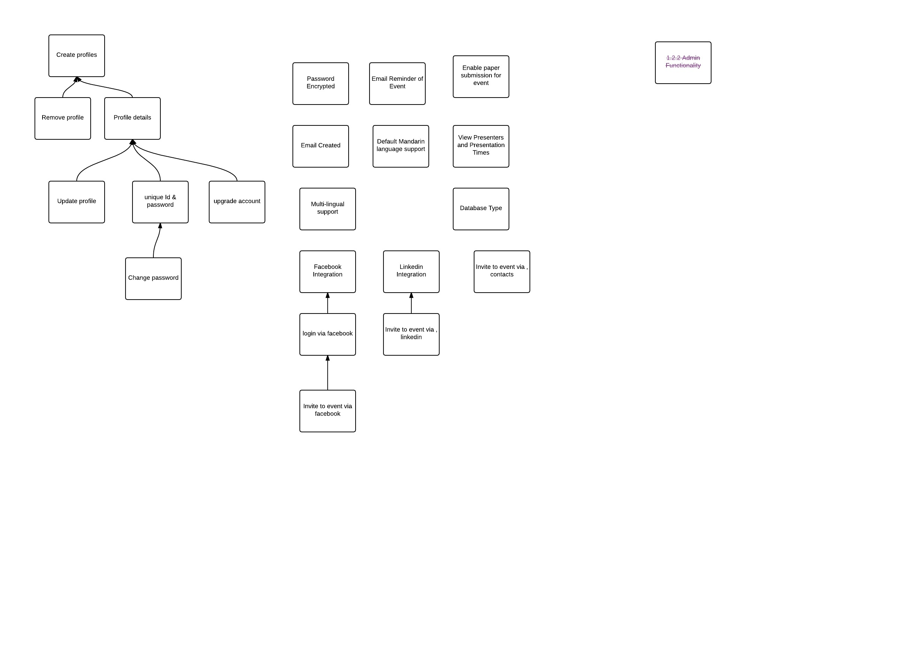

#### Paper management

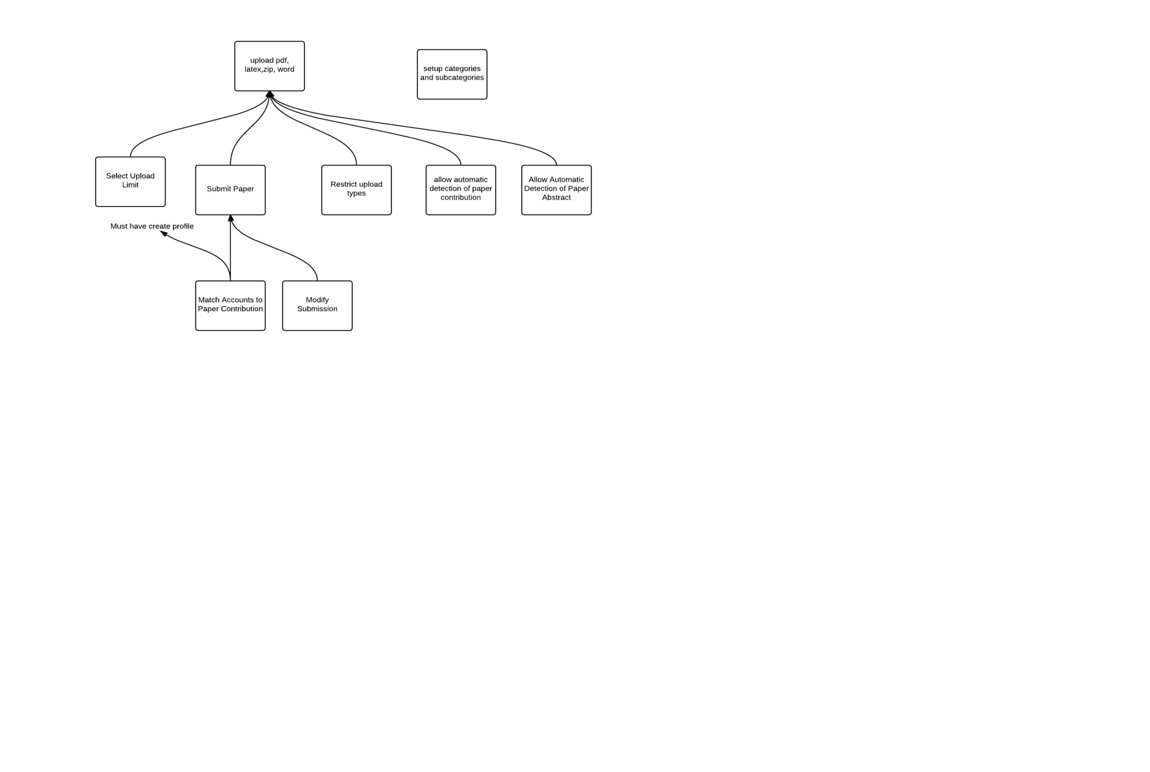

#### Paper Review

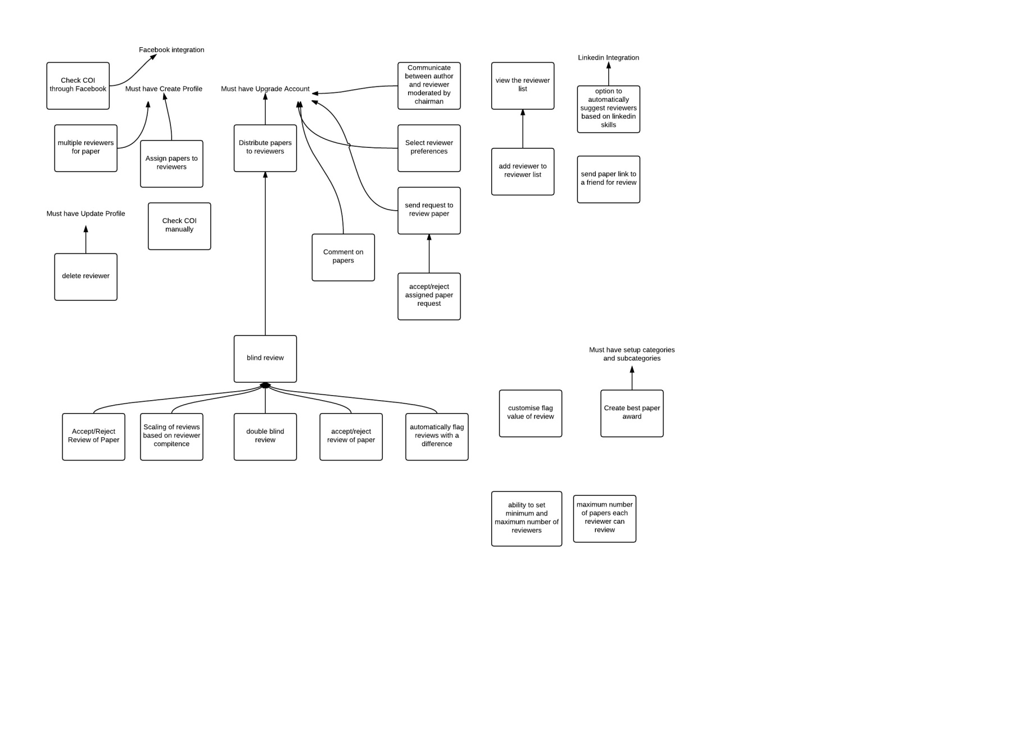

#### Event Creation

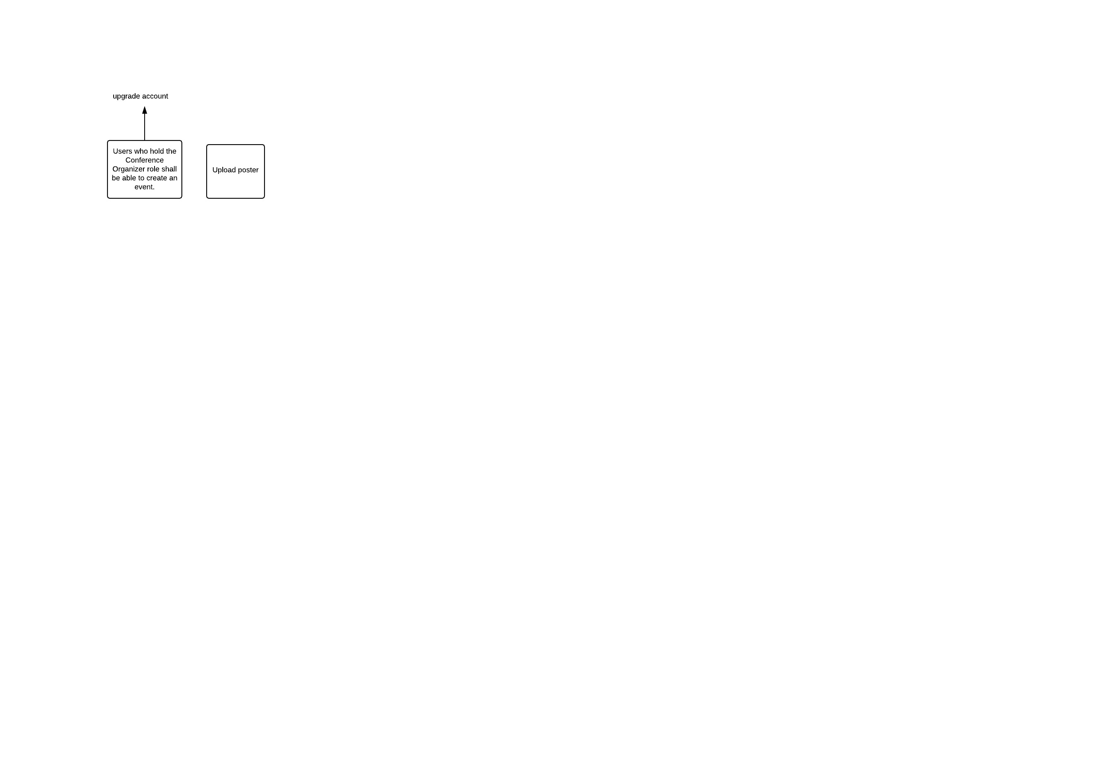

#### Venue Booking

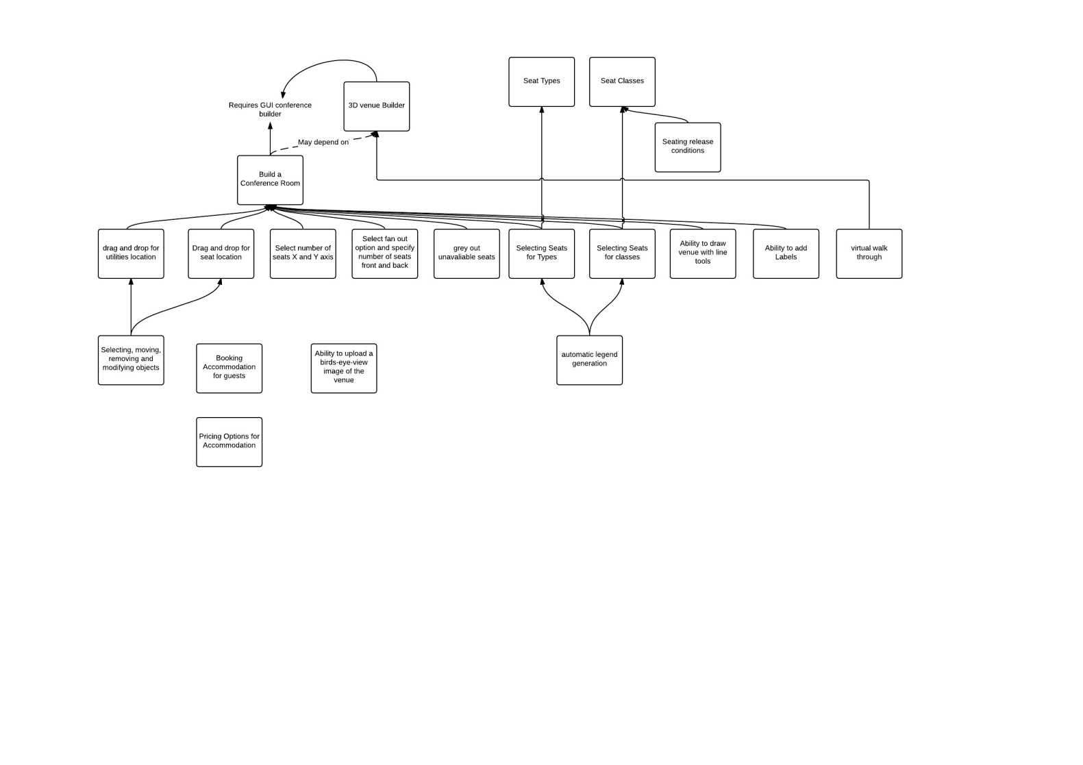

#### Conference Logistics

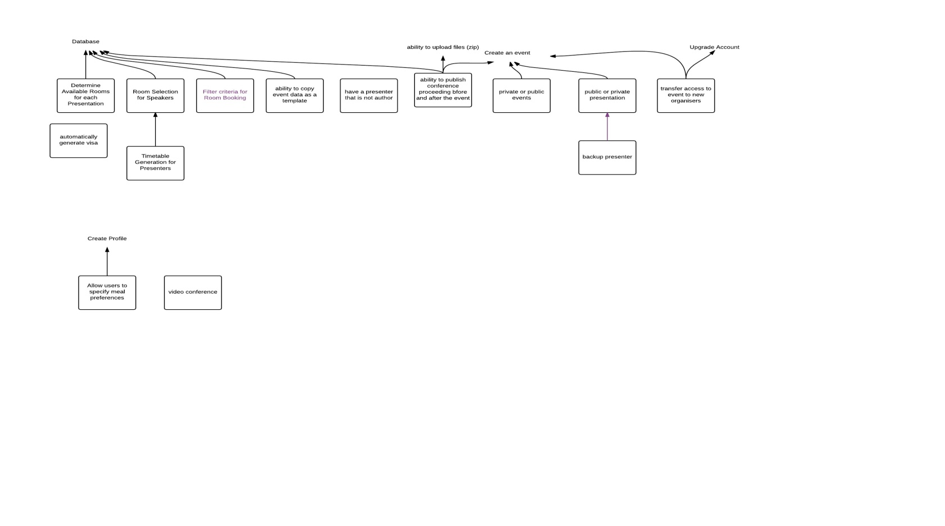

#### Analytics and tracking

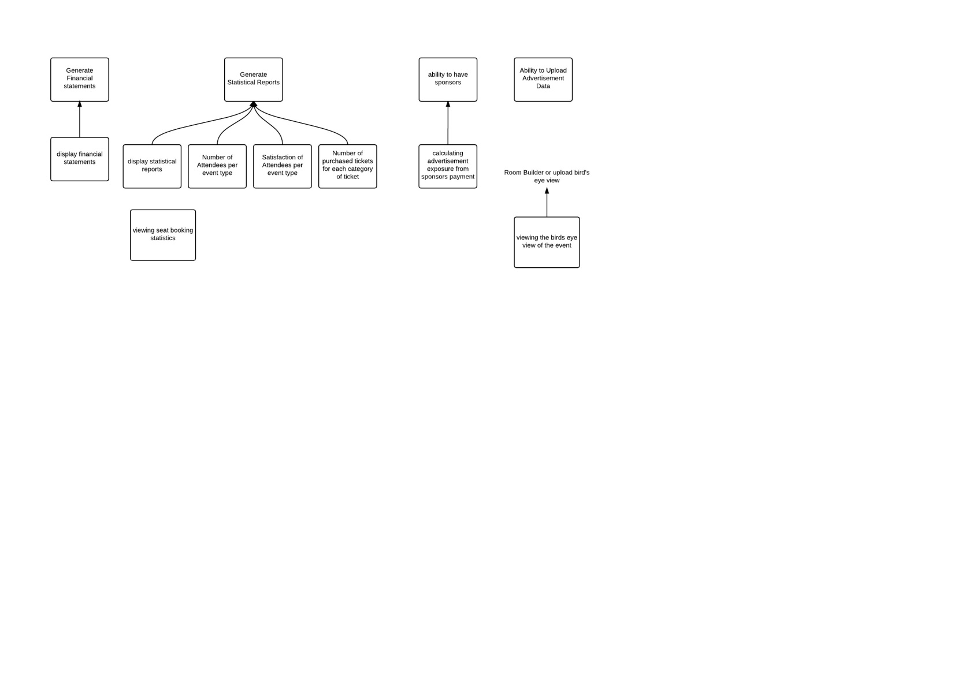

#### Ticketing and Payment

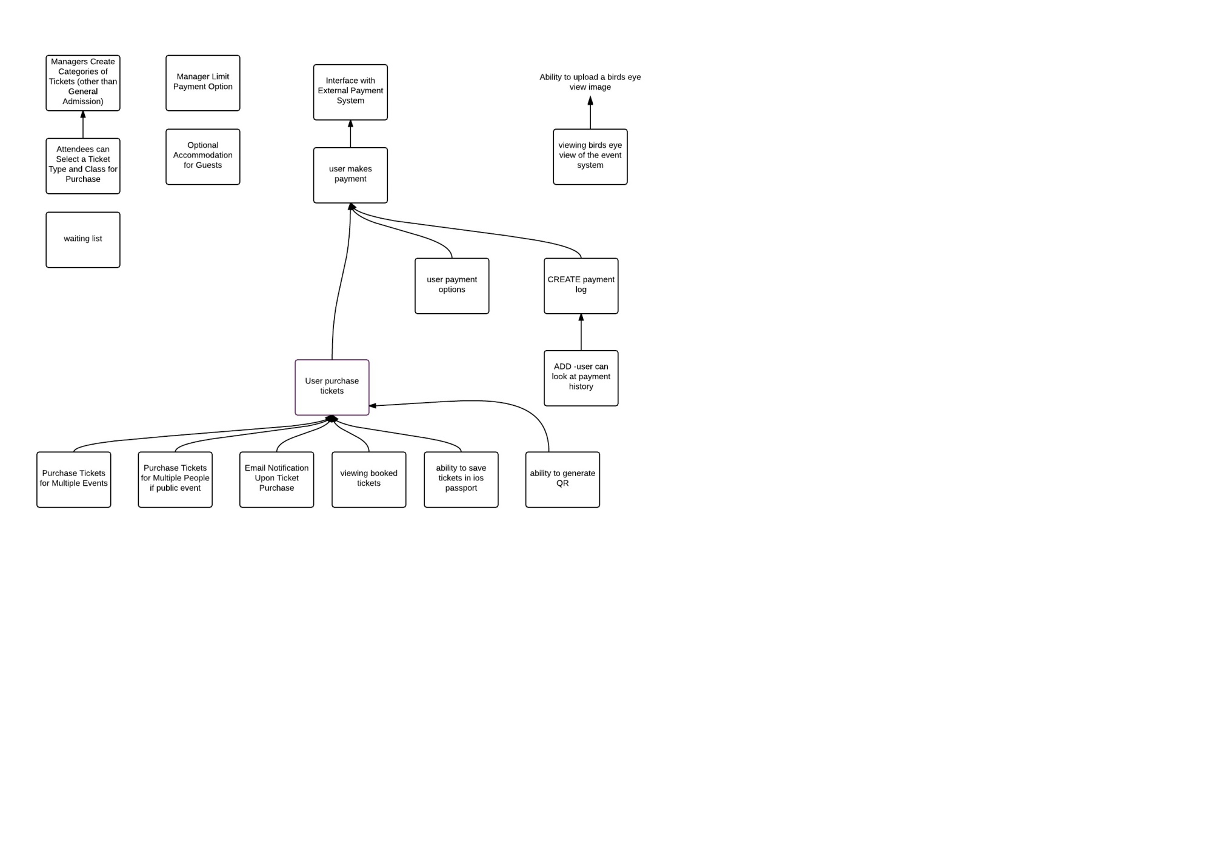

#### In-House

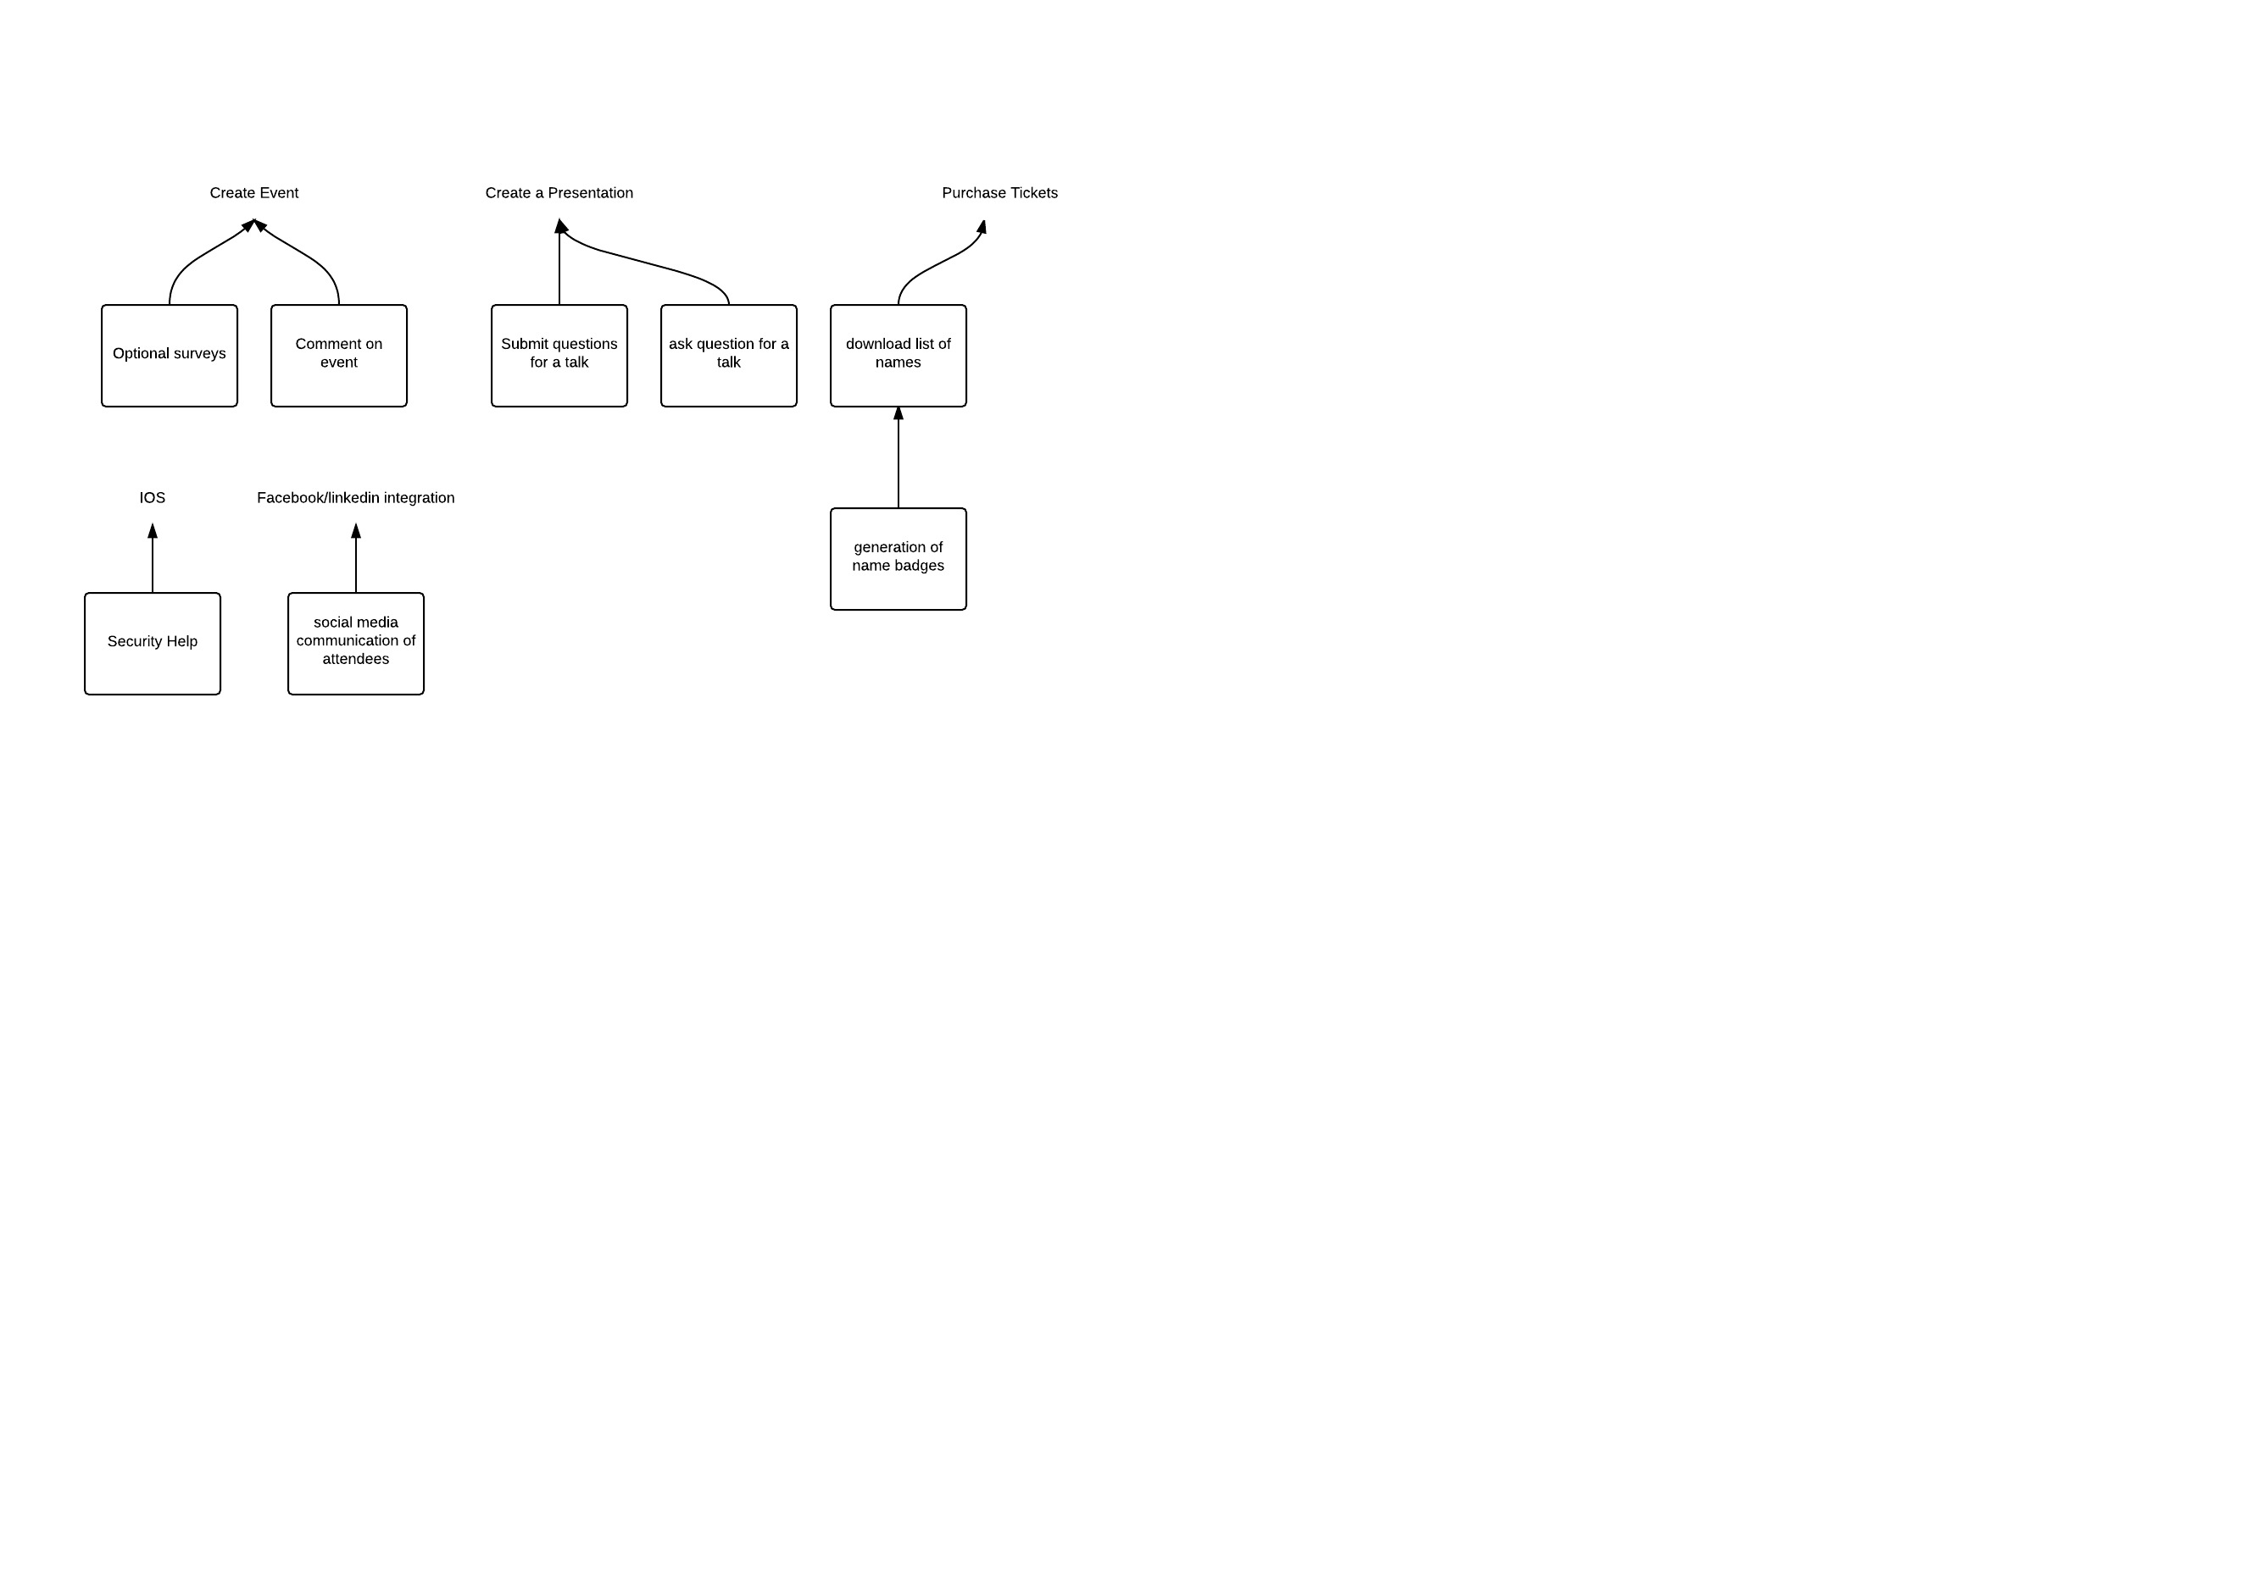

#### General overview

## Functional Requirements

### User Management Subsystem

|  |  |  |
| --- | --- | --- |
| **Name:** Create profiles | | |
| **Requirement #:** F_U1 | **Requirement Type:** Functional | **Use Case ID**: |
| **Description:** The system shall allow users to create a profile from one of the following categories:   * Conference Chair * Author * Reviewer * Financial Secretary * Delegate | | |
| **Rationale:** Users require a profile to use the Event Organiser. | | |
| **Source:** Client | | |
| **Fit Criterion:** Users can successfully create a profile to access the system. | | |
| **Dependencies:** Refer to F_3.1.1.1_02 for details of each profile. | | |
| **Classification:** Core | | |
| **History:** Created by Michael Kong on 30/Jul/2015 | | |

|  |  |  |
| --- | --- | --- |
| **Name:** Remove Profile | | |
| **Requirement #:** F_U2 | **Requirement Type:** Functional | **Use Case ID**: |
| **Description:** The system shall allow users to remove an existing profile. Users will be logged out immediately following the removal of their profile. | | |
| **Rationale:** Users may want to remove their profile from the system. | | |
| **Source:** Client – | | |
| **Fit Criterion:** Users successfully remove their profile from the system. | | |
| **Dependencies:**   * User must have an existing profile. Refer to F_U1. * User must be logged into the system. Refer to F_U5. | | |
| **Classification:** Core | | |
| **History:** Created by Michael Kong on 31/Jul/2015 | | |

|  |  |  |
| --- | --- | --- |
| **Name:** Profile Details | | |
| **Requirement #:** F_U3 | **Requirement Type:** Functional | **Use Case ID**: |
| **required:**  **Description:** All profile categories shall have the following common details:   * Title (Mr/Ms/Dr, associate professor, professor) - we will give a large list * Name * Date of Birth * Email Address (unique identifier) * Password * Address (street, state, city, country)   **Optional:**  Author and delegate profiles have the following additional details:   * Credit Card (issuer, number)   Author profiles have the following optional details:   * Biographies * Photos * Link to web page | | |
| **Rationale:** System should store profile details . | | |
| **Source:** Client – | | |
| **Fit Criterion:** Each profile of a particular profile category shall have its respective details. | | |
| **Dependencies:** F_U1 | | |
| **Classification:** Core | | |
| **History:** Created by Michael Kong on 30/Jul/2015 | | |

|  |  |  |
| --- | --- | --- |
| **Name:** Update Profile | | |
| **Requirement #:** F_U4 | **Requirement Type:** Functional | **Use Case ID**: |
| **Description:** The system shall allow users to modify their profiles. | | |
| **Rationale:** Users may want to update or change their details. | | |
| **Source:** Client – | | |
| **Fit Criterion:** Users can successfully modify their profile. | | |
| **Dependencies:** User must have an existing profile. Refer to F_U3 | | |
| **Classification:** Core | | |
| **History:** Created by Michael Kong on 31/Jul/2015 | | |

|  |  |  |
| --- | --- | --- |
| **Name:** Unique ID & Password | | |
| **Requirement #:** F_U5 | **Requirement Type:** Functional | **Use Case ID**: |
| **Description:** The system should allow all users to login using a unique identifier and password. | | |
| **Rationale:** Users need to login to use the Event Organiser. | | |
| **Source:** Client – | | |
| **Fit Criterion:** Users successfully login to the system after entering the a unique identifier and the correct password associated with the unique identifier. | | |
| **Dependencies:** User must have an existing profile. Refer to F_U3. | | |
| **Classification:** Core | | |
| **History:** Created by Michael Kong on 31/Jul/2015 | | |

|  |  |  |
| --- | --- | --- |
| **Name:** Change and reset Password | | |
| **Requirement #:** F_U6 | **Requirement Type:** Functional | **Use Case ID**: |
| **Description:** The system shall allow all users to change their password. | | |
| **Rationale:** Users may want to update or change their password. | | |
| **Source:** Client – Hoa Dam | | |
| **Fit Criterion:** Users can successfully change their password. | | |
| **Dependencies:**   * User must have an existing profile. Refer to F_U3 * User must be logged into the system. Refer to F_U5 | | |
| **Classification:** Core | | |
| **History:** Created by Michael Kong on 31/Jul/2015 | | |

|  |  |  |
| --- | --- | --- |
| **Name:** Upgrade account by pay | | |
| **Requirement #:** F_U7 | **Requirement Type:** Functional | **Use Case ID**: |
| **Description:** The system shall allow users to upgrade to a paid account. This allows them to become a manager of an event. | | |
| **Rationale:** Users want to create their own events. Business would like to generate money from the system. | | |
| **Source:** Client | | |
| **Fit Criterion:** Users can successfully pay to upgrade their account. | | |
| **Dependencies:** F_U3 | | |
| **Classification:** Core | | |
| **History:** Created by Sandon Joubert on 11/09/2015 | | |

|  |  |  |
| --- | --- | --- |
| **Name:** Password Encryption | | |
| **Requirement #:** F_U8 | **Requirement Type:** Functional | **Use Case ID**: |
| **Description:** User password will be securely stored in our system using salting and hashing technique with famous hashing algorithm like MD5/SHA. | | |
| **Rationale:** Passwords and Credit Card information is very sensitive and to reduce the risk of hacker attaining the information they should be encrypted | | |
| **Source:** Matt | | |
| **Fit Criterion:** User’s password and Credit Card Number is hashed and stored in the database | | |
| **Dependencies:** None | | |
| **Classification:** Main | | |
| **History:** Created by Matthew Boroczky on 24/8/15 | | |

|  |  |  |
| --- | --- | --- |
| **Name:** Create Conference | | |
| **Requirement #:** F_U9 | **Requirement Type:** Functional | **Use Case ID**: |
| **Description:** The system shall allow a user using a Conference Chair profile to create conferences | | |
| **Rationale:** User wants to create a conference. | | |
| **Source:** Client – | | |
| **Fit Criterion:** User successfully creates a new conference in the system. | | |
| **Dependencies:** User must have an existing Conference Chair profile. Refer to F_U3. | | |
| **Classification:** Core | | |
| **History:** Created by Liew Loo Yee 11/9/2015 | | |

|  |  |  |
| --- | --- | --- |
| **Name:**  Enable paper submission for event | | |
| **Requirement #:** F_U10 | **Requirement Type:** Functional | **Use Case ID**: |
| **Description:** The system shall allow a user to submit paper for the event. | | |
| **Rationale:** User wants to submit paper for presentation, as reference, handouts etc. | | |
| **Source:** Client – | | |
| **Fit Criterion:** User successfully submit paper for the event. | | |
| **Dependencies:** User must have an existing profile. Refer to F_U3. | | |
| **Classification:** Core | | |
| **History:** Created by Liew Loo Yee 11/9/2015 | | |

|  |  |  |
| --- | --- | --- |
| **Name:** Create email | | |
| **Requirement #:** F_U11 | **Requirement Type:** Functional | **Use Case ID**: |
| **Description:** The system will automatically create email addresses at the domain name of our product, for all managers and organisers of the event | | |
| **Rationale:** Managers and organisers should not need to provide their personal email to have individuals contact them about events. The system should provide this functionality for convenience. The system should produce one email for each manager/organiser no matter how many events they are manager/organiser for. | | |
| **Source:** Matt | | |
| **Fit Criterion:** The password is successfully created and the information for the account is presented to the owner of the account. | | |
| **Dependencies:** None | | |
| **Classification:** Main | | |
| **History:** Created by Matthew Boroczky on 24/8/15 | | |

|  |  |  |
| --- | --- | --- |
| **Name:** Event Reminders | | |
| **Requirement #:** F_U12 | **Requirement Type:** Functional | **Use Case ID**: |
| **Description:** Email or notification reminders should be sent out to remind attendees/presenters that the event is up-coming | | |
| **Rationale:** Ensure users will attend the event and is a mental queue to ensure necessary actions within the system are completed before the event date. | | |
| **Source:** Matt | | |
| **Fit Criterion:** Picture is successfully uploaded, viewed, saved in the database and embedded into email footers. | | |
| **Dependencies:** None | | |
| **Classification:** Main | | |
| **History:** Created by Matthew Boroczky on 24/8/15 | | |

|  |  |  |
| --- | --- | --- |
| **Name:** View Presenters and Presentation Times | | |
| **Requirement #:** F_U13 | **Requirement Type:** Functional | **Use Case ID**: |
| **Description:** Guest should be able to view a list and/or timetable of the presenters | | |
| **Rationale:** Allows attendees to see if they wish to attend the conference/event based off presenters. Allows them to see if the presenter they want to see has a clashed time with other presenters as there may be multiple presenters presenting at the same time | | |
| **Source:** Matt | | |
| **Fit Criterion:** A timetable and/or list is produced showing the scheduled presenters, they're topic, abstract of the presentation and the time the presentation starts and finished | | |
| **Dependencies:** None | | |
| **Classification:** Stretch | | |
| **History:** Created by Matthew Boroczky on 24/8/15 | | |

|  |  |  |
| --- | --- | --- |
| **Name:** Multi-lingual support | | |
| **Requirement #:** F_U14 | **Requirement Type:** Functional | **Use Case ID**: |
| **Description:** Organisers have the option to provide direct translations for English words in the system. They specify the Language from a List of Languages and the translations are saved into the database. IF TWO MANAGERS PROVIDE DIFFERENT TRANSLATIONS THEY WILL BE NOTIFIED AND SO WILL XXX MANAGER. | | |
| **Rationale:** Providing automatic translation from Google Translator is a viable option however many translations are incorrect. Providing organisers with the ability to provide correct translation will ensure correctness and shift responsibility onto the organiser of the system. | | |
| **Source:** All | | |
| **Fit Criterion:** Fields for every title, heading, subheading and button have a text field to provide a direct translation. | | |
| **Dependencies:** None | | |
| **Classification:** Dream | | |
| **History:** Created by Matthew Boroczky on 24/8/15 | | |

|  |  |  |
| --- | --- | --- |
| **Name:** Default Mandarin Language Support | | |
| **Requirement #:** F_U15 | **Requirement Type:** Functional | **Use Case ID**: |
| **Description:** Admin and guests should be able to view all functionality in both English and Mandarin | | |
| **Rationale:** Two common languages in the Southern Hemisphere are English and Mandarin. Supporting these languages by default broadens our target market to Mandarin speaking countries such as China and Malaysia. | | |
| **Source:** All | | |
| **Fit Criterion:** Developers have set up a database with direct/correct Mandarin translations for all English words on the system providing and out-of-the-box Language support for Mandarin | | |
| **Dependencies:** None | | |
| **Classification:** Stretch | | |
| **History:** Created by Matthew Boroczky on 24/8/15 | | |

|  |  |  |
| --- | --- | --- |
| **Name:** Database type | | |
| **Requirement #:** F_U16 | **Requirement Type:** Functional | **Use Case ID**: |
| **Description:** Database has the ability to store numerous Unicode characters allowing all language characters to be stored into the database for names, addresses, event name as well as direct and default translation. | | |
| **Rationale:** In order to translate WebPages without the use of outsourcing and to increase the market to overseas countries the database should have the ability to store Unicode characters from all languages. | | |
| **Source:** All | | |
| **Fit Criterion:** The database can successfully stores Unicode characters from each language into the database | | |
| **Dependencies:** None | | |
| **Classification:** Dream | | |
| **History:** Created by Matthew Boroczky on 24/8/15 | | |

|  |  |  |
| --- | --- | --- |
| **Name:** Facebook integration | | |
| **Requirement #:** F_U17 | **Requirement Type:** Functional | **Use Case ID**: |
| **Description:** The system shall allow users to integrate their profile with their Facebook account. | | |
| **Rationale:** Users want the added benefits of the system having access to their Facebook profile. | | |
| **Source:** Client | | |
| **Fit Criterion:** Users can successfully integrate their profile with Facebook. | | |
| **Dependencies:** None | | |
| **Classification:** Stretch | | |
| **History:** Created by Sandon Joubert on 11/09/2015 | | |

|  |  |  |
| --- | --- | --- |
| **Name:** Login via Facebook | | |
| **Requirement #:** F_U18 | **Requirement Type:** Functional | **Use Case ID:** |
| **Description:** Users can log into the site using their Facebook account. | | |
| **Rationale:** Flexibility in sign up forms is a crucial part of web design. Users who like to keep all their accounts bound together now have the option to do so. | | |
| **Source:** CY | | |
| **Fit Criterion:** A user may use their Facebook credentials to log in to the site | | |
| **Dependencies:** None | | |
| **Classification:** Stretch | | |
| **History:** Created by Sandon Joubert 5/9/2015 | | |

|  |  |  |
| --- | --- | --- |
| **Name:** Invite Friends to Event via Facebook | | |
| **Requirement #:** F_U19 | **Requirement Type:** Functional | **Use Case ID:** |
| **Description:** Users may be able to invite friends to the event semi-automatically via Facebook API | | |
| **Rationale:** The social side of events are very important, by allowing an easy way for users to invite people whom they know it encourages users to do so. | | |
| **Source:** CY | | |
| **Fit Criterion:** A user may select friends automatically generated from Facebook to send an invitation to for the event | | |
| **Dependencies:** F_U18 | | |
| **Classification:** Stretch | | |
| **History:** Created by Sandon Joubert 5/9/2015 | | |

|  |  |  |
| --- | --- | --- |
| **Name:** LinkedIn integration | | |
| **Requirement #:** F_U20 | **Requirement Type:** Functional | **Use Case ID**: |
| **Description:** The system shall allow users to integrate their profile with their LinkedIn account. | | |
| **Rationale:** Users want the added benefits of the system having access to their LinkedIn profile. | | |
| **Source:** Client | | |
| **Fit Criterion:** Users can successfully integrate their profile with LinkedIn. | | |
| **Dependencies:** F_U19 | | |
| **Classification:** Stretch | | |
| **History:** Created by Sandon Joubert on 11/09/2015 | | |

|  |  |  |
| --- | --- | --- |
| **Name:** Invite Friends to Event via LinkedIn | | |
| **Requirement #:** F_U21 | **Requirement Type:** Functional | **Use Case ID:** |
| **Description:** Users may be able to invite friends to the event semi-automatically via LinkedIn API | | |
| **Rationale:** The social side of events are very important, by allowing an easy way for users to invite people whom they know it encourages users to do so. | | |
| **Source:** CY | | |
| **Fit Criterion:** A user may select friends automatically generated from LinkedIn to send an invitation to for the event | | |
| **Dependencies:** None | | |
| **Classification:** Stretch | | |
| **History:** Created by Sandon Joubert 5/9/2015 | | |

|  |  |  |
| --- | --- | --- |
| **Name:** Invite Friends to Event via Contacts (phone, email) | | |
| **Requirement #:** F_U22 | **Requirement Type:** Functional | **Use Case ID:** |
| **Description:** Users may be able to invite friends to the event semi-automatically via their phone or email contacts | | |
| **Rationale:** The social side of events are very important, by allowing an easy way for users to invite people whom they know it encourages users to do so. | | |
| **Source:** Matt | | |
| **Fit Criterion:** A user may select friends automatically generated from their contacts to send an invitation to for the event | | |
| **Dependencies:** F_U21 | | |
| **Classification:** Stretch | | |
| **History:** Created by Sandon Joubert 5/9/2015 | | |
|  | | |

|  |  |  |
| --- | --- | --- |
| **Name:** Create Profile via Facebook | | |
| **Requirement #:** F_U23 | **Requirement Type:** Functional | **Use Case ID:** |
| **Description:** Users can set up a profile using their Facebook account as a base. | | |
| **Rationale:** Makes the registering process fast and simple for users who like to keep all their accounts bound together. | | |
| **Source:** CY | | |
| **Fit Criterion:** A user may use their Facebook credentials to create a profile for the site | | |
| **Dependencies:** None | | |
| **Classification:** Stretch | | |
| **History:** Created by Sandon Joubert 5/9/2015 | | |

|  |  |  |
| --- | --- | --- |
| **Name:** Admin Functionality | | |
| **Requirement #:** F_U24 | **Requirement Type:** Functional | **Use Case ID**: |
| **Description:** The system shall allow an Administrator to perform any of the functions of the profiles in the system. | | |
| **Rationale:** User wants to have full access to the system. | | |
| **Source:** Client – | | |
| **Fit Criterion:** User is able to perform any of the functions of any profile in the system. | | |
| **Dependencies:** User must have an existing Administrator profile. Refer to F_U1. | | |
| **Classification:** Core | | |

### Paper Management Subsystem

|  |  |  |
| --- | --- | --- |
| **Name:** Match Accounts to Paper Contribution | | |
| **Requirement #:** F_PM7 | **Requirement Type:** Functional | **Use Case ID:** |
| **Description:** The system shall be able to match existing authors who have contributed to submitted papers automatically. The system shall match the respective user accounts to the submitted papers by their email address. | | |
| **Rationale:** Authors of submitted papers want their profiles associated with their paper. Delegates reading papers in the system want to view the profile of the author(s). | | |
| **Source:** Client | | |
| **Fit Criterion:** System successfully matches authors with their papers. Delegates can access the profiles of the author(s) through papers. | | |
| **Dependencies:** F_PM5 | | |
| **Classification:** Main | | |
| **History:** Created by Michael Kong on 02/Aug/2015 | | |

|  |  |  |
| --- | --- | --- |
| **Name:** Submit Paper | | |
| **Requirement #:** F_PM5 | **Requirement Type:** Functional | **Use Case ID:** |
| **Description:** The system shall allow users using the Author profile to submit papers to the system. During submission of papers, users shall fill in a form pertaining to the details of the paper and the author(s).  Information of author(s) includes:   1. First Name 2. Last Name 3. Email 4. University   Information of paper includes:   1. Title 2. Abstract 3. Keywords   Authors who submit the paper will fill in details about other authors who have contributed to the paper. Other authors who have contributed to the paper must have an existing account. Authors are permitted to submit an unlimited amount of papers. | | |
| **Rationale:** Authors want to submit papers to the system. | | |
| **Source:** Client | | |
| **Fit Criterion:** Users successfully submit papers to the system. | | |
| **Dependencies:** F_PM1 | | |
| **Classification:** Core | | |
| **History:** Created by Michael Kong on 02/Aug/2015 | | |

|  |  |  |
| --- | --- | --- |
| **Name:** Modify Submission | | |
| **Requirement #:** F_PM6 | **Requirement Type:** Functional | **Use Case ID:** |
| **Description:** The system shall allow users using the Author profile to modify their submissions. Modifications include changing author(s) details and the paper submission. Paper submission must be done before the submission deadline set by the conference organiser. | | |
| **Rationale:** Authors want to modify their submissions. | | |
| **Source:** Client | | |
| **Fit Criterion:** Users successfully modify their submissions. | | |
| **Dependencies:** F_PM5 | | |
| **Classification:** Core | | |
| **History:** Created by Michael Kong on 02/Aug/2015 | | |

|  |  |  |
| --- | --- | --- |
| **Name:** Setup Categories and Subcategories for Profession | | |
| **Requirement #:** F_PM10 | **Requirement Type:** Functional | **Use Case ID:** |
| **Description:** The Conference Manager should be able to set up categories and subcategories for the presentation and papers to ensure that statistics and paper awards are given based on category or subcategory | | |
| **Rationale:** By implementing categories and subcategories the system will provide a level of distinction which is needed for conference management statistics, conference management with multiple presentations on different topics and will aid in the paper award process. I.e. category Computer Science and Exercise Science should not be compared, Subcategories of Computer Science Security and Software Engineering should not be compared for subcategory awards but may be compared for Computer Science Awards | | |
| **Source:** Michael | | |
| **Fit Criterion:** Conference organisers can successfully add categories to the conference and subcategories. Based off this a paper can be assigned a category or subcategory and thus a presentation | | |
| **Dependencies:** | | |
| **Classification:** Main | | |
| **History:** Created by Matthew Boroczky 4/9/2015 | | |

|  |  |  |
| --- | --- | --- |
| **Name:** Allow ZIP files to be uploaded | | |
| **Requirement #:** F_PM4 | **Requirement Type:** Functional | **Use Case ID:** |
| **Description:** Allow ZIP files containing papers and items related to papers, to be uploaded | | |
| **Rationale:** Certain papers such as Software Engineering papers includes references to source files that should be included and may be needed in order to review a paper | | |
| **Source:** Client | | |
| **Fit Criterion:** A author can upload a zip file which is successfully stored on the server and can be downloaded | | |
| **Dependencies:** | | |
| **Classification:** Main | | |
| **History:** Created by Matthew Boroczky 4/9/2015 | | |

|  |  |  |
| --- | --- | --- |
| **Name:** Allow Word Documents to be Uploaded | | |
| **Requirement #:** F_PM3 | **Requirement Type:** Functional | **Use Case ID:** |
| **Description:** Allow authors to upload they're papers in Doc and Docx formats | | |
| **Rationale:** Many papers are in Word Document format. The system should support the ability to upload Word Documents for this reason. | | |
| **Source:** Client | | |
| **Fit Criterion:** A author can upload one or more Doc or Docx files which will be successfully stored on the server and can be downloaded | | |
| **Dependencies:** | | |
| **Classification:** Main | | |
| **History:** Created by Matthew Boroczky 4/9/2015 | | |

|  |  |  |
| --- | --- | --- |
| **Name:** Allow Latex Documents to be Uploaded | | |
| **Requirement #:** F_PM2 | **Requirement Type:** Functional | **Use Case ID:** |
| **Description:** Allow authors to upload they're papers in Latex format | | |
| **Rationale:** Academic papers are generally written using Latex (e.g. Computer Science papers). As the system is also a conference management system which supports the reviewing of papers it should have the ability to store Latex files | | |
| **Source:** Client | | |
| **Fit Criterion:** A author can upload one or more Latex files which will be successfully stored on the server and can be downloaded | | |
| **Dependencies:** | | |
| **Classification:** Main | | |
| **History:** Created by Matthew Boroczky 4/9/2015 | | |

|  |  |  |
| --- | --- | --- |
| **Name:** Allow PDF Documents to be Uploaded | | |
| **Requirement #:** F_PM1 | **Requirement Type:** Functional | **Use Case ID:** |
| **Description:** Allow authors to upload they're papers in PDF format | | |
| **Rationale:** Academic papers and general papers are usually published in PDF format. Therefore it is crucial that the system at the minimum has the ability to store PDF papers. | | |
| **Source:** Client | | |
| **Fit Criterion:** A author can upload one or more PDF files which will be successfully stored on the server and can be downloaded | | |
| **Dependencies:** | | |
| **Classification:** Core | | |
| **History:** Created by Matthew Boroczky 4/9/2015 | | |

|  |  |  |
| --- | --- | --- |
| **Name:** Allow manager to Restrict Upload Types | | |
| **Requirement #:** F_PM9 | **Requirement Type:** Functional | **Use Case ID:** |
| **Description:** Event Organisers should be able to select from a checkbox the files they allows their users to upload | | |
| **Rationale:** Certain Conferences or Events may not support Latex for example and may only wish to allows users to upload PDF documents | | |
| **Source:** Matt | | |
| **Fit Criterion:** A Administrator selects the files that are allowed to be uploaded and when a user goes to upload a file they allowed files are uploaded and stored on the server and a error is given if the user attempts to upload a invalid file format | | |
| **Dependencies:** F_PM1 | | |
| **Classification:** Main | | |
| **History:** Created by Matthew Boroczky 4/9/2015 | | |

|  |  |  |
| --- | --- | --- |
| **Name:** Allow Automatic Detection of Paper Contributors | | |
| **Requirement #:** F_PM8 | **Requirement Type:** Functional | **Use Case ID:** |
| **Description:** Research papers in latex contain a authors tag. This tag can be used so the system can automatically get the names of the contributing authors of the paper | | |
| **Rationale:** By automating this process it makes it easier on the user however if the user types in the wrong name, or the reading of the latex file is not correct, this will cause difficulties and for this reason the user should be able to manually override the value | | |
| **Source:** Matt | | |
| **Fit Criterion:** User uploads a Latex file and the system displays the authors in a textfield that allows them to edit the authors names if they are incorrect | | |
| **Dependencies:** F_PM1 | | |
| **Classification:** Stretch | | |
| **History:** Created by Matthew Boroczky 4/9/2015 | | |

|  |  |  |
| --- | --- | --- |
| **Name:** Allow Automatic Detection of Paper Abstract | | |
| **Requirement #:** F_PM11 | **Requirement Type:** Functional | **Use Case ID:** |
| **Description:** Research papers in latex contain an Abstract tag. This tag can be used so the system can automatically retrieve the abstract from the paper. If the paper is a Word Document or PDF the first 300 words should be taken. If the paragraph is more than 300 words 297 words should be taken and an ellipsis should be concatenated | | |
| **Rationale:** By automating this process it makes it easier on the user however, for the same reasons as in XXX, to mitigate against faults the system should have a manual override | | |
| **Source:** Matt | | |
| **Fit Criterion:** User uploads a Document and the system displays the abstract in a textbox that allows them to edit the abstract if it is incorrect | | |
| **Dependencies:** F_PM1 | | |
| **Classification:** Stretch | | |
| **History:** Created by Matthew Boroczky 4/9/2015 | | |

|  |  |  |
| --- | --- | --- |
| **Name:** Set limit on file sizes | | |
| **Requirement #:** F_PM12 | **Requirement Type:** Functional | **Use Case ID:** |
| **Description:** The file uploaded should not exceed the file size specified | | |
| **Rationale:** Large files contributes to longer processing time and takes up space, may lead to congestion and inconvenience to organizers while dealing with files. | | |
| **Source:** Client | | |
| **Fit Criterion:** Display limit of file size when user wants to upload file, or display error message when a file exceeding size limit is being uploaded. | | |
| **Dependencies:** F_PM1 | | |
| **Classification:** Stretch | | |
| **History:** Created by Liew Loo Yee 11/9/2015 | | |

### Paper Review Subsystem

|  |  |  |
| --- | --- | --- |
| **Name:** View the reviewer list | | |
| **Requirement #:** F_PR14 | **Requirement Type:** Functional |  |
| **Description:** The system should provide a GUI to list all the reviewer categorize by different expertise skill. | | |
| **Rationale:** A chair wants to view the reviewer list. | | |
| **Source:** Chair | | |
| **Fit Criterion:** A GUI catalogue with different expertise skill should be displayed. | | |
| **Dependencies:** | | |
| **Classification:** Core | | |
| **History:** Created by Ruixi He 02/9/2015 | | |

|  |  |  |
| --- | --- | --- |
| **Name:** Assign Paper to Reviewer | | |
| **Requirement #:** F_PR1 | **Requirement Type:** Functional |  |
| **Description:** The system have the ability to assign a reviewer to a paper | | |
| **Rationale:** A reviewer needs to be notified and be able to access the paper | | |
| **Source:** Chair | | |
| **Fit Criterion:** reviewer receives notification and can access paper | | |
| **Dependencies:** F_U1 | | |
| **Classification:** Core | | |
| **History:** Created by Matthew Boroczky 11/09/2015 | | |

|  |  |  |
| --- | --- | --- |
| **Name:** Add reviewer to the reviewer list | | |
| **Requirement #:** F_PR15 | **Requirement Type:** Functional | **Dependant:** |
| **Description:** The system should provide chair a GUI to add new reviewer to the list and also classify the expertise for him/her. | | |
| **Rationale:** A chair wants to add a new reviewer to the list by classify his/her expertise. | | |
| **Source:** Chair | | |
| **Fit Criterion:** A new reviewer can be added successful into the particular category. | | |
| **Dependencies:** F_PR14 | | |
| **Classification:** Core | | |
| **History:** Created by Ruixi He 02/9/2015 | | |

|  |  |  |
| --- | --- | --- |
| **Name:** Suggest reviewer based on LinkedIn’s skill | | |
| **Requirement #:** F_PR19 | **Requirement Type:** Functional | **Dependant:** |
| **Description:** The system should provide an option to automatically suggest reviewers based on the reviewers’ skill descripted in LinkedIn. | | |
| **Rationale:** A chair wants add reviewer to the reviewer list, and the system can provide an option to suggest one by the skill described in LinkedIn. | | |
| **Source:** Chair | | |
| **Fit Criterion:** An GUI option about whether add this people to the list by the skill of the LinkedIn. | | |
| **Dependencies:** F_U20 | | |
| **Classification:** Dream | | |
| **History:** Created by Ruixi He 02/9/2015 | | |

|  |  |  |
| --- | --- | --- |
| **Name:** Delete reviewer from the reviewer list | | |
| **Requirement #:** F_PR3 | **Requirement Type:** Functional | **Use Case ID:** |
| **Description:** The system should provide chair a GUI to delete an exist reviewer from the list. | | |
| **Rationale:** A chair wants to delete an exist reviewer from the list. | | |
| **Source:** Chair | | |
| **Fit Criterion:** An exist reviewer can be deleted successfully from the list. | | |
| **Dependencies:** F_U4 | | |
| **Classification:** Core | | |
| **History:** Created by Ruixi He 02/9/2015 | | |

|  |  |  |
| --- | --- | --- |
| **Name:** Assign Multiple Papers to a Reviewer | | |
| **Requirement #:** F_PR2 | **Requirement Type:** Functional | **Dependant:** |
| **Description:** Multiple papers must be allowed to be assigned to a single reviewer | | |
| **Rationale:** A Reviewer can review more than one paper | | |
| **Source:** Client | | |
| **Fit Criterion:** A reviewer should be able to review more than one paper | | |
| **Dependencies:** F_U1 | | |
| **Classification:** Core | | |
| **History:** Created by Matthew Boroczky 11/09/2015 | | |

|  |  |  |
| --- | --- | --- |
| **Name:** Select reviewer preferences | | |
| **Requirement #:** F_PR11 | **Requirement Type:** Functional | **Use Case ID:** |
| **Description:** The system should provide reviewer a GUI to select and change he/her preferences (Chemistry, Math, Philosophy, etc) to categorise the expert. | | |
| **Rationale:** A reviewer wants to select or change he/ her preferences. | | |
| **Source:** Reviewer | | |
| **Fit Criterion:** The preference can be selected successfully. | | |
| **Dependencies:** F_U7 | | |
| **Classification:** Core | | |
| **History:** Created by Ruixi He 07/9/2015 | | |

|  |  |  |
| --- | --- | --- |
| **Name:** Send request to assign papers to reviewers | | |
| **Requirement #:** F_PR12 | **Requirement Type:** Functional | **Use Case ID:** |
| **Description:** The system should provide a chair with a GUI to send request to the reviewer to assign paper to him/her on the reviewer list by expertise. | | |
| **Rationale:** A chair wants to assign a paper to a corresponding expertise reviewer from the reviewer list. | | |
| **Source:** Chair | | |
| **Fit Criterion:** A assigning request can be sent successfully to a corresponding reviewer. | | |
| **Dependencies:** F_U7 | | |
| **Classification:** Core | | |
| **History:**   * Created by Ruixi He 02/9/2015 * Edited by Ruixi He 07/9/2015 | | |

|  |  |  |
| --- | --- | --- |
| **Name:** Accept / Reject the reviewing of a paper | | |
| **Requirement #:** F_PR8 | **Requirement Type:** Functional | **Use Case ID**: |
| **Description:** The reviewer may choose to accept or reject the assigning of a paper for review to themselves. | | |
| **Rationale:** The reviewer may get a paper that they do not wish to review for any reason. | | |
| **Source:** Client | | |
| **Fit Criterion:** Reviewer can accept or reject reviewing papers assigned to them | | |
| **Dependencies:** F_PR5 | | |
| **Classification:** Main | | |
| **History:** Created by Sandon Joubert 11/09/2015 | | |

|  |  |  |
| --- | --- | --- |
| **Name:** Check COI manually | | |
| **Requirement #:** F_PR16 | **Requirement Type:** Functional | **Use Case ID:** |
| **Description:** The system should provide a reviewer a GUI to check the conflict of interest in a manual way. (like if the reviewer is a friend of the paper author) | | |
| **Rationale:** The system display a GUI to let the reviewer to confirm whether has COI of the paper. | | |
| **Source:** Reviewer | | |
| **Fit Criterion:** A paper can be confirmed by the reviewer by using the GUI of the system. | | |
| **Dependencies:** | | |
| **Classification:** Core | | |
| **History:** Created by Ruixi He 07/9/2015 | | |

|  |  |  |
| --- | --- | --- |
| **Name:** Check COI through LinkedIn and Facebook | | |
| **Requirement #:** F_PR17 | **Requirement Type:** Functional | **Use Case ID:** |
| **Description:** The system should provide a function to check the COI through LinkedIn and/or Facebook when the chair send an assign paper request to a reviewer. | | |
| **Rationale:** The system can check the COI automatically through LinkedIn and/or Facebook when a chair send a request to a reviewer to check whether the paper author is a friend of the reviewer. | | |
| **Source:** | | |
| **Fit Criterion:** A alert message can be displayed when there is a conflict by the checking of LinkedIn and/ or Facebook. | | |
| **Dependencies:** F_U17, F_U20 | | |
| **Classification:** Stretch | | |
| **History:** Created by Ruixi He 07/9/2015 | | |

|  |  |  |
| --- | --- | --- |
| **Name:** Reviewer accept/reject the assign paper request | | |
| **Requirement #:** F_PR13 | **Requirement Type:** Functional | **Use Case ID:** |
| **Description:** The system should provide a reviewer with a GUI to accept/reject request from the chair. | | |
| **Rationale:** A reviewer decide to accept or reject the assign paper request send by the chair. | | |
| **Source:** Reviewer | | |
| **Fit Criterion:** A request can be accept or reject successfully by reviewer. | | |
| **Dependencies:** F_PR12 | | |
| **Classification:** Core | | |
| **History:**   * Created by Ruixi He 02/9/2015 * Edited by Ruixi He 07/9/2015 | | |

|  |  |  |
| --- | --- | --- |
| **Name:** Distribute papers to reviewers | | |
| **Requirement #:** F_PR4 | **Requirement Type:** Functional | **Use Case ID:** |
| **Description:** The system should provide a function to distribute paper to the reviewer has assigned by chair automatically. | | |
| **Rationale:** The system can distribute paper to a reviewer automatically who has already been assigned the paper to by a chair. | | |
| **Source:** | | |
| **Fit Criterion:** A paper can be distributed successfully to the reviewer by the system. | | |
| **Dependencies:** F_U7 | | |
| **Classification:** Core | | |
| **History:** Created by Ruixi He 07/9/2015 | | |

|  |  |  |
| --- | --- | --- |
| **Name:** Comment on papers – Reviewer | | |
| **Requirement #:** F_PR21 | **Requirement Type:** Functional | **Use Case ID:** |
| **Description:** The system should provide reviewer a GUI to make comment on paper after reviewing the paper. | | |
| **Rationale:** A reviewer wants to make comment on the paper. | | |
| **Source:** Reviewer | | |
| **Fit Criterion:** Comment can be successfully make be reviewer. | | |
| **Dependencies:** F_U7 | | |
| **Classification:** Core | | |
| **History:**   * Created by Ruixi He 02/9/2015 * Edited by Ruixi He 07/9/2015 | | |

|  |  |  |
| --- | --- | --- |
| **Name:** Scaling the reviewed papers | | |
| **Requirement #:** F_PR7 | **Requirement Type:** Functional | **Use Case ID:** |
| **Description:** The system should provide reviewer a GUI to scale a rank to the paper been reviewed. | | |
| **Rationale:** A reviewer wants to scale a rank to the reviewed paper. | | |
| **Source:** Reviewer | | |
| **Fit Criterion:** Comment can be successfully make by reviewer. | | |
| **Dependencies:** F_PR5 | | |
| **Classification:** Main | | |
| **History:** Created by Ruixi He 07/9/2015 | | |

|  |  |  |
| --- | --- | --- |
| **Name:** Accept/reject the reviewed paper | | |
| **Requirement #:** F_PR25 | **Requirement Type:** Functional | **Use Case ID:** |
| **Description:** The system should provide chair with a GUI to accept or reject the paper after the chair read the comments of the paper provided by the reviewer. | | |
| **Rationale:** A chair wants to accept or reject the paper after read the comments by the reviewer. | | |
| **Source:** Chair | | |
| **Fit Criterion:** The paper can be accept or reject successfully. | | |
| **Dependencies:** The paper must be commented. | | |
| **Classification:** Core | | |
| **History:**   * Created by Ruixi He 02/9/2015 * Edited by Ruixi He 07/9/2015 | | |

|  |  |  |
| --- | --- | --- |
| **Name:** Communication between paper author and reviewer | | |
| **Requirement #:** F_PR10 | **Requirement Type:** Functional | **Use Case ID:** |
| **Description:** The system should provide GUI for paper author and reviewer to communicate. During the communication, the chair will act as an intermediary between reviewer and paper author. | | |
| **Rationale:** A paper author and the reviewer of that paper wants to communicate to each other, and chair act as an intermediary. | | |
| **Source:** Chair, Author, Reviewer | | |
| **Fit Criterion:** The GUI for author and reviewer to communicate should be displayed. | | |
| **Dependencies:** F_U7 | | |
| **Classification:** Main | | |
| **History:**   * Created by Ruixi He 02/9/2015 * Edited by Ruixi He 07/9/2015 | | |

|  |  |  |
| --- | --- | --- |
| **Name:** Create best paper award | | |
| **Requirement #:** F_PR22 | **Requirement Type:** Functional | **Use Case ID:** |
| **Description:** The system should provide chair a GUI to nominate the best paper award by the scaling of the reviewed paper. | | |
| **Rationale:** A chair wants to nominate the best paper award from the reviewed paper. | | |
| **Source:** Chair | | |
| **Fit Criterion:** A paper can be nominated the best paper award successfully. | | |
| **Dependencies:** F_PM10 | | |
| **Classification:** Main | | |
| **History:**   * Created by Ruixi He 02/9/2015 * Edited by Ruixi He 07/9/2015 | | |

|  |  |  |
| --- | --- | --- |
| **Name:** Ability to send paper link to friend for peer-review prior to submitting to reviewer | | |
| **Requirement #:** F_PR20 | **Requirement Type:** Functional | **Use Case ID:** |
| **Description:** Authors can upload their paper to the system and get a link to it to send to friends for peer review before submitting to a reviewer. | | |
| **Rationale:** | | |
| **Source:** Sandon | | |
| **Fit Criterion:** On paper upload the author can receive a permalink to the paper. | | |
| **Dependencies:** | | |
| **Classification:** Stretch | | |
| **History:** Created by Sandon Joubert 5/9/2015 | | |

|  |  |  |
| --- | --- | --- |
| **Name:** Multiple Reviewers for a paper | | |
| **Requirement #:** F_PR26 | **Requirement Type:** Functional | **Use Case ID:** |
| **Description:** The PC Chair can set papers to have more than one reviewer. | | |
| **Rationale:** Many conference management systems allow this functionality to create greater impartiality on the review. | | |
| **Source:** Sandon | | |
| **Fit Criterion:** The PC chair can select a natural number from an input field, in the conference settings corresponding to the amount of reviewers per paper. | | |
| **Dependencies:** F_U1 | | |
| **Classification:** Main | | |
| **History:** Created by Sandon Joubert 5/9/2015 | | |

|  |  |  |
| --- | --- | --- |
| **Name:** Reviewer Anonymous – Blind Review | | |
| **Requirement #:** F_PR5 | **Requirement Type:** Functional | **Use Case ID:** |
| **Description:** The reviewer is kept anonymous to the author(s). | | |
| **Rationale:** It is important to remove any possible factors resulting in non-impartial reviews. | | |
| **Source:** Sandon | | |
| **Fit Criterion:** An author(s) who uploads their paper for review will simply see the reviewer as ‘reviewer’ if there are multiple it would be represented with a letter or number appended as a suffix to distinguish between multiple. | | |
| **Dependencies:** F_PR4 | | |
| **Classification:** Core | | |
| **History:** Created by Sandon Joubert 5/9/2015 | | |

|  |  |  |
| --- | --- | --- |
| **Name:** Reviewer and Author Anonymous – Double-Blind Review | | |
| **Requirement #:** F_PR6 | **Requirement Type:** Functional | **Use Case ID:** |
| **Description:** The reviewer is kept anonymous to the author(s) and the author(s) are kept anonymous to the reviewer. | | |
| **Rationale:** It is important to remove any possible factors resulting in non-impartial reviews. | | |
| **Source:** Sandon | | |
| **Fit Criterion:** An author(s) who uploads their paper for review will simply see the reviewer as ‘reviewer’ if there are multiple it would be represented with a letter or number appended as a suffix to distinguish between multiple. The same is applied to author(s) for reviewers. | | |
| **Dependencies:** F_PR5 | | |
| **Classification:** Main | | |
| **History:** Created by Sandon Joubert 5/9/2015 | | |

|  |  |  |
| --- | --- | --- |
| **Name:** Comment on Event - Public | | |
| **Requirement #:** F_PR21 | **Requirement Type:** Functional | **Use Case ID:** |
| **Description:** After a paper has been selected and before the conference begins, attendees may make comments on papers. These can either be used by author(s) to entice attendees to attend their session or have some questions set before hand for which they can prepare answers for. | | |
| **Rationale:** Greater engages author(s) and attendees | | |
| **Source:** Sandon | | |
| **Fit Criterion:** An attendee may view the list of papers to be presented at the conference and add a comment to any of them. | | |
| **Dependencies:** F_U7 | | |
| **Classification:** Core | | |
| **History:** Created by Sandon Joubert 5/9/2015 | | |

|  |  |  |
| --- | --- | --- |
| **Name:** Automatically flag reviews with a difference that is too high | | |
| **Requirement #:** F_PR9 | **Requirement Type:** Functional | **Use Case ID:** |
| **Description:** If there are multiple Reviewers for a paper any reviews to be higher than a set value will be flagged. | | |
| **Rationale:** It is important to remove any possible factors resulting in non-impartial reviews. | | |
| **Source:** Sandon | | |
| **Fit Criterion:** Two reviewers submit scores for a paper differing by more than the number set by the PC Chair; the paper review is then flagged. | | |
| **Dependencies:** P_PR5 | | |
| **Classification:** Main | | |
| **History:** Created by Sandon Joubert 5/9/2015 | | |

|  |  |  |
| --- | --- | --- |
| **Name:** Ability to customise the flag value of the review | | |
| **Requirement #:** F_PR18 | **Requirement Type:** Functional | **Use Case ID:** |
| **Description:** If there are multiple Reviewers for a paper the PC Chair may set a range in which different scored reviews are too great. The default would be three (3). | | |
| **Rationale:** It is important to remove any possible factors resulting in non-impartial reviews. | | |
| **Source:** Sandon | | |
| **Fit Criterion:** The PC Chair is presented with an option for how much scores may differ. | | |
| **Dependencies:** | | |
| **Classification:** Main | | |
| **History:** Created by Sandon Joubert 5/9/2015 | | |

|  |  |  |
| --- | --- | --- |
| **Name:** Ability for chair to define maximum and minimum reviewers | | |
| **Requirement #:** F_PR23 | **Requirement Type:** Functional | **Use Case ID:** |
| **Description:** Manager of event can set how many reviewers for the system to use for distributing papers to. | | |
| **Rationale:** Manager would like to control how many reviewers are associated with the event | | |
| **Source:** Sandon | | |
| **Fit Criterion:** The PC Chair is presented with an option for a minimum and maximum number of reviewers which they can set. | | |
| **Dependencies:** | | |
| **Classification:** Main | | |
| **History:** Created by Sandon Joubert 5/9/2015 | | |

|  |  |  |
| --- | --- | --- |
| **Name:** Ability to set a maximum amount of papers a reviewer may review | | |
| **Requirement #:** P_PR24 | **Requirement Type:** Functional | **Use Case ID:** |
| **Description:** The event manager may set the maximum amount of papers each individual reviewer can review. | | |
| **Rationale:** The event manager would like to not overload any particular reviewers. | | |
| **Source:** Sandon | | |
| **Fit Criterion:** The event manager is presented with an option to set maximum papers a reviewer can review. | | |
| **Dependencies:** | | |
| **Classification:** Main | | |
| **History:** Created by Sandon Joubert 5/9/2015 | | |

### 

### Event Creation Subsystem

|  |  |  |
| --- | --- | --- |
| **Name:** Create an Event | | |
| **Requirement #:** F_E1 | **Requirement Type:** Functional | **Use Case ID**: |
| **Description:** The system shall allow a user using a Conference Chair profile to create events. | | |
| **Rationale:** User wants to create an event. | | |
| **Source:** Client – | | |
| **Fit Criterion:** User successfully creates a new event in the system. | | |
| **Dependencies:** F_U7. | | |
| **Classification:** Core | | |
| **History:** Created by Michael Kong on 30/Jul/2015 | | |

|  |  |  |
| --- | --- | --- |
| **Name:** Upload Poster | | |
| **Requirement #:** F_E2 | **Requirement Type:** Functional | **Use Case ID**: |
| **Description:** Event organisers should be able to upload posters for the event | | |
| **Rationale:** Allows the event to me more publicised and provides and marketing aspect to the actual event/conference. This image should be included as a footer to any invitation to the event. | | |
| **Source:** Matt | | |
| **Fit Criterion:** Picture is successfully uploaded, viewed, saved in the database and embedded into email footers. | | |
| **Dependencies:** None | | |
| **Classification:** Stretch | | |
| **History:** Created by Matthew Boroczky on 24/8/15 | | |

### Venue Creation Subsystem

### 

|  |  |  |
| --- | --- | --- |
| **Name:** Build a Conference Room | | |
| **Requirement #:** F_V1 | **Requirement Type:** Functional | **Use Case ID:** |
| **Description:** The system shall have the ability for managers to graphically build a conference room/event room that consists of seats and utilities such as a screen or a stage in a Birds-Eye-View representation. | | |
| **Rationale:** This is an important part of an event booking system and will tie into the ticketing system. This will reduce/eliminate the cost an organisation may pay to development companies to develop a seat selection tool or reduce cost from purchasing other third party application. Having this information centralised in the one system will also reduce errors and data duplication. | | |
| **Source:** Matt | | |
| **Fit Criterion:** A conference room builder has been built and a manager has access to some graphical representation of the room structure which can be displayed on the drawing board. | | |
| **Dependencies:** F_V15 | | |
| **Classification:** Dream | | |
| **History:** Created by Matthew Boroczky 28/8/2015 | | |

|  |  |  |
| --- | --- | --- |
| **Name:** Drag-and-drop for Utilities Location | | |
| **Requirement #:** F_V2 | **Requirement Type:** Functional | **Use Case ID:** |
| **Description:** The manager should be able to drag and drop utilities that may be provided within a room onto the graphical drawing board to allows design around utilities. Utilities include items such as Screens, Stage, Speakers, Microphones, Disabled hearing areas, Wheelchair ramps, Whiteboards, Smartboards, Bathrooms. Food areas, Couches | | |
| **Rationale:** This will provide some form of map and aid booking. None of these functionalities are mandatory to account for companies who hire graphic designers to design they're birds-eye-view map | | |
| **Source:** Matt | | |
| **Fit Criterion:** There are numerous graphical utilities which can be dragged onto the drawing panel | | |
| **Dependencies:** F_V1 | | |
| **Classification:** Dream | | |
| **History:** Created by Matthew Boroczky 28/8/2015 | | |

|  |  |  |
| --- | --- | --- |
| **Name:** Drag-and-drop for Seat Location | | |
| **Requirement #:** F_V3 | **Requirement Type:** Functional | **Use Case ID:** |
| **Description:** The manager should be able to drag and drop seats provided within a room. This ensures complete customizability to the manager to allow and accurate representation of the seating layout in all possible rooms | | |
| **Rationale:** This is the software that will not only be used to display the seating locations to planners but also to customers in allowing them to book specified seats. | | |
| **Source:** Matt | | |
| **Fit Criterion:** Seats can be dragged onto the drawing panel | | |
| **Dependencies:** F_V1 | | |
| **Classification:** Dream | | |
| **History:** Created by Matthew Boroczky 28/8/2015 | | |

|  |  |  |
| --- | --- | --- |
| **Name:** Selection of Seat Numbers by Axis | | |
| **Requirement #:** F_V4 | **Requirement Type:** Functional | **Use Case ID:** |
| **Description:** The system should provide the functionality for managers to select the number of seats they want in both the X and the Y axis, generating a rectangular/cube block of seats which is displayed on the drawing board | | |
| **Rationale:** This will improve efficiency of the room builder reducing the need to individually drag and drop hundreds or thousands of seats onto the drawing board. | | |
| **Source:** Matt | | |
| **Fit Criterion:** A tool has been developed to allow manual entry of the number of seats in the X and Y axis and one selected the seats should appear on the drawing board. | | |
| **Dependencies:** F_V1 | | |
| **Classification:** Dream | | |
| **History:** Created by Matthew Boroczky 28/8/2015 | | |

|  |  |  |
| --- | --- | --- |
| **Name:** Fan Out | | |
| **Requirement #:** F_V5 | **Requirement Type:** Functional | **Use Case ID:** |
| **Description:** The system should provide a fan out option which allows the user to select a the number of rows in the first row and the number of rows in the last row. The system should automatically fan out increasing/decreasing the number of seats by the appropriate amount (default one). An example of a fanned out venue is below (note that the seating in the diagram is also curved)  http://www.bartlesvillecommunitycenter.com/images/seating-chart-large.png | | |
| **Rationale:** This increases the applicability of the venue builder and moves it from a semi-useful tool to a tool that has the potential to be realistically used within the industry. | | |
| **Source:** Matt | | |
| **Fit Criterion:** The fan our tools when click will fan out the selected seats | | |
| **Dependencies:** F_V1 | | |
| **Classification:** Dream | | |
| **History:** Created by Matthew Boroczky 28/8/2015 | | |

|  |  |  |
| --- | --- | --- |
| **Name:** Unavailable Seats | | |
| **Requirement #:** F_V6 | **Requirement Type:** Functional | **Use Case ID:** |
| **Description:** The system Should have the ability to display unavailable seats by greying out seats that have been booked when being displayed to both the public when booking a ticket and managers when viewing the selected seats sold out. | | |
| **Rationale:** If the system was to not indicate the status of the seats it would have no functional purpose other than a map. By displaying unavailable seats it allows the view to be used as a seat selection tool in the ticketing process. | | |
| **Source:** Matt | | |
| **Fit Criterion:** When seats that are unavailable appear grey to both guest booking tickets and managers viewing report information. | | |
| **Dependencies:** F_V1 | | |
| **Classification:** Dream | | |
| **History:** Created by Matthew Boroczky 28/8/2015 | | |

|  |  |  |
| --- | --- | --- |
| **Name:** Seat Types | | |
| **Requirement #:** F_V7 | **Requirement Type:** Functional | **Use Case ID:** |
| **Description:** The system should allow organisers to set different types of seats. The types and number of number should be up to the organisers however there will be some default seat types in the system. The two default seats present in the system for organisers to employ is wheelchair seating, pram specific seating, children seating, hearing loop seating and couple seating (two seats that are joined together and require a minimum purchase of 2 tickets) | | |
| **Rationale:** Many events have special forms of seating due to individual requirements or users wants. By providing the ability to have special seating types as well as having default seat types the practicality of the system is increased. | | |
| **Source:** Matt | | |
| **Fit Criterion:** When managers can create specific seat types, when managers can select built-in/default seat types, when seat types are displayed on the drawing board, when seat types are displayed during seat selection for ticket purchasing | | |
| **Dependencies:** None | | |
| **Classification:** Main | | |
| **History:** Created by Matthew Boroczky 28/8/2015 | | |

|  |  |  |
| --- | --- | --- |
| **Name:** Seat Classes | | |
| **Requirement #:** F_V8 | **Requirement Type:** Functional | **Use Case ID:** |
| **Description:** The system should allow organisers to set different classes of seats. The classes and number of classes should be up to the organisers. To accurately describe the notion of seat classes the ideas is similar to plane seats where they have first class, business class, premium and economy seats. This is similar for events where there are different seat classes each holding their own price. | | |
| **Rationale:** For the application to be used for not only conferences but events there must be some form of classing available. Therefore to allow the booking via seat selection to events there must be a way to graphically determine what seats belong to what class and a way to graphically represent this to guests purchasing tickets. | | |
| **Source:** Matt | | |
| **Fit Criterion:** When organisers can create numerous seat classes, specify what seats belong to which class and have the system indicate which seats belong to which class | | |
| **Dependencies:** None | | |
| **Classification:** Main | | |
| **History:** Created by Matthew Boroczky 28/8/2015 | | |

|  |  |  |
| --- | --- | --- |
| **Name:** Selecting Seats for Types | | |
| **Requirement #:** F_V9 | **Requirement Type:** Functional | **Use Case ID:** |
| **Description:** The system should allow Managers to select seats and specify what type of seat they are | | |
| **Rationale:** Having a GUI for selecting seats and classifying their type is more effective than simply specifying the rows and number of seats in each row and/or column | | |
| **Source:** Matt | | |
| **Fit Criterion:** When Managers can select one or more seats and specify their Type. Once their Type has been selected an icon on the seat will be added to indicate the type, and a legend will appear to indicate what seats are of what type. | | |
| **Dependencies:** F_V7 | | |
| **Classification:** Main | | |
| **History:** Created by Matthew Boroczky 28/8/2015 | | |

|  |  |  |
| --- | --- | --- |
| **Name:** Selecting Seats for Classes | | |
| **Requirement #:** F_V10 | **Requirement Type:** Functional | **Use Case ID:** |
| **Description:** The Manager is able to select seats and specify which class they belong too. | | |
| **Rationale:** Having a GUI for selecting seats and classifying their class is more effective than simply specifying the rows and number of seats in each row and/or column | | |
| **Source:** Matt | | |
| **Fit Criterion:** When Managers can select one or more seats and specify their class. Once their class has been selected the seats background will change colour and a legend will appear to indicate what seats are of what class. | | |
| **Dependencies:** F_V8 | | |
| **Classification:** Main | | |
| **History:** Created by Matthew Boroczky 10/9/2015 | | |

|  |  |  |
| --- | --- | --- |
| **Name:** Automatic Legend Generation | | |
| **Requirement #:** F_V11 | **Requirement Type:** Functional | **Use Case ID:** |
| **Description:** Based off utilities, seat types and seat classes present on the drawing board a legend will automatically be generated | | |
| **Rationale:** Having graphical representations of different types is good however if customers and managers can't interpret the graphical meaning than the use of graphics to display meaning is useless - a legend is required. | | |
| **Source:** Client | | |
| **Fit Criterion:** When a manager has one or more objects on the drawing panel and the venue design is saved the legend is automatically generated. | | |
| **Dependencies:** F_V9, F_V10 | | |
| **Classification:** Dream | | |
| **History:** Created by Matthew Boroczky 28/8/2015 | | |

|  |  |  |
| --- | --- | --- |
| **Name:** Seating Release Conditions | | |
| **Requirement #:** F_V12 | **Requirement Type:** Functional | **Use Case ID:** |
| **Description:** The system will provide the ability for conditions to be applied to different seats, seat types, or seat classes. | | |
| **Rationale:** For management purposes organisers need to apply constraints from the release of seats such as when 1/4 of the first class seats at the front row are booked release the first class seats on the balcony on both the left and right side. Constraints such as this ensure optimal ticket purchasing and reduce the gaps (unbooked seats) between booked seats, which has the potential to substantially minimise cost by not releasing certain sections. | | |
| **Source:** Matt | | |
| **Fit Criterion:** When managers can specify release conditions and the release conditions can be simulation and the effect are correct based off the conditions | | |
| **Dependencies:** F_V8 | | |
| **Classification:** Dream | | |
| **History:** Created by Matthew Boroczky 28/8/2015 | | |

|  |  |  |
| --- | --- | --- |
| **Name:** Ability to draw venue with line tools | | |
| **Requirement #:** F_V13 | **Requirement Type:** Functional | **Use Case ID:** |
| **Description:** If the system has a line tool then that allows the user to draw within our system the map of the room. | | |
| **Rationale:** This removes the need of graphic designers to draw maps which can be quite costly and not necessarily worthwhile for cheaper events such as small local events with 50-100 people. | | |
| **Source:** Client | | |
| **Fit Criterion:** A straight-line tool has been implemented in the system allowing the drawing of the room | | |
| **Dependencies:** F_V1 | | |
| **Classification:** Dream | | |
| **History:** Created by Matthew Boroczky 28/8/2015 | | |

|  |  |  |
| --- | --- | --- |
| **Name:** Ability to add Labels | | |
| **Requirement #:** F_V14 | **Requirement Type:** Functional | **Use Case ID:** |
| **Description:** The system should have a Label element which can be dragged onto the drawing board | | |
| **Rationale:** This is necessary for communication between designer of the system and customers (potentially even other managers of the system need labels to understand) | | |
| **Source:** Client | | |
| **Fit Criterion:** A Label element has been implemented which can be dragged into the drawing panel and can be doubled clicked in order to override the current default text | | |
| **Dependencies:** F_V1 | | |
| **Classification:** Dream | | |
| **History:** Created by Matthew Boroczky 28/8/2015 | | |

|  |  |  |
| --- | --- | --- |
| **Name:** 3D Venue Builder | | |
| **Requirement #:** F_V15 | **Requirement Type:** Functional | **Use Case ID**: |
| **Description:** The event manager may use a gui interface to construct a 3D version of the venue. | | |
| **Rationale:** Event managers may wish to show off the venue in more detail. | | |
| **Source:** Matthew | | |
| **Fit Criterion:** Event managers can create a 3D environment | | |
| **Dependencies:** None | | |
| **Classification:** Dream | | |
| **History:** Created by Sandon Joubert 11/09/2015 | | |

|  |  |  |
| --- | --- | --- |
| **Name:** Virtual Walkthrough | | |
| **Requirement #:** F_V16 | **Requirement Type:** Functional | **Use Case ID**: |
| **Description:** Attendees may experience a virtual walkthrough of the venue. | | |
| **Rationale:** The attendees of an event may wish to check out the layout of the event in much better detail than a 2D birds-eye view. | | |
| **Source:** Matthew | | |
| **Fit Criterion:** Users can successfully walkthrough the venue in a virtual environment | | |
| **Dependencies:** F_V15 | | |
| **Classification:** Dream | | |
| **History:** Created by Sandon Joubert 11/09/2015 | | |

|  |  |  |
| --- | --- | --- |
| **Name:** Selecting, moving, removing and modifying Objects | | |
| **Requirement #:** F_V17 | **Requirement Type:** Functional | **Use Case ID:** |
| **Description:** All objects on the drawing board will have individual selection as well as multiple selection (most likely by left click and drag). Once selected they can be moved, deleted or if a seat have their class and/or type changed. | | |
| **Rationale:** Designs will never be final and all individuals make mistakes. By implementing the ability to modify the objects in the view we are adding necessary functionality for a drag-and-drop view | | |
| **Source:** Client | | |
| **Fit Criterion:** Individual and multiple items can be selected, moved, removed and depending on the object becomes modified (seat class and type) | | |
| **Dependencies:** F_V2, F_V3 | | |
| **Classification:** Dream | | |
| **History:** Created by Matthew Boroczky 28/8/2015 | | |

|  |  |  |
| --- | --- | --- |
| **Name:** Book Accommodation for Guests | | |
| **Requirement #:** F_V18 | **Requirement Type:** Functional | **Use Case ID:** |
| **Description:** The system shall have the ability to Book numerous amounts of rooms, and different types of rooms for conference managers and event organisers. This allows conference managers to offer rooms for the conference and give the ability to add tickets to the event/conference that are inclusive of accommodation types. | | |
| **Rationale:** Certain events/conferences have hotel already booked for their attendees. Providing some level of automation would aid the organisers job. | | |
| **Source:** Client – | | |
| **Fit Criterion:** Organisers can have specified number and types of rooms and a request has successfully been sent to the associated hotel. | | |
| **Dependencies:** None | | |
| **Classification:** Stretch | | |
| **History:** Created by Matthew Boroczky 28/8/2015 | | |

|  |  |  |
| --- | --- | --- |
| **Name:** Pricing options for Accommodation | | |
| **Requirement #:** F_V19 | **Requirement Type:** Functional | **Use Case ID:** |
| **Description:** The system shall have the pricing options for optional accommodations offered | | |
| **Rationale:** For events/conferences that provide accommodation booking services, display pricing options for users who is keen to make a booking. | | |
| **Source:** Client – | | |
| **Fit Criterion:** Organizers can have specified pricing options to the associated hotel on the event page. | | |
| **Dependencies:** None | | |
| **Classification:** Stretch | | |
| **History:** Created by Liew Loo Yee 11/9/2015 | | |

|  |  |  |
| --- | --- | --- |
| **Name:** Upload Birds-Eye-View Image of Venue | | |
| **Requirement #:** F_V20 | **Requirement Type:** Functional | **Use Case ID:** |
| **Description:** Organisers can upload a Birds-Eye-View image of the venue done by their graphical design team. | | |
| **Rationale:** This allows the graphical design to be left to the designer whilst allowing the organiser to take advantage of the seat selection tool for ticketing and analytics. | | |
| **Source:** Client | | |
| **Fit Criterion:** A image can be uploaded and is presented on a low layer on the drawing board (i.e. drawing utilities and seat are on top of the image) | | |
| **Dependencies:** None | | |
| **Classification:** Stretch | | |
| **History:** Created by Matthew Boroczky 28/8/2015 | | |

### Conference Logistics Subsystem

|  |  |  |
| --- | --- | --- |
| **Name:** Book Accommodation for Guests | | |
| **Requirement #:** F_L1 | **Requirement Type:** Functional | **Use Case ID:** |
| **Description:** The system shall have the ability to Book numerous amounts of rooms, and different types of rooms for conference managers and event organisers. This allows conference managers to offer rooms for the conference and give the ability to add tickets to the event/conference that are inclusive of accommodation types. | | |
| **Rationale:** Certain events/conferences have hotel already booked for their attendees. Providing some level of automation would aid the organisers job. | | |
| **Source:** Client – | | |
| **Fit Criterion:** Organisers can have specified number and types of rooms and a request has successfully been sent to the associated hotel. | | |
| **Dependencies:** None | | |
| **Classification:** Stretch | | |
| **History:** Created by Matthew Boroczky 28/8/2015 | | |

|  |  |  |
| --- | --- | --- |
| **Name:** Room Selection for Speakers | | |
| **Requirement #:** F_L2 | **Requirement Type:** Functional | **Use Case ID:** |
| **Description:** The organiser can select the room for presenter based on the way the organiser wanted. | | |
| **Rationale:** This will allow the organiser to manage that each track have how many presenter, present for how much time. | | |
| **Source:** Michael | | |
| **Fit Criterion:** Assign presenter into different track by topics, room criteria and other reason. | | |
| **Dependencies:** F_U15 | | |
| **Classification:** Main | | |
| **History:** Created by Chee Yeong Lim at September 4th, 2015 | | |

|  |  |  |
| --- | --- | --- |
| **Name:** Create a presentation | | |
| **Requirement #:** F_L3 | **Requirement Type:** Functional | **Use Case ID**: |
| **Description:** The event manager can create presentations for the event. An event may have one or many presentations. | | |
| **Rationale:** It’s not much of an event without presentations. | | |
| **Source:** Matt | | |
| **Fit Criterion:** Event manager can successfully create a presentation for the event and add extras if they wish. | | |
| **Dependencies:** F_U15 | | |
| **Classification:** Core | | |
| **History:** Created by Sandon Joubert 11/09/2015 | | |

|  |  |  |
| --- | --- | --- |
| **Name:** Determine Available Rooms for Presenters | | |
| **Requirement #:** F_L4 | **Requirement Type:** Functional | **Use Case ID:** |
| **Description:** Based off the topic and room criteria for presentation, the system suggest organiser to place the presenter in suitable room. | | |
| **Rationale:** A huge conference might have a few session on going at the same time, this features will save time on managing room. | | |
| **Source:** Toby | | |
| **Fit Criterion:** When organiser want to select room for presenters, the system will recommend the organiser to place presenters on certain room based on the topic, room criteria and time. | | |
| **Dependencies:** Nonde | | |
| **Classification:** Main | | |
| **History:** Created by Chee Yeong Lim at September 4th, 2015 | | |

|  |  |  |
| --- | --- | --- |
| **Name:** Filter Criteria for Room Booking | | |
| **Requirement #:** F_L5 | **Requirement Type:** Functional | **Use Case ID:** |
| **Description:** The presenter can select what equipment organized have to provide in order to help organiser organize the room easily. | | |
| **Rationale:** Due to scarcity, the organiser can’t place every equipment in every room. | | |
| **Source:** Blithe | | |
| **Fit Criterion:** When a presenter is assigned for a topic, the presenter can select the equipment needed. | | |
| **Dependencies:** F_U15 | | |
| **Classification:** Stretch | | |
| **History:** Created by Chee Yeong Lim at September 4th, 2015 | | |

|  |  |  |
| --- | --- | --- |
| **Name:** Timetable Generation | | |
| **Requirement #:** F_L6 | **Requirement Type:** Functional | **Use Case ID:** |
| **Description:** Based on the session selected by attendees or assigned by organiser, generalize personal timetable. | | |
| **Rationale:** Attendees and presenters can have a personalized timetable, so that they will know they should attend which session. | | |
| **Source:** Sandon | | |
| **Fit Criterion:** A conference usually have a few track on going for a few days, looking at the full conferences timetable will be a bit mess, participants can select the session they are interested before hand. | | |
| **Dependencies:** F_L2 | | |
| **Classification:** Main | | |
| **History:** Created by Chee Yeong Lim at September 4th, 2015 | | |

|  |  |  |
| --- | --- | --- |
| **Name:** User Specific Meal Preferences | | |
| **Requirement #:** F_L7 | **Requirement Type:** Functional | **Use Case ID:** |
| **Description:** Allow participants to select their meal preferences (normal, vegan, halal, etc). | | |
| **Rationale:** As an organiser, we should take care of everyone food preferences. | | |
| **Source:** Loo Yee | | |
| **Fit Criterion:** Attendees always have different food preferences, attendee select their preferences, which allow the organiser to prepare the foods according to the ratio in order to reduce food wastage. | | |
| **Dependencies:** None | | |
| **Classification:** Stretch | | |
| **History:** Created by Chee Yeong Lim at September 4th, 2015 | | |

|  |  |  |
| --- | --- | --- |
| **Name:** Video Conference Capabilities | | |
| **Requirement #:** F_L8 | **Requirement Type:** Functional | **Use Case ID:** |
| **Description:** Provide live broadcast to remote attendees. | | |
| **Rationale:** Conferences location always have limited space, live broadcast is one of the way to extend the information spread. | | |
| **Source:** Matt | | |
| **Fit Criterion:** Attendees don’t have to travel to the conferences anymore, attendees have the right to access to the topic which is related to the attendees and don’t have to worry that the participants limitation for certain session. | | |
| **Dependencies:** None | | |
| **Classification:** Dream | | |
| **History:** Created by Chee Yeong Lim at September 4th, 2015 | | |

|  |  |  |
| --- | --- | --- |
| **Name:** Ability to have Private or Public Events | | |
| **Requirement #:** F_L9 | **Requirement Type:** Functional | **Use Case ID:** |
| **Description:** Events can be publicly available or invited basic. | | |
| **Rationale:** The event can be hidden from search or publicly available based on the event property. | | |
| **Source:** Toby | | |
| **Fit Criterion:** Organiser can organize Annual General Meeting or other private events for his own company or certain targeted group. | | |
| **Dependencies:** F_E1 | | |
| **Classification:** Main | | |
| **History:** Created by Chee Yeong Lim at September 4th, 2015 | | |

|  |  |  |
| --- | --- | --- |
| **Name:** Ability to have Private or Public Presentations/Performances | | |
| **Requirement #:** F_L10 | **Requirement Type:** Functional | **Use Case ID:** |
| **Description:** There is some presentations are for targeted attendees which is not open for public. | | |
| **Rationale:** There is some product or technique are not available in market and it is still under development, some attendees are invited to be the pilot program. | | |
| **Source:** CY | | |
| **Fit Criterion:** Some technology company do have secret track in a conferences while some other session on going. | | |
| **Dependencies:** F_E1 | | |
| **Classification:** Stretch | | |
| **History:** Created by Chee Yeong Lim at September 4th, 2015 | | |

|  |  |  |
| --- | --- | --- |
| **Name:** Automatically generate Visa Letters | | |
| **Requirement #:** F_L11 | **Requirement Type:** Functional | **Use Case ID:** |
| **Description:** Generate letter for foreigner to apply for Visa | | |
| **Rationale:** Visa approval is one of the issues that blocked attendees from oversea, it is also an extra work for organiser to personalize each of the letter when the person request for it. | | |
| **Source:** Matt | | |
| **Fit Criterion:** Oversea Attendees can use the letter as a proof to apply for Visa for going to the conference. | | |
| **Dependencies:** None | | |
| **Classification:** Stretch | | |
| **History:** Created by Chee Yeong Lim at September 4th, 2015 | | |

|  |  |  |
| --- | --- | --- |
| **Name:** Ability to have a presenter that is not an author of a paper | | |
| **Requirement #:** F_L12 | **Requirement Type:** Functional | **Use Case ID:** |
| **Description:** Author is able to select presenter to present the topic/research/finding. | | |
| **Rationale:** Author of a paper might not good in presentation, in order to let attendees have better understanding, author is allow to choose presenter. | | |
| **Source:** Loo Yee | | |
| **Fit Criterion:** When the paper is elected, the actor can select the presenter to represent himself for present the paper. | | |
| **Dependencies:** None | | |
| **Classification:** Main | | |
| **History:** Created by Chee Yeong Lim at September 4th, 2015 | | |

|  |  |  |
| --- | --- | --- |
| **Name:** Ability to have backup presenters | | |
| **Requirement #:** F_L13 | **Requirement Type:** Functional | **Use Case ID:** |
| **Description:** Appoint a backup presenter to present the topic in case of presenter unable to make it. | | |
| **Rationale:** In order to minimize the unknown circumstances affect the conference workflow. | | |
| **Source:** Toby | | |
| **Fit Criterion:** If the presenter doesn’t show up in the event, the backup presenter will be the one who present for the topic. | | |
| **Dependencies:** F_L10 | | |
| **Classification:** Main | | |
| **History:** Created by Chee Yeong Lim at September 4th, 2015 | | |

|  |  |  |
| --- | --- | --- |
| **Name:** Ability to transfer access to a event to new organisers | | |
| **Requirement #:** F_L14 | **Requirement Type:** Functional | **Use Case ID:** |
| **Description:** Assign another person as organiser and remove self from the role. | | |
| **Rationale:** To make sure that the event can continue if the organiser changed. | | |
| **Source:** Michael | | |
| **Fit Criterion:** Organiser can promote any management role to the organiser position and revoke himself. | | |
| **Dependencies:** F_E1, F_U7 | | |
| **Classification:** Dream | | |
| **History:** Created by Chee Yeong Lim at September 4th, 2015 | | |

|  |  |  |
| --- | --- | --- |
| **Name:** Ability to copy event data as a template for others user | | |
| **Requirement #:** F_L15 | **Requirement Type:** Functional | **Use Case ID:** |
| **Description:** Event data can be copied to another event as a template | | |
| **Rationale:** Some events are organized in a series, ability to use an old event as template saved a lot of time for the event organiser. | | |
| **Source:** CY | | |
| **Fit Criterion:** Event organiser can go to the old event, and select “Use as template” to create new event with most of the data from old event. | | |
| **Dependencies:** F_U15 | | |
| **Classification:** Stretch | | |
| **History:** Created by Chee Yeong Lim at September 4th, 2015 | | |

|  |  |  |
| --- | --- | --- |
| **Name:** Ability to publish conference/event proceedings before and after the event | | |
| **Requirement #:** F_L16 | **Requirement Type:** Functional | **Use Case ID:** |
| **Description:** Published proceedings contain every presentation resources, attendees can use the resource to do further research or contact the speaker. | | |
| **Rationale:** The attendees doesn’t have to ask each speaker for resources, as the organiser will publish it during or after the conference. | | |
| **Source:** Sandon | | |
| **Fit Criterion:** The organiser can use the resources that had been submitted during call for papers to publish proceedings. | | |
| **Dependencies:** F_U15, F_E1, F_PM1, F_PM2, F_PM3, F_PM4 | | |
| **Classification:** Stretch | | |
| **History:** Created by Chee Yeong Lim at September 4th, 2015 | | |

### Ticketing and Payment

#### Ticketing

|  |  |  |
| --- | --- | --- |
| **Name:** User purchase ticket | | |
| **Requirement #:** F_TP1 | **Requirement Type:** Functional | **Use Case ID:** |
| **Description:** User has the ability to purchase tickets for an event they would like to attend | | |
| **Rationale:** Provide convenience to buy and book tickets via the conference management system so users can save time and secure a spot as early as they can | | |
| **Source:** Client | | |
| **Fit Criterion:** By clicking a buy ticket button navigates user to select ticket and select payment method | | |
| **Dependencies:** F_TP11 | | |
| **Classification:** Core | | |
| **History:** Created by Liew Loo Yee 5/9/2015 | | |

|  |  |  |
| --- | --- | --- |
| **Name:** Interface with external payment system | | |
| **Requirement #:** F_TP2 | **Requirement Type:** Functional | **Use Case ID**: |
| **Description:** The system will be able to interact with external payment systems to handle payments. External systems will include Mastercard, Visa, PayPal. | | |
| **Rationale:** Handling transactions involving money should always be handled by an outside agent for security. | | |
| **Source:** Client | | |
| **Fit Criterion:** The system successfully makes transactions to external payment systems. | | |
| **Dependencies:** None | | |
| **Classification:** Main | | |
| **History:** Created by Sandon Joubert 11/09/2015 | | |

|  |  |  |
| --- | --- | --- |
| **Name:** Select seat type and class of seat | | |
| **Requirement #:** F_TP3 | **Requirement Type:** Functional | **Use Case ID**: |
| **Description:** An attendee may select a type of seat and class of seat to purchase a ticket for using a GUI 2D interface of the venue. Types are like wheelchair, hearing-aid, normal, etc. Classes are like first-class, economy, etc. | | |
| **Rationale:** Different attendees have different needs as well as different willingness to get better seats. | | |
| **Source:** Client | | |
| **Fit Criterion:** Attendees can successfully select a seat type and class of seat. | | |
| **Dependencies:** None | | |
| **Classification:** Stretch | | |
| **History:** Created by Sandon Joubert 11/09/2015 | | |

|  |  |  |
| --- | --- | --- |
| **Name:** Viewing bird’s eye view of the event system | | |
| **Requirement #:** F_TP4 | **Requirement Type:** Functional | **Use Case ID**: |
| **Description:** Attendees may view the venue from a 2D bird’s eye perspective. | | |
| **Rationale:** Attendees would like an idea of the layout of the venue. | | |
| **Source:** Client | | |
| **Fit Criterion:** Users can successfully view the venue. | | |
| **Dependencies:** None | | |
| **Classification:** Main | | |
| **History:** Created by Sandon Joubert 11/09/2015 | | |

|  |  |  |
| --- | --- | --- |
| **Name:** Optional accommodation for guests | | |
| **Requirement #:** F_TP5 | **Requirement Type:** Functional | **Use Case ID:** |
| **Description:** Guests can choose to have their accommodation booked through the conference organiser | | |
| **Rationale:** Provide convenience for guests looking for accommodation for attending the conference, or guests who do not have time to go through accommodation booking process | | |
| **Source:** Sandon | | |
| **Fit Criterion:** After purchasing ticket, ask user if they want to have their accommodations booked by the system automatically, presented by a button or link | | |
| **Dependencies:** | | |
| **Classification:** Stretch | | |
| **History:** Created by Liew Loo Yee 31/8/2015 | | |

|  |  |  |
| --- | --- | --- |
| **Name:** Managers create categories of tickets (other than general admission) | | |
| **Requirement #:** F_TP6 | **Requirement Type:** Functional | **Use Case ID:** |
| **Description:** Different categories of tickets to be sold/generated, for example children tickets, special guests, seated or standing tickets, or tickets for various talks. | | |
| **Rationale:** Cater for different types of events with a variety of ticket types and pricing, create more flexibility | | |
| **Source:** Michael | | |
| **Fit Criterion:** Conference manager can create multiple ticket types (with specified pricing) whilst creating/managing conference page at the “ticket” segment | | |
| **Dependencies:** | | |
| **Classification:** Main | | |
| **History:** Created by Liew Loo Yee 31/8/2015 | | |

|  |  |  |
| --- | --- | --- |
| **Name:** Attendees can select a ticket type for purchase | | |
| **Requirement #:** F_TP7 | **Requirement Type:** Functional | **Use Case ID:** |
| **Description:** When they are different types of tickets available, attendees can choose their preferred ticket type to purchase. | | |
| **Rationale:** If conference managers offer choices for ticket types, users should be able to pick ticket types of their own preference. | | |
| **Source:** Michael | | |
| **Fit Criterion:** The ticketing segment displays different ticket types (if any) in form of checkbox or drop-down list | | |
| **Dependencies:** F_TP6 | | |
| **Classification:** Main | | |
| **History:** Created by Liew Loo Yee 31/8/2015 | | |

|  |  |  |
| --- | --- | --- |
| **Name:** Email notification upon ticket purchase | | |
| **Requirement #:** F_TP8 | **Requirement Type:** Functional | **Use Case ID:** |
| **Description:** Users get email notification of purchase summary upon transaction/booking | | |
| **Rationale:** Confirmation on transaction, confirm buyer identity, also act as a record for backtrack purposes. | | |
| **Source:** Michael | | |
| **Fit Criterion:** Sends automatically generated email through a no-reply account, embed link in the email for purchase confirmation | | |
| **Dependencies:** F_TP1 | | |
| **Classification:** Main | | |
| **History:** Created by Liew Loo Yee 31/8/2015 | | |

|  |  |  |
| --- | --- | --- |
| **Name:** Purchase ticket for multiple people if public event | | |
| **Requirement #:** F_TP9 | **Requirement Type:** Functional | **Use Case ID:** |
| **Description:** User is allowed to book more than one ticket (group booking) for public event that requires no identification for each attendee | | |
| **Rationale:** In case of a company or education institute, provide convenience of having one person to book ticket for a group of people going to conference, higher chances to have group seating arranged, avoid trouble and missing out on the booking | | |
| **Source:** Michael | | |
| **Fit Criterion:** A drop down list of ticket quantity in the ticket booking section, strictly for public events only. Submission of attendees’ details depends on the demand of the conference manager. | | |
| **Dependencies:** F_TP1 | | |
| **Classification:** Main | | |
| **History:** Created by Liew Loo Yee 31/8/2015 | | |

|  |  |  |
| --- | --- | --- |
| **Name:** Purchase ticket for multiple events | | |
| **Requirement #:** F_TP10 | **Requirement Type:** Functional | **Use Case ID:** |
| **Description:**  User should be able to purchase tickets for multiple events with their account | | |
| **Rationale:** It is not ideal to restrict user on ticket purchasing, limitation on number of tickets to be purchased by user reduces user experience. | | |
| **Source:** Client | | |
| **Fit Criterion:** Ability to purchase tickets even though user has already purchased tickets for other events. | | |
| **Dependencies:** F_TP1 | | |
| **Classification:** Core | | |
| **History:** Created by Liew Loo Yee 6/9/2015 | | |

#### 

#### Payment

|  |  |  |
| --- | --- | --- |
| **Name:** User makes payment | | |
| **Requirement #:** F_TP11 | **Requirement Type:** Functional | **Use Case ID:** |
| **Description:**  Upon ticket purchasing, users can make payment online through implemented payment methods | | |
| **Rationale:** Online transaction provide convenience, saves traveling time and provide 24/7 accessibility | | |
| **Source:** Client | | |
| **Fit Criterion:** For priced tickets, display payment options and ask user to fill in information regarding their credit card/paypal etc. | | |
| **Dependencies:** F_TP2 | | |
| **Classification:** Core | | |
| **History:** Created by Liew Loo Yee 6/9/2015 | | |

|  |  |  |
| --- | --- | --- |
| **Name:** Different payment option | | |
| **Requirement #:** F_TP12 | **Requirement Type:** Functional | **Use Case ID:** |
| **Description:** The system supports different payment options such as paypal, credit card, visa etc. | | |
| **Rationale:** To cater for different types of payment method, expand market size and enhance user experience | | |
| **Source:** Michael | | |
| **Fit Criterion:** Display several types of payment option for selection on the ticket payment page | | |
| **Dependencies:** F_TP2 | | |
| **Classification:** Core | | |
| **History:** Created by Liew Loo Yee 6/9/2015 | | |

|  |  |  |
| --- | --- | --- |
| **Name:** Option to limit payment method | | |
| **Requirement #:** F_TP13 | **Requirement Type:** Functional | **Use Case ID:** |
| **Description:** Organiser can choose to limit payment method for the event’s ticket purchasing procedures | | |
| **Rationale:**  Some organiser may want to limit to payment method for easy managing and analytic purposes | | |
| **Source:** Matthew | | |
| **Fit Criterion:** When creating an event, organiser can select the option to limit payment method before publish, or during page editing | | |
| **Dependencies:** None | | |
| **Classification:** Main | | |
| **History:** Created by Liew Loo Yee 6/9/2015, edited by Liew Loo Yee 10/9/2015 | | |

|  |  |  |
| --- | --- | --- |
| **Name:** Payment log to keep track of transaction record | | |
| **Requirement #:** F_TP14 | **Requirement Type:** Functional | **Use Case ID:** |
| **Description:**  Every user on the system should have a payment log to keep track of their personal transaction record | | |
| **Rationale:** To keep track of user’s payment, for both user and system’s record and reference purposes | | |
| **Source:** Matthew | | |
| **Fit Criterion:** When a transaction is made, add the information to the transaction log. | | |
| **Dependencies:** F_TP2 | | |
| **Classification:** Core | | |
| **History:** Created by Liew Loo Yee 6/9/2015, edited by Liew Loo Yee 10/9/2015 | | |

|  |  |  |
| --- | --- | --- |
| **Name:** Ability to view payment log | | |
| **Requirement #:** F_TP15 | **Requirement Type:** Functional | **Use Case ID:** |
| **Description:**  Every user on the system should be able to view their own payment log/transaction records | | |
| **Rationale:** For user’s own reference, know what they paid for and when the transaction is made, can act as useful evidence when error or problem occurs to be forwarded to organiser or system developer | | |
| **Source:** Matthew | | |
| **Fit Criterion:** On the user’s personal page, display option to view transaction record. | | |
| **Dependencies:** F_TP14 | | |
| **Classification:** Core | | |
| **History:** Created by Liew Loo Yee 10/9/2015 | | |

|  |  |  |
| --- | --- | --- |
| **Name:** Waiting list | | |
| **Requirement #:** F_TP16 | **Requirement Type:** Functional | **Use Case ID:** |
| **Description:** System will create a queue for users that missed out on tickets to an event. If more tickets are released those at the front of the queue are given priority. | | |
| **Rationale:** Possible attendees are would like to be able to still go to the event. | | |
| **Source:** Junyan Fan | | |
| **Fit Criterion:** When clients press the button about waiting list, the system will show a list. In this list, custom can check future event and the time of start sale ticket. | | |
| **Dependencies:** None | | |
| **Classification:** Stretch | | |
| **History:** Created by Junyan Fan 05/9/2015 | | |

|  |  |  |
| --- | --- | --- |
| **Name:** Ability to generate QR codes for tickets | | |
| **Requirement #:** F_TP17 | **Requirement Type:** Functional | **Use Case ID:** |
| **Description:** The system can generate QR codes for tickets allowing easy mobile processing of tickets at the door. | | |
| **Rationale:** QR codes make ticket processing process very easy and fast. | | |
| **Source:** Loo Yee | | |
| **Fit Criterion:** When client buys a ticket, the system will provide a pdf version of the ticket with a QR code. Can be scanned at event as admittance. | | |
| **Dependencies:**F_TP1 | | |
| **Classification:** Stretch | | |
| **History:** Created by by Junyan Fan 05/9/2015 | | |

|  |  |  |
| --- | --- | --- |
| **Name:** Ability to save tickets in iOS Passport | | |
| **Requirement #:** F_TP18 | **Requirement Type:** Functional | **Use Case ID:** |
| **Description:** System can save the ticket to iOS passport if attendee wants. Event organiser can check the ticket in the ‘passport’ app of every apple mobile devices. | | |
| **Rationale:** Lots of people use apple mobile devices, if we cans save the ticket to ‘passport’, user can check their e-ticket easily. | | |
| **Source:** CY | | |
| **Fit Criterion:** After user bought a ticket, client will find a “save to passport” button near the ticket, if client press it, system will ask the apple id, then save it to these id’s passport. | | |
| **Dependencies:** F_TP1 | | |
| **Classification:** Stretch | | |
| **History:** Created by Junyan Fan 05/9/2015 | | |

### Analytics Subsystem

|  |  |  |
| --- | --- | --- |
| **Name: Generate financial statements** | | |
| **Requirement #:** F_A1 | **Requirement Type:** Functional | **Use Case ID:** |
| **Description:** The system should provide chair a GUI to generate the financial statement which include: Total income from the ticket selling, … | | |
| **Rationale:** A chair wants to generate financial statement by using the system. | | |
| **Source:** Chair | | |
| **Fit Criterion:** The financial statement can be generated and displayed successfully. | | |
| **Dependencies:** None | | |
| **Classification:** Stretch | | |
| **History:** Created by Ruixi He 07/9/2015 | | |

|  |  |  |
| --- | --- | --- |
| **Name: Generate statistical reports** | | |
| **Requirement #:** F_A2 | **Requirement Type:** Functional | **Use Case ID:** |
| **Description:** The system should provide chair a GUI to generate a statistical report, which include: number of attendees per event type, satisfaction of attendees per event type, | | |
| **Rationale:** A chair wants to generate statistical reports by using the system. | | |
| **Source:** Chair | | |
| **Fit Criterion:** The statistical reports can be generated and displayed successfully. | | |
| **Dependencies:** None | | |
| **Classification:** Dream | | |
| **History:** Created by Ruixi He 07/9/2015 | | |

|  |  |  |
| --- | --- | --- |
| **Name: Number of attendees per event type** | | |
| **Requirement #:** F_A3 | **Requirement Type:** Functional | **Use Case ID:** |
| **Description:** The system should provide chair a function to calculate the number of attendees per event type. | | |
| **Rationale:** During the generating of the statistical report, the system can calculate the number of attendees per event type. | | |
| **Source:** Chair | | |
| **Fit Criterion:** The number of attendees per event type can be calculated and generate to the statistical report successfully. | | |
| **Dependencies:** F_A2 | | |
| **Classification:** Stretch | | |
| **History:** Created by Ruixi He 07/9/2015 | | |

|  |  |  |
| --- | --- | --- |
| **Name: Satisfaction of Attendees per event type** | | |
| **Requirement #:** F_A4 | **Requirement Type:** Functional | **Use Case ID:** |
| **Description:** The system should provide chair a function to generate the satisfaction of attendees per event type by rank from 1 to 5. | | |
| **Rationale:** During the generating of the statistical report, the system can also generate the satisfaction of attendees per event type by rank from 1 to 5. | | |
| **Source:** Chair | | |
| **Fit Criterion:** The satisfaction rank can be generated successfully. | | |
| **Dependencies:** F_A2 | | |
| **Classification:** Stretch | | |
| **History:** Created by Ruixi He 07/9/2015 | | |

|  |  |  |
| --- | --- | --- |
| **Name: Number of purchased tickets for each category of ticket** | | |
| **Requirement #:** F_A5 | **Requirement Type:** Functional | **Use Case ID:** |
| **Description:** The system should provide chair a function to calculate the number of purchased tickets for each category of ticket. | | |
| **Rationale:** During the generating of the statistical report, the system can calculate the number of purchased tickets for each category of ticket. | | |
| **Source:** Chair | | |
| **Fit Criterion:** The number of purchased tickets for each category of ticket can be calculated and generate to the statistical report successfully.. | | |
| **Dependencies:** F_A2 | | |
| **Classification:** Stretch | | |
| **History:** Created by Ruixi He 07/9/2015 | | |

|  |  |  |
| --- | --- | --- |
| **Name: Generate budget reports** | | |
| **Requirement #:** F_A6 | **Requirement Type:** Functional | **Use Case ID:** |
| **Description:** The system should provide chair a GUI to generate the budget report. | | |
| **Rationale:** A chair wants to generate the budget report by using the system. | | |
| **Source:** Chair | | |
| **Fit Criterion:** The budget report can be successfully generated. | | |
| **Dependencies:** None | | |
| **Classification:** Stretch | | |
| **History:** Created by Ruixi He 07/9/2015 | | |

|  |  |  |
| --- | --- | --- |
| **Name: Ability to have sponsors** | | |
| **Requirement #:** F_A7 | **Requirement Type:** Functional | **Use Case ID:** |
| **Description:** The system should provide chair a GUI to add a sponsor into the event. | | |
| **Rationale:** A chair wants to add a sponsor into the event. | | |
| **Source:** Chair | | |
| **Fit Criterion:** The sponsor can be added successfully. | | |
| **Dependencies:** None | | |
| **Classification:** Main | | |
| **History:** Created by Ruixi He 07/9/2015 | | |

|  |  |  |
| --- | --- | --- |
| **Name: Ability to upload advertisement data** | | |
| **Requirement #:** F_A8 | **Requirement Type:** Functional | **Use Case ID:** |
| **Description:** The system should provide chair a GUI to upload the advertisement data to the system. | | |
| **Rationale:** A chair wants to upload advertisement data to the system. | | |
| **Source:** Chair | | |
| **Fit Criterion:** The advertisement data can be uploaded successfully. | | |
| **Dependencies:** None | | |
| **Classification:** Main | | |
| **History:** Created by Ruixi He 07/9/2015 | | |

|  |  |  |
| --- | --- | --- |
| **Name: Calculating advertisement exposure from payment** | | |
| **Requirement #:** F_A9 | **Requirement Type:** Functional | **Use Case ID:** |
| **Description:** The system should provide chair a GUI to upload the advertisement data to the system. | | |
| **Rationale:** A chair wants to upload advertisement data to the system. | | |
| **Source:** Chair | | |
| **Fit Criterion:** The advertisement data can be uploaded successfully. | | |
| **Dependencies:** F_A6 | | |
| **Classification:** Stretch | | |
| **History:** Created by Ruixi He 07/9/2015 | | |

|  |  |  |
| --- | --- | --- |
| **Name: Viewing purchased and available seats with Statistics (birds-eye)** | | |
| **Requirement #:** F_A10 | **Requirement Type:** Functional | **Use Case ID:** |
| **Description:** The system should provide chair a GUI to view the statistics of seat as the bird-eye view, red as purchased and green for the available one. | | |
| **Rationale:** A chair wants to view the bird-eye side of the purchased and available seats. | | |
| **Source:** Chair | | |
| **Fit Criterion:** The different colour of the seats can be displayed successfully. | | |
| **Dependencies:** F_V20 | | |
| **Classification:** Stretch | | |
| **History:** Created by Ruixi He 07/9/2015 | | |

|  |  |  |
| --- | --- | --- |
| **Name: Viewing Birds-Eye-View of the event** | | |
| **Requirement #:** F_A11 | **Requirement Type:** Functional | **Use Case ID:** |
| **Description:** The system should provide chair a GUI to show the event area as birds-eye view. | | |
| **Rationale:** A chair wants view the whole event area in a birds-eye view. | | |
| **Source:** Chair | | |
| **Fit Criterion:** The birds-eye view of the whole event area can be showed successfully. | | |
| **Dependencies:** F_V20 | | |
| **Classification:** Dream | | |
| **History:** Created by Ruixi He 07/9/2015 | | |

|  |  |  |
| --- | --- | --- |
| **Name:** Displaying Financial Statements | | |
| **Requirement #:** F_A12 | **Requirement Type:** Functional | **Use Case ID:** |
| **Description:** system can display some report or data about financial, like sum of the ticket sale, a diagram about every month’s income. | | |
| **Rationale:** the Organisers or administrator want to have a report or diagram to tell them Financial Statements, it can let them know what happen about their business. | | |
| **Source:** Client | | |
| **Fit Criterion:** in the home page, the system have button about report, the report have a selection about financial report, and the organisers can see the diagram, table about the financial. | | |
| **Dependencies:** F_A1 | | |
| **Classification:** Stretch | | |
| **History:** Created by by Junyan Fan 05/9/2015 | | |

|  |  |  |
| --- | --- | --- |
| **Name:** Displaying Statistical Reports | | |
| **Requirement #:** F_A12 | **Requirement Type:** Functional | **Use Case ID:** |
| **Description:** system can display a statistical report if user wants it.  This report include the sum of user, the increasing about user... | | |
| **Rationale:** the Organisers or administrator want to have a statistical report to tell them statistical data about every part. It can let them know what happen about their conference. | | |
| **Source:** Matt | | |
| **Fit Criterion:** in the home page, the system have button about report, the report have a selection about Statistical Reports, and the organisers can see statistical data about every part. | | |
| **Dependencies:** F_A12 | | |
| **Classification:** Dream | | |
| **History:** Created by by Junyan Fan 05/9/2015 | | |

### In-House Subsystem

|  |  |  |
| --- | --- | --- |
| **Name:** Optional Surveys | | |
| **Requirement #:** F_IH1 | **Requirement Type:** Functional | **Use Case ID:** |
| **Description:** Event/Conference organisers have the options to create surveys in the system. They should be able to specify a question, answer type - multiple choice or textfield and multiple choice answers if a multiple choice question. They should be able to select when the survey is released/sent out and select individual users as-well as categories of users who will receive the survey e.g. presenters of computer science security paper. | | |
| **Rationale:** Eliminates the need for the client to resort to the use of third party applications for surveys and generating links for users to be sent out via email - simplified for client. | | |
| **Source:** Michael | | |
| **Fit Criterion:** When a organiser can create a questionnaire/survey with questions and answers, and can select a users or categories of users who will receive the survey, and can specify the release time/date, and the correct users receive the survey at the correct time | | |
| **Dependencies:** F_E1 | | |
| **Classification:** Main | | |
| **History:** Created by Matthew Boroczky 3/9/2015 | | |

|  |  |  |
| --- | --- | --- |
| **Name:** Security Help | | |
| **Requirement #:** F_IH2 | **Requirement Type:** Functional | **Use Case ID:** |
| **Description:** The IOS application has a help button which will notify security that you are in danger/an emergency situation is occurring. Security will be notified and your location will be sent to them. | | |
| **Rationale:** Not necessary but a useful feature when dealing with large events where locating injured or threatened individuals would be difficult. To prevent accidental requesting of security there should be a twostep process for verification. | | |
| **Source:** Sandon | | |
| **Fit Criterion:** After a individual clicks the security button and confirms they are in trouble security employees on both web platforms and IOS devices will receive a notification that someone is in danger | | |
| **Dependencies:** None | | |
| **Classification:** Main | | |
| **History:** Created by Matthew Boroczky 3/9/2015 | | |

|  |  |  |
| --- | --- | --- |
| **Name:** Comment on Event | | |
| **Requirement #:** F_IH3 | **Requirement Type:** Functional | **Use Case ID:** |
| **Description:** After the event completion general comments can be made by attendees and presenters about the conference is they desire to do so. | | |
| **Rationale:** Feedback is an important part in planning future events which is why feedback of previous events is a useful tool that will be provided to conference organisers | | |
| **Source:** ? | | |
| **Fit Criterion:** After the event date and time has finished attendees (including presenters - anyone with a ticket excluding managers and organisers) has the ability to comment on the event | | |
| **Dependencies:** F_E1 | | |
| **Classification:** Core | | |
| **History:** Created by Matthew Boroczky 3/9/2015 | | |

|  |  |  |
| --- | --- | --- |
| **Name:** Submit Questions for a Presentation | | |
| **Requirement #:** F_IH4 | **Requirement Type:** Functional | **Use Case ID:** |
| **Description:** The attendees should be able to submit questions during a presentation for the presenter to answer | | |
| **Rationale:** Having a question system not only opens the ability to have an online audience asking questions from at home but also allows the ability for physical attendees to ask question when they may not be able to ask them due to the large number of attendees at the conference i.e. if you're at the back of a conference of thousands of people it will be difficult to ask a question | | |
| **Source:** ? | | |
| **Fit Criterion:** Attendees can successfully post a question and presenters can successfully view posted questions | | |
| **Dependencies:** F_L3 | | |
| **Classification:** Stretch | | |
| **History:** Created by Matthew Boroczky 4/9/2015 | | |

|  |  |  |
| --- | --- | --- |
| **Name:** Speaker can ask question and attendees can answer | | |
| **Requirement #:** F_IH5 | **Requirement Type:** Functional | **Use Case ID:** |
| **Description:** The speaker should be able to submit a question during a presentation. Attendees then can immediately respond gathering a consensus on the question. | | |
| **Rationale:** Speakers may sometimes seek crowd involvement of participation, building it into the in-house system allows this to be done fast and easily especially when dealing with larger audiences. | | |
| **Source:** Junyan Fan | | |
| **Fit Criterion:** Speaker can use the ask a question button, specifying the question and answers. | | |
| **Dependencies:** F_L3 | | |
| **Classification:** Stretch | | |
| **History:** Created by Junyan Fan 05/9/2015 | | |

|  |  |  |
| --- | --- | --- |
| **Name:** Generation of Name Badges | | |
| **Requirement #:** F_IH6 | **Requirement Type:** Functional | **Use Case ID:** |
| **Description:** The system can generate a formatted list of attendees names as a pdf file. | | |
| **Rationale:** Event managers want to get a pdf file of attendees names that can be printed as name badges. | | |
| **Source:** Michael | | |
| **Fit Criterion:** After pressing a button a formatted pdf is downloaded ready for printing. | | |
| **Dependencies:** F_IH7 | | |
| **Classification:** Stretch | | |
| **History:** Created by Junyan Fan 05/9/2015 | | |

|  |  |  |
| --- | --- | --- |
| **Name:** Download list of Attendee Names | | |
| **Requirement #:** F_IH7 | **Requirement Type:** Functional | **Use Case ID:** |
| **Description:** The system can generate a list of all attendees attending the event. | | |
| **Rationale:** A list of attendees can be useful for manual attendance checking at the door or into presentations | | |
| **Source:** Junyan Fan | | |
| **Fit Criterion:** A list of attendee’s is generated on button press | | |
| **Dependencies:** F_TP1 | | |
| **Classification:** Core | | |
| **History:** Created by Junyan Fan 05/9/2015 | | |

|  |  |  |
| --- | --- | --- |
| **Name:** Social-Media communication with attendees ( find people, who’s around you and their expertise) | | |
| **Requirement #:** F_IH8 | **Requirement Type:** Functional | **Use Case ID:** |
| **Description:** The system should provide chair a social-media platform for the communication with all the attendees, which includes search the attendees, see the attendees around the user and the expertise of other attendees. | | |
| **Rationale:** A user wants to use the social-media platform to communicate with the other attendees. | | |
| **Source:** System user. | | |
| **Fit Criterion:** The social-media platform can be launched successfully. | | |
| **Dependencies:** None | | |
| **Classification:** Dream | | |
| **History:** Created by Ruixi He 07/9/2015 | | |

## Non-Functional Requirements

|  |  |  |
| --- | --- | --- |
| **Name:** Availability | | |
| **Requirement #:** NFREQ_01 | **Requirement Type:** Non-Functional | **Use Case ID:** None |
| **Description:** The system shall be able to work 24/7 except during maintenance. | | |
| **Rationale:** Users who are located globally want to access the system 24/7. | | |
| **Source:** All users who interact with the system. | | |
| **Fit Criterion:** Users can use the system at any time (24/7). | | |
| **Dependencies:** None | | |
| **Classification:** Core | | |
| **History:** Created by Michael Kong on 06/09/2015 | | |

|  |  |  |
| --- | --- | --- |
| **Name:** Performance | | |
| **Requirement #:** NFREQ_02 | **Requirement Type:** Non-Functional | **Use Case ID:** None |
| **Description:** The system shall be responsive. The system must respond to actions by any users within 20 seconds. | | |
| **Rationale:** Users want to receive a quick response from the system. | | |
| **Source:** All users who interact with the system. | | |
| **Fit Criterion:** The system responds to the user’s action in 20 seconds or less. | | |
| **Dependencies:** None | | |
| **Classification:** Core | | |
| **History:** Created by Michael Kong on 06/09/2015 | | |

|  |  |  |
| --- | --- | --- |
| **Name:** Learnability | | |
| **Requirement #:** NFREQ_03 | **Requirement Type:** Non-Functional | **Use Case ID:** None |
| **Description:** The system shall not require any specific knowledge or technical skills to operate. Within 1 day or less of exploring the system, the user should understand how to use the system regardless of their role within the system. | | |
| **Rationale:** Users want to understand how to use the system quickly. | | |
| **Source:** All users who interact with the system. | | |
| **Fit Criterion:** The user is able to use the Event Organiser System in 1 day or less. | | |
| **Dependencies:** None | | |
| **Description:** The system shall not require any specific knowledge or technical skills to operate. Within 1 day or less of exploring the system, the user should understand how to use the system regardless of their role within the system. | | |
| **Rationale:** Users want to understand how to use the system quickly. | | |

|  |  |  |
| --- | --- | --- |
| **Name:** Reliability | | |
| **Requirement #:** NFREQ_04 | **Requirement Type:** Non-Functional | **Use Case ID:** None |
| **Description:** In 1 day or less, the system shall fully recover from any failure. | | |
| **Rationale:** Users want to be able to access the system. | | |
| **Source:** All users who interact with the system. | | |
| **Fit Criterion:** The system takes 1 day or less to recover from any failure. | | |
| **Dependencies:** None | | |
| **Classification:** Core | | |
| **History:** Created by Michael Kong on 06/09/2015 | | |

|  |  |  |
| --- | --- | --- |
| **Name:** Scalability | | |
| **Requirement #:** NFREQ_05 | **Requirement Type:** Non-Functional | **Use Case ID:** None |
| **Description:** The system shall support at least 500 simultaneous users at any given time. | | |
| **Rationale:** The system will be used by many people across different countries across the world. | | |
| **Source:** All users who interact with the system. | | |
| **Fit Criterion:** The system should support at least 500 users at any given time. | | |
| **Dependencies:** None | | |
| **Classification:** Core | | |
| **History:** Created by Michael Kong on 06/09/2015 | | |

|  |  |  |
| --- | --- | --- |
| **Name:** Security | | |
| **Requirement #:** NFREQ_06 | **Requirement Type:** Non-Functional | **Use Case ID:** None |
| **Description:** The system shall automatically log a user out after 10 minutes of idle time. | | |
| **Rationale:** The system wants to control the amount of users who are currently logged on to the system. | | |
| **Source:** All users who interact with the system. | | |
| **Fit Criterion:** The system logs out a user who has been idle for more than 10 minutes. | | |
| **Dependencies:** None | | |
| **Classification:** Main | | |
| **History:** Created by Michael Kong on 06/09/2015 | | |

|  |  |  |
| --- | --- | --- |
| **Name:** Scalability | | |
| **Requirement #:** NFREQ_10 | **Requirement Type:** Non-Functional | **Use Case ID:** None |
| **Description:** The system shall be able to store at least 5000 user profiles. | | |
| **Rationale:** The system must be able to store user profiles so that users can access the system and its functionalities. | | |
| **Source:** All users who interact with the system. | | |
| **Fit Criterion:** At least 5000 user profiles can be stored in the system. | | |
| **Dependencies:** None | | |
| **Classification:** Core | | |
| **History:** Created by Michael Kong on 06/09/2015 | | |

|  |  |  |
| --- | --- | --- |
| **Name:** Documentation | | |
| **Requirement #:** NFREQ_11 | **Requirement Type:** Non-Functional | **Use Case ID:** None |
| **Description:** The system shall have adequate documentation so that any purchasers of the system are able to understand the workings of the system. | | |
| **Rationale:** Purchasers of the system want to be able to understand the system without needing to look at the code of the system. | | |
| **Source:** Potential purchasers system. | | |
| **Fit Criterion:** Sufficient documentation including planning, design, implementation and testing documents are created. | | |
| **Dependencies:** None | | |
| **Classification:** Core | | |
| **History:** Created by Michael Kong on 06/09/2015 | | |

|  |  |  |
| --- | --- | --- |
| **Name:** Extensibility | | |
| **Requirement #:** NFREQ_12 | **Requirement Type:** Non-Functional | **Use Case ID:** None |
| **Description:** The system shall be able to have additional functionality built on it. | | |
| **Rationale:** The system may need to adopt new features to meet the various needs of users in the future. | | |
| **Source:** All users who interact with the system. | | |
| **Fit Criterion:** Additional functionality can be added to the system. | | |
| **Dependencies:** NFREQ_11 | | |
| **Classification:** Stretch | | |
| **History:** Created by Michael Kong on 06/09/2015 | | |

|  |  |  |
| --- | --- | --- |
| **Name:** Maintainability | | |
| **Requirement #:** NFREQ_13 | **Requirement Type:** Non-Functional | **Use Case ID:** None |
| **Description:** Potential defects in the system shall be easily corrected or repaired. | | |
| **Rationale:** Potential defects in the system may occur. So to quickly correct these defects, the system needs to be built in a way that these defects may be quickly isolated and corrected. | | |
| **Source:** All users who interact with the system. | | |
| **Fit Criterion:** Defects within the system are quickly isolated and corrected. | | |
| **Dependencies:** NFREQ_11 | | |
| **Classification:** Stretch | | |
| **History:** Created by Michael Kong on 06/09/2015 | | |