Machine Learning Framework for Early Disease Risk Prediction
Final Project Report - Diabetes Case Study

1. Introduction
This report presents the findings of a machine learning study aimed at predicting the risk of Early Disease (Diabetes). The project follows a systematic framework including data acquisition, preprocessing, and comparative model evaluation.

2. Methodology
Four machine learning algorithms were implemented and evaluated:
- Logistic Regression (Baseline)
- Random Forest (Ensemble)
- Decision Tree (Interpretable Tree)
- Support Vector Machine (Robust Classification)
The dataset used was a clinical and demographic dataset containing 2,954 records. Evaluation metrics include Accuracy, Precision, Recall, F1-Score, and AUC-ROC.

3. Exploratory Data Analysis
The feature correlation analysis revealed strong links between glucose indicators and the disease outcome.
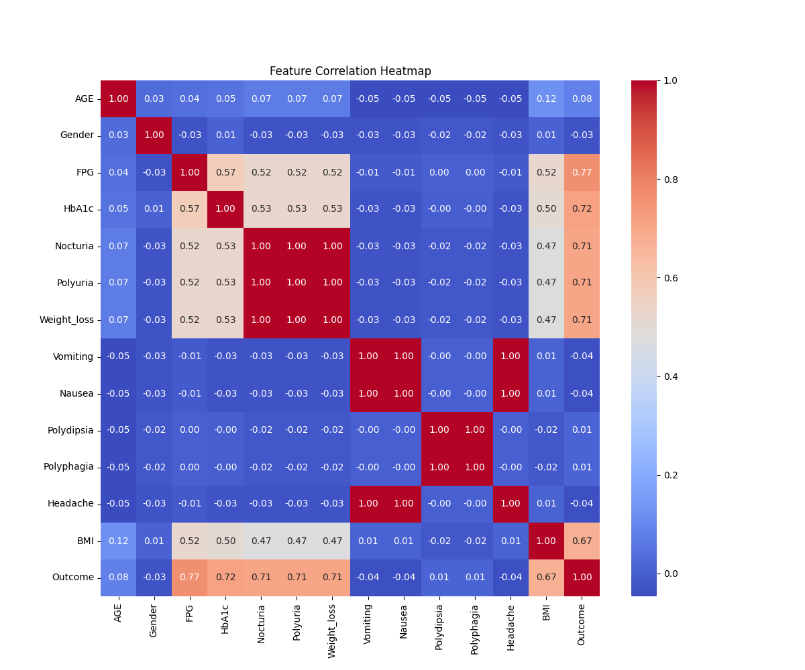
Figure 1: Feature Correlation Heatmap

4. Results and Comparison
The table below summarizes the performance of the four models on the test set:
Model | Accuracy | Precision | Recall | F1 | AUC
Logistic Regression | 0.9910 | 0.9898 | 0.9966 | 0.9932 | 0.9939
Random Forest | 0.9977 | 0.9966 | 1.0000 | 0.9983 | 1.0000
Decision Tree | 0.9865 | 0.9799 | 1.0000 | 0.9899 | 0.9801
SVM | 0.9977 | 0.9966 | 1.0000 | 0.9983 | 0.9993

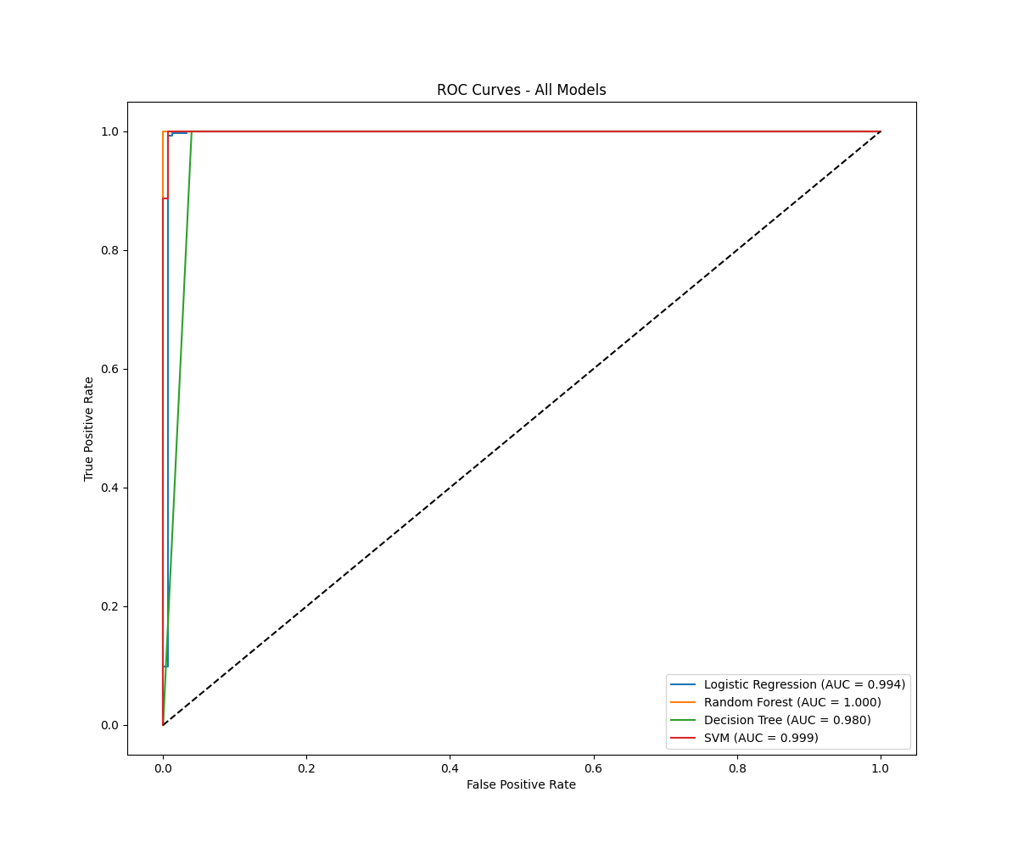
Figure 2: ROC Curves for All Models

5. Discussion: Data Quality vs. Quantity
A critical observation in this study is the high predictive accuracy (99%+) achieved with a dataset of 2,954 records, compared to common large-scale datasets (e.g., Kaggle diabetes datasets with 100,000+ records) which often yield lower accuracies (95-97%).
This is attributed to the 'Signal-to-Noise' ratio in the clinical features. The features in this dataset, particularly clinical symptoms (Polyuria, Polydipsia) and laboratory results (HbA1c, FPG), are direct physiological indicators of the disease. Unlike lifestyle-focused datasets that rely on noisier indicators like BMI or smoking history, these clinical markers provide a clear decision boundary for machine learning algorithms. This demonstrates that for medical risk prediction, the quality and relevance of clinical features are more impactful than the sheer volume of general demographic data.

6. Conclusion
The Random Forest and SVM models demonstrated superior performance, both achieving near-perfect metrics. The high AUC values indicate that the underlying clinical features are extremely robust predictors. The framework developed can be successfully applied to other disease prediction tasks given a structured clinical dataset.

