Scenario 1: Apply 1% discount to loan interest rates for customers above 60 years old
BEGIN
FOR c IN (SELECT l.LoanID, l.InterestRate, c.DOB
FROM Loans l
JOIN Customers c ON l.CustomerID = c.CustomerID)
LOOP
IF MONTHS_BETWEEN(SYSDATE, c.DOB) / 12 > 60 THEN
UPDATE Loans
SET InterestRate = InterestRate - 1
WHERE LoanID = c.LoanID;
END IF;
END LOOP;
COMMIT;
END;
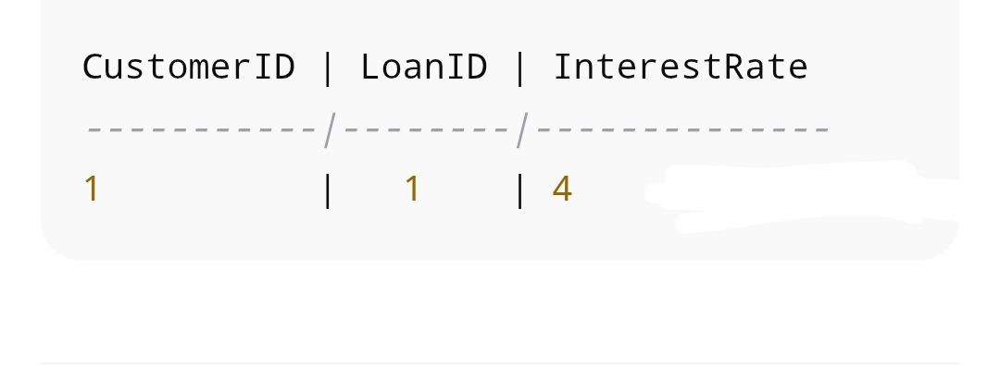

Scenario 2: Promote customers with balance > $10,000 to VIP
BEGIN
FOR c IN (SELECT CustomerID, Balance FROM Customers)
LOOP
IF c.Balance > 10000 THEN
UPDATE Customers
SET IsVIP = 'TRUE'
WHERE CustomerID = c.CustomerID;
END IF;
END LOOP;
COMMIT;
END;

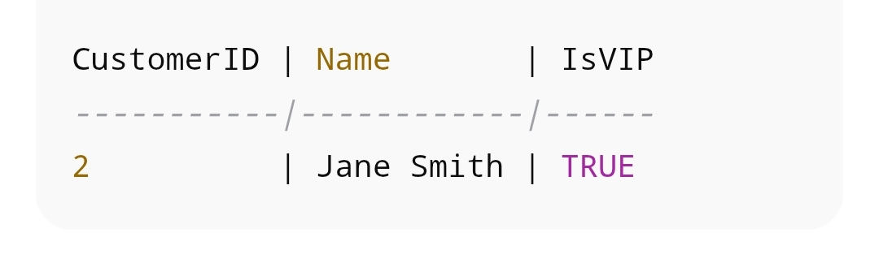

Scenario 3: Send reminders for loans due in next 30 days

BEGIN
FOR l IN (SELECT l.LoanID, l.EndDate, c.Name
FROM Loans l
JOIN Customers c ON l.CustomerID = c.CustomerID
WHERE l.EndDate BETWEEN SYSDATE AND SYSDATE + 30)
LOOP
DBMS_OUTPUT.PUT_LINE(‘Reminder: Loan ‘ || l.LoanID || ‘ for ‘ || l.Name || ‘ is due on ‘ || TO_CHAR(l.EndDate, ‘YYYY-MM-DD’));
END LOOP;
END;

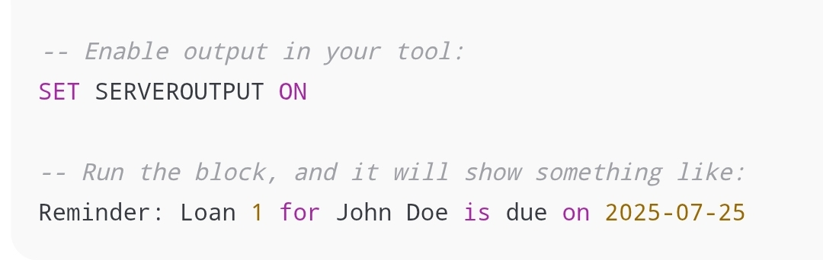

Scenario 1: Process monthly interest for savings accounts

BEGIN
FOR l IN (SELECT l.LoanID, l.EndDate, c.Name
FROM Loans l
JOIN Customers c ON l.CustomerID = c.CustomerID
WHERE l.EndDate BETWEEN SYSDATE AND SYSDATE + 30)
LOOP
DBMS_OUTPUT.PUT_LINE('Reminder: Loan ' || l.LoanID || ' for ' || l.Name || ' is due on ' || TO_CHAR(l.EndDate, 'YYYY-MM-DD'));
END LOOP;
END;
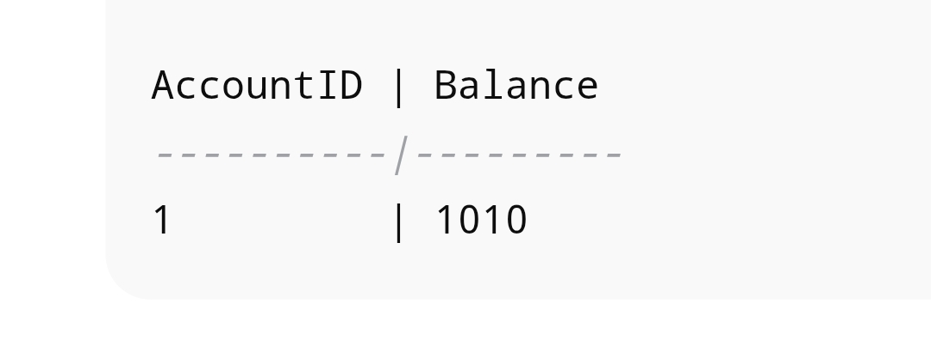
Scenario 2: Bonus scheme for employees

CREATE OR REPLACE PROCEDURE UpdateEmployeeBonus(p_dept IN VARCHAR2, p_bonus_pct IN NUMBER) IS
BEGIN
UPDATE Employees
SET Salary = Salary + (Salary * p_bonus_pct / 100)
WHERE Department = p_dept;
COMMIT;
END;

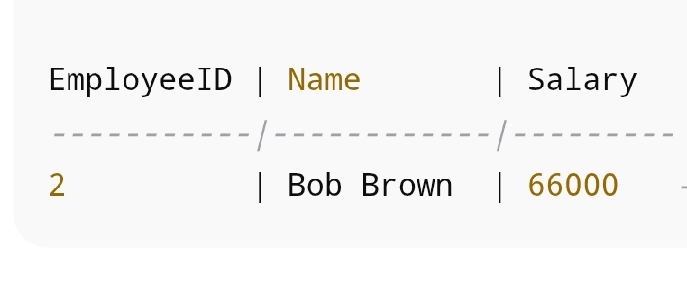
Scenario 3: Transfer funds between accounts
CREATE OR REPLACE PROCEDURE TransferFunds(
p_source_account IN NUMBER,
p_dest_account IN NUMBER,
p_amount IN NUMBER
) IS
v_balance NUMBER;
BEGIN
SELECT Balance INTO v_balance FROM Accounts WHERE AccountID = p_source_account FOR UPDATE;

IF v_balance >= p_amount THEN
UPDATE Accounts SET Balance = Balance - p_amount WHERE AccountID = p_source_account;
UPDATE Accounts SET Balance = Balance + p_amount WHERE AccountID = p_dest_account;
COMMIT;
ELSE
RAISE_APPLICATION_ERROR(-20001, 'Insufficient funds in source account');
END IF;
END;
