Utilization of Explainable AI on the XGBoost optimal model with the Tree-structured Parzen Estimator algorithm to Deconstruct Multifactorial Causes of Stunting with a SHAP-Based Interpretability framework

Aryanto¹, Radian J. Situmeang^{1*}
¹Department of Mathematics, Faculty of Mathematics and Science, Cenderawasih University, Indonesia

Article Info |  | ABSTRACT
Article history:  Received month 11, 2025  Revised month 11, 2025  Accepted month dd, yyyy |  | Analysis and modeling of stunting risk in toddlers in the Mamberamo Raya Regency, Papua, in 2024 using an XGBoost model optimized with the Tree-structured Parzen Estimator algorithm achieved an accuracy of 88.52%. The model demonstrated excellent capability in identifying non-stunting cases (recall 96.5%) but still misclassified 18.5% of stunting cases. This study revealed that three main variables such as Malnutrition Level, relevant district health policies and service area, and Exclusive Breastfeeding are the most dominant predictors based on Explainable AI (SHAP) analysis of their complex interactions. Malnutrition Level was the strongest contributor, while variables related to difficulties in accessing healthcare services played a significant role both structurally in building the XGBoost model and through their interactions with nutritional factors. These findings emphasize the importance of a multidimensional approach combining nutritional interventions and improved healthcare accessibility as a priority strategy to reduce stunting, considering the local context and the interplay among risk factors.
Keywords:
Stunting
Malnutrition
XGBoost
Classification
Explainable AI
This is an open access article under the CC BY-SA license.

Corresponding Author:
Radian Januari Situmeang
Department of Mathematics, College of Statistics, Cenderawasih of University
Camp Walker, Jayapura, Papua, Indonesia
Email: radian.situmeang@fmipa.uncen.ac.id

- INTRODUCTION
Papua Province presents one of the most complex and challenging regions in Indonesia for addressing stunting. According to the results of the 2022 Indonesian Nutritional Status Survey (Status Gizi Indonesia / SGI), the prevalence of stunting in Papua was 34.6%, significantly exceeding the national average (21.6%) and ranking as the second highest prevalence nationally, after West Sulawesi [1]. Specifically, Mamberamo Raya Regency (KMR) within Papua Province was recorded as the largest contributor to severe malnutrition among children under five, with a rate of 40.0% based on the 2023 Indonesian Health Survey (SKI) [2]. It is noteworthy that the SKI 2023 measured 1,536 children, and 28.6% of this cohort suffered from stunting. Furthermore, the KMR region possesses unique geographical characteristics, encompassing mountainous and lowland areas. A substantial portion of its territory is characterized by difficult-to-access areas, which consequently limits the reach of healthcare services, the distribution of nutritious food, and the availability of basic infrastructure, such as access to clean water and sanitary latrines. These conditions are strongly presumed to be significant risk factors contributing to the persistently high rate of stunting in the KMR region.
While the postnatal environment is critical, the foundational risk for stunting often begins in utero. Adequate nutrition during pregnancy is essential for preventing fetal growth restriction and subsequent stunting in children. This requires pregnant women to fulfill diverse dietary components in their daily meals, including staple foods, vegetables, plant-source protein, animal-source protein, and complementary foods [3]. The calculation of a mother's specific nutritional needs, based on her total energy expenditure, basal energy expenditure, physical activity, and stress factors, underscores the individualized nature of this challenge [3]. However, a significant gap exists in understanding and addressing these precise maternal factors within the KMR context. Consequently, this study focuses on modeling stunting risk specifically among children under five years of age in KMR, utilizing data collected post-birth. The scope is deliberately constrained to factors measurable after delivery, acknowledging that while maternal nutrition is a known critical determinant, our available data does not capture the antenatal conditions of the mothers[4], [5]. The research aims to identify the key postnatal and early childhood predictors that can be leveraged by machine learning models to accurately identify children at high risk within this unique and vulnerable population.
In reaction to being identified as the regency with the highest stunting prevalence in Papua, the Mamberamo Raya government has initiated the Gerakan Orang Tua Asuh Cegah Stunting (GENTING) program [6]. This community-based program, which leverages foster parents to directly support at-risk children, represents a significant commitment to combating stunting. However, the design and targeting of such interventions could be substantially enhanced by empirical data on the key drivers of stunting in the region. Presently, there is a gap in the profiling of the distinct characteristics and indicators that predict stunting cases among children under five in KMR. This study aims to fill that gap, providing evidence that can help refine the targeting and strategy of ongoing government efforts.
While previous research on stunting in Papua New Guinea (PNG) has identified socioeconomic correlates such as household wealth, maternal education, and immunization status, these studies are often constrained by significant methodological limitations [7][8]. Many rely on sub-nationally representative data or temporally outdated national surveys, such as the PNG Household Income and Expenditure Survey (HIES) 2009–2010 [8]. The use of such dated data impedes the generalizability of findings to the contemporary PNG context and fails to capture the dynamic nature of stunting's risk factors. To overcome these limitations, this study leverages advanced machine learning (ML) algorithms, including Random Forest and eXtreme Gradient Boosting (XGBoost), which are superior to classical statistical models in capturing complex, non-linear interactions among predictors. A critical component of our methodology is the application of robust Feature Selection (FS) techniques to refine these ML models by eliminating redundant and irrelevant features, thereby enhancing predictive performance and mitigating overfitting. Furthermore, we will employ model-agnostic interpretation tools, such as SHAP (SHapley Additive exPlanations), to move beyond mere prediction and provide granular insights into the specific drivers of stunting [9]. By applying this integrated FS-ML framework to the recent, nationally representative 2016–2018 PNG Demographic and Health Survey (DHS) data, this research aims to identify the most accurate predictive model and elucidate the key determinants of stunting. The ultimate objective is to generate robust, evidence-based guidance for policymakers in PNG to design precisely targeted and effective interventions [7].
A seminal recent study by [10] pioneered an Explainable Artificial Intelligence (XAI) framework for early stunting detection, demonstrating that XGBoost achieved exceptional performance (97.57% accuracy) using minimalist anthropometric data from 40,071 toddlers in Indonesia, a finding consistent with its high precision and recall in predicting stunting among Zambian children [11]. The critical contribution of their work lies in integrating SHAP (SHapley Additive exPlanations) to illuminate model logic, identifying height, age, and sex as the most influential predictors [12]. While this XAI framework provides a powerful tool for post-measurement detection and offers globally relevant insights, its reliance on child-level anthropometrics underscores a key limitation. It is inherently reactive, identifying stunting after significant growth faltering has already occurred. Therefore, this study seeks to build upon their methodological advancement by shifting the predictive horizon earlier. We propose a model that incorporates a broader feature set of antecedents, modifiable risk factors such as maternal health, socioeconomic status, and environmental conditions to enable a more proactive, preventative prediction of stunting risk in the unique context of KMR.
This study proposes a data-driven framework for the early prediction of stunting in children aged 0-59 months in KMR by leveraging Explainable Machine Learning (specificly using XGBoost). The research is designed with two primary objectives. First, to develop a high-performance predictive model for classifying child nutritional status. And second, to transcend the black box nature of conventional machine learning by employing model interpretation techniques. This involves identifying the most influential predictors of stunting at both a global and individual level. The ultimate aim is to generate transparent, actionable intelligence that can inform precise public health decision-making and facilitate targeted interventions, even within KMR's resource-constrained setting.

- METHOD
This study used a quantitative analytical approach, augmented by the application of machine learning models. The research methodology follows a systematic, data-driven pipeline designed to ensure robust model development and evaluation. A detailed schematic of this workflow, encompassing all stages from data preprocessing and feature engineering to model training, interpretation, and validation, is presented in Figure 1. This structured process guarantees the reproducibility of the analysis and provides a clear framework for identifying key predictors of stunting in the target population.
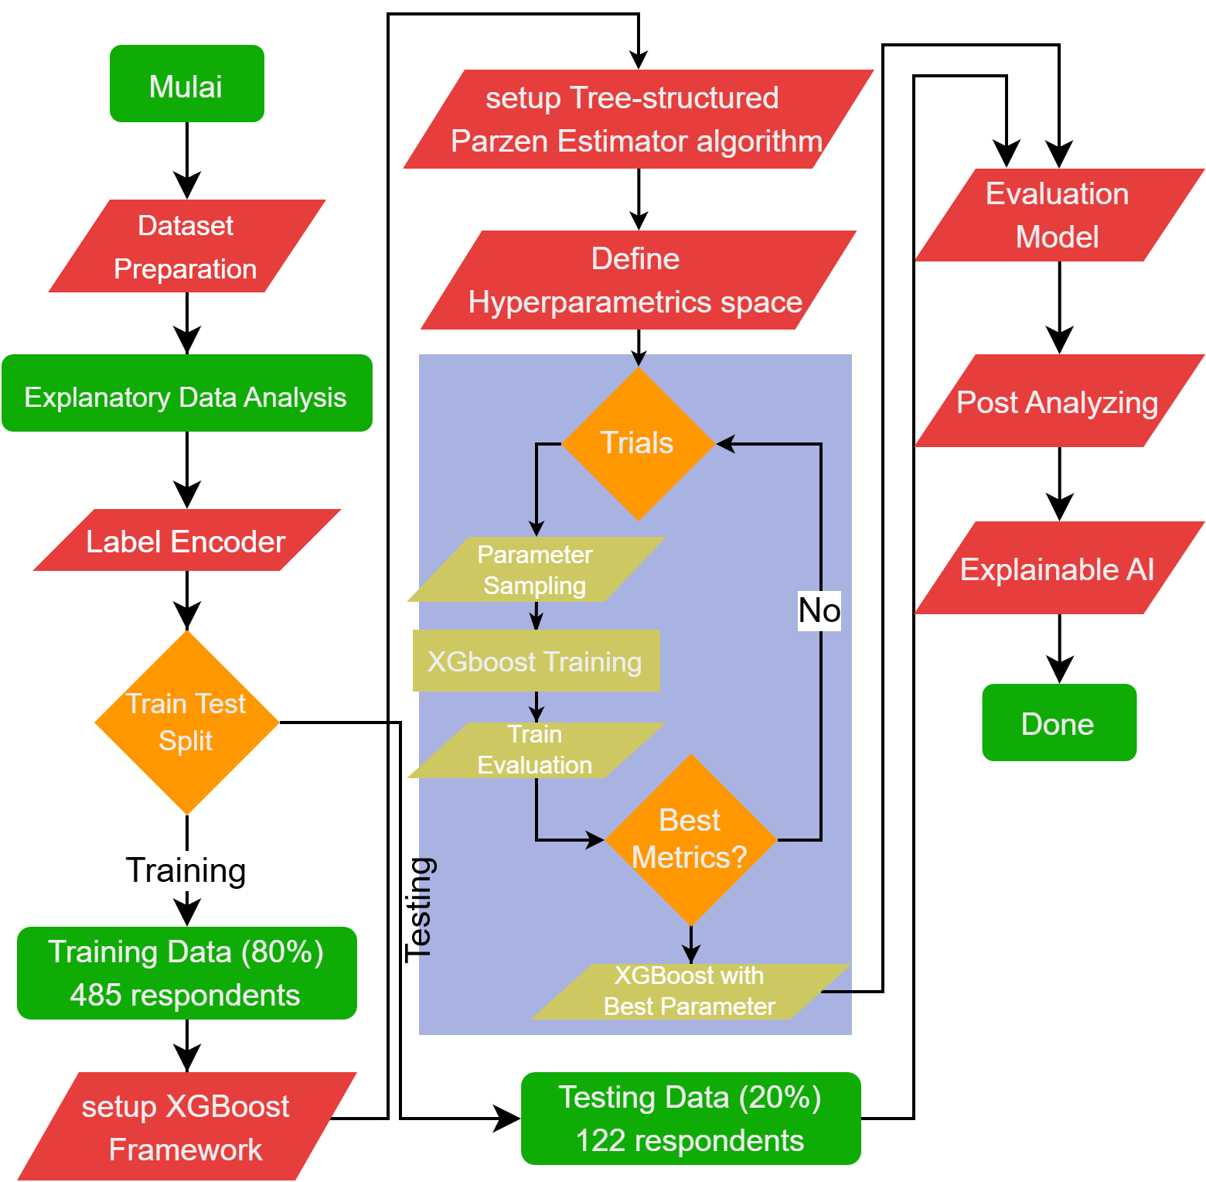

Figure 1. Flowchart of workflow training AI-based models

  - Data Source and Study Population
The data for this study were sourced from a health survey conducted across all community health center (Puskesmas) working areas in the districts of KMR (see figure 2). The survey results, which were input into the KMR Health Office database in August 2024, initially comprised a total of 607 children under five. To facilitate robust model development and evaluation, the dataset was partitioned into a training set of 485 samples (80%) for building the predictive models and a hold-out testing set of 122 samples (20%) for unbiased performance assessment.
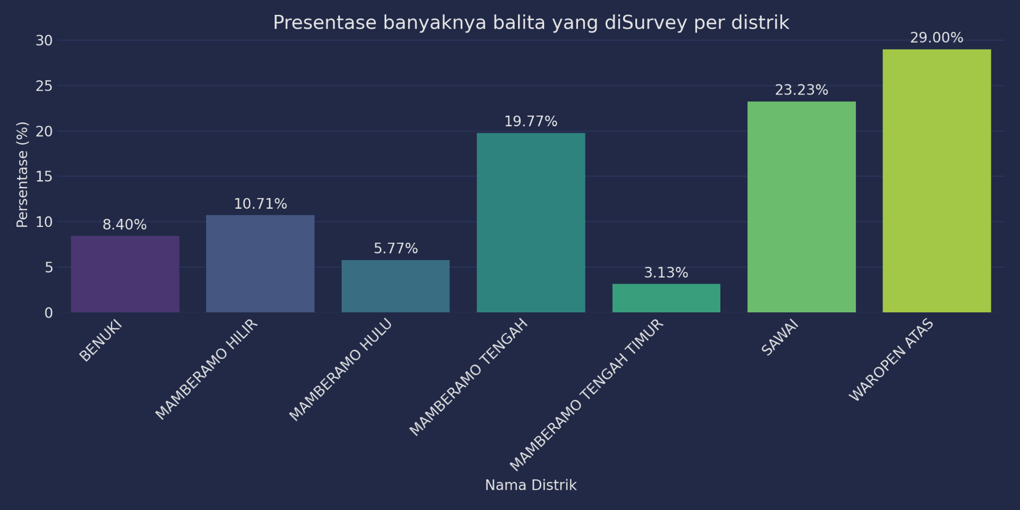
Figure 2. Amount of data in each district in KMR

  - Study Design and Analytical Approach
This study employs an observational case-control design to investigate the determinants of stunting among toddlers and to quantify the associated risk (odds ratio) for each factor. The analysis utilizes data systematically collected by the KMR Health Office over a three-month period (June-August 2024) from Puskesmas jurisdictions throughout the regency. The application of a case-control framework is particularly suited for this research context, as it allows for an efficient examination of multiple risk factors against a clearly defined outcome. This design provides a solid epidemiological foundation upon which the advanced machine learning analysis is built.

  - Data Collection and Variable Specification
Data were collected from primary caregivers (mothers or guardians) of children aged 59 months or younger. Trained health personnel conducted face-to-face interviews and recorded the responses directly into a structured questionnaire. The survey results were synthesized into the following key variables for analysis:
- Gender: The biological sex of the child, coded as Male (1) and Female (0).
- Exclusive Breastfeeding: This variable assesses infant and young child feeding practices from birth until the time of the survey. It was constructed from a series of questions regarding exclusive breastfeeding, timing of complementary feeding, and the quality of complementary foods (MP-ASI). A composite score was calculated and tested for normality, following the methodology of Kusumawati (2015), to categorize practices as either 'Adequate' (1) or 'Inadequate' (0).
- Household Smoking Habits: A binary variable indicating whether at least one family member has a smoking habit (1 = Yes, 0 = No). This serves as a proxy for secondhand smoke exposure, which is a known environmental risk factor for respiratory infections and impaired growth.
- Access to Clean Water: A crucial environmental determinant, these binary variable records whether the household has access to a clean water source located within 200 meters of the residence (1 = Yes, 0 = No). This is critical for preventing waterborne diseases that impede nutrient absorption.
- Availability of Sanitary Latrine: This binary variable indicates the presence (1) or absence (0) of a hygienic toilet facility in the household. Proper sanitation is essential for reducing the risk of fecal-oral diseases, which are significant contributors to malnutrition and stunting.
- Household Location Accessibility: This variable captures the ease of access to the child's home, categorized binarily. A score of 1 denotes a residence that is readily accessible (e.g., located near a main road), while a score of 0 indicates a residence that is difficult to access (e.g., requiring a long walk, situated on a hill, or having other significant access barriers).
- Nutritional Status Score: This is an ordinal scale (0-6) that quantifies the severity of a child's nutritional status, with 6 representing the most severe condition. The score was determined by health center personnel through anthropometric measurements (weight, height, mid-upper arm circumference) compared against WHO growth standards [13]. It provides a graded indicator of malnutrition risk.
- Stunting Status (Target Variable): This is the primary binary outcome variable for the study. It represents a clinical diagnosis of stunting, determined by a qualified health professional or doctor based on a comprehensive physical examination and assessment of the child's growth. A value of 1 indicates a diagnosis of stunting, and 0 indicates the absence of stunting. This expert assessment provides crucial clinical validation for the study [14].

- RESULTS AND DISCUSSION
- Class Distribution
The 2024 dataset from KMR may contain potential judgment bias in the 'Stunting' variable, as it is based on clinical assessments by health experts. The distribution is visually summarized in Figure 3. To mitigate this and establish a clear analytical endpoint, the variable was formatted as a binary target for prediction. A preliminary analysis of the outcome variable revealed a class distribution that is notably balanced for a public health dataset. Specifically, 54.0% of the study population (328 cases) were classified as stunted (coded as 1), while 46.0% (279 cases) were non-stunted (coded as '0'). This results in a stunting-to-non-stunting ratio of approximately 1.18:1. As this ratio falls well within the acceptable range for machine learning modeling and is far from the critical imbalance thresholds suggested by [15], typically between 1:3 and 1:6, no specialized class imbalance correction techniques were deemed necessary prior to model training.
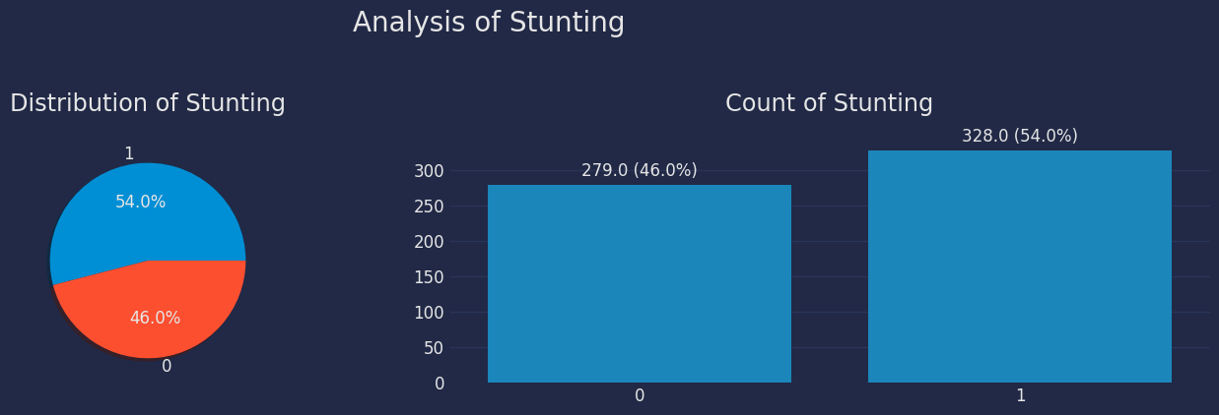
Figure 3 Distribution of binary values ​​of the target variable Stunting

- Feature Correlation Analysis and Multicollinearity Assessment
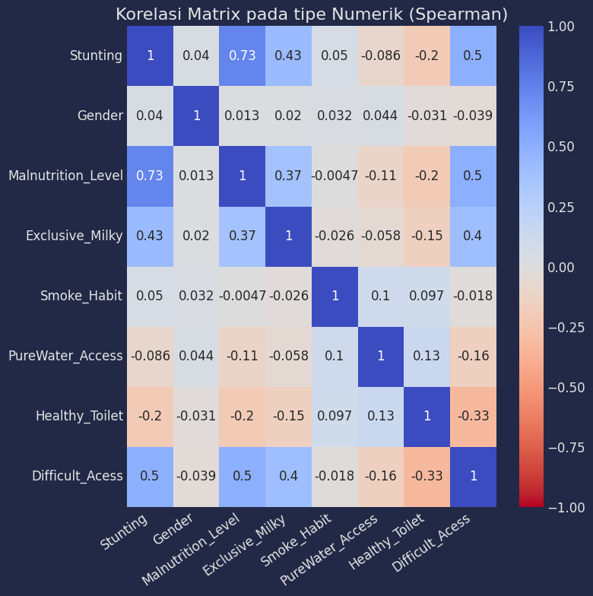In machine learning, high inter-feature correlation typically above a threshold of 0.8 or 0.9, presents a significant concern as it can induce multicollinearity. This phenomenon can distort the interpretation of a model's feature importance, increase the risk of overfitting, and impede the training process [16]. Consequently, high-correlation filtering techniques are often employed to eliminate or combine redundant variables, thereby enhancing model performance and generalizability [17]. An analysis of the stunting dataset revealed several features with notable associations with the stunting outcome. The ‘Malnutrition Level’ exhibited a strong positive correlation with stunting (r = 0.73), underscoring a powerful link between a child's nutritional status and their risk of being stunted. Furthermore, ‘Difficult_Access’ demonstrated a moderate positive correlation (r = 0.5), followed by ‘Exclusive Breastfeeding’ (r = 0.43). These findings highlight that nutritional status and accessibility to services and infrastructure are critical determinants closely associated with stunting in this population. It is important to note that while these variables are correlated with the target, the inter-feature correlations remained below the critical threshold, thus mitigating major multicollinearity concerns for the predictive models. For the details, you could refer on figure 4.
Figure 4 Correlation Matrix on Stunting Data
Conversely, several variables demonstrated weak negative or negligible correlations with the stunting outcome. The 'Healthy_Toilet' variable exhibited a weak negative correlation (Pearson's r = -0.20), suggesting that while the presence of a sanitary latrine is inversely related to stunting, the strength of this linear association is modest. Other variables, such as ‘Smoke_Habit’ and ‘PureWater_Access’, showed too weak and statistically non-significant correlations, with coefficients approaching zero. It is critical to note, however, that a weak bivariate correlation does not necessarily imply that a variable is a weak predictor. The Pearson correlation coefficient only measures the strength of a simple linear relationship and does not capture a variable's potential contribution within a complex, multivariate predictive model. A variable with a weak individual correlation may still serve as a crucial predictor when interacting with other features or when its relationship with the outcome is non-linear, a nuance that machine learning models are particularly adept at capturing [18]. Overall, there are no variables that are bound by more than 0.8 so there is no need to segment the variables in the data.

- Data Analysis
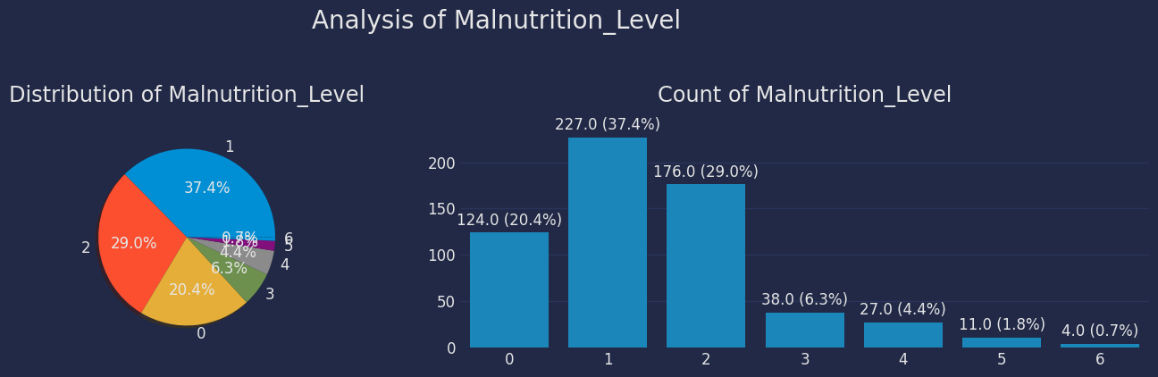
Figure 5 Distribution of malnutrition level data

Figure 5 illustrates the distribution of malnutrition levels, revealing significant variation across the defined categories. The most prevalent condition is Level 1 malnutrition, comprising 37.4% of the study population (n=227). This is followed by Level 2 malnutrition at 29.0% (n=176), indicating that a combined two-thirds (66.4%) of the cohort falls into these two categories. In contrast, children classified with normal nutritional status (Level 0) account for 20.4% (n=124). The more severe and extreme levels of malnutrition (Levels 3 through 6) are less common, with prevalences of 6.3% (n=38), 4.4% (n=27), 1.8% (n=11), and 0.7% (n=4), respectively. This distribution highlights that while malnutrition is widespread, its burden is concentrated at the mild to moderate stages based on WHO standards. Crucially, a comparative analysis with stunting rates reveals a strong epidemiological link; the high prevalence of Level 1 and Level malnutrition serves as a direct precursor and explanatory factor for the region's elevated stunting incidence, underscoring the critical window for intervention before nutritional deficits become severe and chronic.
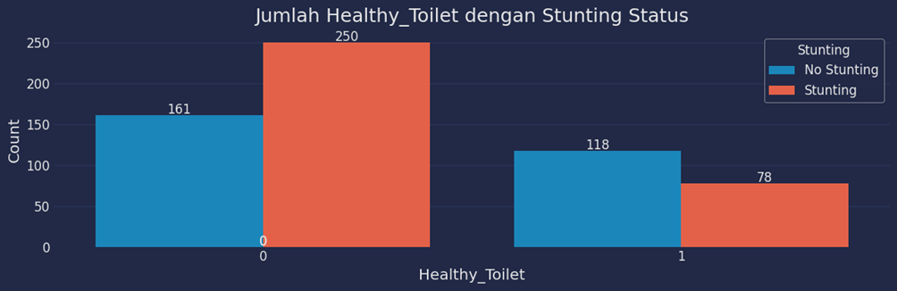
Figure 6 Availability of healthy toilet standards in data

Figures 6 and 7, which present the relationship between stunting status and sanitation (availability of a healthy toilet and access to clean water), reveal compelling patterns regarding these environmental risk factors. The data for healthy toilet availability (Healthy_Toilet) demonstrate a pronounced disparity. A clear majority of stunting cases (n=250) are found in households without a healthy toilet (category 0), whereas non-stunted children are more evenly distributed between the two groups (n=161 without a toilet vs. n=118 with a toilet). Conversely, in households with a healthy toilet (category 1), the number of stunting cases decreases significantly to 78. This stark contrast suggests that the absence of adequate sanitation may constitute a substantial population-level risk factor, potentially by increasing exposure to fecal-oral pathogens that cause recurrent infections, impair nutrient absorption, and ultimately disrupt linear growth. A similar, though less pronounced, trend is observed for access to clean water (PureWater_Access), reinforcing the critical role of WASH (Water, Sanitation, and Hygiene) infrastructure as a foundational element for child growth, even within the complex etiology of stunting.
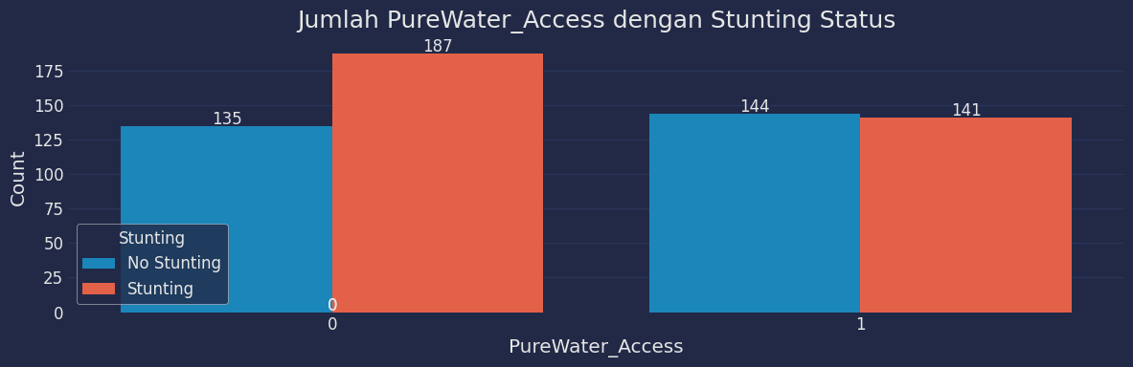
Figure 7 Comparison of pure drinking water and stunting cases

Figure 6 indicates an inverse relationship between healthy toilet availability and stunting cases, underscoring the fundamental role of basic sanitation in stunting prevention. The data reveal a stark contrast: households without a healthy toilet account for a disproportionately high number of stunting cases. Figure 7, detailing access to clean water, presents a more nuanced picture. While stunting cases are still more prevalent in the group without clean water access (category 0), with 187 cases, the distribution is considerably more balanced in the group with access (category 1). In this latter group, the number of stunting cases (141) is nearly equivalent to the number of non-stunting cases (144). This near-parity suggests that while access to clean water is a necessary foundational element, it may not be a sufficient standalone protective factor in this specific context. The comparative analysis of both figures implies that within the KMR respondent sample, the presence of a healthy toilet serves as a more extreme differentiator of stunting risk than access to clean water alone. This finding potentially highlights the critical importance of preventing direct fecal-oral contamination through safe excreta disposal, a pathway that may have a more immediate and direct impact on a child's gut health and nutrient absorption than water quality alone in this environment.
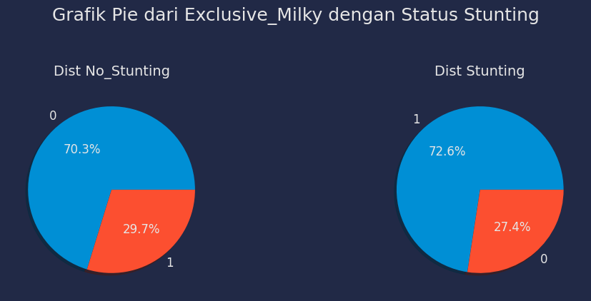
Figure 9 Comparison of exclusive breastfeeding in cases of stunting

An anomalous and counterintuitive pattern emerges from the analysis of exclusive breastfeeding practices in relation to stunting status. Within the non-stunted cohort, a significant majority of children (70.3%) were not exclusively breastfed, whereas only 29.7% had received exclusive breastfeeding. This distribution directly inverts within the stunted group, where the vast majority (72.6%) were exclusively breastfed. This inverse correlation, as visually detailed in Figure 8, suggests that in this specific sample, exclusive breastfeeding is associated with a higher prevalence of stunting. This apparent contradiction to established biological knowledge, wherein exclusive breastfeeding is a documented protective factor [19], strongly indicates the presence of residual confounding. Socioeconomic conditions are a plausible explanation; in this resource-constrained setting, the practice of exclusive breastfeeding may be less of an optimal choice and more a necessity driven by an inability to afford nutritious complementary foods, thereby making it a proxy for underlying poverty. Consequently, this variable may be capturing the effect of economic deprivation rather than the biological impact of breast milk itself, underscoring the complexity of interpreting nutritional predictors in isolation.

- XGBoost model with TPE optimization
To achieve robust predictive performance for stunting risk in toddlers, this study employed an XGBoost classifier, a powerful ensemble algorithm known for its efficiency and accuracy in handling tabular data. The model's hyperparameters were systematically optimized using the Tree-structured Parzen Estimator (TPE) algorithm via the Optuna framework. This Bayesian optimization approach is particularly adept at efficiently navigating a complex hyperparameter space, moving beyond traditional grid or random search by using probabilistic models to direct the search toward promising regions. This process, which was tailored specifically to the characteristics of the training dataset, successfully identified a set of optimal parameters that balance model complexity with generalization capability. The subsequent application of this tuned model allows for a more reliable assessment of feature importance, as the relationships within the data are captured with higher fidelity, thereby providing greater confidence in the identified predictors of stunting.

Table 1. Optimized Model parameter
No. | parameter | value
1 | alpha | 0.9139587480021765
2 | colsample_bytree | 0.6720470924598951
3 | enable_categorical | True
4 | Gamma | 0.15045909399647112
5 | Lambda | 0.4550490817971364
6 | Learning_rate | 0.15769956764519155
7 | Max_depth | 10
8 | n_estimators | 3217

For other parameters follow the default configuration.
The optimized XGBoost model demonstrated a distinct performance profile across the two classification categories, revealing a deliberate trade-off in its predictive strategy. For the Non-Stunting class, the model achieved an exceptionally high recall of 96.5%, indicating a remarkable ability to correctly identify the vast majority of children who are genuinely not stunted. However, the precision for this class was notably lower at 82.1%, implying that among all instances predicted as Non-Stunting, approximately 17.9% were false positives that’s children who were, in fact, stunted. This specific performance characteristic suggests that the model is strategically calibrated to minimize False Negatives, effectively ensuring that healthy children are rarely misclassified as being at risk. Consequently, while the model is highly sensitive in detecting non-stunted cases, this comes at the cost of a higher False Positive rate for the Stunting class. This bias is often operationally desirable in public health screening, as it prioritizes casting a wider net to capture all potential at-risk cases, even if it means some healthy individuals are flagged for further assessment, thereby preventing the more critical error of overlooking a stunted child.
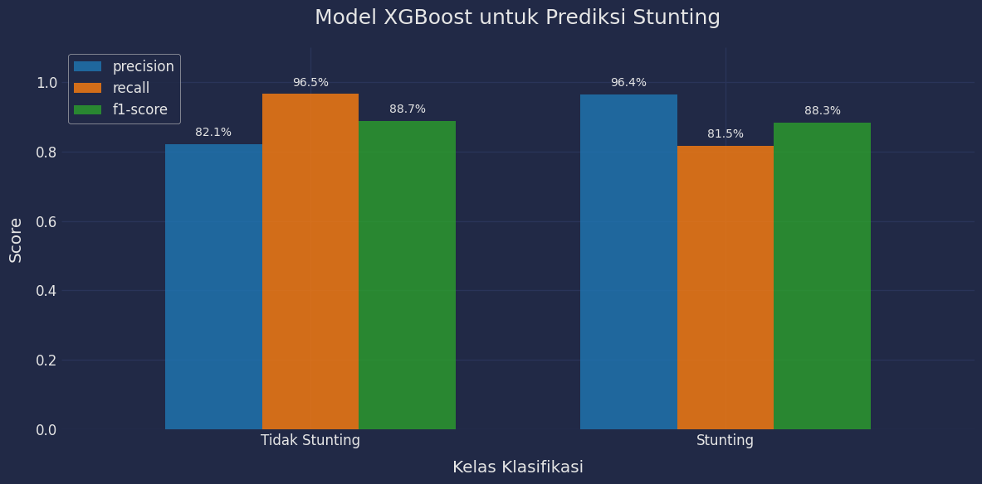
Figure 10. Comparison of metrics in the Not Stunting and Stunting classes

Conversely, the model's performance for the Stunting class reveals a different, yet equally critical, strategic emphasis. It achieved an exceptionally high precision of 96.4%, signifying that when the model flags a child as stunted, it is almost certainly correct. This high predictive value makes the model a highly reliable tool for triggering interventions, ensuring that resources are allocated to children who genuinely need them. However, this comes with a trade-off: the recall for this class was lower, meaning the model failed to identify approximately 18.5% of true stunting cases (False Negatives). This high-precision, lower-recall profile indicates a conservative classification strategy for the positive class, which is highly valuable for ensuring the cost-effectiveness of follow-up actions but inherently allows a portion of true cases to go undetected. The overall robustness of the model is confirmed by the balanced and high F1-scores for both classes (88.7% and 88.3%). From a public health perspective, this specific trade-off necessitates a careful evaluation of the program's goals; while minimizing false alarms is efficient, the consequences of missing true stunting cases which can lead to irreversible developmental deficits, must be weighed heavily, especially in a high-prevalence region like Mamberamo Raya.

- CONCLUSION
Provide a statement that what is expected, as stated in the "INTRODUCTION" section can ultimately result in "RESULTS AND DISCUSSION" section, so there is compatibility. Moreover, the prospects for the development of research results and the application of further studies can also be added to the next (based on the results and discussion).

REFERENCES
[1] B. Kebijakan, P. Kesehatan, and K. K. Ri, “BUKU SAKU Hasil Survei Status Gizi Indonesia (SSGI) 2022.”
[2] B. Kebijakan Pembangunan, K. Kementerian, and K. Ri, “DALAM ANGKA TIM PENYUSUN SKI 2023 DALAM ANGKA KEMENTERIAN KESEHATAN REPUBLIK INDONESIA,” 2023.
[3] D. Kurnianingtyas, N. Daud, K. Arai, Indriati, and Marji, “Automated menu planning for pregnancy based on nutrition and budget using population-based optimization method,” IAES International Journal of Artificial Intelligence, vol. 14, no. 5, pp. 3483–3492, Oct. 2025, doi: 10.11591/ijai.v14.i5.pp3483-3492.
[4] S. Ndagijimana, I. H. Kabano, E. Masabo, and J. M. Ntaganda, “Prediction of Stunting among Under-5 Children in Rwanda Using Machine Learning Techniques,” Journal of Preventive Medicine and Public Health, vol. 56, no. 1, pp. 41–49, Jan. 2023, doi: 10.3961/jpmph.22.388.
[5] J. Jureksi, H. Tunsa, and Y. Thanri, “Simulasi Penyebaran Stunting Pada Balita Dengan Pengaruh Imunisasi Menggunakan Metode Agent Based Modeling Simulation of the Spread Of Stunting In Toddlers With The Effect Of Immunization Using The Agent Based Modeling Method,” 2024, [Online]. Available: https://kti.potensi-utama.ac.id/index.php/
[6] C. Pos, “Tertinggi di Papua, Kasus Prevalensi Stunting di Mamberamo Raya Capai 40,” Cenderawasih Pos, Jayapura, 2024.
[7] H. Shen, H. Zhao, and Y. Jiang, “Machine Learning Algorithms for Predicting Stunting among Under-Five Children in Papua New Guinea,” Children, vol. 10, no. 10, Oct. 2023, doi: 10.3390/children10101638.
[8] R. J. Culas and C. Pombre, “Assessing socioeconomic impact of pathogen tested and conventional practice sweet potato production in the highlands of Papua New Guinea,” J Agric Food Res, vol. 14, Dec. 2023, doi: 10.1016/j.jafr.2023.100701.
[9] H. A. Santoso, N. S. Dewi, S. C. Haw, A. D. Pambudi, and S. A. Wulandari, “Enhancing nutritional status prediction through attention-based deep learning and explainable AI,” Intell Based Med, vol. 11, Jan. 2025, doi: 10.1016/j.ibmed.2025.100255.
[10] A. Wicaksono, D. Prasetyo, Y. Mar’atullatifah, D. U. Iswavigra, H. Mahmudah, and A. Hapsari, “Data Analysis and Explainable Machine Learning for Stunting Prediction,” 2025.
[11] O. N. Chilyabanyama et al., “Performance of Machine Learning Classifiers in Classifying Stunting among Under-Five Children in Zambia,” Children, vol. 9, no. 7, Jul. 2022, doi: 10.3390/children9071082.
[12] G. Nduwayezu, P. Zhao, P. Pilesjö, J. P. Bizimana, and A. Mansourian, “Multilevel small-area childhood stunting risk estimation: Insights from spatial ensemble learning, agro-ecological and environmentally remotely sensed indicators,” Environmental and Sustainability Indicators, vol. 27, Sep. 2025, doi: 10.1016/j.indic.2025.100822.
[13] E. Kusumawati, S. Rahardjo, and H. P. Sari, “Model Pengendalian Faktor Risiko Stunting pada Anak Bawah Tiga Tahun,” Kesmas: National Public Health Journal, vol. 9, no. 3, p. 249, Apr. 2015, doi: 10.21109/kesmas.v9i3.572.
[14] M. Muhdar, R. Rosmiati, and G. T. Tulak, “Peran Petugas Kesehatan dalam Pencegahan dan Penanganan Stunting di Kabupaten Kolaka,” Jurnal Kesehatan Andalas, vol. 11, pp. 32–38, Mar. 2022, doi: 10.25077/jka.v11i1.1930.
[15] T. Sugihartono, B. Wijaya, Marini, A. F. Alkayes, and H. A. Anugrah, “Optimizing Stunting Detection through SMOTE and Machine Learning: a Comparative Study of XGBoost, Random Forest, SVM, and k-NN,” Journal of Applied Data Sciences, vol. 6, no. 1, pp. 667–682, Jan. 2025, doi: 10.47738/jads.v6i1.494.
[16] H. Akoglu, “User’s guide to correlation coefficients,” Sep. 01, 2018, Emergency Medicine Association of Turkey. doi: 10.1016/j.tjem.2018.08.001.
[17] H. Yıldırım, “The Multicollinearity Effect on the Performance of Machine Learning Algorithms: Case Examples in Healthcare Modelling,” Academic Platform Journal of Engineering and Smart Systems, vol. 12, no. 3, pp. 68–80, Sep. 2024, doi: 10.21541/apjess.1371070.
[18] S. A. R. Manaf, Erfiani, Indahwati, A. Fitrianto, and R. Amelia, “Faktor-Faktor yang Memengaruhi Permasalahan Stunting di Jawa Barat Menggunakan Regresi Logistik Biner,” bogor, Jul. 2022. doi: 10.36456/jstat.vol15.no2.a5654.
[19] M. Refky Pratama and S. Irwandi, “The Relationship Between Exclusive Breastfeeding and Stunting At The Hinai Kiri Public Health Center, Secanggang District, Langkat Regency,” JURNAL KEDOKTERAN STM, vol. 4, Jan. 2021, doi: 10.30743/stm.v4i1.65.

BIOGRAPHIES OF AUTHORS (10 PT)
In this section, authors are required to provide their professional biography, which should include their academic background, current position, research interests, and any significant contributions to the current study. Additionally, authors should include links to their professional profiles, such as ORCID (mandatory) and, if applicable, Google Scholar, Scopus Author ID, or Web of Science (WoS) ResearcherID. This helps establish the author’s academic identity and enhances the visibility of their research.

Required Information:
- Full name: Include the author's full name as it appears in official records. If preferred, authors may use the format consistent with his/her Scopus profile.
- Email address for each author: Provide the author's professional email address to facilitate correspondence.
- Social media account:
- ORCiD iD: This is a mandatory. Each author must include their ORCID iD (https://orcid.org/), which helps link his/her research output to their identity.
- Google Scholar Profile: Include the link to the author's Google Scholar profile. If the author does not have a Google Scholar profile, they may create a new one and include the link.
- Scopus Author ID: If available, include the Scopus Author ID to enhance visibility on Scopus.
- Web of Science (WoS) ResearcherID: Include the Web of Science ResearcherID. If the author does not have a WoS profile, they may create a new one and include the link.
- Brief biography: Provide a concise overview of the author's academic background, research interests, notable publications, and contributions to the current paper. This should be no longer than 150 to 200 words (9 pt).
- Professional achievements: If available, mention any important awards, recognition, or research projects the author has been involved in.
- Photo Submission: Authors must submit a clear, professional headshot (3x4 cm). The photo should be of high quality, well-lit, and not blurry. Avoid using photos that are overly casual or low resolution.

Below is an example of how to format the biography section for each author:

BIOGRAPHIES OF AUTHORS (10 PT)

 | Abdel‑Rahman Hedar  holds a Doctor of Informatics degree from Kyoto University, Japan in 2004. He also received his B.Sc. and M.Sc. (Mathematics) from Assiut University, Egypt in 1993 and 1997, respectively. He is currently an associate professor at Computer Science Department in Jamoum, Umm Al-Qura University, Makkah, Saudi Arabia. He is also an associate professor of artifcial intelligence in Assiut University since January 2012. His research includes meta-heuristics, global optimization, machine learning, data mining, bioinformatics, graph theory and parallel programming. He has published over 70 papers in international journals and conferences. From July 2005 to July 2007, he was a JSPS research fellow in Kyoto University, Japan. He can be contacted at email: ahahmed@uqu.edu.sa or hedar@aun.edu.eg.
 | Patricia Melin  received the D.Sc. degree (Doctor Habilitatus D.Sc.) in computer science from the Polish Academy of Sciences, Warsaw, Poland, with the Dissertation “Hybrid Intelligent Systems for Pattern Recognition using Soft Computing”. She is a Professor of Computer Science in the Graduate Division, Tijuana Institute of Technology, Tijuana, Mexico since 1998. In addition, she is serving as Director of Graduate Studies in computer science and Head of the research group on Computational Intelligence (2000–present). Her research interests are in Type-2 Fuzzy Logic, Modular Neural Networks, Pattern Recognition, Neuro-Fuzzy and Genetic-Fuzzy hybrid approaches., She is currently the President of Hispanic American Fuzzy Systems Association (HAFSA) and is the founding Chair of the Mexican Chapter of the IEEE Computational Intelligence Society. She can be contacted at email: pmelin@tectijuana.mx.
 | Dr. Kennedy Okokpujie  holds a Bachelor of Engineering (B.Eng.) in Electrical and Electronics Engineering, Master of Science (M.Sc.) in Electrical and Electronics Engineering, Master of Engineering (M.Eng.) in Electronics and Telecommunication Engineering and Master of Business Administration (MBA), Ph.D in Information and Communication Engineering, besides several professional certificates and skills. He is currently lecturing with the department of Electrical and Information Engineering at Covenant University, Ota, Ogun State, Nigeria. He is a member of the Nigeria Society of Engineers and the Institute of Electrical and Electronics Engineers (IEEE). His research areas of interest include Biometrics, Artificial Intelligent, and Digital signal Processing. He can be contacted at email: kennedy.okokpujie@covenantuniversity.edu.ng.

