Reviewer Comparison

Yishan Guo

May 25, 2017

### Number of patients reviewed by each reviewer

|  |  |
| --- | --- |
| ra | N |
| 1 | 17 |
| 2 | 16 |
| 3 | 17 |
| 5 | 16 |
| 6 | 16 |

### Summary of Variables (number of patients with discrepancy, total N = 18)

|  |  |
| --- | --- |
| variable_name | Number_of_patient_with_discrepancy |
| no_systolic___1 | 0 |
| systolic | 9 |
| no_disatolic___1 | 0 |
| diastolic | 5 |
| no_gcs___1 | 3 |
| gcs | 5 |
| no_rr___1 | 0 |
| respi_high | 3 |
| no_ox_sat___1 | 0 |
| lowest_oxygen | 5 |
| no_ox_rate___1 | 3 |
| max_oxygen_rate | 3 |
| no_ox_frac___1 | 2 |
| max_fio2 | 2 |
| no_rebreather___1 | 15 |
| rebreather_yn | 15 |
| no_mech_vent___1 | 16 |
| mech_vent | 16 |
| no_high_temp___1 | 2 |
| highest_temp | 6 |
| no_low_temp___1 | 1 |
| lowest_temp | 6 |
| no_heart_rate___1 | 0 |
| highest_heart | 2 |
| appendix_4_drmteam_chart_abstraction_tool_complete | 0 |

### Summary of Patients (number of variables with discrepancy, total N = 25)

|  |  |
| --- | --- |
| gemini_id | Number_of_variables_with_discrepancy |
| 11100503 | 4 |
| 11101257 | 9 |
| 11101368 | 10 |
| 11101664 | 9 |
| 11102335 | 5 |
| 11104039 | 0 |
| 11107078 | 7 |
| 11107524 | 5 |
| 11107949 | 8 |
| 11108148 | 8 |
| 11109420 | 7 |
| 11110891 | 0 |
| 11115016 | 6 |
| 11115196 | 8 |
| 11115222 | 5 |
| 11117002 | 11 |
| 11119184 | 7 |
| 11121588 | 10 |

### Heat Map for Number of Unique Values by Variable and Patient

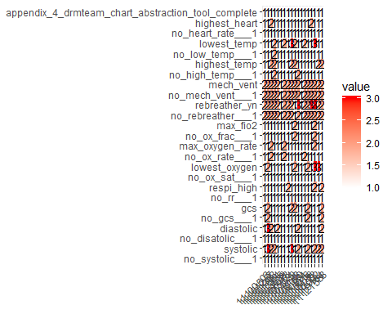 notice that patient 11104039 and patient 11110891 do not have any discrepancy because both of them were only reviewed by one RA.