Analyses for presentation to hospital administrators

Yishan Guo

March 22, 2017

# Figure 1. Average length-of-stay per Doctor

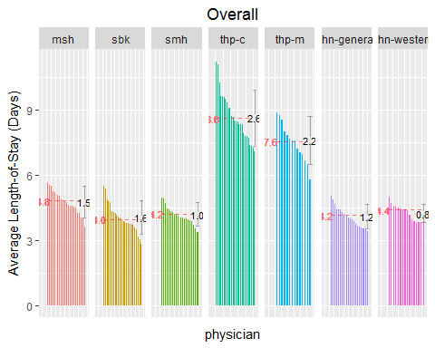

## code.new site N phy.ave phy first.name last.name  
## 1 23 msh 254 5.650262 1 Debaroti Borschel  
## 2 118 msh 287 3.638066 21 Matthew Morgan  
## 3 579 sbk 528 5.481061 1 Mireille Norris  
## 4 652 sbk 1688 2.847897 24 Steven Shadowitz  
## 5 253 smh 436 4.966456 1 Ahmed Bayoumi  
## 6 616 smh 295 3.385452 20 Joel Ray  
## 7 383 thp-c 516 11.236674 1 Melissa Graham  
## 8 543 thp-c 542 7.084256 26 Katherine Monkman  
## 9 582 thp-m 1106 8.901596 1 Clifford Oh  
## 10 691 thp-m 1276 5.776324 14 Joo-Meng Soh  
## 11 130 uhn-general 328 5.045018 1 Andrea Page  
## 12 21 uhn-general 539 3.415224 20 Isaac Bogoch  
## 13 144 uhn-western 891 4.982895 1 Lisa Richardson  
## 14 37 uhn-western 460 3.816849 16 Caroline Chessex

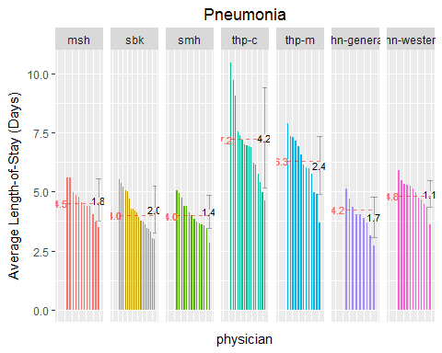

## code.new site N phy.ave phy first.name last.name  
## 1 8 msh 26 5.610577 1 Meyer Balter  
## 2 63 msh 37 3.481982 12 Shiphra Ginsburg  
## 3 491 sbk 23 5.534420 1 Donald Livingstone  
## 4 467 sbk 23 2.996377 19 Ayelet Kuper  
## 5 420 smh 25 5.038333 1 Stephen Hwang  
## 6 730 smh 28 2.843750 14 Khai-Minh Tram  
## 7 284 thp-c 59 10.472140 1 Rajpal Chandi  
## 8 543 thp-c 29 4.615254 16 Katherine Monkman  
## 9 116 thp-m 66 7.903777 1 Michelle Mohammed  
## 10 69 thp-m 28 3.702877 13 Patrick Gudgeon  
## 11 151 uhn-general 105 5.109689 1 Mohammad Shafiee  
## 12 103 uhn-general 20 2.715972 9 Ken Locke  
## 13 11 uhn-western 20 5.900764 1 Raviqubal Basi  
## 14 144 uhn-western 42 3.601637 12 Lisa Richardson

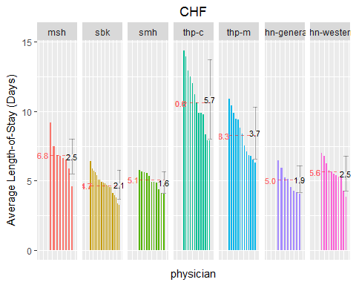

## code.new site N phy.ave phy first.name  
## 1 125 msh 28 9.177083 1 Mitra  
## 2 49 msh 24 4.578125 8 Luke  
## 3 579 sbk 33 6.417929 1 Mireille  
## 4 764 sbk 49 3.256803 19 Brian  
## 5 547 smh 28 5.785714 1 Ophyr  
## 6 426 smh 22 4.079545 11 Trevor  
## 7 135 thp-c 33 14.400379 1 Nausheen  
## 8 456 thp-c 61 7.925683 13 Waheed  
## 9 325 thp-m 85 10.909485 1 Chikkahanumaiah  
## 10 64 thp-m 49 6.275269 13 Amir  
## 11 65 uhn-general 65 6.452286 1 Wayne  
## 12 174 uhn-general 48 4.034057 8 Katina  
## 13 40 uhn-western 63 7.009270 1 Bill  
## 14 37 uhn-western 22 3.863194 11 Caroline  
## last.name  
## 1 Niroumand-Sarvestani  
## 2 Devine  
## 3 Norris  
## 4 Wong  
## 5 Mourad  
## 6 Jamieson  
## 7 Pirzada  
## 8 Kirmani  
## 9 Devaraj  
## 10 Ginzburg  
## 11 Gold  
## 12 Tzanetos  
## 13 Coke  
## 14 Chessex

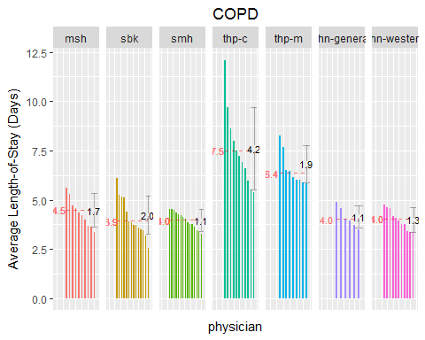

## code.new site N phy.ave phy first.name last.name  
## 1 48 msh 50 5.625000 1 Allan Detsky  
## 2 49 msh 31 3.376344 10 Luke Devine  
## 3 491 sbk 36 6.081019 1 Donald Livingstone  
## 4 652 sbk 60 2.565278 14 Steven Shadowitz  
## 5 767 smh 29 4.550287 1 Natalie Wong  
## 6 326 smh 30 3.259722 15 Irfan Dhalla  
## 7 596 thp-c 21 12.096693 1 James Pencharz  
## 8 300 thp-c 20 5.386007 11 David Clarkson  
## 9 116 thp-m 39 8.253063 1 Michelle Mohammed  
## 10 325 thp-m 110 5.821149 9 Chikkahanumaiah Devaraj  
## 11 21 uhn-general 21 4.868717 1 Isaac Bogoch  
## 12 22 uhn-general 33 3.493245 6 Mark Bonta  
## 13 40 uhn-western 33 4.751052 1 Bill Coke  
## 14 37 uhn-western 24 3.354485 11 Caroline Chessex

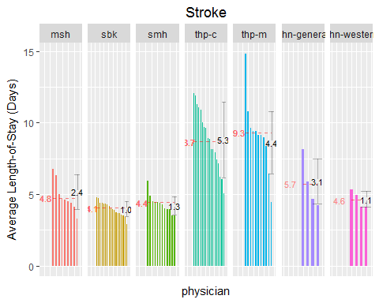

## code.new site N phy.ave phy first.name last.name  
## 1 178 msh 29 6.771552 1 Hillar Vellend  
## 2 128 msh 36 3.320602 9 Mirek Otremba  
## 3 579 sbk 74 4.811374 1 Mireille Norris  
## 4 62 sbk 23 2.922101 18 Jeremy Gilbert  
## 5 292 smh 48 5.950521 1 Vincent Chien  
## 6 326 smh 20 3.497917 12 Irfan Dhalla  
## 7 300 thp-c 49 12.048101 1 David Clarkson  
## 8 543 thp-c 45 5.045432 18 Katherine Monkman  
## 9 329 thp-m 37 14.841141 1 Gagandeep Dhillon  
## 10 723 thp-m 35 4.465000 11 Kerry Thompson  
## 11 65 uhn-general 26 8.173478 1 Wayne Gold  
## 12 22 uhn-general 20 4.226910 4 Mark Bonta  
## 13 33 uhn-western 23 5.310930 1 Rodrigo Cavalcanti  
## 14 40 uhn-western 21 4.135284 4 Bill Coke

# Figure 2. Average ALC Days per Doctor

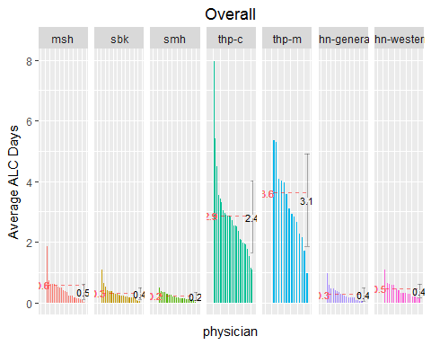

## code.new site N phy.ave phy first.name last.name  
## 1 128 msh 1160 1.865517241 1 Mirek Otremba  
## 2 69 msh 139 0.021582734 21 Patrick Gudgeon  
## 3 104 sbk 377 1.082228117 1 Julia Lowe  
## 4 699 sbk 110 0.045454545 24 John Staples  
## 5 292 smh 990 0.508080808 1 Vincent Chien  
## 6 617 smh 128 0.031250000 20 Fahad Razak  
## 7 577 thp-c 138 7.971014493 1 Vipan Nikore  
## 8 450 thp-c 255 1.082352941 26 Vikas Khera  
## 9 470 thp-m 1516 5.358179420 1 Peter J. Lam  
## 10 634 thp-m 560 0.960714286 14 Jasdeep Saluja  
## 11 119 uhn-general 283 0.982332155 1 Dante Morra  
## 12 84 uhn-general 278 0.007194245 20 Murray D. Krahn  
## 13 154 uhn-western 984 1.092479675 1 Abdul Sharkawy  
## 14 88 uhn-western 235 0.136170213 16 Aly Lakhani

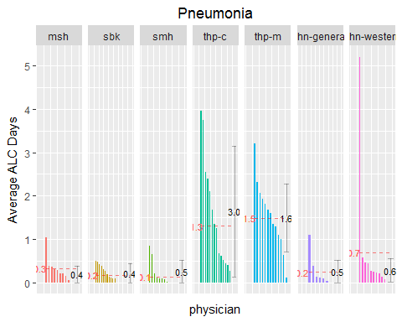

## code.new site N phy.ave phy first.name last.name  
## 1 133 msh 88 1.0340909 1 Yashesh Patel  
## 2 63 msh 37 0.0000000 12 Shiphra Ginsburg  
## 3 104 sbk 26 0.5000000 1 Julia Lowe  
## 4 764 sbk 56 0.0000000 19 Brian Wong  
## 5 394 smh 32 0.8437500 1 Rajesh Gupta  
## 6 91 smh 44 0.0000000 14 Yuna Lee  
## 7 736 thp-c 43 3.9534884 1 Mark Unger  
## 8 463 thp-c 48 0.0000000 16 Michael Kroll  
## 9 330 thp-m 35 3.2000000 1 Claudio Di Prizito  
## 10 634 thp-m 33 0.1212121 13 Jasdeep Saluja  
## 11 22 uhn-general 54 1.0925926 1 Mark Bonta  
## 12 79 uhn-general 28 0.0000000 9 Moira K. Kapral  
## 13 89 uhn-western 40 5.2000000 1 Bohdan Laluck  
## 14 132 uhn-western 25 0.0000000 12 Daniel M. Panisko

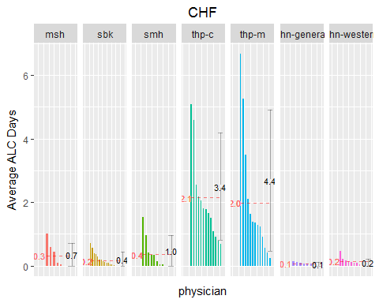

## code.new site N phy.ave phy first.name last.name  
## 1 133 msh 49 1.0204082 1 Yashesh Patel  
## 2 66 msh 21 0.0000000 8 Barry Goldlist  
## 3 104 sbk 27 0.7037037 1 Julia Lowe  
## 4 764 sbk 49 0.0000000 19 Brian Wong  
## 5 547 smh 28 1.5357143 1 Ophyr Mourad  
## 6 91 smh 29 0.0000000 11 Yuna Lee  
## 7 411 thp-c 39 5.0769231 1 Sasha High  
## 8 775 thp-c 29 0.6896552 13 Nina Yashpal  
## 9 723 thp-m 28 6.6785714 1 Kerry Thompson  
## 10 634 thp-m 33 0.2424242 13 Jasdeep Saluja  
## 11 174 uhn-general 48 0.1458333 1 Katina Tzanetos  
## 12 79 uhn-general 24 0.0000000 8 Moira K. Kapral  
## 13 110 uhn-western 84 0.4642857 1 David Mcneely  
## 14 88 uhn-western 22 0.0000000 11 Aly Lakhani

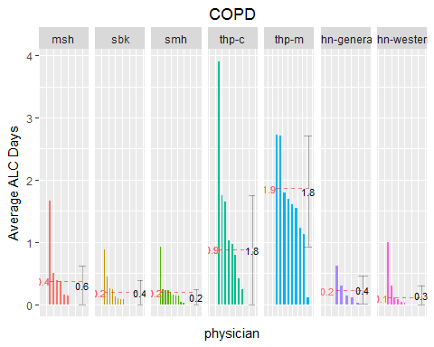

## code.new site N phy.ave phy first.name last.name  
## 1 48 msh 50 1.6600000 1 Allan Detsky  
## 2 63 msh 25 0.0000000 10 Shiphra Ginsburg  
## 3 673 sbk 73 0.8767123 1 Steven Shumak  
## 4 764 sbk 32 0.0000000 14 Brian Wong  
## 5 292 smh 63 0.9206349 1 Vincent Chien  
## 6 730 smh 28 0.0000000 15 Khai-Minh Tram  
## 7 596 thp-c 21 3.9047619 1 James Pencharz  
## 8 642 thp-c 28 0.0000000 11 Rosemarie Schwarz  
## 9 325 thp-m 110 2.7181818 1 Chikkahanumaiah Devaraj  
## 10 723 thp-m 26 0.1153846 9 Kerry Thompson  
## 11 151 uhn-general 55 0.6181818 1 Mohammad Shafiee  
## 12 187 uhn-general 39 0.0000000 6 Robert Wu  
## 13 38 uhn-western 20 1.0000000 1 Angela Cheung  
## 14 58 uhn-western 40 0.0000000 11 David Frost

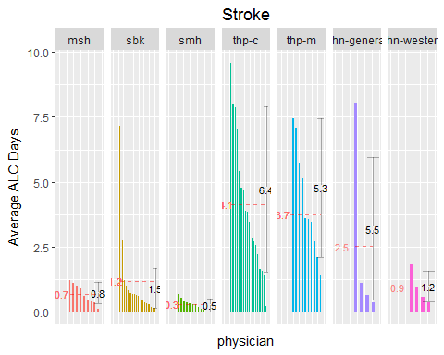

## code.new site N phy.ave phy first.name last.name  
## 1 128 msh 36 1.1944444 1 Mirek Otremba  
## 2 48 msh 32 0.0937500 9 Allan Detsky  
## 3 104 sbk 46 7.1521739 1 Julia Lowe  
## 4 164 sbk 25 0.1200000 18 Graham Slaughter  
## 5 547 smh 23 0.6521739 1 Ophyr Mourad  
## 6 394 smh 21 0.0000000 12 Rajesh Gupta  
## 7 284 thp-c 72 9.5972222 1 Rajpal Chandi  
## 8 250 thp-c 37 0.1891892 18 Milan Barboza  
## 9 330 thp-m 93 8.1290323 1 Claudio Di Prizito  
## 10 691 thp-m 39 1.3846154 11 Joo-Meng Soh  
## 11 65 uhn-general 26 8.0384615 1 Wayne Gold  
## 12 151 uhn-general 34 0.3529412 4 Mohammad Shafiee  
## 13 89 uhn-western 28 1.8214286 1 Bohdan Laluck  
## 14 40 uhn-western 21 0.3333333 4 Bill Coke

# Figure 3. Average Cost per Doctor

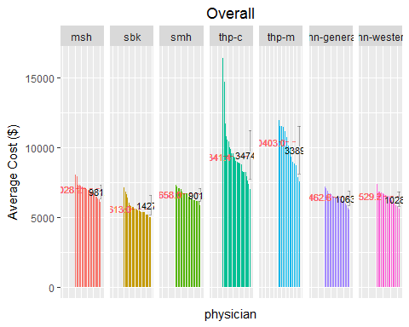

## code.new site N phy.ave phy first.name last.name  
## 1 23 msh 254 8002.294 1 Debaroti Borschel  
## 2 118 msh 287 6075.367 21 Matthew Morgan  
## 3 104 sbk 377 7092.259 1 Julia Lowe  
## 4 467 sbk 276 4964.319 24 Ayelet Kuper  
## 5 253 smh 436 7317.371 1 Ahmed Bayoumi  
## 6 617 smh 128 5826.396 20 Fahad Razak  
## 7 577 thp-c 138 16397.117 1 Vipan Nikore  
## 8 444 thp-c 105 7020.586 26 Kimberley Kent  
## 9 325 thp-m 2154 11927.015 1 Chikkahanumaiah Devaraj  
## 10 69 thp-m 481 7526.222 14 Patrick Gudgeon  
## 11 119 uhn-general 283 7190.909 1 Dante Morra  
## 12 185 uhn-general 384 5559.502 20 Rene Wong  
## 13 154 uhn-western 984 7358.769 1 Abdul Sharkawy  
## 14 7 uhn-western 158 5618.543 16 Michael A. Baker

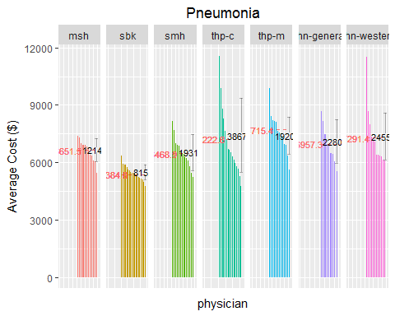

## code.new site N phy.ave phy first.name last.name  
## 1 178 msh 41 7375.273 1 Hillar Vellend  
## 2 63 msh 37 5432.263 12 Shiphra Ginsburg  
## 3 436 sbk 27 6371.946 1 David Juurlink  
## 4 164 sbk 46 4767.741 19 Graham Slaughter  
## 5 253 smh 23 8140.161 1 Ahmed Bayoumi  
## 6 730 smh 28 5226.866 14 Khai-Minh Tram  
## 7 284 thp-c 59 11570.149 1 Rajpal Chandi  
## 8 463 thp-c 48 4783.121 16 Michael Kroll  
## 9 116 thp-m 66 9874.091 1 Michelle Mohammed  
## 10 69 thp-m 28 5610.264 13 Patrick Gudgeon  
## 11 174 uhn-general 51 8662.957 1 Katina Tzanetos  
## 12 2 uhn-general 20 5517.581 9 Howard Abrams  
## 13 89 uhn-western 40 11526.520 1 Bohdan Laluck  
## 14 11 uhn-western 20 6090.158 12 Raviqubal Basi

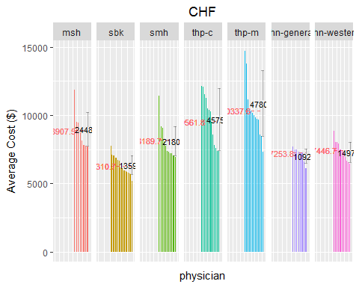

## code.new site N phy.ave phy first.name last.name  
## 1 178 msh 35 11849.072 1 Hillar Vellend  
## 2 49 msh 24 7695.058 8 Luke Devine  
## 3 687 sbk 22 7754.204 1 Andrew Smaggus  
## 4 764 sbk 49 5180.809 19 Brian Wong  
## 5 91 smh 29 11422.842 1 Yuna Lee  
## 6 426 smh 22 6913.272 11 Trevor Jamieson  
## 7 250 thp-c 29 12155.794 1 Milan Barboza  
## 8 463 thp-c 29 7355.856 13 Michael Kroll  
## 9 325 thp-m 85 14734.029 1 Chikkahanumaiah Devaraj  
## 10 330 thp-m 51 7345.297 13 Claudio Di Prizito  
## 11 151 uhn-general 90 7722.530 1 Mohammad Shafiee  
## 12 21 uhn-general 30 6144.325 8 Isaac Bogoch  
## 13 132 uhn-western 47 8835.469 1 Daniel M. Panisko  
## 14 33 uhn-western 65 6431.893 11 Rodrigo Cavalcanti

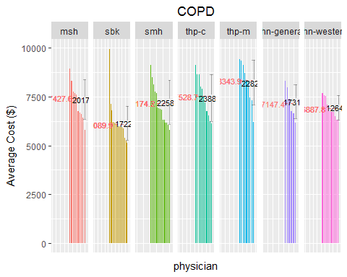

## code.new site N phy.ave phy first.name last.name  
## 1 48 msh 50 8940.447 1 Allan Detsky  
## 2 8 msh 28 5809.847 10 Meyer Balter  
## 3 764 sbk 32 9949.047 1 Brian Wong  
## 4 652 sbk 60 5125.232 14 Steven Shadowitz  
## 5 469 smh 45 9133.009 1 Ignazio Ladelfa  
## 6 326 smh 30 5777.753 15 Irfan Dhalla  
## 7 596 thp-c 21 9127.128 1 James Pencharz  
## 8 463 thp-c 27 6126.647 11 Michael Kroll  
## 9 691 thp-m 20 9407.273 1 Joo-Meng Soh  
## 10 723 thp-m 26 6212.942 9 Kerry Thompson  
## 11 21 uhn-general 21 8296.047 1 Isaac Bogoch  
## 12 22 uhn-general 33 6149.422 6 Mark Bonta  
## 13 40 uhn-western 33 7667.333 1 Bill Coke  
## 14 37 uhn-western 24 6312.491 11 Caroline Chessex

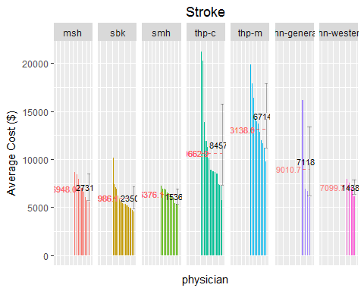

## code.new site N phy.ave phy first.name last.name  
## 1 178 msh 29 8669.038 1 Hillar Vellend  
## 2 66 msh 20 5574.985 9 Barry Goldlist  
## 3 104 sbk 46 10174.096 1 Julia Lowe  
## 4 491 sbk 34 4550.267 18 Donald Livingstone  
## 5 335 smh 31 7278.445 1 Vera Dounaevskaia  
## 6 326 smh 20 5287.483 12 Irfan Dhalla  
## 7 300 thp-c 49 21237.824 1 David Clarkson  
## 8 543 thp-c 45 5770.563 18 Katherine Monkman  
## 9 329 thp-m 37 19847.580 1 Gagandeep Dhillon  
## 10 723 thp-m 35 9741.922 11 Kerry Thompson  
## 11 65 uhn-general 26 16125.279 1 Wayne Gold  
## 12 187 uhn-general 22 6069.480 4 Robert Wu  
## 13 33 uhn-western 23 7965.175 1 Rodrigo Cavalcanti  
## 14 110 uhn-western 34 6124.811 4 David Mcneely

# Figure 4. Readmission (within 30 days) Rate per Doctor

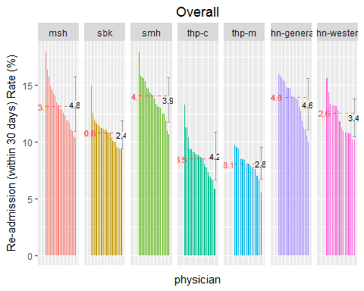

## code.new site N phy.ave phy first.name last.name  
## 1 69 msh 139 17.985612 1 Patrick Gudgeon  
## 2 88 msh 135 10.370370 21 Aly Lakhani  
## 3 682 sbk 362 14.958449 1 Khalil Sivjee  
## 4 687 sbk 388 9.278351 24 Andrew Smaggus  
## 5 730 smh 373 17.910448 1 Khai-Minh Tram  
## 6 420 smh 430 10.697674 20 Stephen Hwang  
## 7 375 thp-c 249 13.253012 1 Akash Girn  
## 8 284 thp-c 957 5.851620 26 Rajpal Chandi  
## 9 338 thp-m 522 9.770115 1 Jeanne Du Manoir  
## 10 582 thp-m 1106 5.519779 14 Clifford Oh  
## 11 174 uhn-general 918 16.055046 1 Katina Tzanetos  
## 12 69 uhn-general 140 10.000000 20 Patrick Gudgeon  
## 13 37 uhn-western 460 15.652174 1 Caroline Chessex  
## 14 88 uhn-western 235 10.212766 16 Aly Lakhani

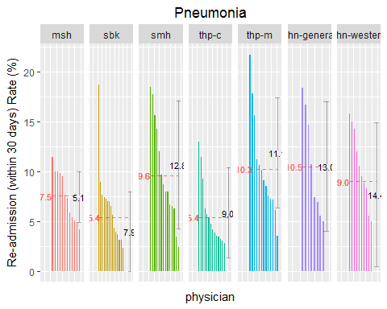

## code.new site N phy.ave phy first.name last.name  
## 1 66 msh 35 11.428571 1 Barry Goldlist  
## 2 120 msh 25 4.166667 12 Andrew Morris  
## 3 295 sbk 48 18.750000 1 Gregory Choy  
## 4 687 sbk 21 0.000000 19 Andrew Smaggus  
## 5 326 smh 27 18.518519 1 Irfan Dhalla  
## 6 91 smh 44 2.380952 14 Yuna Lee  
## 7 402 thp-c 77 12.987013 1 Shahzad Hashim  
## 8 383 thp-c 28 0.000000 16 Melissa Graham  
## 9 329 thp-m 23 21.739130 1 Gagandeep Dhillon  
## 10 338 thp-m 28 3.571429 13 Jeanne Du Manoir  
## 11 174 uhn-general 51 18.367347 1 Katina Tzanetos  
## 12 103 uhn-general 20 0.000000 9 Ken Locke  
## 13 58 uhn-western 38 15.789474 1 David Frost  
## 14 37 uhn-western 21 0.000000 12 Caroline Chessex

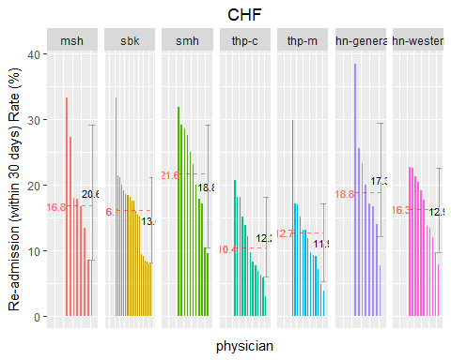

## code.new site N phy.ave phy first.name last.name  
## 1 66 msh 21 33.333333 1 Barry Goldlist  
## 2 49 msh 24 8.333333 8 Luke Devine  
## 3 104 sbk 27 33.333333 1 Julia Lowe  
## 4 752 sbk 25 8.000000 19 Adina Weinerman  
## 5 426 smh 22 31.818182 1 Trevor Jamieson  
## 6 420 smh 21 9.523810 11 Stephen Hwang  
## 7 463 thp-c 29 20.689655 1 Michael Kroll  
## 8 135 thp-c 33 3.030303 13 Nausheen Pirzada  
## 9 64 thp-m 49 29.787234 1 Amir Ginzburg  
## 10 338 thp-m 26 3.846154 13 Jeanne Du Manoir  
## 11 26 uhn-general 26 38.461538 1 Paul Evan Bunce  
## 12 65 uhn-general 65 7.692308 8 Wayne Gold  
## 13 37 uhn-western 22 22.727273 1 Caroline Chessex  
## 14 33 uhn-western 65 7.812500 11 Rodrigo Cavalcanti

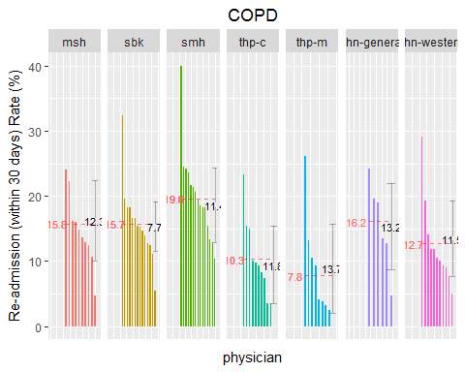

## code.new site N phy.ave phy first.name last.name  
## 1 128 msh 50 24.000000 1 Mirek Otremba  
## 2 59 msh 21 4.761905 10 Shital Gandhi  
## 3 164 sbk 34 32.352941 1 Graham Slaughter  
## 4 703 sbk 37 5.405405 14 Lynfa Stroud  
## 5 326 smh 30 40.000000 1 Irfan Dhalla  
## 6 253 smh 30 10.344828 15 Ahmed Bayoumi  
## 7 736 thp-c 43 23.255814 1 Mark Unger  
## 8 596 thp-c 21 0.000000 11 James Pencharz  
## 9 330 thp-m 26 26.086957 1 Claudio Di Prizito  
## 10 691 thp-m 20 0.000000 9 Joo-Meng Soh  
## 11 22 uhn-general 33 24.242424 1 Mark Bonta  
## 12 21 uhn-general 21 4.761905 6 Isaac Bogoch  
## 13 37 uhn-western 24 29.166667 1 Caroline Chessex  
## 14 38 uhn-western 20 5.000000 11 Angela Cheung

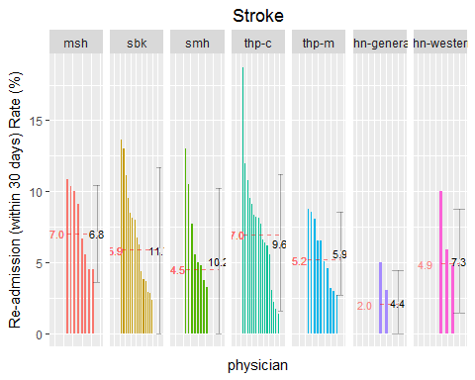

## code.new site N phy.ave phy first.name last.name  
## 1 133 msh 47 10.869565 1 Yashesh Patel  
## 2 178 msh 29 0.000000 9 Hillar Vellend  
## 3 295 sbk 22 13.636364 1 Gregory Choy  
## 4 764 sbk 26 0.000000 18 Brian Wong  
## 5 547 smh 23 13.043478 1 Ophyr Mourad  
## 6 469 smh 37 0.000000 12 Ignazio Ladelfa  
## 7 300 thp-c 49 18.750000 1 David Clarkson  
## 8 383 thp-c 29 0.000000 18 Melissa Graham  
## 9 470 thp-m 106 8.737864 1 Peter J. Lam  
## 10 691 thp-m 39 0.000000 11 Joo-Meng Soh  
## 11 22 uhn-general 20 5.000000 1 Mark Bonta  
## 12 65 uhn-general 26 0.000000 4 Wayne Gold  
## 13 40 uhn-western 21 10.000000 1 Bill Coke  
## 14 89 uhn-western 28 0.000000 4 Bohdan Laluck

# Figure 5. In-hospital Mortality Rate per Doctor

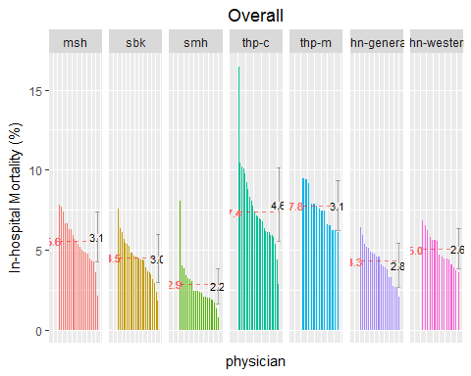

## code.new site N phy.ave phy first.name last.name  
## 1 16 msh 320 7.812500 1 Chaim Bell  
## 2 69 msh 139 2.158273 21 Patrick Gudgeon  
## 3 579 sbk 528 7.575758 1 Mireille Norris  
## 4 752 sbk 334 1.796407 24 Adina Weinerman  
## 5 469 smh 608 8.059211 1 Ignazio Ladelfa  
## 6 617 smh 128 0.781250 20 Fahad Razak  
## 7 375 thp-c 249 16.465863 1 Akash Girn  
## 8 444 thp-c 105 2.857143 26 Kimberley Kent  
## 9 330 thp-m 1451 9.441764 1 Claudio Di Prizito  
## 10 338 thp-m 522 6.130268 14 Jeanne Du Manoir  
## 11 69 uhn-general 140 6.428571 1 Patrick Gudgeon  
## 12 7 uhn-general 244 2.049180 20 Michael A. Baker  
## 13 88 uhn-western 235 6.808511 1 Aly Lakhani  
## 14 132 uhn-western 717 3.626220 16 Daniel M. Panisko

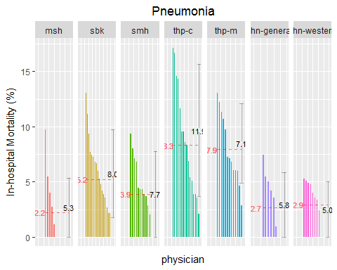

## code.new site N phy.ave phy first.name last.name  
## 1 178 msh 41 9.756098 1 Hillar Vellend  
## 2 8 msh 26 0.000000 12 Meyer Balter  
## 3 491 sbk 23 13.043478 1 Donald Livingstone  
## 4 62 sbk 43 0.000000 19 Jeremy Gilbert  
## 5 394 smh 32 9.375000 1 Rajesh Gupta  
## 6 547 smh 46 0.000000 14 Ophyr Mourad  
## 7 300 thp-c 35 17.142857 1 David Clarkson  
## 8 411 thp-c 48 2.083333 16 Sasha High  
## 9 329 thp-m 23 13.043478 1 Gagandeep Dhillon  
## 10 330 thp-m 35 2.857143 13 Claudio Di Prizito  
## 11 22 uhn-general 54 7.407407 1 Mark Bonta  
## 12 65 uhn-general 58 0.000000 9 Wayne Gold  
## 13 58 uhn-western 38 5.263158 1 David Frost  
## 14 89 uhn-western 40 0.000000 12 Bohdan Laluck

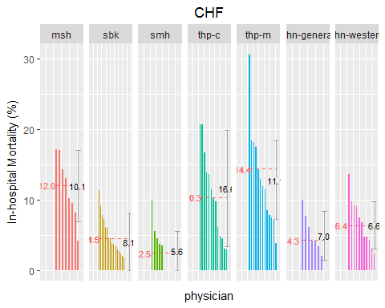

## code.new site N phy.ave phy first.name last.name  
## 1 178 msh 35 17.142857 1 Hillar Vellend  
## 2 49 msh 24 4.166667 8 Luke Devine  
## 3 703 sbk 53 11.320755 1 Lynfa Stroud  
## 4 752 sbk 25 0.000000 19 Adina Weinerman  
## 5 469 smh 20 10.000000 1 Ignazio Ladelfa  
## 6 91 smh 29 0.000000 11 Yuna Lee  
## 7 250 thp-c 29 20.689655 1 Milan Barboza  
## 8 736 thp-c 34 2.941176 13 Mark Unger  
## 9 325 thp-m 85 30.588235 1 Chikkahanumaiah Devaraj  
## 10 338 thp-m 26 3.846154 13 Jeanne Du Manoir  
## 11 21 uhn-general 30 10.000000 1 Isaac Bogoch  
## 12 22 uhn-general 41 0.000000 8 Mark Bonta  
## 13 88 uhn-western 22 13.636364 1 Aly Lakhani  
## 14 1 uhn-western 42 2.380952 11 Nadine Abdullah

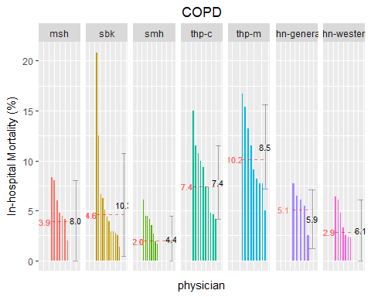

## code.new site N phy.ave phy first.name last.name  
## 1 178 msh 36 8.333333 1 Hillar Vellend  
## 2 8 msh 28 0.000000 10 Meyer Balter  
## 3 579 sbk 24 20.833333 1 Mireille Norris  
## 4 703 sbk 37 0.000000 14 Lynfa Stroud  
## 5 335 smh 33 6.060606 1 Vera Dounaevskaia  
## 6 767 smh 29 0.000000 15 Natalie Wong  
## 7 300 thp-c 20 15.000000 1 David Clarkson  
## 8 402 thp-c 28 0.000000 11 Shahzad Hashim  
## 9 470 thp-m 24 16.666667 1 Peter J. Lam  
## 10 691 thp-m 20 5.000000 9 Joo-Meng Soh  
## 11 187 uhn-general 39 7.692308 1 Robert Wu  
## 12 21 uhn-general 21 0.000000 6 Isaac Bogoch  
## 13 110 uhn-western 78 6.410256 1 David Mcneely  
## 14 38 uhn-western 20 0.000000 11 Angela Cheung

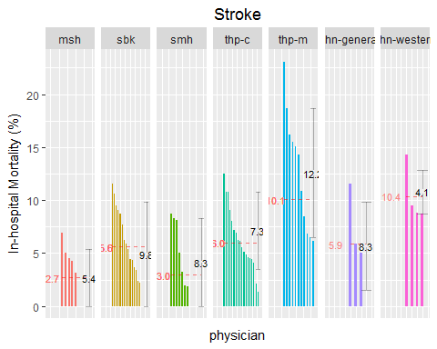

## code.new site N phy.ave phy first.name last.name  
## 1 178 msh 29 6.896552 1 Hillar Vellend  
## 2 59 msh 22 0.000000 9 Shital Gandhi  
## 3 764 sbk 26 11.538462 1 Brian Wong  
## 4 62 sbk 23 0.000000 18 Jeremy Gilbert  
## 5 767 smh 23 8.695652 1 Natalie Wong  
## 6 91 smh 40 0.000000 12 Yuna Lee  
## 7 284 thp-c 72 12.500000 1 Rajpal Chandi  
## 8 736 thp-c 76 1.315789 18 Mark Unger  
## 9 691 thp-m 39 23.076923 1 Joo-Meng Soh  
## 10 697 thp-m 98 6.122449 11 Melanie Spring  
## 11 65 uhn-general 26 11.538462 1 Wayne Gold  
## 12 187 uhn-general 22 0.000000 4 Robert Wu  
## 13 89 uhn-western 28 14.285714 1 Bohdan Laluck  
## 14 33 uhn-western 23 8.695652 4 Rodrigo Cavalcanti

# Figure 6. Short-admission (<48h) Rate per Doctor

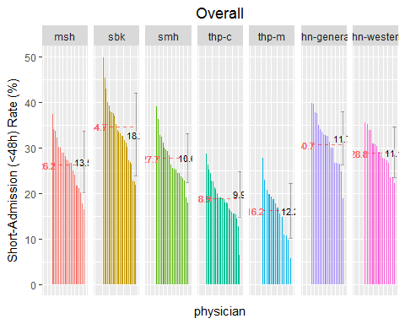

## code.new site N phy.ave phy first.name last.name  
## 1 118 msh 287 37.282230 1 Matthew Morgan  
## 2 130 msh 416 16.346154 21 Andrea Page  
## 3 652 sbk 1688 49.822275 1 Steven Shadowitz  
## 4 579 sbk 528 21.780303 24 Mireille Norris  
## 5 616 smh 295 38.983051 1 Joel Ray  
## 6 617 smh 128 17.968750 20 Fahad Razak  
## 7 444 thp-c 105 28.571429 1 Kimberley Kent  
## 8 710 thp-c 230 6.521739 26 Terence Tang  
## 9 691 thp-m 1276 27.664577 1 Joo-Meng Soh  
## 10 582 thp-m 1106 5.605787 14 Clifford Oh  
## 11 21 uhn-general 539 39.703154 1 Isaac Bogoch  
## 12 130 uhn-general 328 18.902439 20 Andrea Page  
## 13 7 uhn-western 158 35.443038 1 Michael A. Baker  
## 14 11 uhn-western 225 22.222222 16 Raviqubal Basi

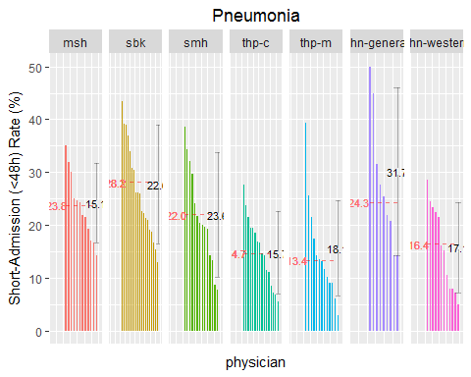

## code.new site N phy.ave phy first.name last.name  
## 1 59 msh 40 35.000000 1 Shital Gandhi  
## 2 130 msh 21 14.285714 12 Andrea Page  
## 3 673 sbk 76 43.421053 1 Steven Shumak  
## 4 491 sbk 23 13.043478 19 Donald Livingstone  
## 5 91 smh 44 38.636364 1 Yuna Lee  
## 6 767 smh 26 7.692308 14 Natalie Wong  
## 7 543 thp-c 29 27.586207 1 Katherine Monkman  
## 8 642 thp-c 36 5.555556 16 Rosemarie Schwarz  
## 9 69 thp-m 28 39.285714 1 Patrick Gudgeon  
## 10 330 thp-m 35 2.857143 13 Claudio Di Prizito  
## 11 103 uhn-general 20 50.000000 1 Ken Locke  
## 12 79 uhn-general 28 14.285714 9 Moira K. Kapral  
## 13 37 uhn-western 21 28.571429 1 Caroline Chessex  
## 14 11 uhn-western 20 5.000000 12 Raviqubal Basi

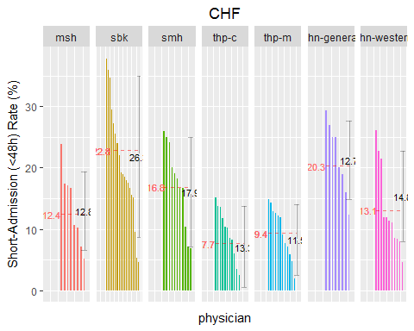

## code.new site N phy.ave phy first.name last.name  
## 1 66 msh 21 23.809524 1 Barry Goldlist  
## 2 128 msh 39 5.128205 8 Mirek Otremba  
## 3 652 sbk 119 37.815126 1 Steven Shadowitz  
## 4 682 sbk 22 4.545455 19 Khalil Sivjee  
## 5 292 smh 27 25.925926 1 Vincent Chien  
## 6 458 smh 29 6.896552 11 James Kitchens  
## 7 402 thp-c 33 15.151515 1 Shahzad Hashim  
## 8 284 thp-c 48 0.000000 13 Rajpal Chandi  
## 9 691 thp-m 67 14.925373 1 Joo-Meng Soh  
## 10 329 thp-m 35 0.000000 13 Gagandeep Dhillon  
## 11 22 uhn-general 41 29.268293 1 Mark Bonta  
## 12 65 uhn-general 65 12.307692 8 Wayne Gold  
## 13 33 uhn-western 65 26.153846 1 Rodrigo Cavalcanti  
## 14 88 uhn-western 22 4.545455 11 Aly Lakhani

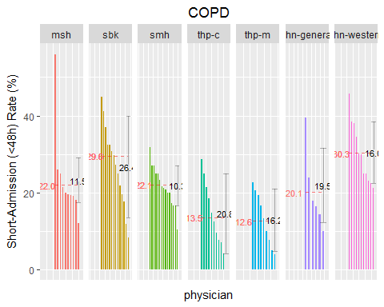

## code.new site N phy.ave phy first.name last.name  
## 1 63 msh 25 56.000000 1 Shiphra Ginsburg  
## 2 48 msh 50 12.000000 10 Allan Detsky  
## 3 652 sbk 60 45.000000 1 Steven Shadowitz  
## 4 579 sbk 24 8.333333 14 Mireille Norris  
## 5 426 smh 44 31.818182 1 Trevor Jamieson  
## 6 767 smh 29 10.344828 15 Natalie Wong  
## 7 642 thp-c 28 28.571429 1 Rosemarie Schwarz  
## 8 250 thp-c 20 0.000000 11 Milan Barboza  
## 9 64 thp-m 22 22.727273 1 Amir Ginzburg  
## 10 330 thp-m 26 3.846154 9 Claudio Di Prizito  
## 11 22 uhn-general 33 39.393939 1 Mark Bonta  
## 12 174 uhn-general 40 10.000000 6 Katina Tzanetos  
## 13 37 uhn-western 24 45.833333 1 Caroline Chessex  
## 14 40 uhn-western 33 21.212121 11 Bill Coke

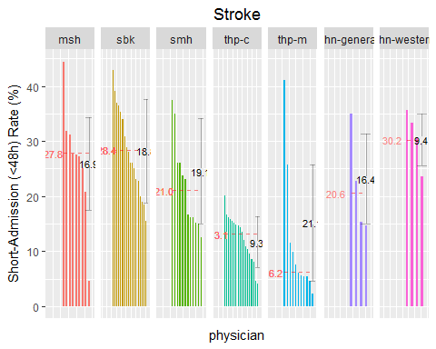

## code.new site N phy.ave phy first.name last.name  
## 1 128 msh 36 44.444444 1 Mirek Otremba  
## 2 125 msh 22 4.545455 9 Mitra Niroumand-Sarvestani  
## 3 532 sbk 42 42.857143 1 Rajin Mehta  
## 4 682 sbk 45 15.555556 18 Khalil Sivjee  
## 5 91 smh 40 37.500000 1 Yuna Lee  
## 6 292 smh 48 12.500000 12 Vincent Chien  
## 7 456 thp-c 129 20.155039 1 Waheed Kirmani  
## 8 284 thp-c 72 4.166667 18 Rajpal Chandi  
## 9 691 thp-m 39 41.025641 1 Joo-Meng Soh  
## 10 582 thp-m 833 2.280912 11 Clifford Oh  
## 11 22 uhn-general 20 35.000000 1 Mark Bonta  
## 12 151 uhn-general 34 14.705882 4 Mohammad Shafiee  
## 13 89 uhn-western 28 35.714286 1 Bohdan Laluck  
## 14 110 uhn-western 34 23.529412 4 David Mcneely

# Figure 7. ICU Utilization Rate per Doctor

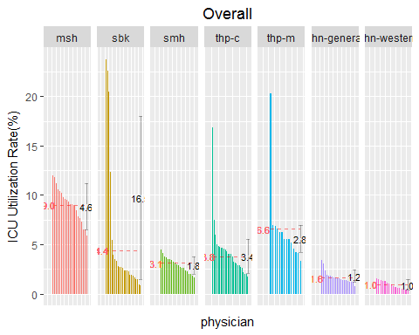

## code.new site N phy.ave phy first.name last.name  
## 1 103 msh 233 12.0171674 1 Ken Locke  
## 2 131 msh 221 5.8823529 21 Christian Pagnoux  
## 3 682 sbk 362 23.7569061 1 Khalil Sivjee  
## 4 398 sbk 115 0.8695652 24 Ilana Halperin  
## 5 16 smh 266 4.5112782 1 Chaim Bell  
## 6 220 smh 237 1.6877637 20 Jonathan Ailon  
## 7 375 thp-c 249 16.8674699 1 Akash Girn  
## 8 710 thp-c 230 1.7391304 26 Terence Tang  
## 9 582 thp-m 1106 20.2531646 1 Clifford Oh  
## 10 723 thp-m 909 3.3003300 14 Kerry Thompson  
## 11 103 uhn-general 290 3.4482759 1 Ken Locke  
## 12 149 uhn-general 273 0.7326007 20 Clodagh Ryan  
## 13 160 uhn-western 128 1.5625000 1 Robert D. Silver  
## 14 38 uhn-western 326 0.3067485 16 Angela Cheung

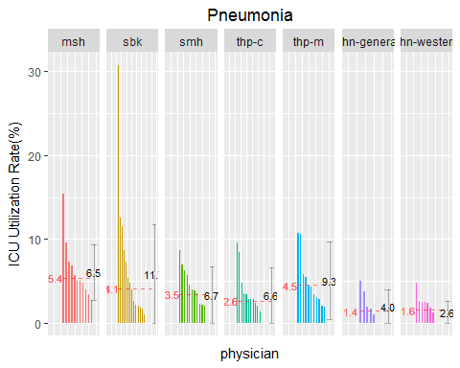

## code.new site N phy.ave phy first.name last.name  
## 1 8 msh 26 15.384615 1 Meyer Balter  
## 2 120 msh 25 0.000000 12 Andrew Morris  
## 3 579 sbk 26 30.769231 1 Mireille Norris  
## 4 62 sbk 43 0.000000 19 Jeremy Gilbert  
## 5 426 smh 23 8.695652 1 Trevor Jamieson  
## 6 335 smh 31 0.000000 14 Vera Dounaevskaia  
## 7 135 thp-c 21 9.523810 1 Nausheen Pirzada  
## 8 463 thp-c 48 0.000000 16 Michael Kroll  
## 9 338 thp-m 28 10.714286 1 Jeanne Du Manoir  
## 10 69 thp-m 28 0.000000 13 Patrick Gudgeon  
## 11 103 uhn-general 20 5.000000 1 Ken Locke  
## 12 79 uhn-general 28 0.000000 9 Moira K. Kapral  
## 13 37 uhn-western 21 4.761905 1 Caroline Chessex  
## 14 40 uhn-western 28 0.000000 12 Bill Coke

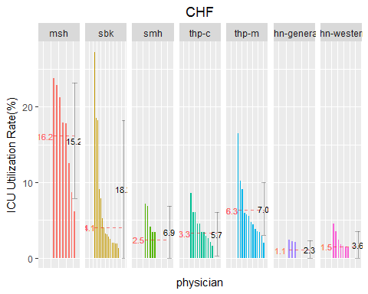

## code.new site N phy.ave phy first.name last.name  
## 1 66 msh 21 23.809524 1 Barry Goldlist  
## 2 133 msh 49 6.122449 8 Yashesh Patel  
## 3 682 sbk 22 27.272727 1 Khalil Sivjee  
## 4 764 sbk 49 0.000000 19 Brian Wong  
## 5 547 smh 28 7.142857 1 Ophyr Mourad  
## 6 767 smh 20 0.000000 11 Natalie Wong  
## 7 642 thp-c 35 8.571429 1 Rosemarie Schwarz  
## 8 463 thp-c 29 0.000000 13 Michael Kroll  
## 9 325 thp-m 85 16.470588 1 Chikkahanumaiah Devaraj  
## 10 330 thp-m 51 1.960784 13 Claudio Di Prizito  
## 11 22 uhn-general 41 2.439024 1 Mark Bonta  
## 12 79 uhn-general 24 0.000000 8 Moira K. Kapral  
## 13 37 uhn-western 22 4.545455 1 Caroline Chessex  
## 14 88 uhn-western 22 0.000000 11 Aly Lakhani

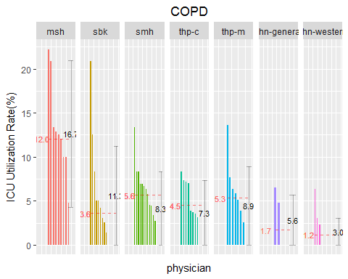

## code.new site N phy.ave phy first.name last.name  
## 1 178 msh 36 22.222222 1 Hillar Vellend  
## 2 8 msh 28 0.000000 10 Meyer Balter  
## 3 579 sbk 24 20.833333 1 Mireille Norris  
## 4 703 sbk 37 0.000000 14 Lynfa Stroud  
## 5 469 smh 45 13.333333 1 Ignazio Ladelfa  
## 6 730 smh 28 0.000000 15 Khai-Minh Tram  
## 7 411 thp-c 24 8.333333 1 Sasha High  
## 8 596 thp-c 21 0.000000 11 James Pencharz  
## 9 64 thp-m 22 13.636364 1 Amir Ginzburg  
## 10 691 thp-m 20 0.000000 9 Joo-Meng Soh  
## 11 65 uhn-general 46 6.521739 1 Wayne Gold  
## 12 22 uhn-general 33 0.000000 6 Mark Bonta  
## 13 89 uhn-western 63 6.349206 1 Bohdan Laluck  
## 14 58 uhn-western 40 0.000000 11 David Frost

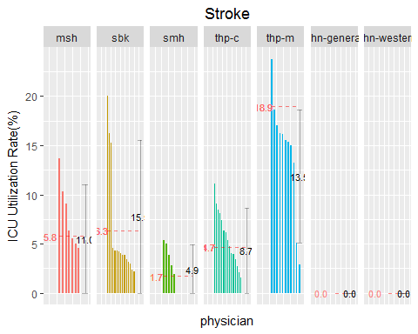

## code.new site N phy.ave phy first.name last.name  
## 1 59 msh 22 13.636364 1 Shital Gandhi  
## 2 49 msh 29 0.000000 9 Luke Devine  
## 3 682 sbk 45 20.000000 1 Khalil Sivjee  
## 4 436 sbk 27 0.000000 18 David Juurlink  
## 5 469 smh 37 5.405405 1 Ignazio Ladelfa  
## 6 91 smh 40 0.000000 12 Yuna Lee  
## 7 284 thp-c 72 11.111111 1 Rajpal Chandi  
## 8 710 thp-c 22 0.000000 18 Terence Tang  
## 9 582 thp-m 833 23.769508 1 Clifford Oh  
## 10 723 thp-m 35 2.857143 11 Kerry Thompson  
## 11 151 uhn-general 34 0.000000 1 Mohammad Shafiee  
## 12 65 uhn-general 26 0.000000 4 Wayne Gold  
## 13 110 uhn-western 34 0.000000 1 David Mcneely  
## 14 89 uhn-western 28 0.000000 4 Bohdan Laluck