
MZILIKAZI × NHANELO

Digital Presence Conversation Guide
A practical guide for showing what “more than a website” means for Mzilikazi Apartments.

CORE IDEA: The website is the foundation. The opportunity is to build the journey around it so more people discover, trust, enquire and book.

Use this document while talking. Do not read it word-for-word — show the examples as you explain the idea.

1. Start with the business problem, not the service
Say it simply: “The website gives Mzilikazi a strong home online. What I want us to think about now is what happens before someone reaches the website, and what happens after they become interested.”
Then relate it to a guest journey:
- A tourist searches “where to stay in Victoria Falls”.
- They see Google, Facebook, Instagram, Booking platforms or a recommendation.
- They look at photos, reviews, location and room information.
- They visit the website or WhatsApp.
- They ask about availability, price or activities.
- Mzilikazi follows up, confirms the booking and later asks for a review.
Discovery → Trust → Explore → Enquire → Book → Review / Refer

The point to make
If those steps feel disconnected, guests can lose confidence or disappear. The offer is to help Mzilikazi manage the whole digital presence around the website, not simply keep posting on social media.

2. Show her what stronger positioning looks like
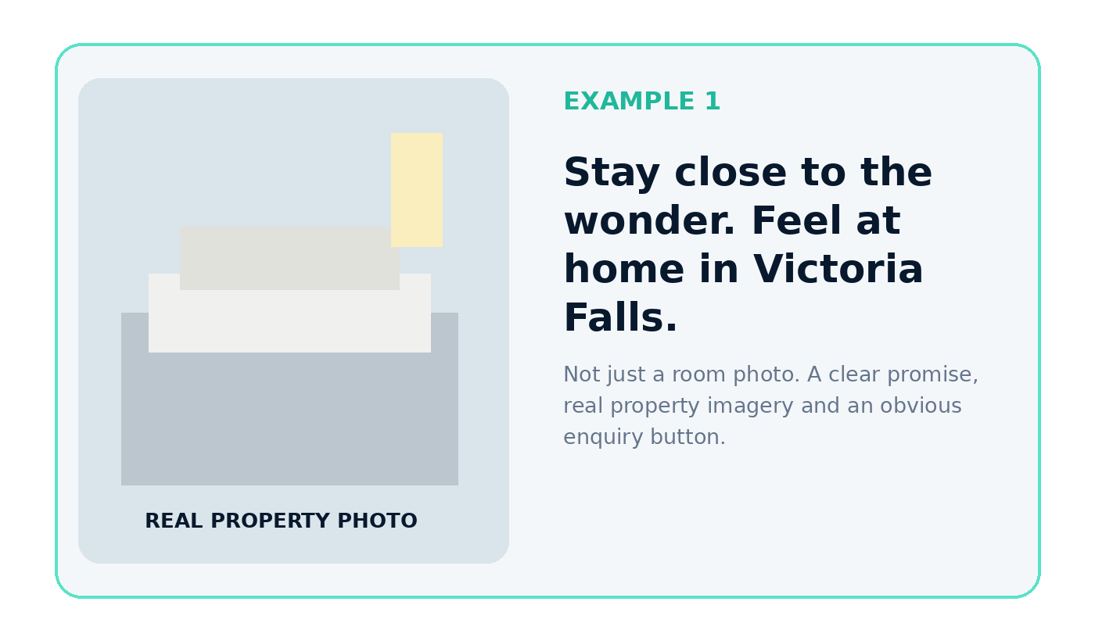

What you can say
“Instead of only posting a room and saying ‘book now’, we can communicate why somebody should choose Mzilikazi, answer the questions they are already asking, and then make the next step easy.”

Headline examples you can relate to Mzilikazi
- Stay close to the wonder. Feel at home in Victoria Falls.
- Your Victoria Falls stay should feel simple before you even arrive.
- More than a place to sleep — a comfortable base for your Victoria Falls experience.
- Planning Victoria Falls? Start with a stay that gives you the information you need before you book.

Example educational content
Post idea: “First time visiting Victoria Falls? Here are 5 things to know before choosing where to stay.” Mzilikazi can then explain location, transport, self-catering, nearby activities and how guests can ask the team for help.

3. Show what “digital presence” actually means
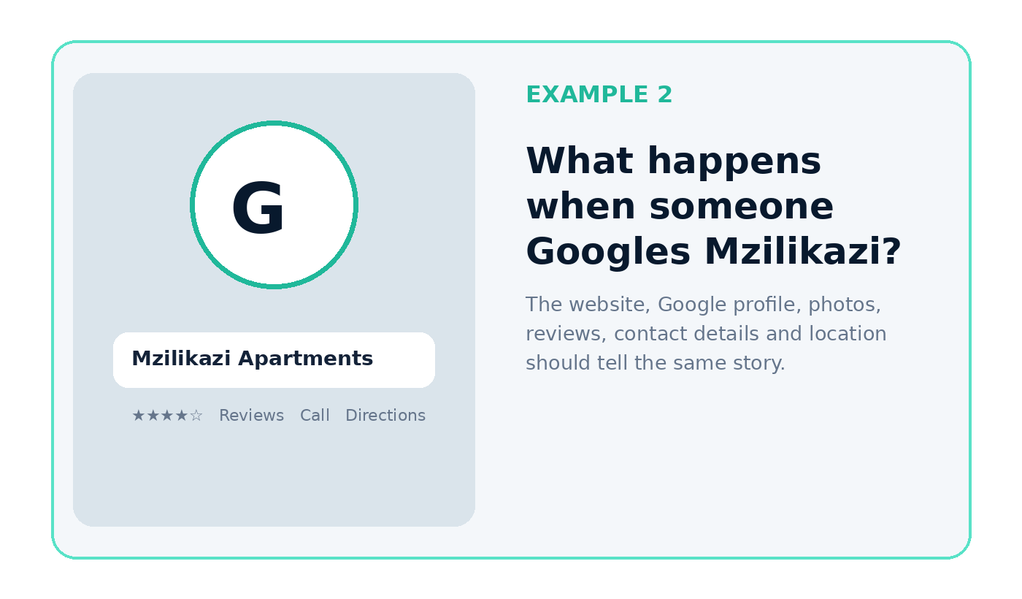

What you can say
“Imagine I hear about Mzilikazi from a friend and Google the name. The impression I get from Google, the website, Facebook, Instagram and WhatsApp should all make me more confident — not give me different names, old photos or incomplete information.”

Examples of what Nhanelo would improve and maintain
- Google Business: correct name, location, phone number, photos, services, website link and reviews.
- Website: current room information, real photos, rates or enquiry guidance, experiences, FAQs and clear calls-to-action.
- Facebook / Instagram: useful accommodation and Victoria Falls content that builds trust over time.
- WhatsApp Business: greeting, quick replies, room information, location, booking questions and follow-up.
- Reviews: ask satisfied guests for reviews and make those reviews visible across the customer journey.

A concrete example
A guest sees a Reel: “7 activities most first-time visitors do in Victoria Falls.” The caption links to the Experiences page. The page explains each activity and ends with: “Want something else? Talk to our team.” The guest then taps WhatsApp. That is one connected journey rather than three separate marketing activities.

4. Show how enquiries can become easier to convert
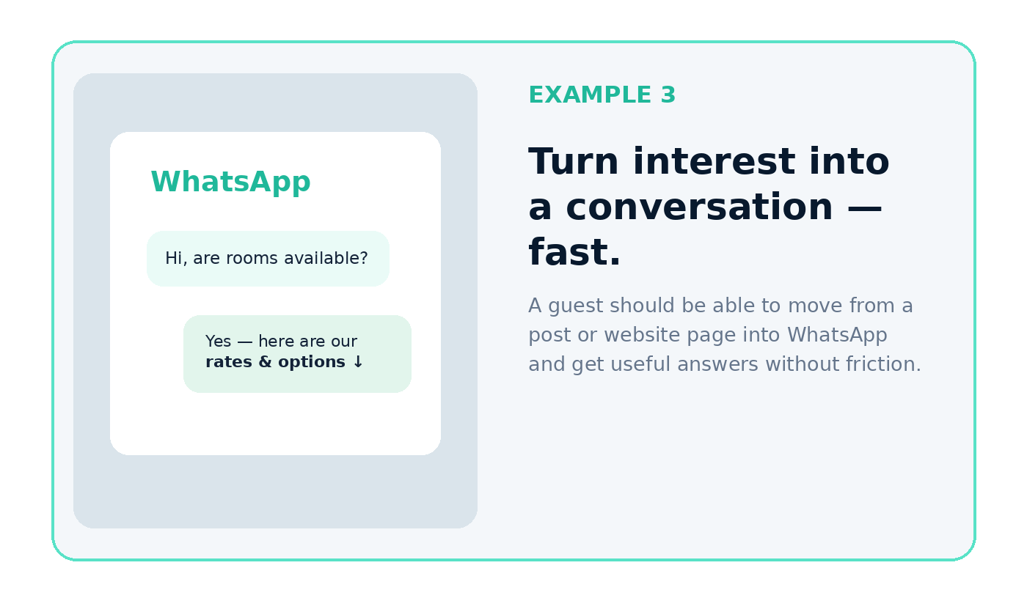

What you can say
“The job is not finished when somebody sends a message. We also need to make it easier to answer quickly, follow up and move the guest toward a booking.”

Example WhatsApp flow
- Guest: “Hi, do you have rooms available from 12–15 December?”
- Mzilikazi: quick acknowledgement + asks number of guests.
- Send room option, relevant photos, rate and what is included.
- Offer useful extras: airport transfer, activities or local guidance where applicable.
- If the guest does not reply, follow up politely rather than losing the enquiry.
- After checkout, request a Google review.

The commercial point
You are not selling “posts”. You are helping Mzilikazi reduce the gap between online interest and an actual conversation or booking.

5. A simple three-month picture
Period | Focus | What she should see
Month 1 | Foundation | Google / social / WhatsApp cleanup, real information, photography priorities, website completion, tracking setup.
Month 2 | Proof + consistency | Regular content, project/property proof, reviews, educational posts, website updates and enquiry improvements.
Month 3 | Measure + improve | Review what attracts enquiries, improve weak points, strengthen high-performing content and build a repeatable routine.

Questions to ask her during the conversation
- Where do most guests currently hear about Mzilikazi?
- What questions do guests ask most before booking?
- How many enquiries come through WhatsApp, calls or booking platforms?
- Which type of guest do you most want more of?
- What makes guests choose Mzilikazi when they do book?
- What happens today when someone enquires but does not book immediately?

Close the conversation like this
“What I am proposing is that we do not finish the website and then leave it on its own. For three months, we work on the full presence around it — the information, Google, social media, WhatsApp, proof, reviews and enquiry journey — then we can actually see what is helping Mzilikazi generate interest and bookings.”
Do not lead with price. First make sure she sees the difference between building the website and actively managing the digital presence around it.

