The source for this code can be found here:

<https://github.com/masters3d/AntSieve>

Please change the default password in the dockerfile before building:

`ant-dev:devPassword`

* Inclusion of files adequate to perform ‘docker build’ – demonstrate portability

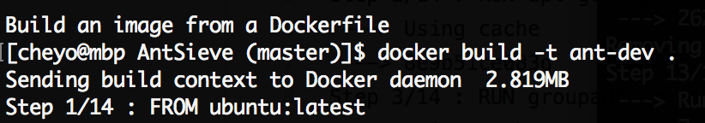

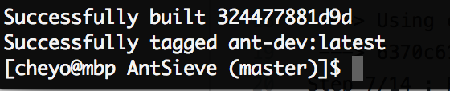

See full log here:

<https://gist.github.com/masters3d/3dff2b140f286708e9065d0f2d49900c>

* Show start control of the container – demonstrate control of the infrastructure

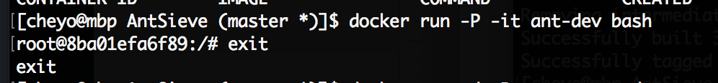

You can run the container on the foreground and once you are done you can exit. For this project we are going to run the container on the background.

* Results of ‘docker ps’ – demonstrate existence of the container.

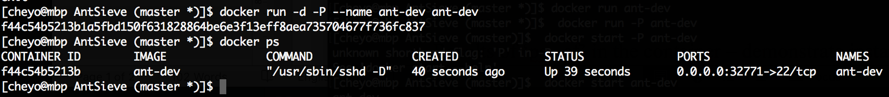

* Start SSH session with container on port 22.

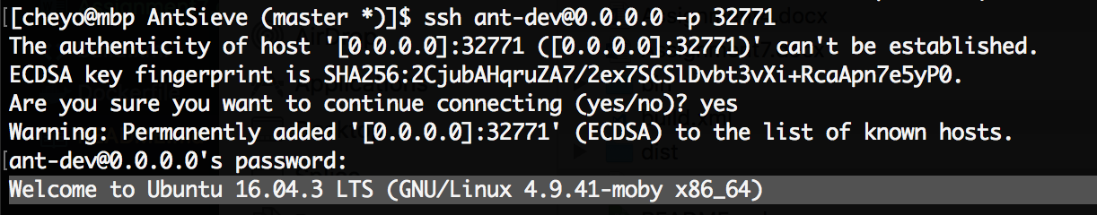

Under ports you need to get the outside IP and Port:

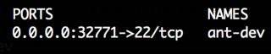

* Results of ‘ps –ef’ in the container – demonstrate instantiation.

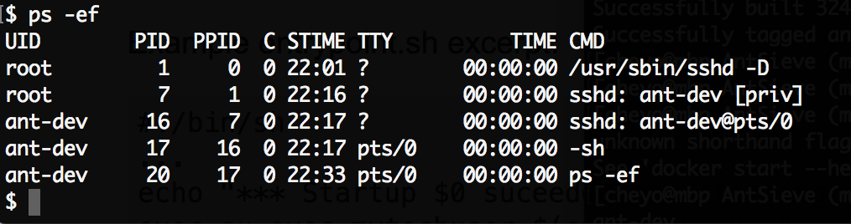

* Demonstration of the primes – demonstrate a working application

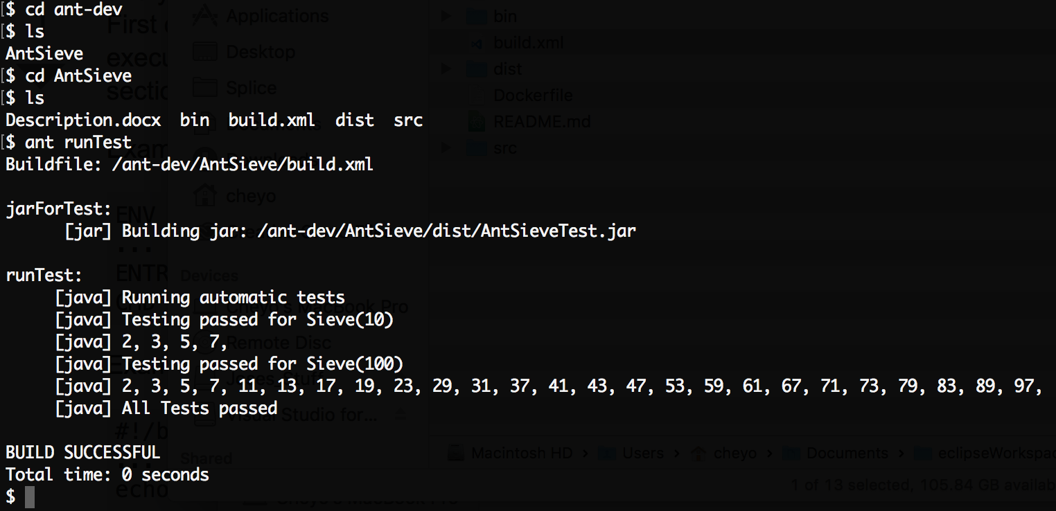

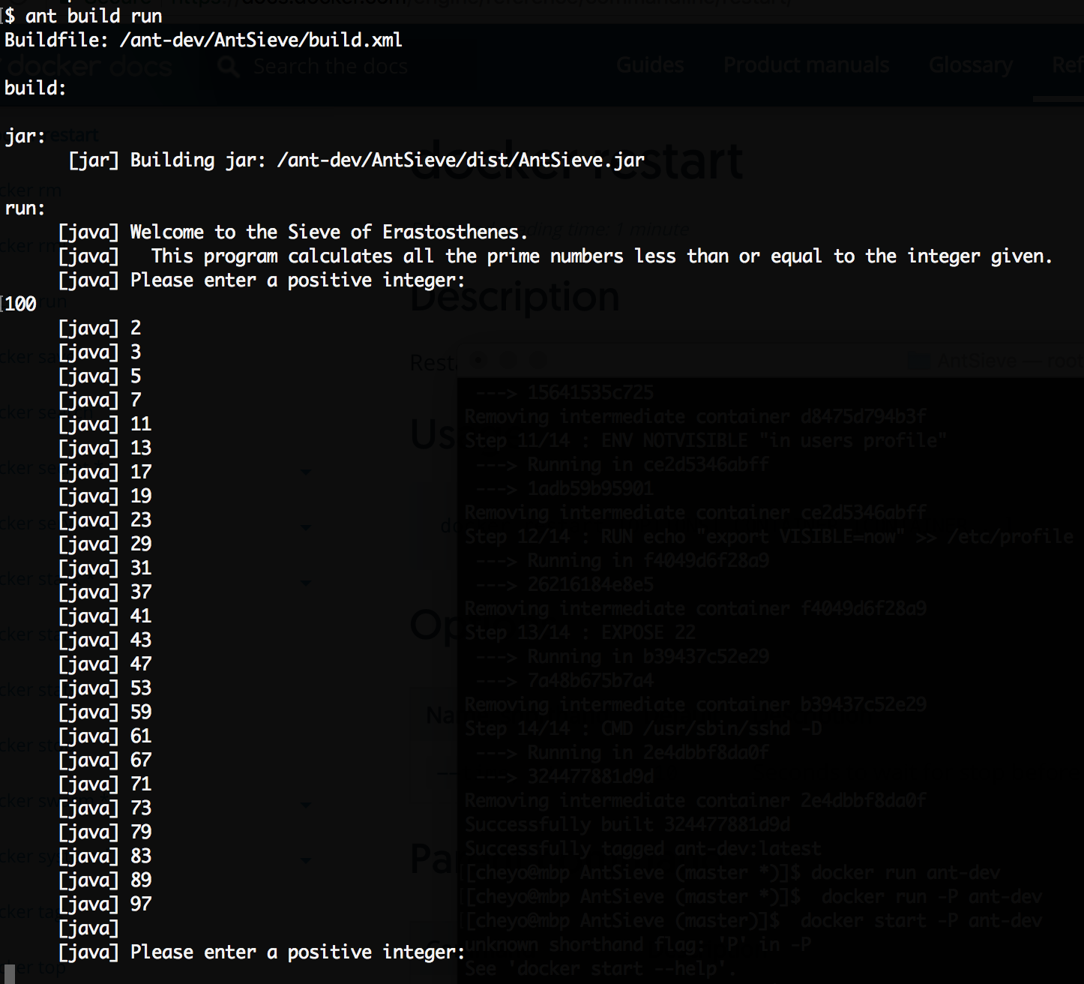

* Show stop control of the container – demonstrate control of the infrastructure

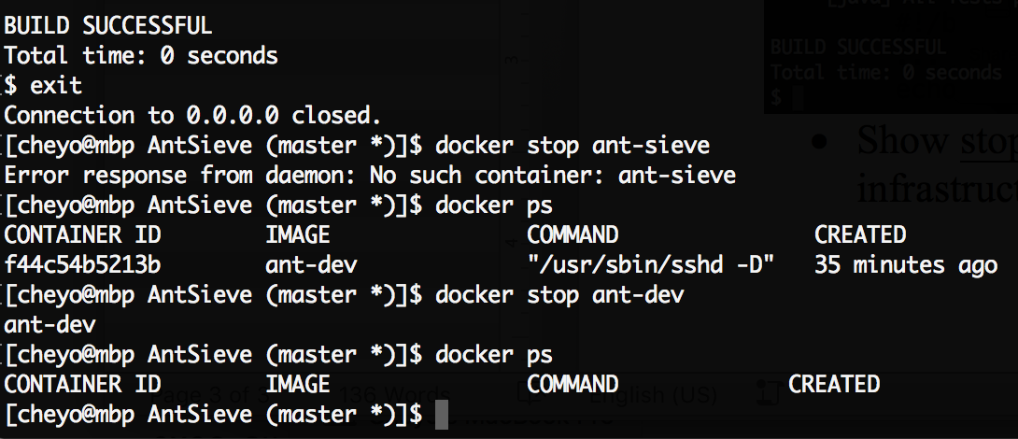

* Show restart control of the container – demonstrate control of the infrastructure

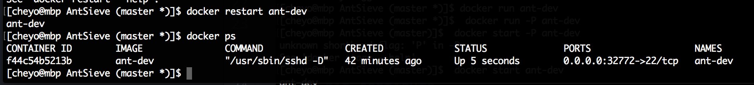

**References Accessed Sept 18th 2017**

[Run Docker Image]

(https://stackoverflow.com/questions/18497688/run-a-docker-image-as-a-container)

[Fix git configure permission]

(https://confluence.atlassian.com/stashkb/permission-denied-on-git-config-file-314447088.html)

[Add an SSH port]

(https://docs.docker.com/engine/examples/running_ssh_service/#build-an-eg_sshd-image)