* Create a program in Java.

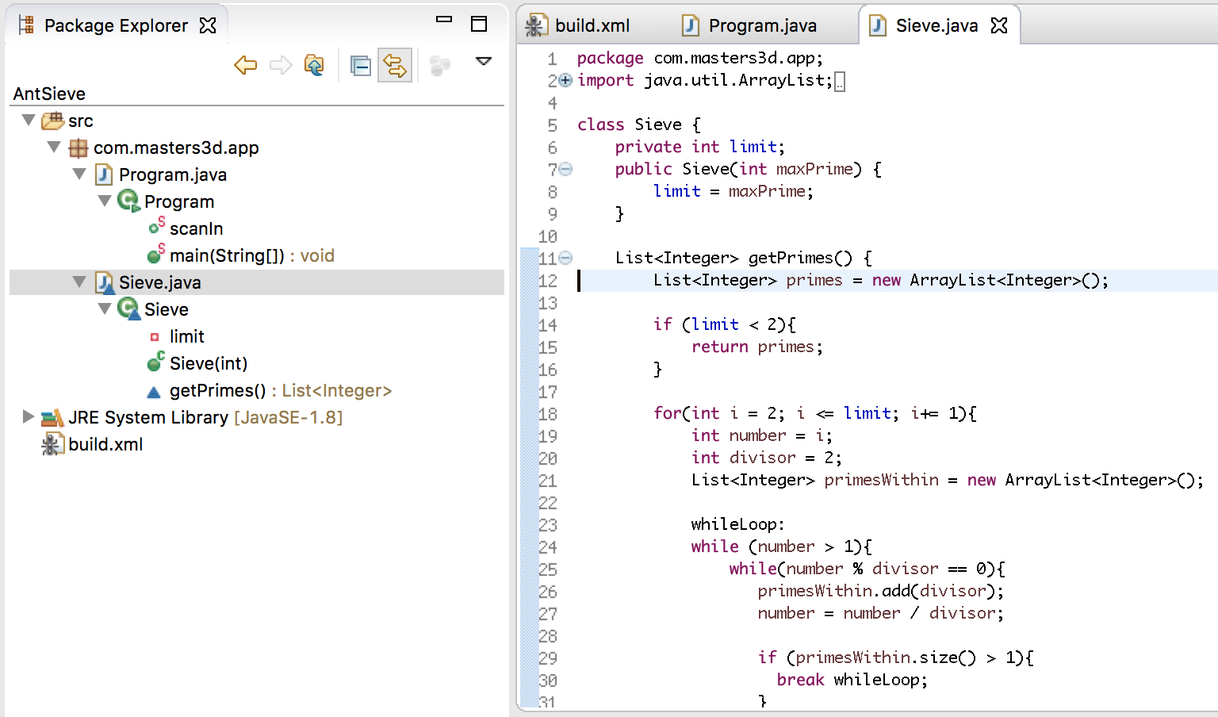

* Create a build.xml file.
* 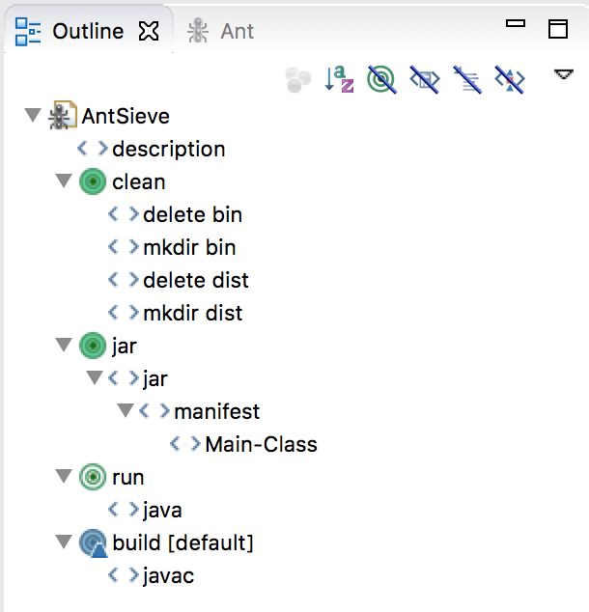
* Demonstrate that the Ant Editor was used to create the build.xml file.

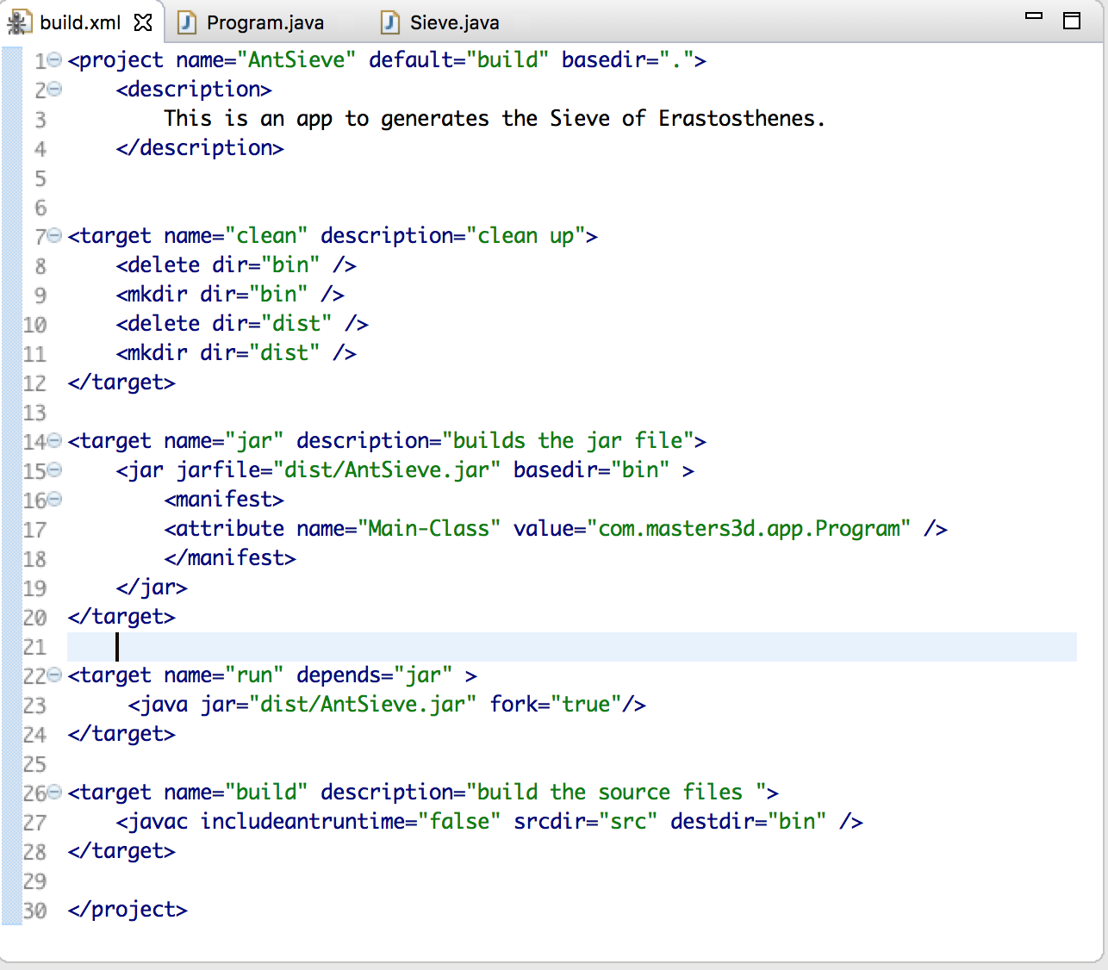

* Demonstrate that the Ant commands work correctly.
* 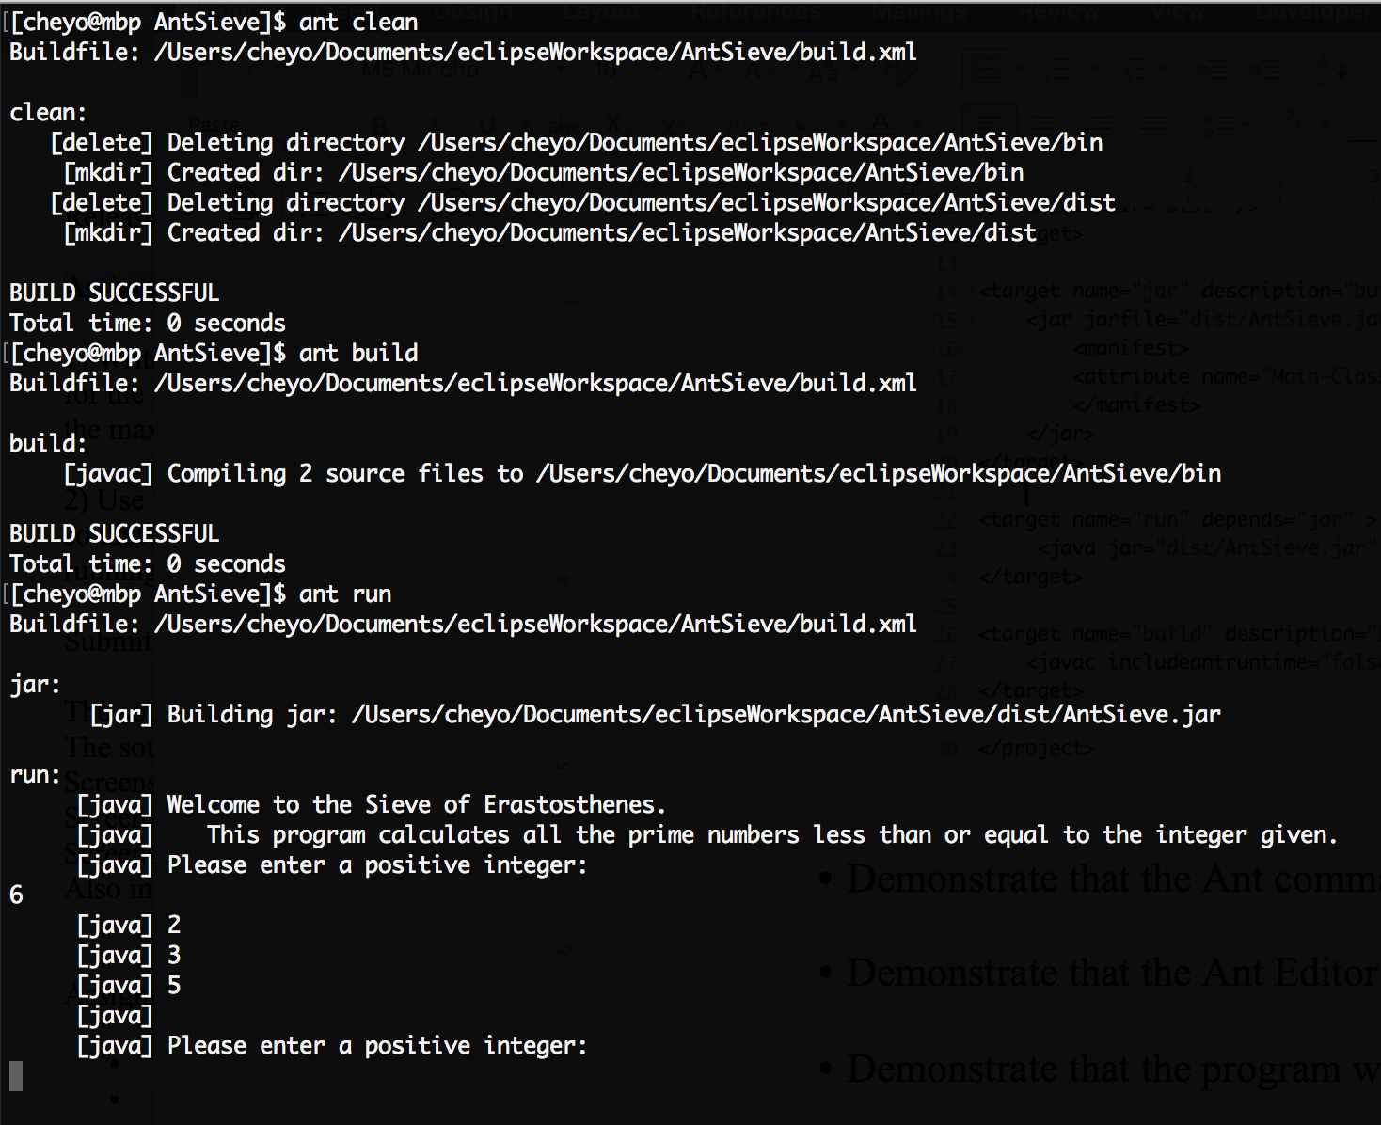
* Demonstrate that the program works as intended.

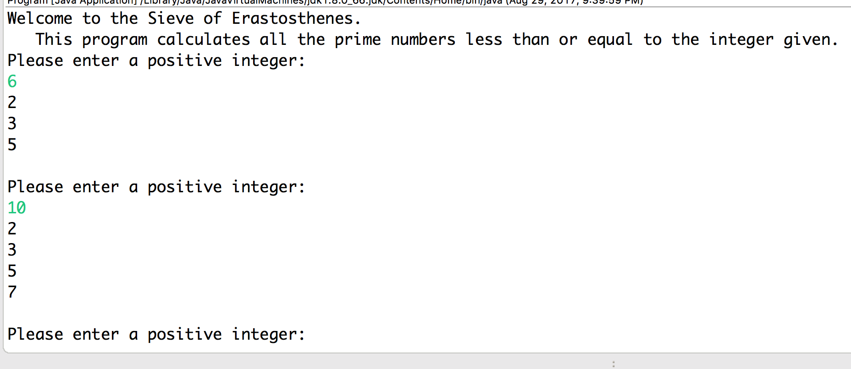

References:

<https://www.mkyong.com/ant/ant-how-to-create-a-java-project/>

<https://ant.apache.org/manual/tutorial-HelloWorldWithAnt.html>

<http://www.vogella.com/tutorials/ApacheAnt/article.html>