Log into google dashboard [here](https://console.developers.google.com)

Click on Create Project on Right hand side or click [here](https://console.developers.google.com/projectcreate)

Give the Project a name and click Create

Now click on API library

When on the API Library search for YouTube data api v3 and click on it.

Click Enable

Click the Create Credentials.

Choose the following options stated in the image below.

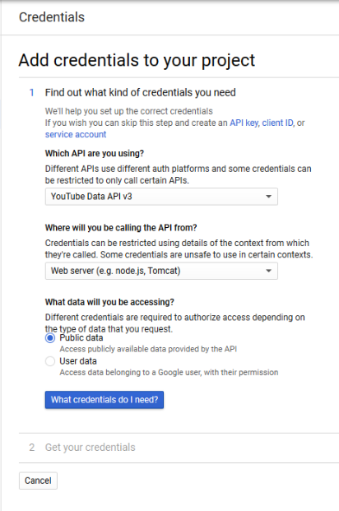

Click the what credentials do I need ?

You will now get an API key. Copy to a notepad and click done