Log into Amazon AWS [here](https://aws.amazon.com/), if it is your first time create an account.

In your main page, set your region to N. Virginia (America) or Ireland (European users).

Next, click on Lambda under All services

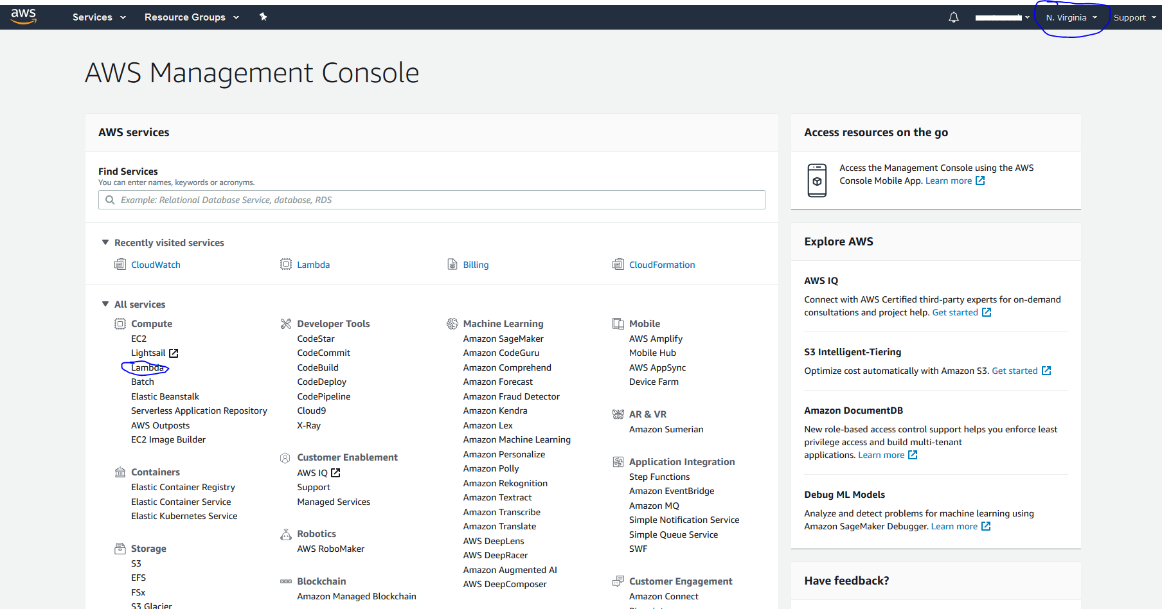

Click on Create Function

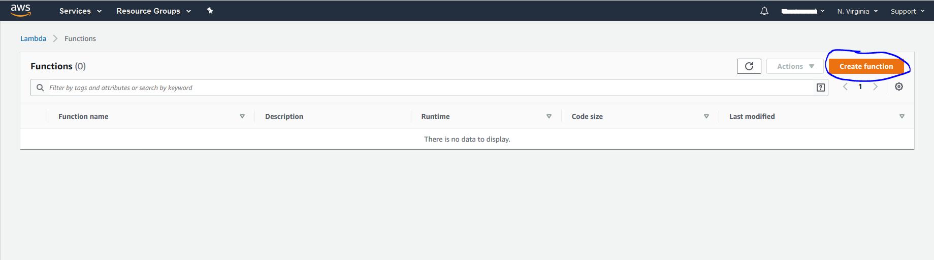

Select the Browse serverless app repository and click alexa-skills-color-expert-python (you can search for "alexa" to find it.

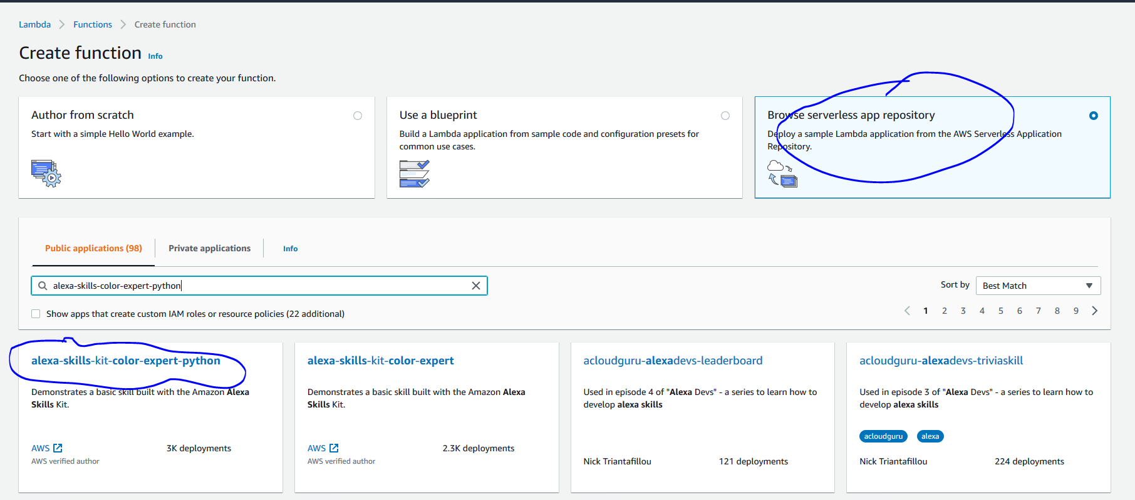

Give the TopicNameParameter a name and then click Deploy

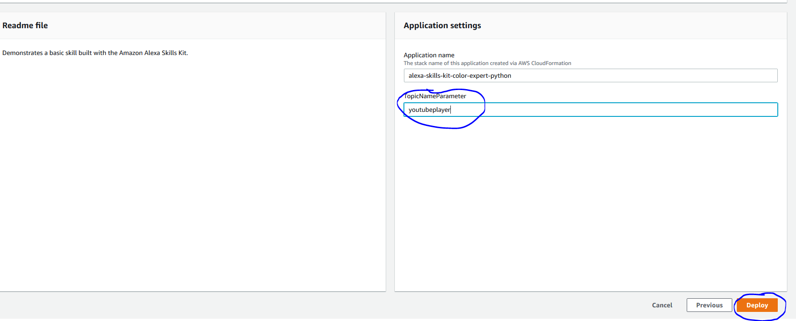

On the left menu click on Functions

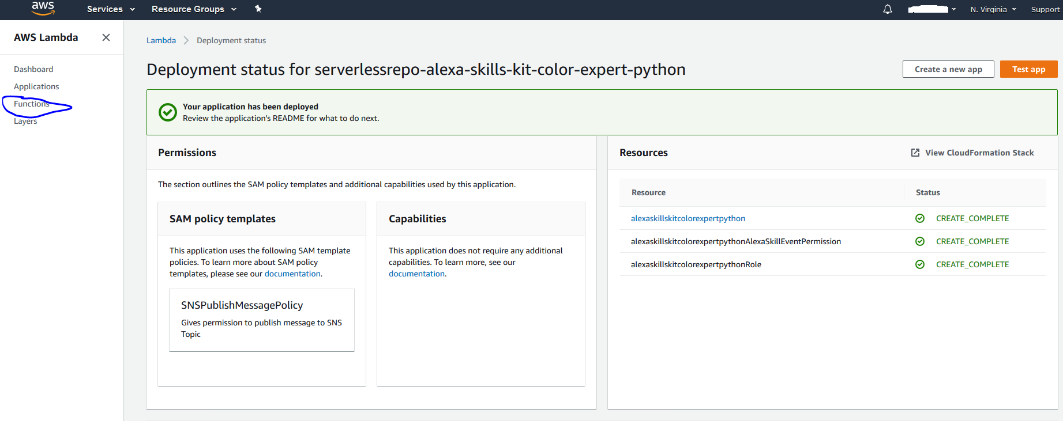

Then click on the function that was just created

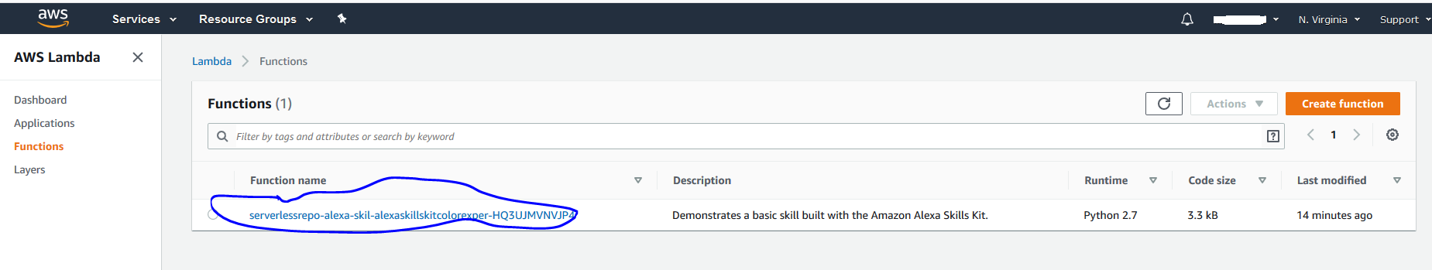

Click add trigger and select Alexa Skill Kit. Under skill ID verification select disable and click Add

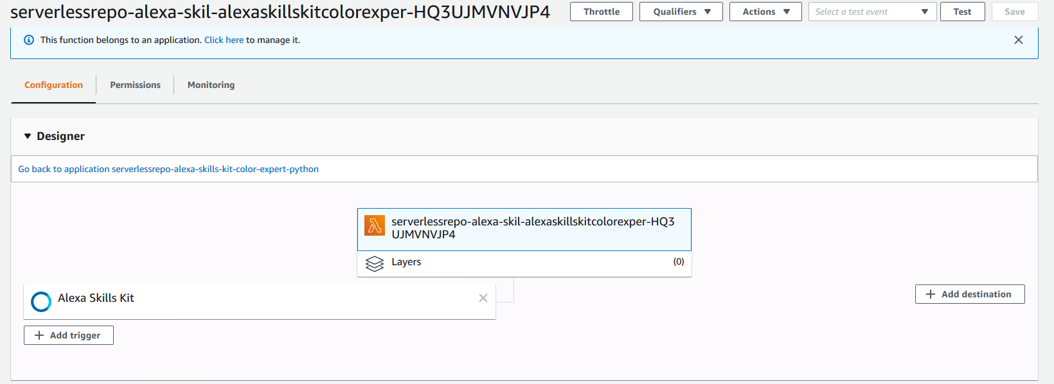

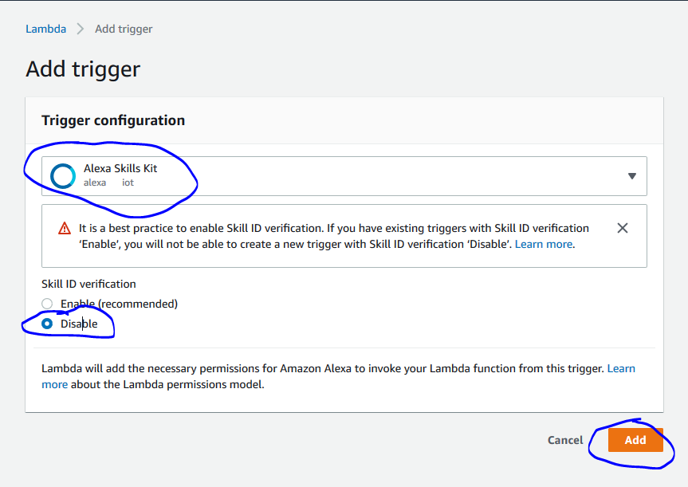

Click back on the function name as soon below to make sure it is selected

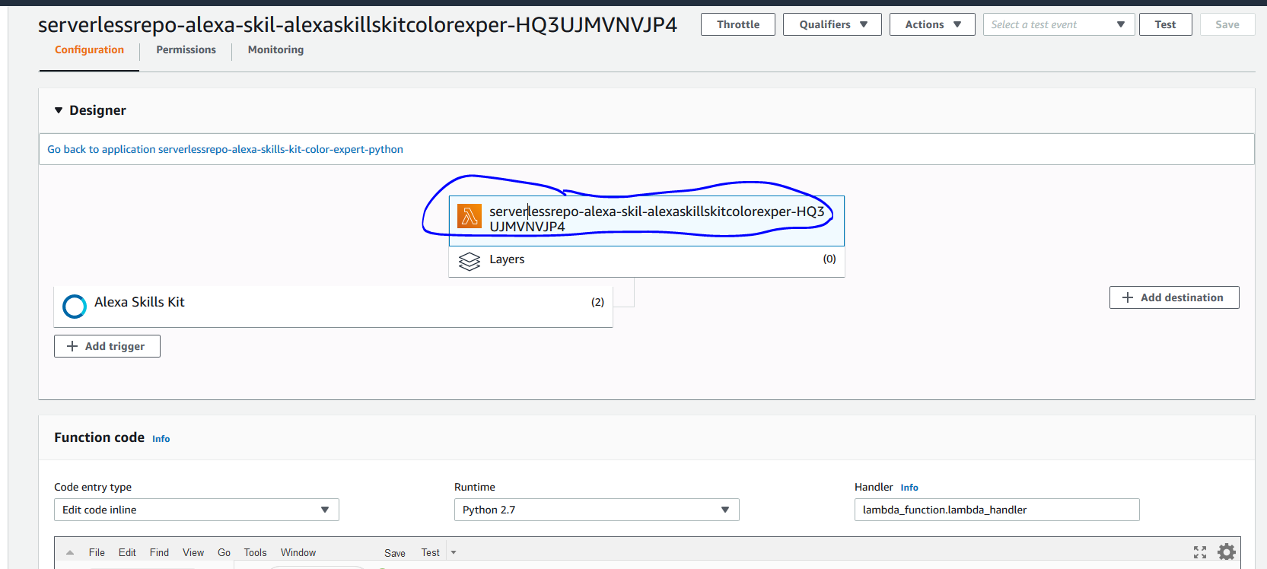

You will need to upload the ZIP file containing the code for the YouTube skill to Lambda. To do that, select Code entity type to "Upload a .ZIP file" and click on the Upload button. You will need to have downloaded the ZIP file called lambda_function.zip from this link: <https://github.com/masterzad/Alexa-Youtube>

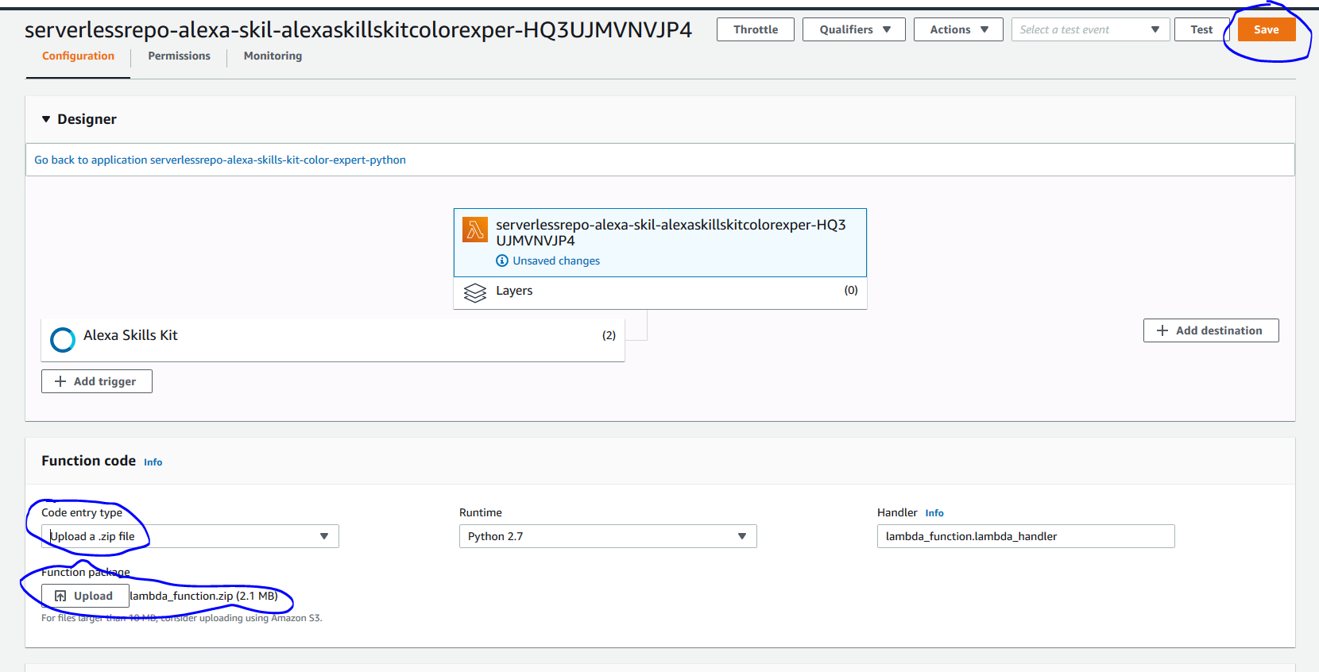

Next we click on Manage Environment Variables and Add environment variable

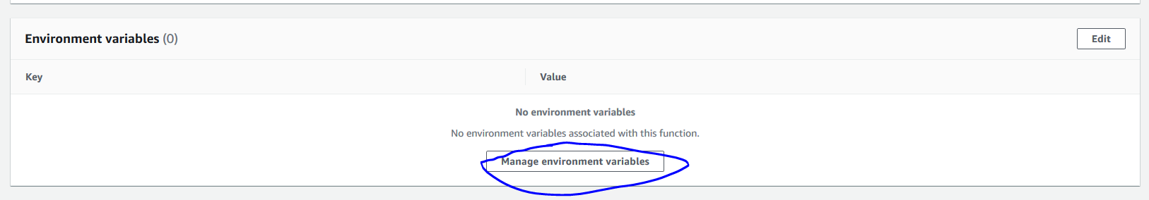

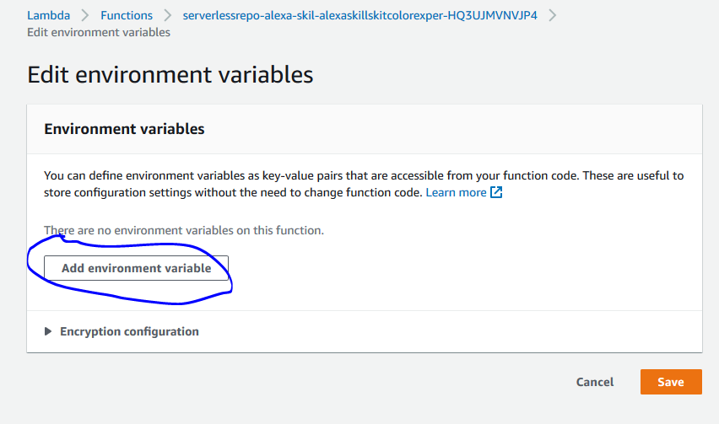

You need to add 2 environment variable.

The first needs to be called "DEVELOPER_KEY" and value should be your Google YouTube API Key

The second is recommended and needs to be called “youtube_dl” and the value should be “true”

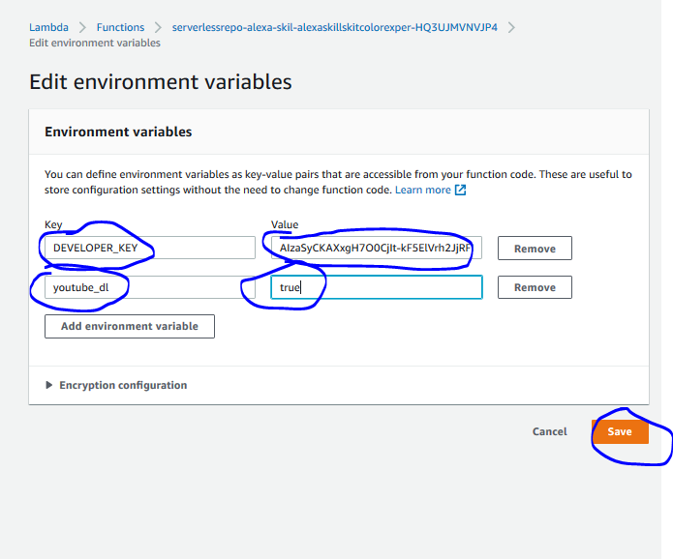

We need to edit the basic settings

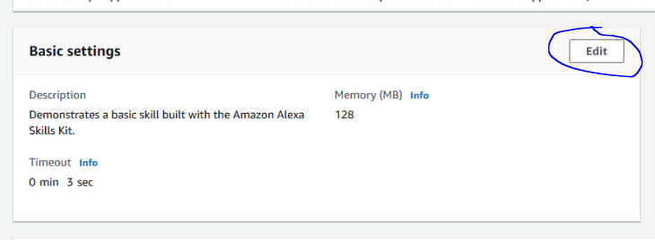

Select memory as 512MB, Timeout 10sec

Create a new role from AWS policy templates

Give the Role any name and select the Basic Lambda@Edge Permissions (for CloudFront trigger)

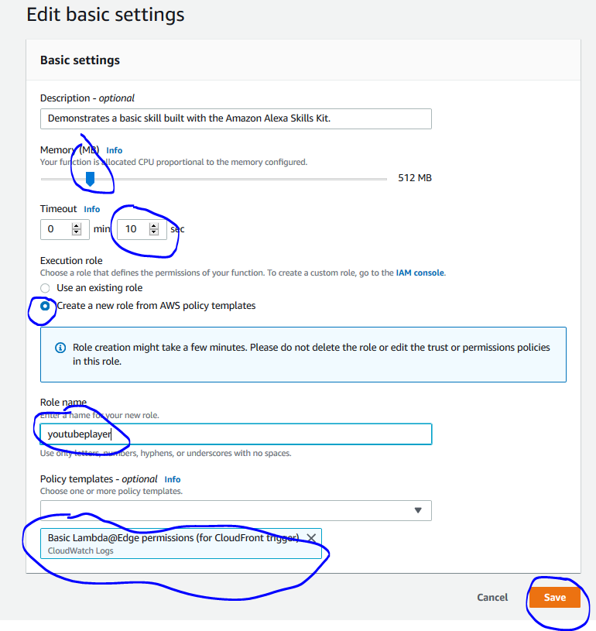

Now click Save and Copy the ARN name at TOP.

