**University of sulaymaniyah**

**College of science**

**Computer department**

**Forecasting the rate migration**

**in kurdistan**

Prepared by:

Sana Dara Ali

Sozyar Osman Ali

Saya Kamil Karim

Kani Hawre Mahmud

Mastan Faiaq Muhamad

Table of Contents

1. Introduction ………………………………………………………………….………..3
2. The problem ……………………………………………………………….………....4
3. Solutions …………………………………………………………………………...…..5
4. About dataset …………………..…………………………………………………...6
5. Result …………………………………………………………………………………….7
6. Some method and library used to Represent result ……………….7

6.1 – Library …………………………………………………………………………..7

6.2 - Method …………………………………………………………………………8

7- Conclution ……………………………………….……………………………………10

8-Reference ………………………………………….…………………………………..11

1-Introduction: -

Our project is about the migration of migrants to countries outside of Kurdistan.

Human migration can be defined as the transfer of human beings from one geographic region to another with the aim of achieving sustainable or temporary stability. Human migration may be individually or collectively, in some cases families move entirely from one region to another. Immigration from one country to another is carried out in accordance with international treaties and conventions at some point until human rights principles are violated.

and refugee is someone who has left their home and does not have a new home to go to. Often refugees do not carry many possessions with them and do not have a clear idea of where they may finally settle.

There are many types of human migration that occur all over the world , individuals are constantly migrating from one region to another due to a variety of factors, circumstances and variables that cause the distribution of migration types.

Individual migration :- is the migration of an individual from one geographical region to another.

Mass migration :- is the migration of families and communities from one geographic region to another.

Internal migration :- is the migration caused by the migration of individuals or groups from one region to another within the geographical boundaries of a particular state.

External migration :- is the migration that is transmitted during the transfer of individuals or groups from a territory of a state to a different state.

Voluntary migration :- is the type of migration that individuals or groups do according to their will to change their place of residence in order to achieve stability in another area outside or within the country.

Forced migration :- is the type of migration of individuals or groups in accordance

with the circumstances and events that occur and forces them to change their places of residence in order to achieve stability in an area outside or within the country.

There are many reasons that motivate individuals and groups to migrate and leave the place where they used to be stable، and these factors highlight the type of migration and motivations that cause individuals or groups to consider changing their place of residence in a country or region of a country، here are the most obvious reasons for human migration:

Economic factors:- Economic factors include the search for new jobs and improving living standards than is available by moving to a different area outside or within the country.

Political causes:- political disruptions and wars that force individuals and groups to seek safer and more stable areas outside or within the country.

Social factors:- whether there is an abuse of religion or ethnicity or racism، this leads individuals and groups to seek a better area with some form of social justice.

Natural causes :- are natural disasters that occur in cities and towns that cause semi-destruction or complete destruction, such as earthquakes, storms and volcanoes.

2-The problem: -

The problems in our project and we tried to solve it through the tools and methods that we used, we can say that these are the reasons that make migrants leave their homeland and visit countries outside Kurdistan for life.

Unemployment:- Unemployment and lack of employment opportunities in the private sector are the main reasons for the migration of young people out of the country and the employment of a large proportion of university and institute graduates.

Creating employment opportunities for foreigners:- This will reduce employment opportunities for people in the ruling or private sector.

Political factors:- political instability, political complexity, poor democratic status, poor form of government war, internal complexity، and lack of political freedom, which, as a result, force individuals to flee their country and seek a more suitable, safe, stable and peaceful place, or to find a place to govern freely under a democratic authority.

Economic factors:- Economic instability and lack of economic justice ,for example, the current situation in the region, where salaries are not distributed on time, encourage individuals, groups and families to seek an alternative mechanism that provides them with new employment opportunities and a better economic life, by moving from their homeland to another region، whether inside the country or abroad.

Social factors:- They find themselves in the presence of national and religious abuse, or from the continuing phenomenon of racism, which causes individuals and groups to seek a better and more suitable place to live، including social justice and human rights principles.

Lack of a good education system:- The education system is very important in any country because it determines the future of the country but there is no good budget in our country which makes people resort to other countries where the level of education is at a high level.

Non-provision of market freedom:- Party interference and private interference in the private sector and small businesses to work and stand on their own feet and work.

3-Solutions:-

* Improving the economic situation of the country in a realistic and scientific way.
* Establishment of university graduates and institutes and creating job opportunities for them especially in the official institutions and government sectors of the country.
* Taking advantage of youth's abilities and participation in the political governmental and economic arenas، in order to take advantage of their strength and skills in order to advance the development of society's infrastructure.
* To provide housing to low-income citizens and renters and those who are newly married by forcing the government to provide for companies to provide apartments without advances or long-term loans so that everyone can benefit.
* Rapid improvement of basic services such as water electricity education and health.
* Providing freedom of the market so that the private sector and small businesses can work away from party and private interference and stand on their own feet and work.
* Strengthen and reform the education sector in a way that can create creative and capable students. In the public and private sectors he can serve and find himself.
* To provide a democratic atmosphere in the Region، in which the citizens feel at least confident in their own dignity, justice ,stability, and security and feel that their rights and freedoms are protected, in order to build and restore the trust of the people of the Region to their homeland and land.
* Ensure the political stability and peace of the country.

4-About dataset: -

We have collected data on the migration of migrants to the areas outside Kurdistan، the data collected by people inside Kurdistan with people who are Kurds living outside Kurdistan. Based on the data we have collected، we have tried to determine a suitable route for our data collection.

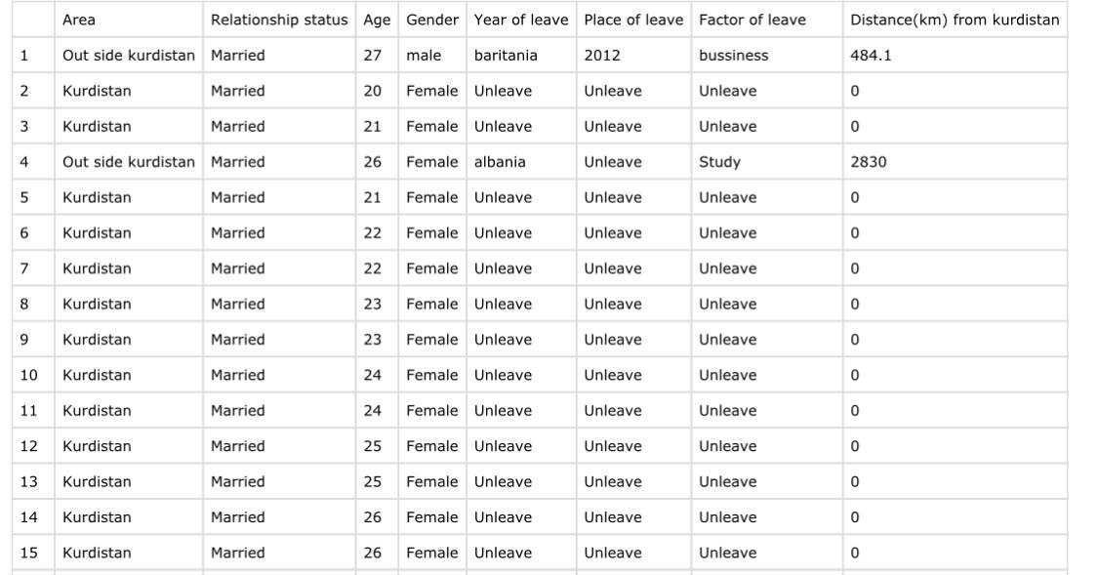

5-Result:-

as a result of this data set that we have collected, the work we have done on it using a set of models to design our data set has resulted in a number of results:

* As the rate of marriage increases، the rate of migration decreases.
* Even as the economic situation in Kurdistan is bad, it reduces the rate of migration.
* Until war and conflict in Kurdistan The rate of migration has increased.
* One of the models we used for Colum We used age people who had an increase in immigration between the ages of 20 and over the age of 40.

6-Some method and library used to Represent result :-

6.1-Library:-

import numpy as np

import pandas as pd

import seaborn as sns

import matplotlib.pyplot as plt

import scipy.stats as st

sns.set(color_codes=True) from sklearn.model_selection

import train_test_split from sklearn.preprocessing

import StandardScaler,OneHotEncoderfrom sklearn.metrics

import accuracy_score,classification_report

from sklearn.compose

import ColumnTransformer from sklearn.pipeline

import Pipeline from sklearn.linear_model

import LinearRegressionfrom sklearn.metrics

import mean_squared_error

6.2-Method :-

# Read data from CSV file

data = read_csv('last-data.csv')

# Plot histogram

data.plot_histogram(figsize=(20, 10))

# Plot distribution plot for 'Age'

sns.plot_distribution(data['Age'])

# Generate random values using skewnorm

random_values = skewnorm_random_values(shape=10, size=500)

# Create a subplot

subplot = create_subplot()

# Calculate and print variance

variance = calculate_variance(data)

print(variance)

# Calculate and print standard deviation

std_deviation = calculate_standard_deviation(data)

print(std_deviation)

# Concatenate arrays

concatenated_array = concatenate_arrays()

# Check for missing values

missing_values = check_missing_values(data)

print(missing_values)

# Split data into training and testing sets

x_train, x_test, y_train, y_test = split_data(x, y, test_size=0.33, random_state=0)

# Create a numeric transformer using StandardScaler

numeric_transformer = create_standard_scaler()

# Create a pipeline with preprocessor and model steps

pipeline = create_pipeline(preprocessor, model)

# Fit the pipeline on the training data

pipeline.fit(x_train, y_train)

# Make predictions on the test set

y_pred = pipeline.predict(x_test)

# Calculate mean squared error

mse = calculate_mean_squared_error(y_test, y_pred)

print(mse)

# Make predictions on new data using the trained pipeline

new_data_predictions = pipeline.predict(new_data)

7-Conclusion:-

If this phenomenon is not solved it will be destroyed by the government because leaving their homeland with the hope of "young" will be destroyed. Because every young person is the founder of the future of society and the protector of our homeland and the survival of the nation. Leaving the country is not the first time to leave the country. Those who leave Kurdistan have not been tested elsewhere migrants are not going anywhere، they are returning from their home country and arriving in one place، and this resistance stems from the dissolution of society where citizens no longer have any social ties. Examples of things that bind people to society are: work, economy, language and culture ,role in society and security.

It is the duty of the Kurdistan Regional Government, despite all the obstacles and challenges, to make serious efforts to eliminate the causes of youth migration abroad through political، economic and security stability, creating job opportunities, eliminating hunger poverty, unemployment ,persecution, disrespect, and eliminating inequality, corruption, etc. etc. Therefore, if these steps are not taken، the future of our Kurdish community in this region will face a serious threat on the one hand due to the migration of Kurdish youth to outside Kurdistan and on the other hand، the migration of The Arab citizens of southern and central Iraq to the region their residents their ownership and their permanent residence.

8-Reference

Get data by sharing a Google Sheet for peoples to answer specific questions

[https://www.britannica.com](https://www.britannica.com/topic/immigration)

<https://www.quora.com>

https://www.brookings.edu