Google Merchandise Store: Marketing Metrics and Analysis

Name

Professor

Course Code

Sunday, 10 May, 2020

Table of Contents

1.Introduction

2.Web-Accessibility and UX Analysis

3.Social Media Comments/Textual Analysis

4.Quantitative Analysis

5.Qualitative Analysis

6.Synthesis of Findings

7.Recommendations for Marketing Strategy

References

**Introduction**

Google Merchandise Store currently stands at a profit margin of approximately £48,000 per year and sells virtual reality, electronic devices, clothing, as well as Google paper products (Angell & Kraemer, 2017). This report will include a web-accessibility and UX analysis, a social media comments analysis, as well as a textural analysis, a quantitative analysis, a qualitative analysis based upon introducing the mixed methods concept to this report, and synthesis of findings and recommendations for marketing strategy (Azizi & Hu, 2019, June).

**Web-Accessibility and UX Analysis**

This section of the report will first discuss web-accessibility, followed by an UX analysis (Banerjee, Xu & Johnson, 2020; Blank & Dorf, 2020).

With 15% of the world’s population having a disability, creating the Google Merchandise Store as a highly-functional website that is user-friendly to those people with disabilities is an untapped market that has strong potential for Google Merchandise Store to achieve its financial potential as a business (Banerjee, Xu & Johnson, 2020). To define disabilities further, a disability is not always a physical one (Banerjee, Xu & Johnson, 2020). A disability can also be having a poor Internet connection and the inability to access the Google Merchandise Store due to the location where a user would be in the world, such as place as Africa and India, where are many times when Internet connection is slow and there are not many landlines, resulting in many people using mobile devices with poor visibility components (Blank & Dorf, 2020). This would then be known as a socio-economic disability (Blank & Dorf, 2020). There are also those people with mental challenges where the content which exists on a website is challenging and/or puzzling to them, which mean that it is also vitally important that the information on a website be extremely clear and easy to understand (Blank & Dorf, 2020).

**UX Analysis**

After analyzing several players in retail industry , to create an authentic experience through the shopping experience we have identified several key factors ,these are several components which make the online experience of shopping

* Home / landing page
* Menu & navigation
* Search
* Category / product
* Conversion
* Form optimization
* 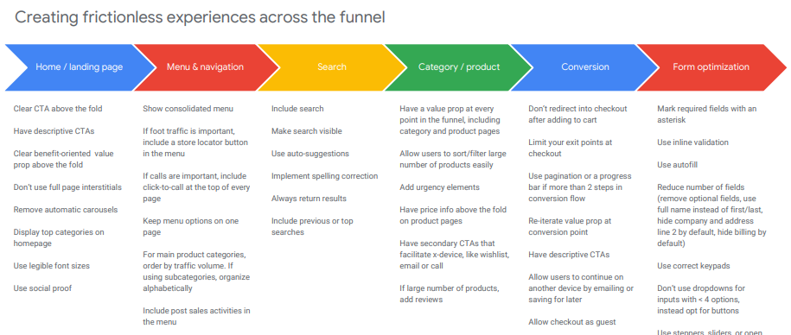

Comparison of several retail websites for Home and Landing Page

|  |  |
| --- | --- |
| Clear CTA: Search  (Boots.com)  ❏ Clear Value proposition: 1) order today, collect tomorrow  ❏ Consolidated menu with cheeseburger and truck  ❏ Location icon to drive foot traffic  ❏ Top categories on homepage  ❏ Legible font sizes  ❏ No revolving carousels  ❏ No full page interstitials | Boots W |
| Categorization  ❏ Consolidated nav bar with simple to discover menu  ❏ Clear, simple to discover CTAs  ❏ Benefit oriented worth prop - '$95/pair'  ❏ Top categories/ways people would shop- - Sunglasses/eyeglasses,  men/women  ❏ Has other key actions like discover a location, find out more  ❏ Has key contact information at the bottom of the page |  |
| Consolidated menu with cheeseburger and truck  ❏ Menu options kept on single page  ❏ Post deals actions like 'Register' and 'Signin' are incorporated above  the fold in menu  ❏ Initial categories ordered by traffic volume  ❏ Subcategories ordered one after another in order  ❏ Easy to move back  ❏ Bonus: Uses dynamic menu as opposed to expanders |  |
| Consolidated menu with cheeseburger and truck  ❏ Menu options kept on single page  ❏ Post deals actions like 'Register' and 'Sign-in' are incorporated  above the fold in menu  ❏ Initial categories ordered by traffic volume  ❏ Easy to move back or out of menu  ❏ Bonus: Uses dynamic menu |  |
| Search bar is noticeable  ❏ Uses composing suggestions- - both products and categories  ❏ Uses auto-correct for common spelling errors  ❏ Always brings results back  ❏ Shows previous search items |  |
| Search bar is noticeable  ❏ Uses composing suggestions- - both products and categories  ❏ Shows ongoing ventures and patterns  ❏ Shows previous quests  ❏ Uses auto-correct for most incorrect spellings |  |
|  |  |

One of the major points of web accessibility is the colour choice used for a website. Figure 1 shows an exemplar of an ideal of web accessibility colour choices (Blank & Dorf, 2020):

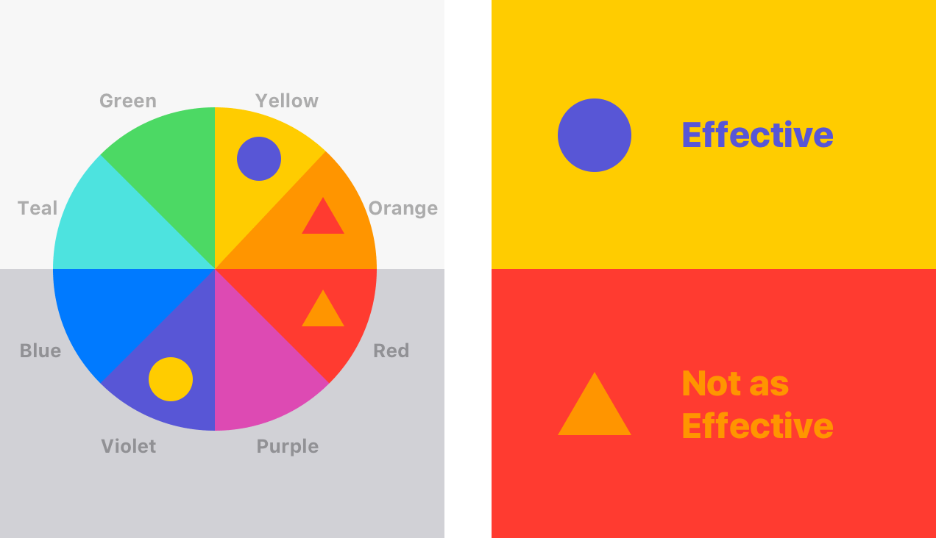

*Figure 1: Ideal Use of Colour Choices for Web Accessibility*

In Figure 1 above, the effective web accessibility colours of yellow and violet are highlighted, the not as effective colours of red and orange are highlighted, and the medium-range effectiveness colours of green, blue, and teal are clearly indicated in the diagram above (Blank & Dorf, 2020).

In Figure 2 below, this is how the Google Merchandise Store looks in terms of its colour scheme (Banerjee, Xu & Johnson, 2020; Blank & Dorf, 2020):

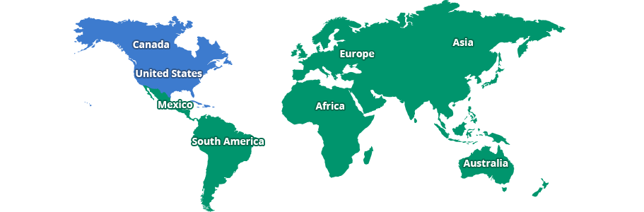

*Figure 2: Body of Google Merchandise Store Homepage*

The image above in Figure 2 is the body of the homepage (Banerjee, Xu & Johnson, 2020; Blank & Dorf, 2020). In Figure 3 below is the header of the homepage (Banerjee, Xu & Johnson, 2020; Blank & Dorf, 2020):



*Figure 3: Header of Google Merchandise Store with Logo*

In Figure 3, the header is displayed in a luminance of different light from the logo which is multi-coloured and utilising the variety of colours available on the rainbow spectrum, as well there is a contrast to the words “Merchandise Store” in order to illuminate the word “Google” (Banerjee, Xu & Johnson, 2020; Blank & Dorf, 2020). In Figure 2, the body of the Google Merchandise Store utilises the medium-accessibility colour acceptances and creates a contrast with the white non-colour lettering in order to make it visible against generally darker colours for the user to choose the country in which they are located to shop from the Google Merchandise Store (Banerjee, Xu & Johnson, 2020; Blank & Dorf, 2020).

It is the suggestion of this report that the ideal colour use of Google’s logo would be to replace the blue colour in the letters “G” with violet, and the red “O” and “E” to blue. This would then have the Google logo transformed into what it is seen in Figure 4 below (Banerjee, Xu & Johnson, 2020; Blank & Dorf, 2020):

**GOOGLE**

*Figure 4: Suggestion of More Web-Accessible Logo for Google*

As you can see by reviewing this paper, the suggestion for a more web-accessible logo for Google in Figure 4 is easier to see than the existing Google logo in Figure 3 with the exception of the size difference (Banerjee, Xu & Johnson, 2020; Blank & Dorf, 2020).

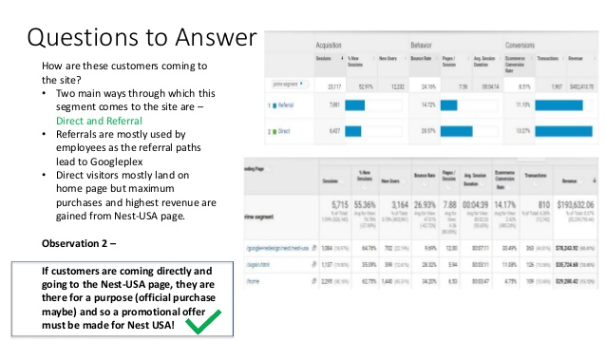

*Figure 5: Google Merchandise Store User Experience Design and Questions for Analysis*

As Figure 5 begins the discussion in this report of the user experience design for the Google Merchandise Store, as it states in the figure, the users arrive at the Google Merchandise Store either directly, or via referral (Banerjee, Xu & Johnson, 2020; Blank & Dorf, 2020). In the online realm, the referral system would most often come from social media networks primarily which will be discussed later in this marketing report (Banerjee, Xu & Johnson, 2020; Blank & Dorf, 2020).

For the users of the Google Merchandise Store who are arriving to the site directly, it would then serve the purposes of this report to know and to understand how the Google Merchandise Store itself ranks within a Google search (Banerjee, Xu & Johnson, 2020; Blank & Dorf, 2020). Figure 6 below indicates the ranking of the Google Merchandise Store in a Google search, and further discussion of the user experience design will follow (Banerjee, Xu & Johnson, 2020; Blank & Dorf, 2020):

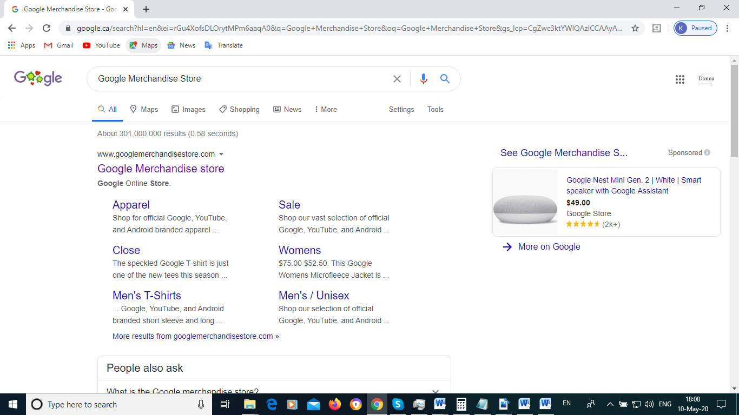

*Figure 6: Google Merchandise Store Google Search Rankings*

As it indicates in the display above, the Google Merchandise Store has more than 301 billion generations in a Google search and is top-ranked for its name (Banerjee, Xu & Johnson, 2020; Blank & Dorf, 2020). This would mean that the Google Merchandise Store would not need to change its name for rebranding purposes (Banerjee, Xu & Johnson, 2020; Blank & Dorf, 2020). It terms of its user experience design based on its name, the rankings are strong and it is an identifiable name to a wide variety of worldwide consumers (Banerjee, Xu & Johnson, 2020; Blank & Dorf, 2020). The question would still remain why is the Google Merchandise Store only earning a profit margin of £48,000 per year with a league of 170,000 clearly brilliant minds who work for the company (Banerjee, Xu & Johnson, 2020; Blank & Dorf, 2020)? We will examine further the user experience design of the Google Merchandise Store.

As the user chooses their country for shipping purposes, the next page which opens up for EU and United Kingdom countries is a pop-up making the user aware that there will be fewer staff on-hand at the Manchester warehouse and there will be delays in shipping (Banerjee, Xu & Johnson, 2020; Blank & Dorf, 2020). Right away, a joyful shopper is hearing bad news (Banerjee, Xu & Johnson, 2020; Blank & Dorf, 2020). The user who is shopping with money at their disposable and wants to purchase fun things is right away hearing bad news (Banerjee, Xu & Johnson, 2020; Blank & Dorf, 2020). It would be no different than a shopper who goes into a store in-person and hears that the store will be closing in five minutes and their pockets are full with money to shop (Banerjee, Xu & Johnson, 2020; Blank & Dorf, 2020). However, the dilemma is that the Google Merchandise Store must include that notification, but, perhaps the placement of the notification is wrong (Banerjee, Xu & Johnson, 2020; Blank & Dorf, 2020). It does assume that a user is definitely going to shop, as well, that the shopper has been to the store before and is a loyal and frequent shopper (Banerjee, Xu & Johnson, 2020; Blank & Dorf, 2020). It is vitally important, bearing in mind that the Google Merchandise Store only makes £48,000 per year of a profit margin that they be constantly seeking to increase the amount of purchasing users for the experience design of their e-commerce site (Banerjee, Xu & Johnson, 2020; Blank & Dorf, 2020).

A suggestion towards improving this element of the user experience would be to have the disclosure of the Manchester warehouse closer to the point when the shopper/user is checking out of the e-commerce store and has selected their items (Banerjee, Xu & Johnson, 2020; Blank & Dorf, 2020). This would increase the amount of users who would continue to follow through with the purchases on the Google Merchandise Store, rather than turn away at a sign at the e-commerce store that there is already a challenge that they must face by shopping with the Google Merchandise Store (Banerjee, Xu & Johnson, 2020; Blank & Dorf, 2020).

This fact that the Google Merchandise Store does not indicate the prices of their items upon the third layer of entering the site as part of the user experience design could be one of the number one reasons why the Google Merchandise Store only makes £48,000 per year (Banerjee, Xu & Johnson, 2020; Blank & Dorf, 2020). Reports indicate that 96% of shoppers will not shop at a store if they are unaware right away of the prices of the items within the store that they want (Banerjee, Xu & Johnson, 2020; Blank & Dorf, 2020). Clearly, for the user experience design, the Google Merchandise Store would be displaying some of their top items on their “store window” in the third layer of the e-commerce site (Banerjee, Xu & Johnson, 2020; Blank & Dorf, 2020). Without displaying the items, they are only reaching 4% based on statistics of the purchasing users who come to the Google Merchandise Store and this again could be a large part of why their profit margin is so low (Banerjee, Xu & Johnson, 2020; Blank & Dorf, 2020). The study indicates that the main reason why people who are shopping leave a store without any items in-person are due to the fact that they are unaware of the prices for the items they want (Banerjee, Xu & Johnson, 2020; Blank & Dorf, 2020). The difference with an in-person store though, however, is that a shopper has the opportunity to touch and feel the items that are in the store prior to purchasing them, which also increases the likelihood that the shopper may take a “chance” and purchase something without being aware of the price tag for the item (Banerjee, Xu & Johnson, 2020; Blank & Dorf, 2020). However, when it comes to the issue of user experience design, many online shoppers are wary as it is, and not being aware of the prices of the things that they want in the Google Merchandise Store “window” on the third-layer of the e-commerce site would have many shoppers wonder if the store is also “for real,” is this just a “show and tell,” as Google is famous for being (Banerjee, Xu & Johnson, 2020; Blank & Dorf, 2020). If the Google Merchandise Store means business right away and business means money, they must indicate their price points right away on their e-commerce site (Banerjee, Xu & Johnson, 2020; Blank & Dorf, 2020). The recommendations will discuss this in further detail.

**Social Media Comments/Textual Analysis**

The social media comments and textual analysis pertaining to the Google Merchandise Store will be derived from the following social media channels: LinkedIn, Facebook, Twitter, Pinterest, Instagram, and YouTube.com (Campbell, Sands, Ferraro, Tsao & Mavrommatis, 2020; Delnevo, Giovenco, Kurti & Al-Shujairi, 2020). We will begin with LinkedIn.

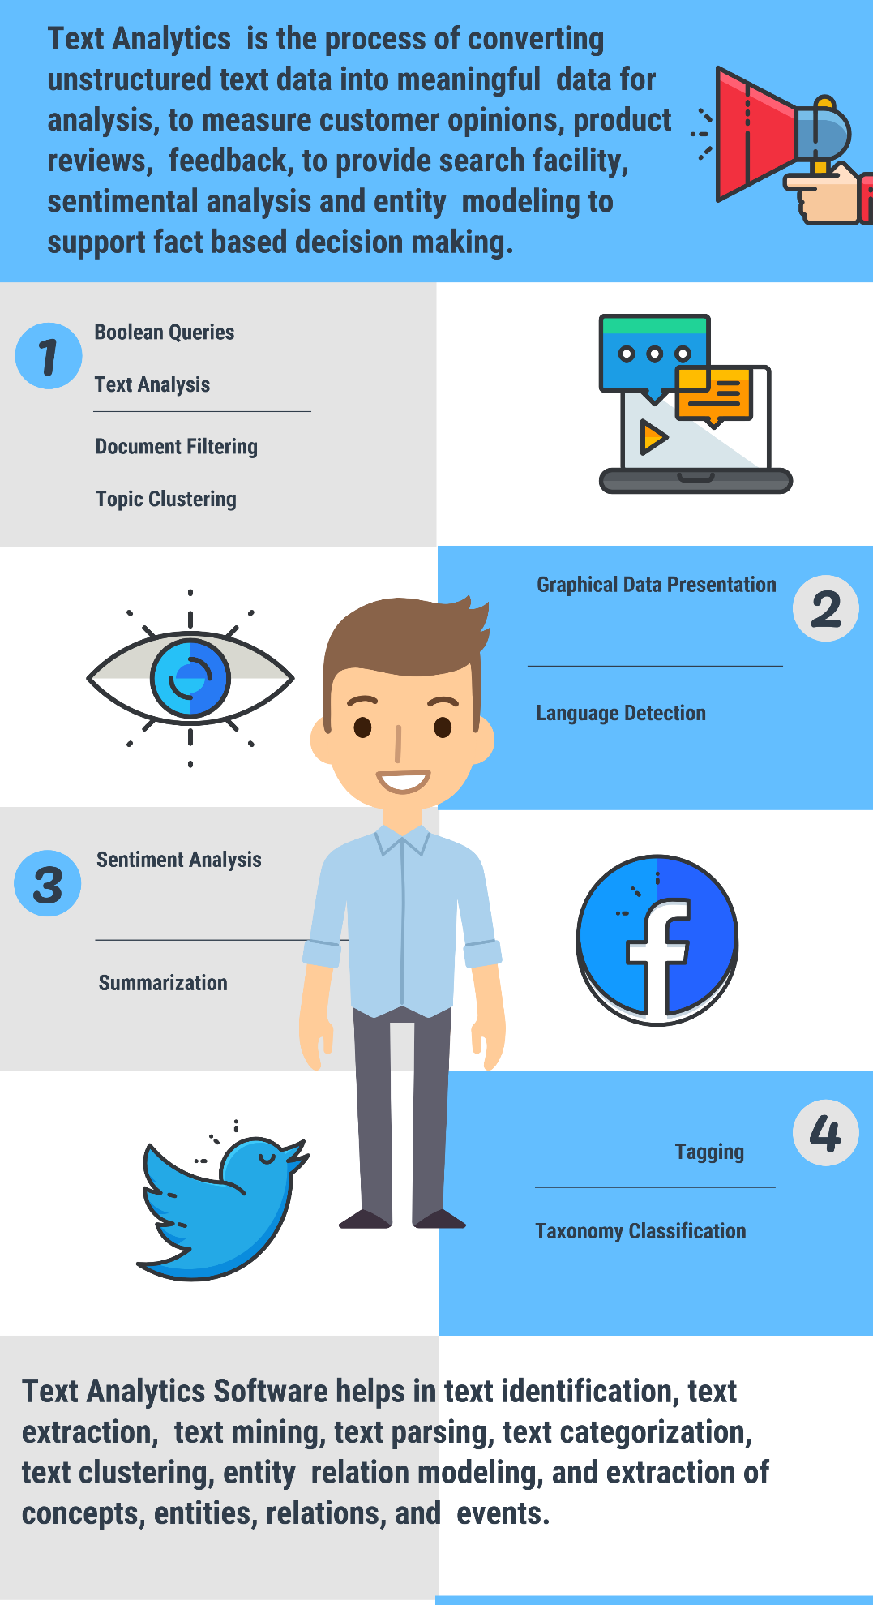

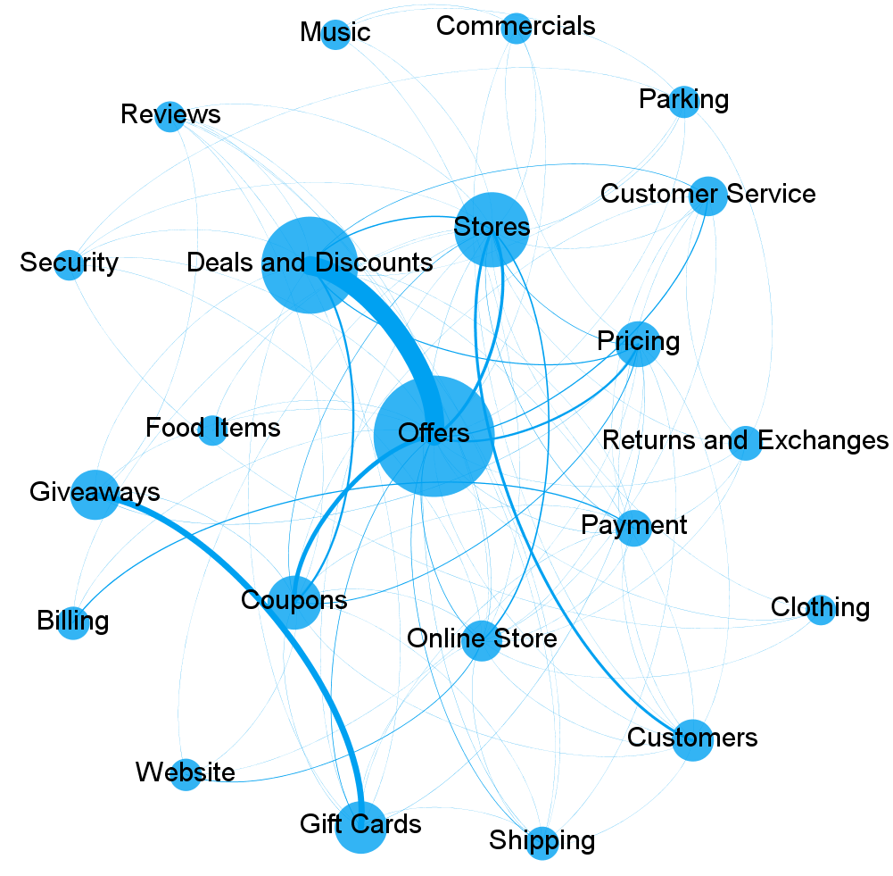

There is barely any presence of the Google Merchandise Store, even for jobs and/or employment, despite the fact the Google Merchandise Store employs 170,000 people in the London, England area to use one example on LinkedIn (Campbell, Sands, Ferraro, Tsao & Mavrommatis, 2020; Delnevo, Giovenco, Kurti & Al-Shujairi, 2020). There is not any textual analysis to analyse with the Google Merchandise Store pertaining to LinkedIn (Campbell, Sands, Ferraro, Tsao & Mavrommatis, 2020; Delnevo, Giovenco, Kurti & Al-Shujairi, 2020). Considering that LinkedIn has close to 580 million users, if not more, on their social media site that primarily is linked to business, partnerships, and employment, and the Google Merchandise Store is basically quiet on this enormous social media site is again another reason why it is understandable that this vacancy of marketing opportunities is contributing to the low profit margin of the Google Merchandise Store (Campbell, Sands, Ferraro, Tsao & Mavrommatis, 2020; Delnevo, Giovenco, Kurti & Al-Shujairi, 2020).

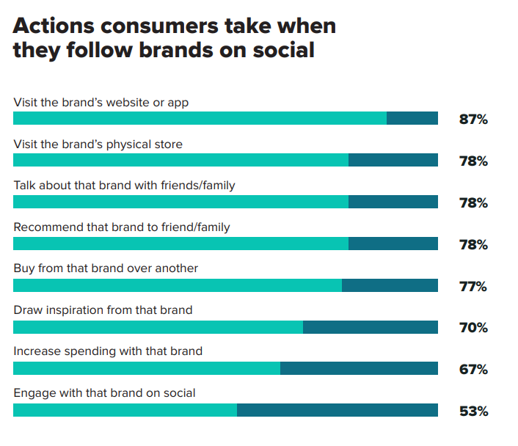

Facebook has an extremely minute presence for the Google Merchandise Store (Campbell, Sands, Ferraro, Tsao & Mavrommatis, 2020; Delnevo, Giovenco, Kurti & Al-Shujairi, 2020). With only 25 people who like their dedicated Facebook page and a textual analysis of non-English language with English being considered the top language of business around the world, the Google Merchandise Store needs to also increase its social media presence on Facebook as well in order to reach its income potential for e-commerce stores online (Campbell, Sands, Ferraro, Tsao & Mavrommatis, 2020; Delnevo, Giovenco, Kurti & Al-Shujairi, 2020).

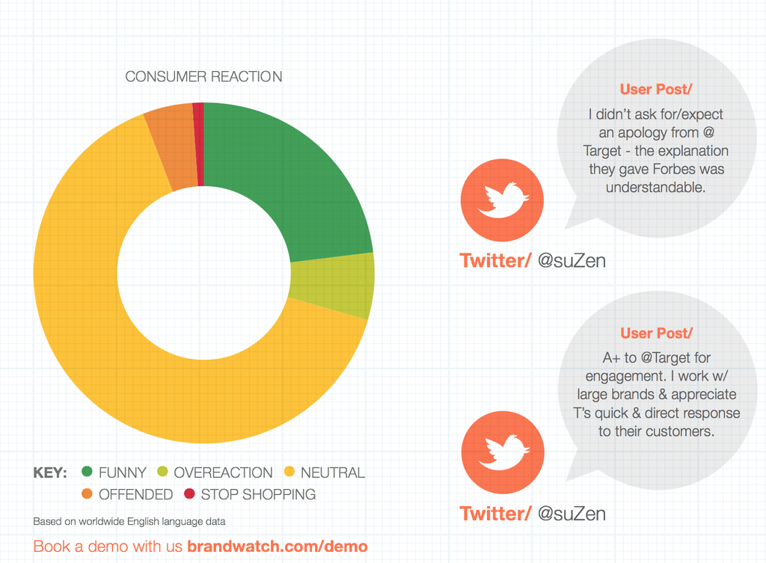

On Twitter, the Google Merchandise Store has recently moved, however, has a far more impressive social media presence than the previous two social media channels (Campbell, Sands, Ferraro, Tsao & Mavrommatis, 2020; Delnevo, Giovenco, Kurti & Al-Shujairi, 2020). With almost 142,000 followers, however, since they have moved from their main site creating an absence of textual analysis, when many online shoppers would not take the time to go to the other site on Twitter of the Google Merchandise Store when they are checking out the business, for the purposes of this marketing report, that journey to the other Twitter page online will take place (Campbell, Sands, Ferraro, Tsao & Mavrommatis, 2020; Delnevo, Giovenco, Kurti & Al-Shujairi, 2020).

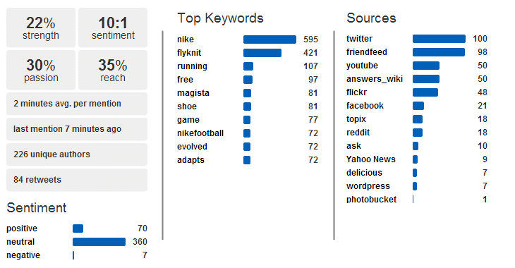

The journey took place and leads you to a dead end, just as the social media marketing appears to be so far with its analysis of the Google Merchandise Store – a dead end (Campbell, Sands, Ferraro, Tsao & Mavrommatis, 2020; Delnevo, Giovenco, Kurti & Al-Shujairi, 2020).

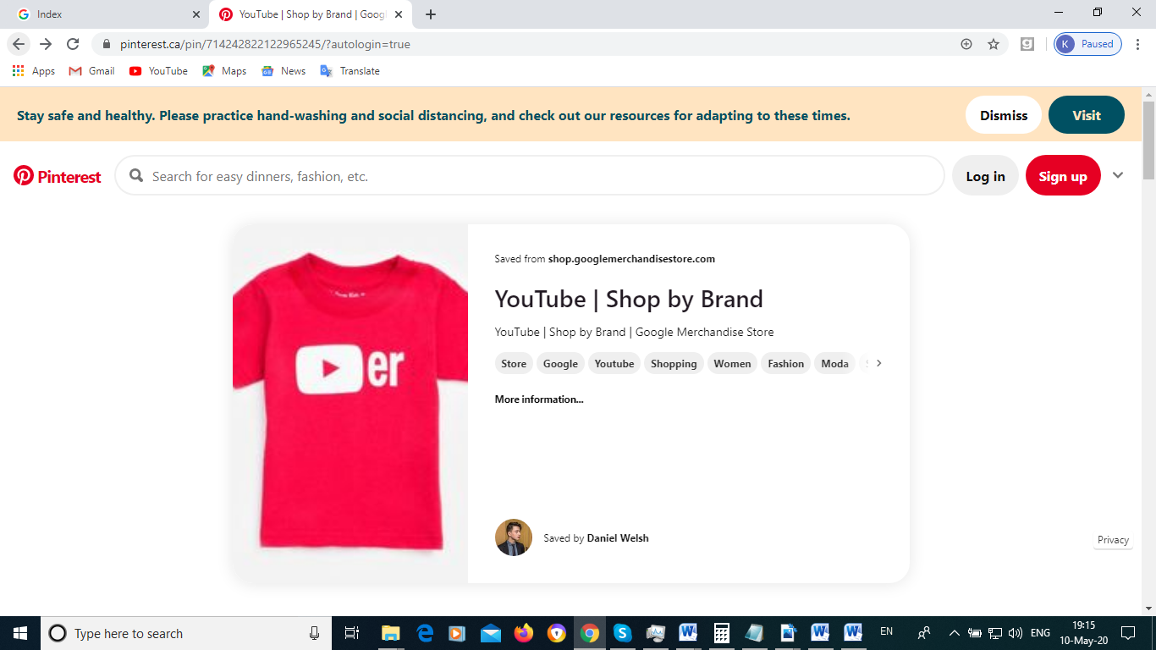

*Figure 7: Pinterest, YouTube.com, and Google Merchandise Store Involved in Social Media Market Together*

The YouTube | Shop by Brand | Google Merchandise Store pins that are on Pinterest are a superb way to add a visual textual analysis to online social media marketing that the Google Merchandise Store is doing (Campbell, Sands, Ferraro, Tsao & Mavrommatis, 2020; Delnevo, Giovenco, Kurti & Al-Shujairi, 2020). It leaves us with one more question for how the Google Merchandise Store is doing with social media marketing – Instagram (Campbell, Sands, Ferraro, Tsao & Mavrommatis, 2020; Delnevo, Giovenco, Kurti & Al-Shujairi, 2020).

Figure 8 below provides an online snapshot of the visual textual analysis of the Google Merchandise Store on Instagram (Campbell, Sands, Ferraro, Tsao & Mavrommatis, 2020; Delnevo, Giovenco, Kurti & Al-Shujairi, 2020):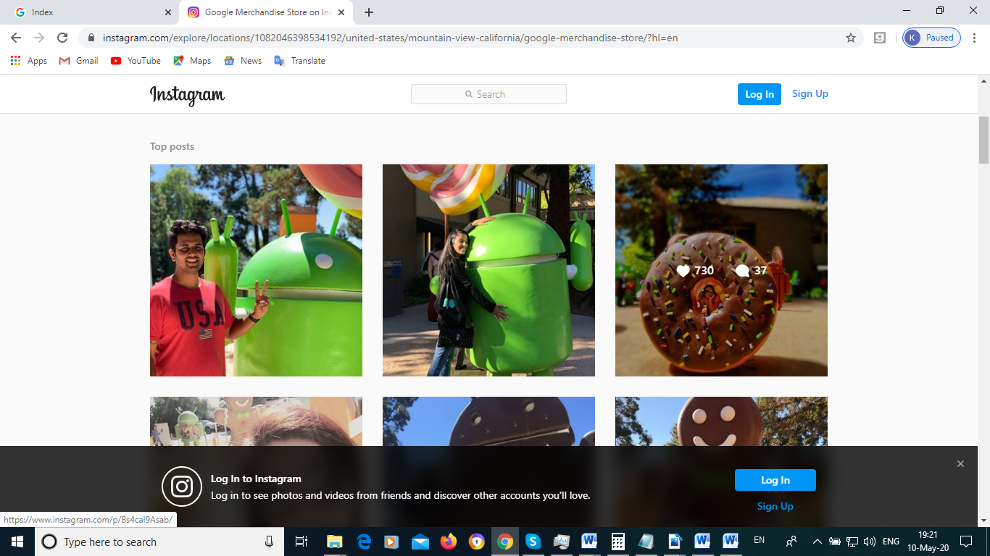

*Figure 8: Google Merchandise Store on Instagram*

With happy action-packed images that do not impinge on the representations of the Google Merchandise Store with the Pinterest and YouTube.com partnership, as well as a festive almost Disney World nature to the images on Instagram, Google Merchandise Store is marketing itself clearly on Instagram to the younger audience which it tends to attract, promising fun and good times with the purchases of Google Merchandise Store products (Campbell, Sands, Ferraro, Tsao & Mavrommatis, 2020; Delnevo, Giovenco, Kurti & Al-Shujairi, 2020).

\

**Quantitative Analysis**

It is estimated that the Google Merchandise Store has approximately 105 million people around the world who are aware of the store, however, these potential purchasing users do not always tend to translate into financial profits (Grewal & Roggeveen, 2020; Hanaysha, 2020).

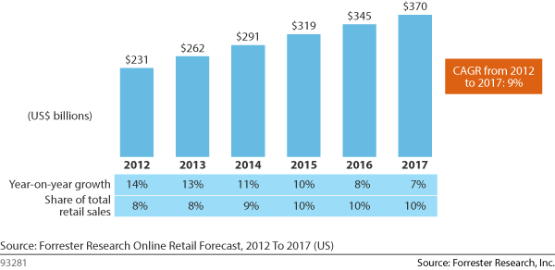

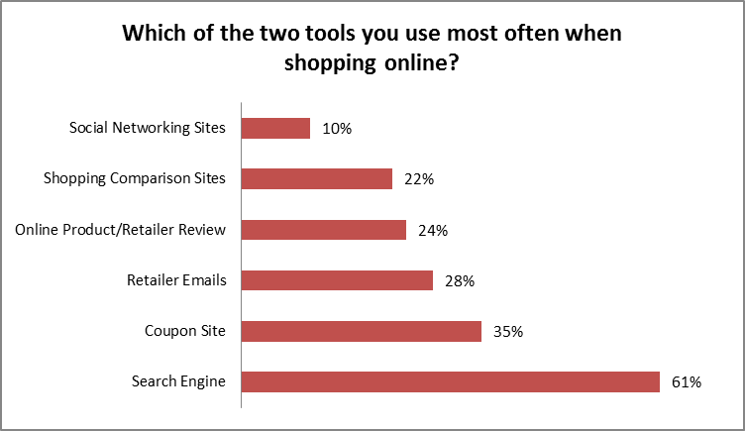

**Qualitative Analysis**

The qualitative analysis of the Google Merchandise Store is that most people from a textual analysis standpoint think of the Google Merchandise Store as a way of receiving tools that will support their own business, in particular, Google Analytics (Kostelijk & Alsem, 2020; Magnelli, Pizziol & Manzo, 2020). The average person does not care in particular about what the Google Merchandise Store offers, their social media representation online is excessively low considering how many people they employ, as well as the international knowledge base of the Google brand itself (Campbell, Sands, Ferraro, Tsao & Mavrommatis, 2020; Delnevo, Giovenco, Kurti & Al-Shujairi, 2020).

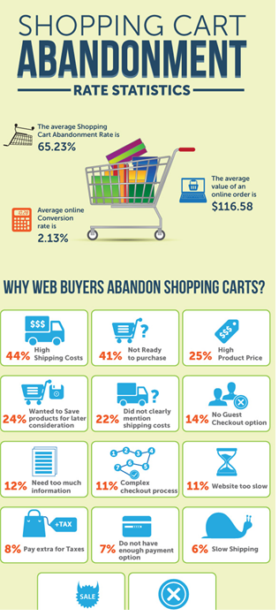

**Synthesis of Findings and Recommendations for Marketing Strategy**

**1.) Target People Who are Ready to Buy**

The most effortless people to sell are people who are as of now looking to purchase. Therefore, Google Shopping is a staggeringly important tool in any retail advertiser's stockpile.

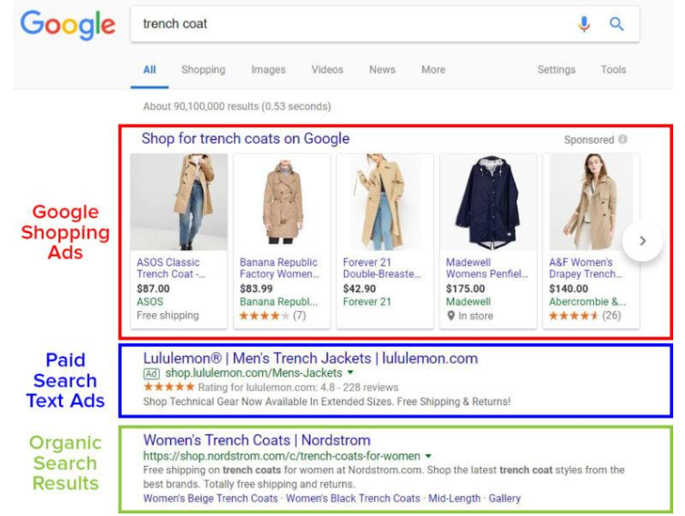

Google conveys results for over 40,000 web look through a second, so running promotions on Google Shopping is virtual must for most ecommerce organizations—particularly in the event that you need to have a possibility of showing up on the principal page when someone is scanning for a product you sell.

**2.Improving User Actions**

As mentioned before consumer behavior of every region is extraordinary. The retail showcase scenario is becoming more testing with expanding number of new global players and changing behavior of consumer. It requires an away from and implementation of a productive showcasing methodology that require an unmistakable comprehension of consumer needs, propensities, expectations and qualities. Therefore, the need to utilize consumer behavior to arrive at the best consideration of various kinds of requests has become essential fixing. The company should adopt an away from of operative showcasing decisions and vital advertising policy to deliver the issues identified with client behavior. We recommend that Google should plan a comprehensive framework, in which every part of consumer behavior should be tended to profoundly. Google should adopt various advertising tools to investigate post purchasing behavior, pre purchasing behavior, consumer buy intentions, and complex purchasing behavior

3.UI/UX Improvements

As you can see by reviewing this paper, the suggestion for a more web-accessible logo for Google in Figure 4 is easier to see than the existing Google logo in Figure 3 with the exception of the size difference (Banerjee, Xu & Johnson, 2020; Blank & Dorf, 2020). The logo in Figure 4 is based on the web-accessibility principles of colours from Figure 1 (Blank & Dorf, 2020). With the suggested change for the Google Merchandise Store logo, this would help for the store to achieve its optimum level of financial profits in terms of the effectiveness of marketing strategies (Banerjee, Xu & Johnson, 2020; Blank & Dorf, 2020; Pegan, Vianelli & de Luca, 2020; Zenk, Leider, Pugach, Pipito & Powell, 2020).

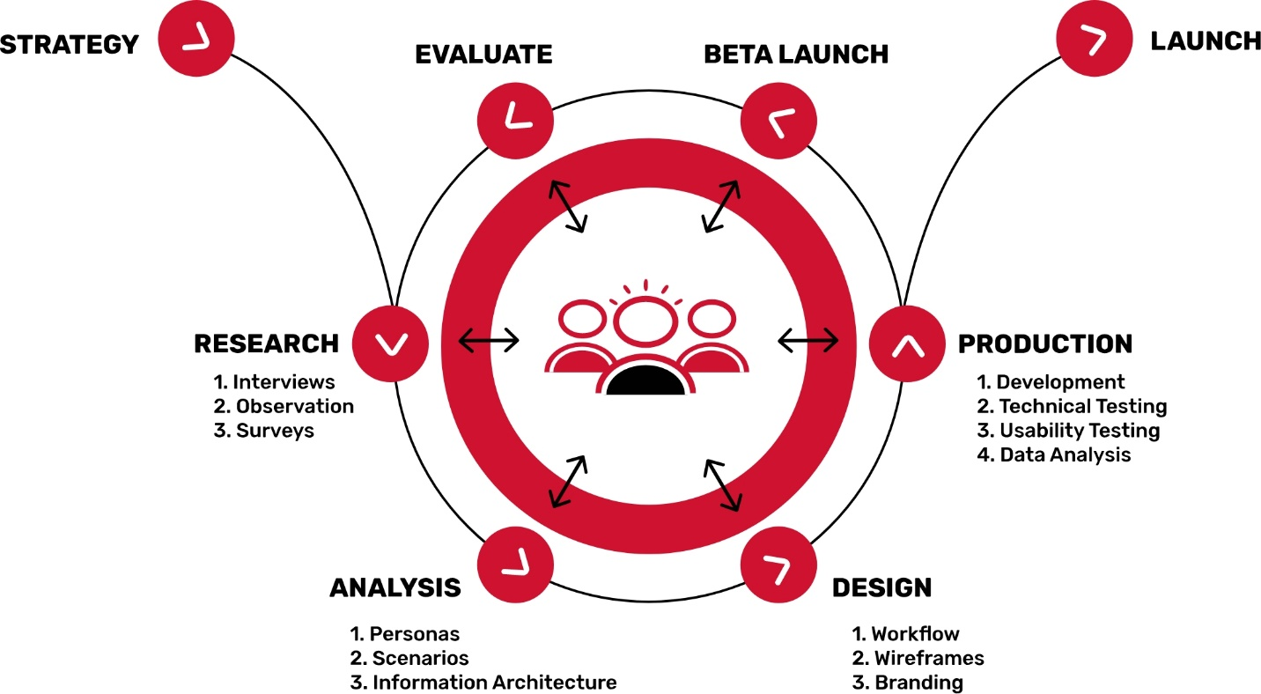

4.Influencer Marketing and aggerated social media platforms

The influencer approach to promoting is a slow-and-consistent one. In contrast to traditional promoting, organizations should be eager to contribute an opportunity to develop honest and bona fide relationships with their influencers. Furthermore, often, the outcomes aren't estimated in dollars and pennies, however in the acquisition of new brand loyalists. It tends to be hard to check accomplishment without a bank articulation to back it up.

While the real showcasing requires time and personal attention, overseeing efforts and influencer relationships doesn't need to be so labor-concentrated. Finding the correct people to work with, monitoring efforts, estimating achievement (or disappointment)— these are immeasurably important errands. However, that doesn't mean they need to set enormous expectations for your time. That is the thing that software is for. Similarly that accounting tools spare you time in counting your money, leaving you allowed to focus on procuring it, influencer showcasing platforms decrease the time-suck of the regulatory errands that can occupy you from arriving at your goals.

5.Adclick Spending

Advanced advertisers utilize both the conversion rate and the active visitor clicking percentage to quantify the achievement of their showcasing efforts. However, as Andrew Chu from MGX notes, navigate rates and conversion rate influence two unique phases of the advertising/deals pipe. At the top of the business pipe, the active visitor clicking percentage quantifies what number people perform an action, (for example, click your promotion) before they get to your site. At the center and bottom of the business pipe, conversion rates measure actions that people take when they're on your site, as present a form, pursue a bulletin, download an infographic, make a buy, and others. For instance, suppose I need to know what number people visited my site in the wake of seeing my Facebook promotion. For this situation, I would need to decide the active visitor clicking percentage. On the off chance that my Facebook advertisement earned 100,000 impressions, and 3,500 of those people clicked my promotion to visit my site, that makes my active clicking factor 3.5%.

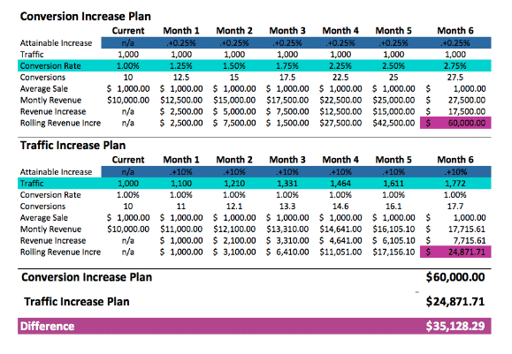

6.KPI for increased sales and retail

Other elements of the user experience design are the variety of items shown without price points (Banerjee, Xu & Johnson, 2020; Blank & Dorf, 2020). Marketing evidence shows, with examples such as Walmart, that indicating the prices of items is often an incentive for the user online to purchase the items that they want (Banerjee, Xu & Johnson, 2020; Blank & Dorf, 2020). The prices on items are not indicated until you click through to almost the fourth layer of the e-commerce site (Banerjee, Xu & Johnson, 2020; Blank & Dorf, 2020). By this time, as the items of the Google Merchandise Store are flashing by, many users would veer off the site as they would at any in-person store that does not indicate the prices of their items in the store window (Banerjee, Xu & Johnson, 2020; Blank & Dorf, 2020).

Appendix

1. Dashboard 1

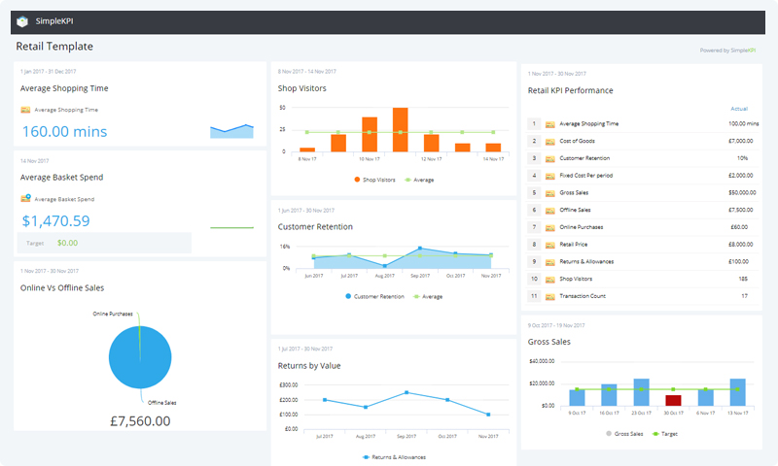

1. Dashboard 2

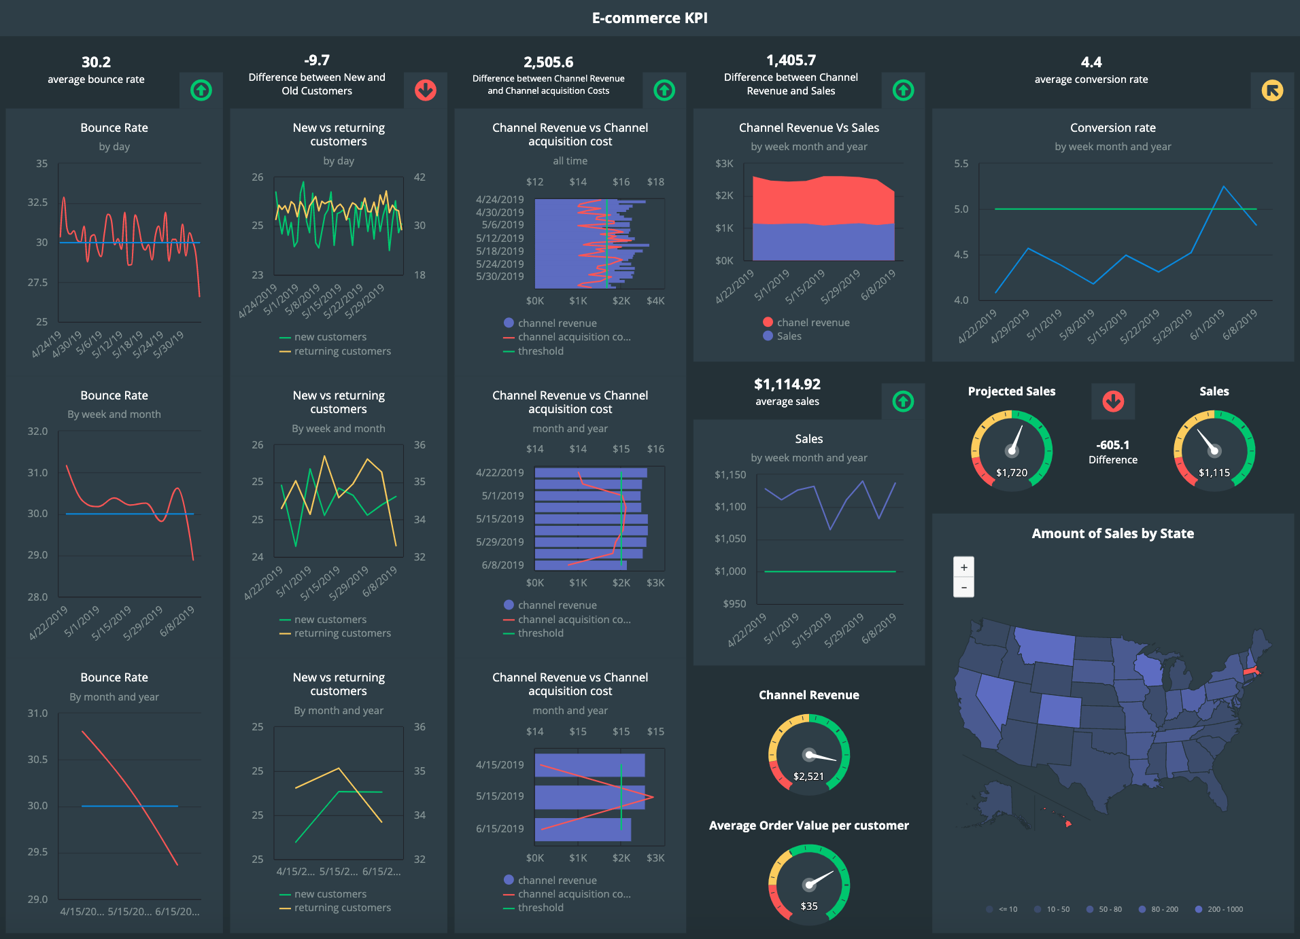

1. Dashboard 3

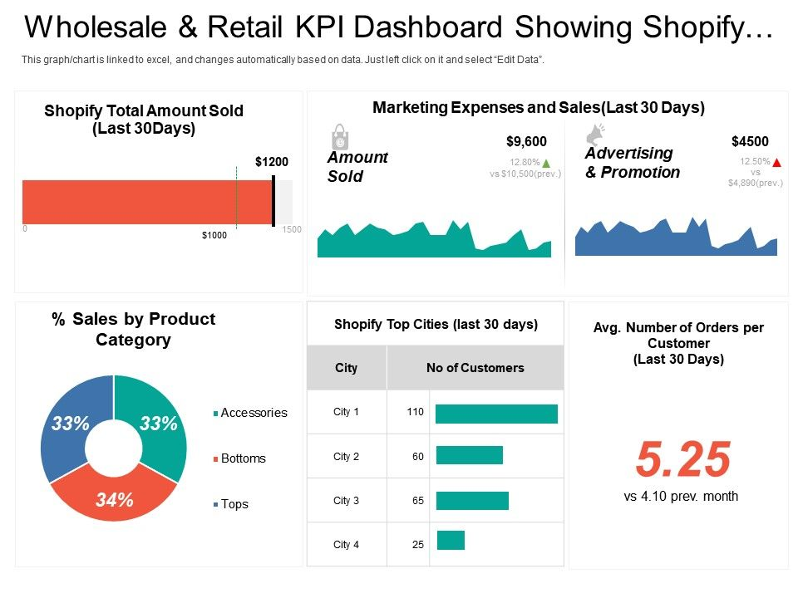

References

Angell, R. L., & Kraemer, J. R. (2017). *U.S. Patent No. 9,685,048*. Washington, DC: U.S. Patent

and Trademark Office.

Azizi, V., & Hu, G. (2019, June). Machine Learning Methods for Revenue Prediction in Google

Merchandise Store. In *INFORMS International Conference on Service Science* (pp. 65-75). Springer, Cham.

Banerjee, S., Xu, S., & Johnson, S. D. (2020). How does location based marketing affect mobile

retail revenues? The complex interplay of delivery tactic, interface mobility and user privacy. *Journal of Business Research*.

Blank, S., & Dorf, B. (2020). *The startup owner's manual: The step-by-step guide for building a*

*great company*. John Wiley & Sons.

Campbell, C., Sands, S., Ferraro, C., Tsao, H. Y. J., & Mavrommatis, A. (2020). From data to

action: How marketers can leverage AI. *Business Horizons*, *63*(2), 227-243.

Delnevo, C., Giovenco, D. P., Kurti, M. K., & Al-Shujairi, A. (2020). Co-marketing of marijuana

and cigars in US convenience stores. *Tobacco Control*, *29*(2), 224-225.

Grewal, D., & Roggeveen, A. L. (2020). Understanding Retail Experiences and Customer

Journey Management. *Journal of Retailing*, *96*(1), 3-8.

Hanaysha, J. R. (2020). Marketing Mix Elements and Corporate Social Responsibility: Do they