This document is about how GUI works with Arduino board and restrictions Board has.

1. Open given application “../ArduinoControlerGUI.exe” from application folder.
2. GUI looks like this

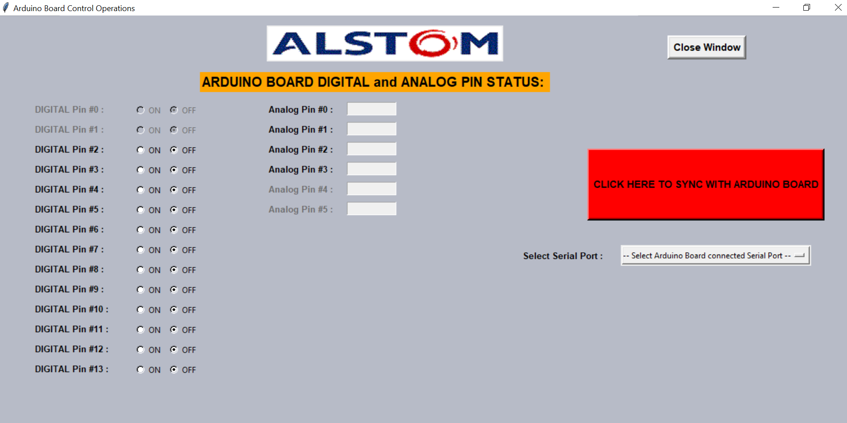

1. **Uploading Firmata sketch to Arduino board:**
   1. Open Arduino board
   2. Goto (click) “File -> Examples -> Firmata -> StandardFirmata”
   3. Compile and upload sketch to board.
   4. Make sure sketch uploaded properly.
2. **Steps to Sync GUI with board:**
   1. Select a serial COM port where Arduino board configured from dropdown box.
   2. Click on “CLICK HERE TO SYNC WITH ARDUINO BOARD” button.
   3. Wait for few seconds (max 5seconds).
   4. After successful Sync with board, then GUI shows up something like this

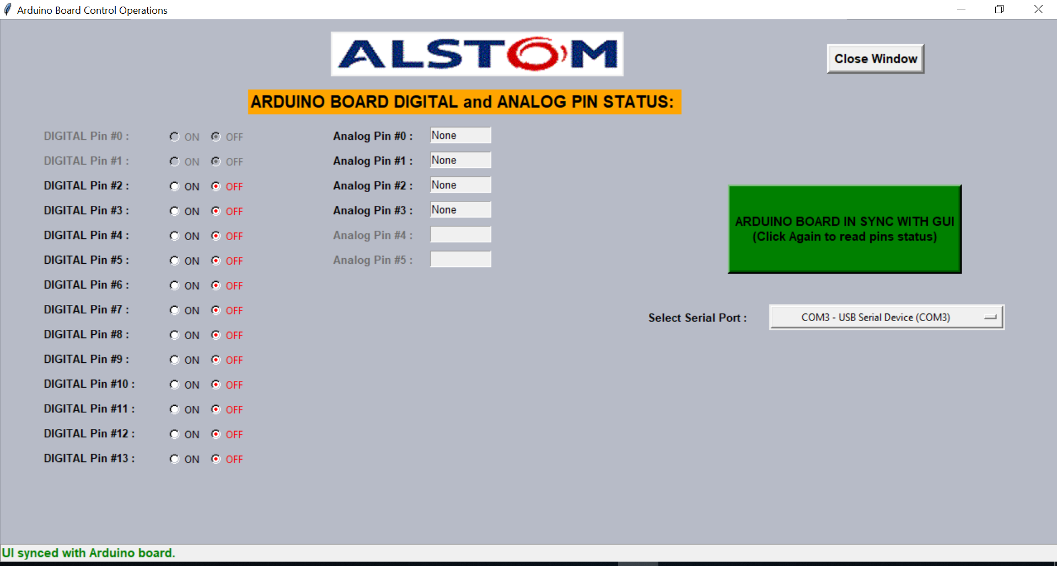

1. After GUI successfully sync with board, then
   1. we should be able to control digital pins from Digital pin2 to Digital Pin13. Digital Pin0 and Digital Pin1 has its limitations to control as these bits meant for Tx and Rx operations only.
   2. Analog voltage of pin0 to pin3 should be able to read from board and display voltage in text box in GUI (analog pins voltage takes 2 sec to update in GUI as we give enough time to settle down the voltage). Again, Analog Pin4 and Pin5 are spare as of now in the board, so these pins disabled. We are not able to write data to Analog pins as Control has only reading voltage from board, not writing voltage to board.