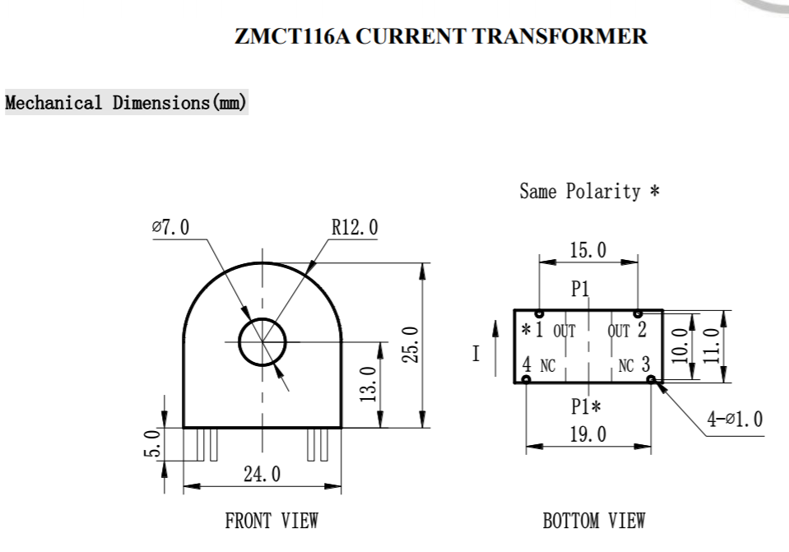
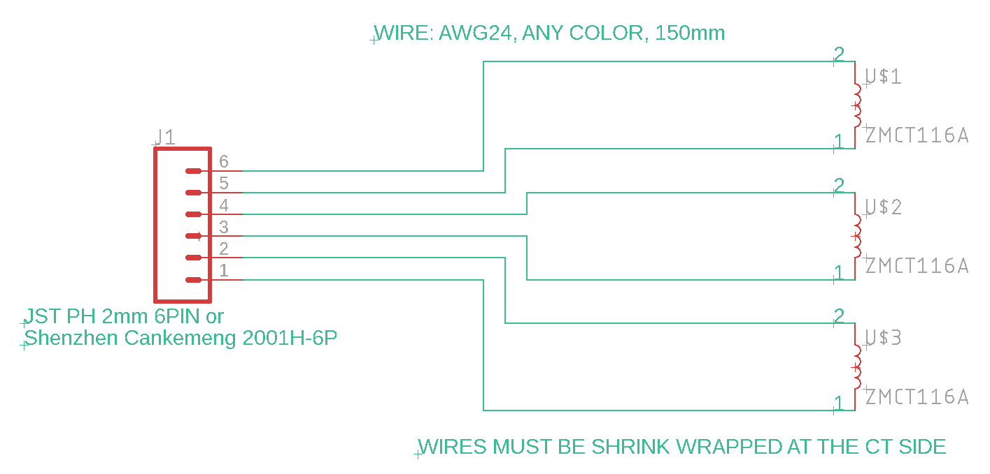
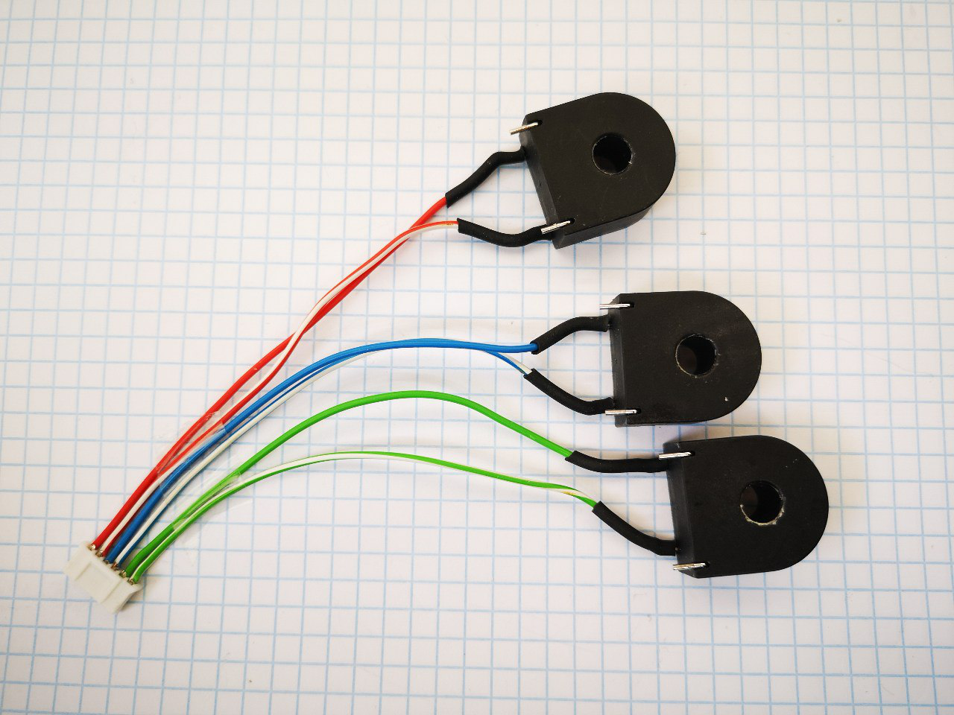
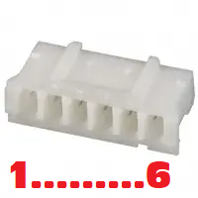
CONNECTOR:
SC 2001H-6P
https://lcsc.com/product-detail/_Shenzhen-Cankemeng-2001H-6P_C132488.html

JST PHR-6
https://www.digikey.it/products/en?mpart=PHR-6&v=455

WIRES MUST BE SHRINK WRAPPED AT THE CT SIDE (SEE PICTURE)

