WARNING! PINS ARE INVERTED FROM ONE CONNECTOR 1 TO CONNECTOR 2 (1-4, 2-3, 3-2, 4-1, NOTE INVERTED CONNECTOR IN PICTURE)

https://lcsc.com/product-detail/_Shenzhen-Cankemeng-2001H-4P_C126370.html
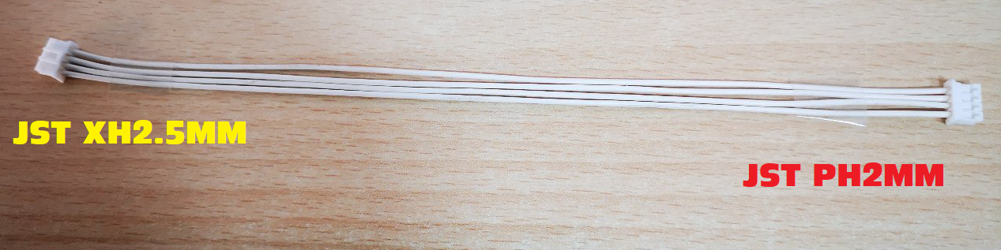
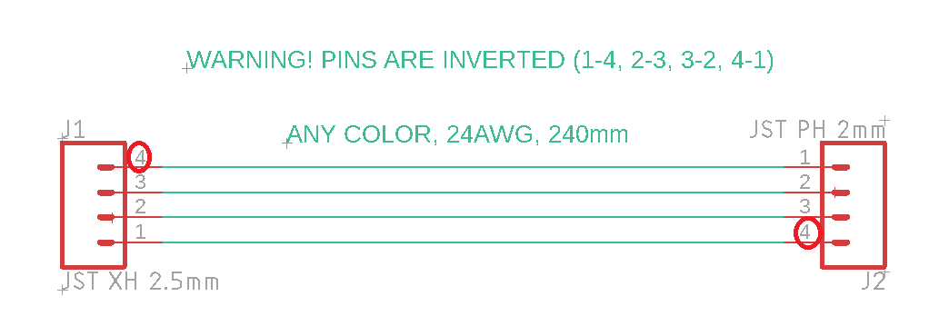
https://lcsc.com/product-detail/_JST-Sales-America_XHP-4_JST-Sales-America-XHP-4_C144403.html

