**Install PHP Pear**

Screenshot:

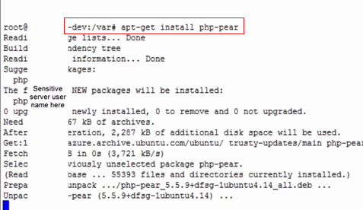

**Install PHP-5 Dev**

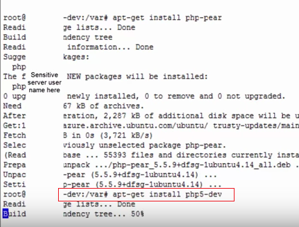

**Install Gearman Job Server**

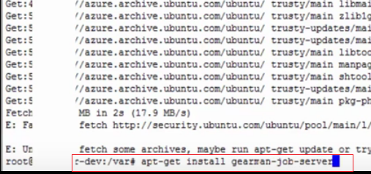

**Install Lib Gearman Dev**

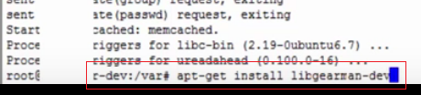

**Install PECL Gearman**

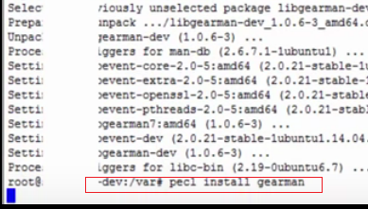

**Install PHP-5 Dev**

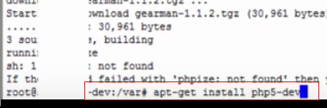

**Update apt-get for new server – to update the resource file**

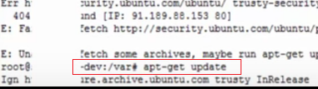

**Install PHP-5 Dev**

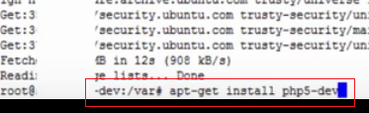

**Install PECL Gearman**

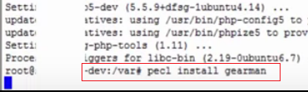

**Edit php.ini**

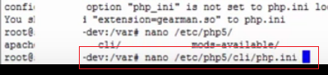

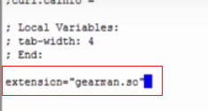

**Check gearman version via php – Test.php**

Run via > php Test.php

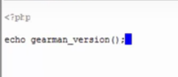

Version encircle

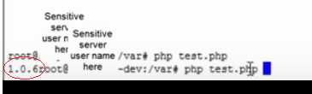

**Subscribe:** https://youtu.be/IhS6cBLpYco