**Install PHP Pear**

**Screenshot:**

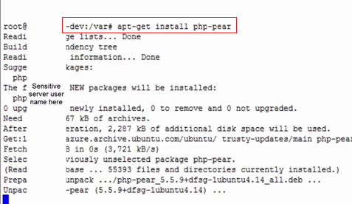

**Fedora command:**

yum update php-pear

**Install Gearman Job Server**

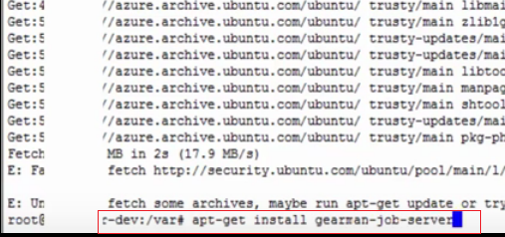

**Fedora command:**

yum install gearmand

**Install Lib Gearman Dev**

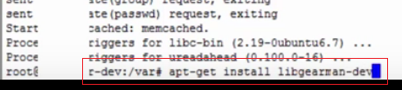

yum install libgearman-devel

**Update apt-get for new server – to update the resource file**

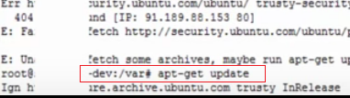

**Install PHP-5 Dev**

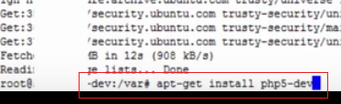

yum install php-devel

**Install PECL Gearman**

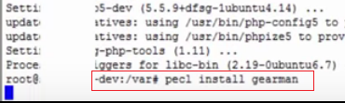

yum install php-pecl-gearman

**Edit php.ini**

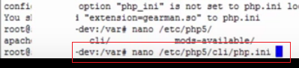

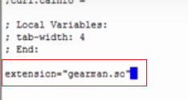

**Check gearman version via php – Test.php**

Run via > php Test.php

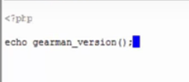

Version encircle

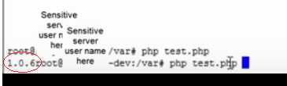

**Subscribe:** <https://youtu.be/IhS6cBLpYco>

**Restart gearman on local apache:** sudo service gearmand restart