Overview

This project aims to create a tool that can automate the generation of site map (xml file that lists all the URL of a website with important metadata of each URL).

Scope
- All websites

General Requirements
- The sitemap should be generated per page type
- These details should be provided by the user before generating a sitemap
  - Website
  - Template :
    - template 1 - XML with location and last modification
    - template 2 - XML with location, last modification, frequency, priority
  - Page Type URL
- If template 2 is selected, user must provide the frequency and priority.
- The last modification should be the date the user generated the sitemap.
- The value of the Page Type URL dropdown is based on the selected website
- The sitemap file should not be larger than 10MB or have more than 50,000 links. If it exceeds, a new file should be created.
- Naming convention: <website>/sitemap-<page type>.xml. If a page type is divided into several files: <website>/sitemap-<page type><increment>.xml
- Status of each URL should be checked, URLs with status 200 should be separated to the URLs with 404 status.
- After extraction of sitemap, it should be compressed to gunzip (.gz)
- /sitemap_index.xml should be updated after all files have been compressed.
- The generation of sitemap should be incremental
- Data Requirements:
  - Website - Dropdown option
  - Template - Dropdown option
  - Page Type URL: Dropdown option
  - Frequency: Dropdown option
  - Priority: Dropdown option
- Updating of data options should be done backend

Process Flow

File Structure
- template 1
<urlset>
<url>
<loc> [this is where the url should be placed] </loc>
<lastmod> [date of last modification] </lastmod>
</url>
</urlset>
- template 2
<urlset>
<url>
<loc> [this is where the url should be placed] </loc>
<lastmod> [date of last modification] </lastmod>
<changefreq> [change frequency: daily, weekly, monthly] </changefreq>
<priority> [priority 0.5, 1, 2] </priority>
</url>
</urlset>

Mock Up
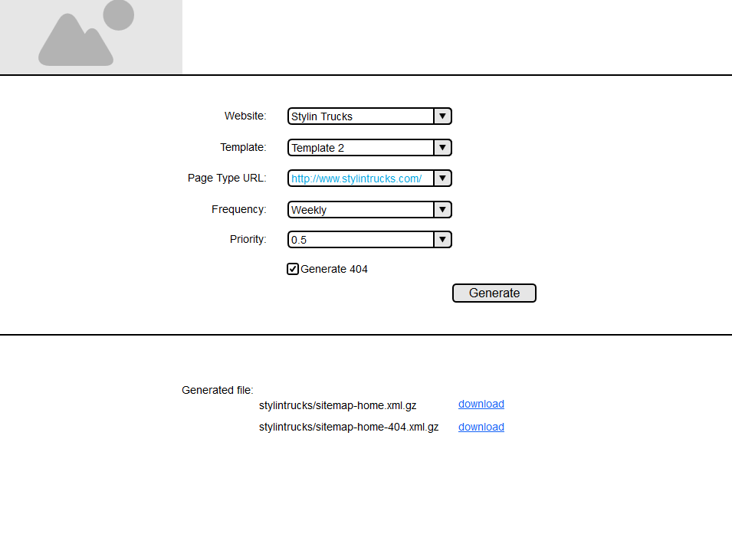

Last modified 2 weeks ago

Attachments (4)
- USAP Site SEO Page Types Structure.xlsx​ (14.7 KB) - added by dceleste 2 weeks ago. Sample Page Type
- sitemap.png​ (19.5 KB) - added by dceleste 2 weeks ago.
- SITEMAPGENERATOR.2.png​ (66.8 KB) - added by dceleste 2 weeks ago.
- SITEMAPGENERATOR.png​ (66.8 KB) - added by dceleste 2 weeks ago.
Download all attachments as: .zip

