U2M1.LW.Core SQL

#### 

Mastykina Elizaveta

# 2.1. Task 01: CREATE Storage Objects

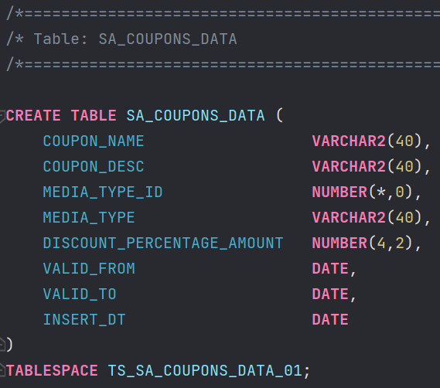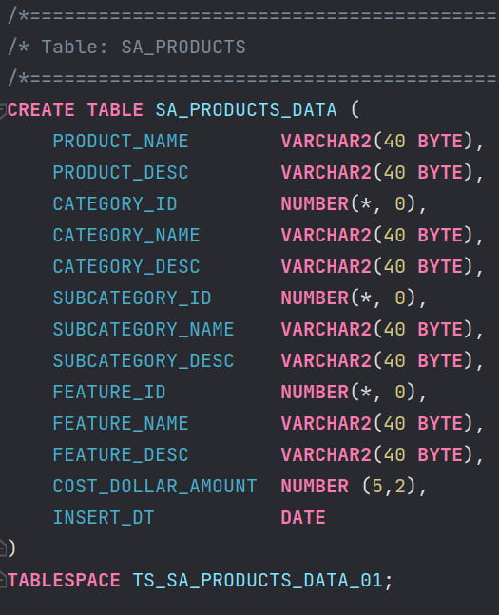

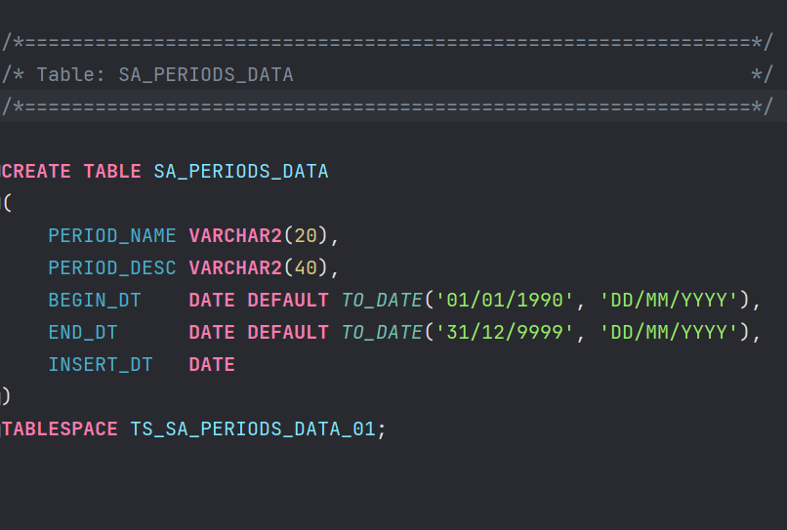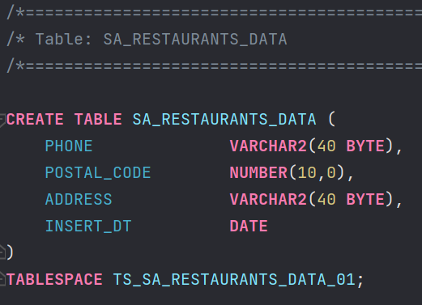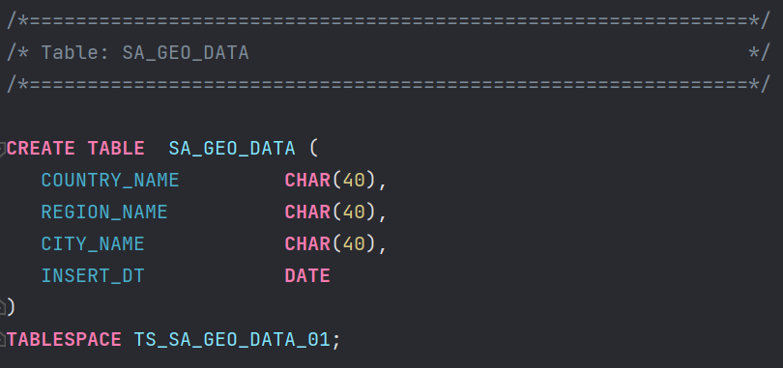

# 2.2. Task 02: Generate Test Data in Storage Layers

Data generation for SA_PRODUCTS_DATA:

Data about products, categories, subcategories was generated by python utility (code is stored on github ) in csv-format.

To add all possible combinations of products and features I create CTE statement and LEFT JOIN.

Result-screenshots:

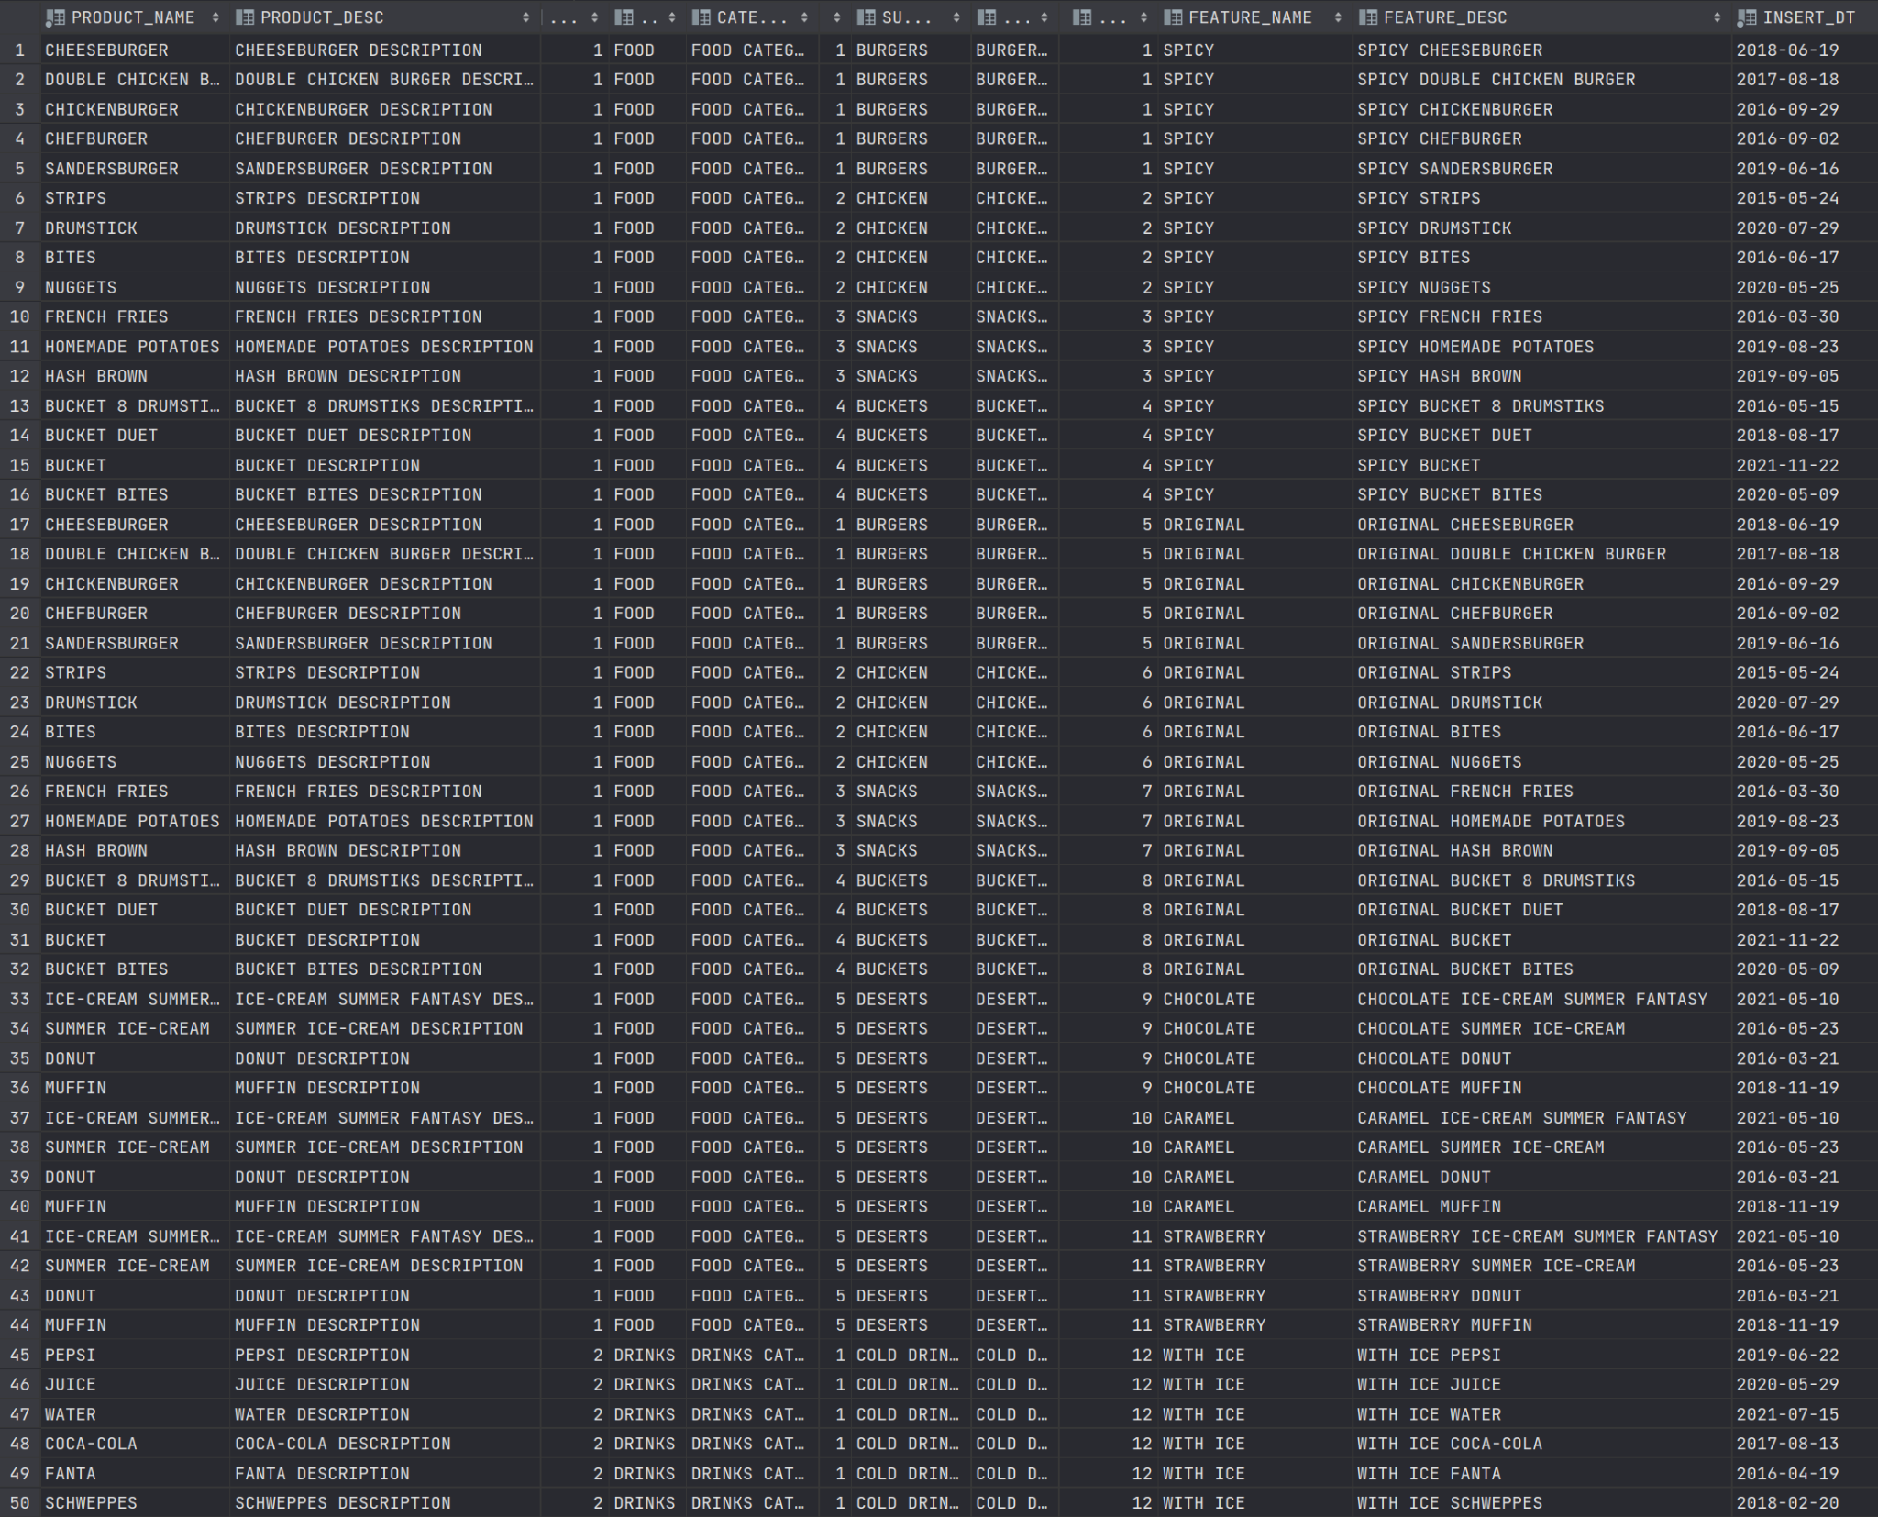

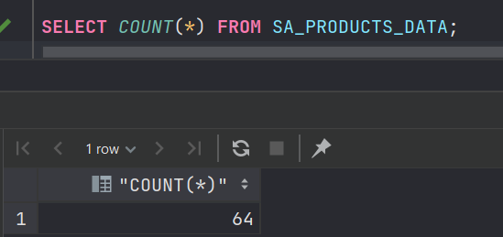

Data generation for SA_RESTAURANTS_DATA:

Result-screenshots:

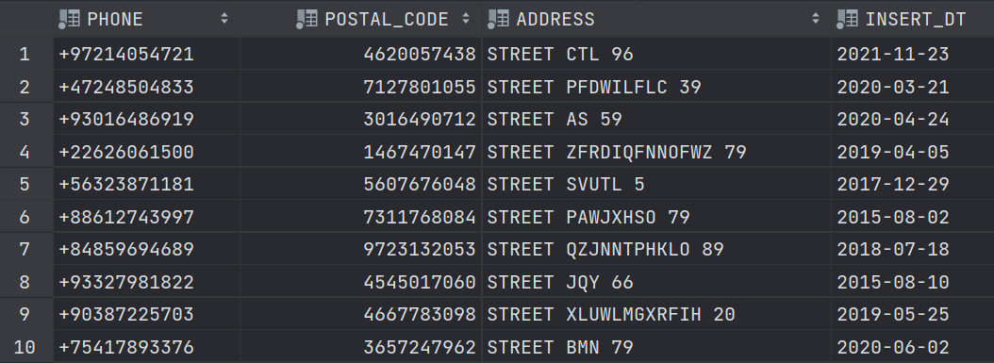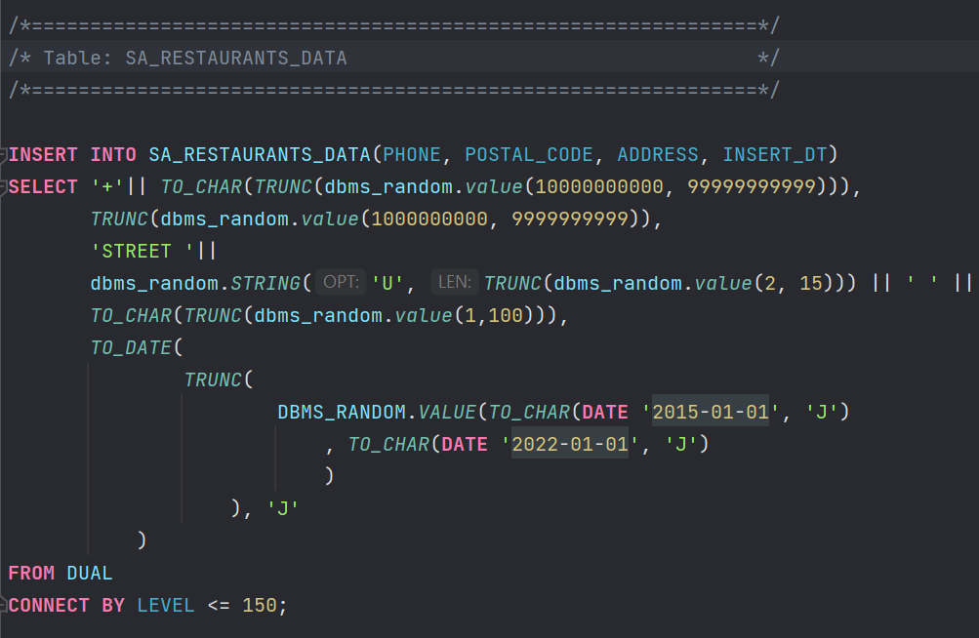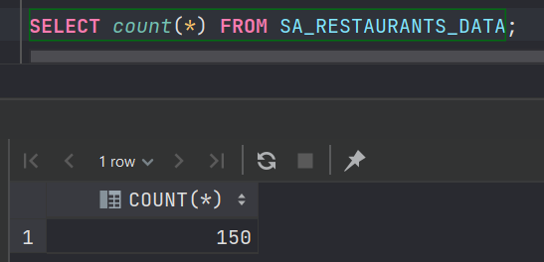

Data generation for SA_COUPONS_DATA:

Result-screenshots:

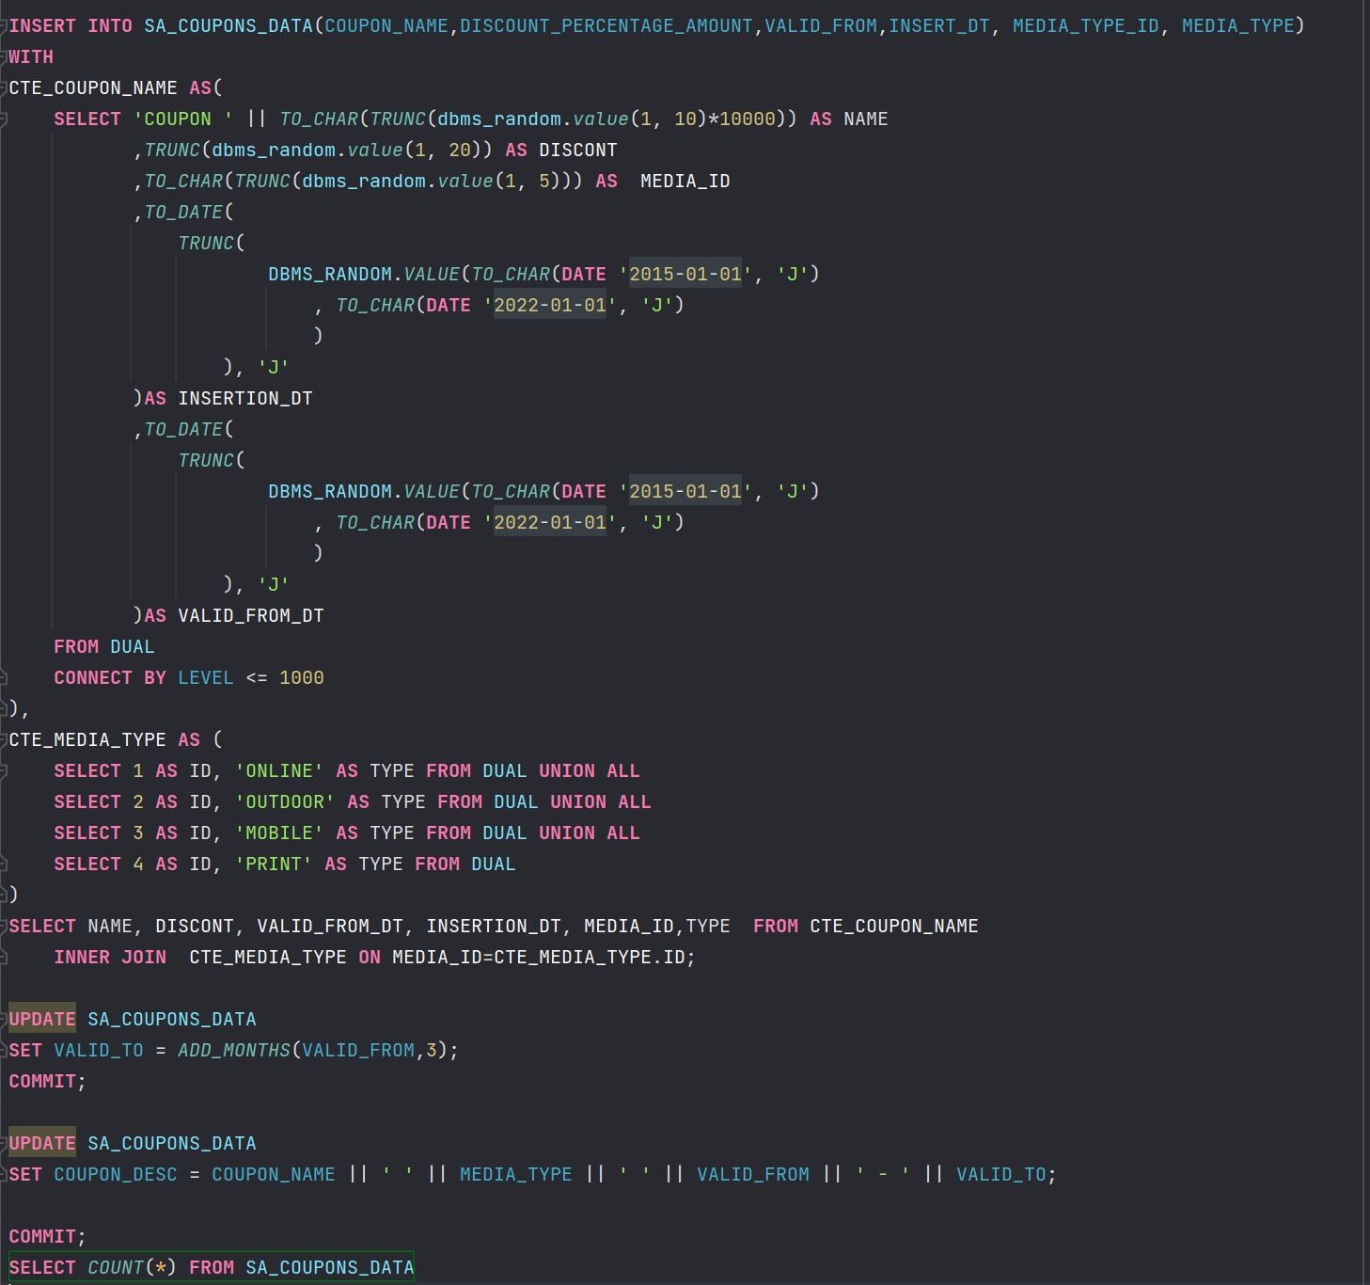

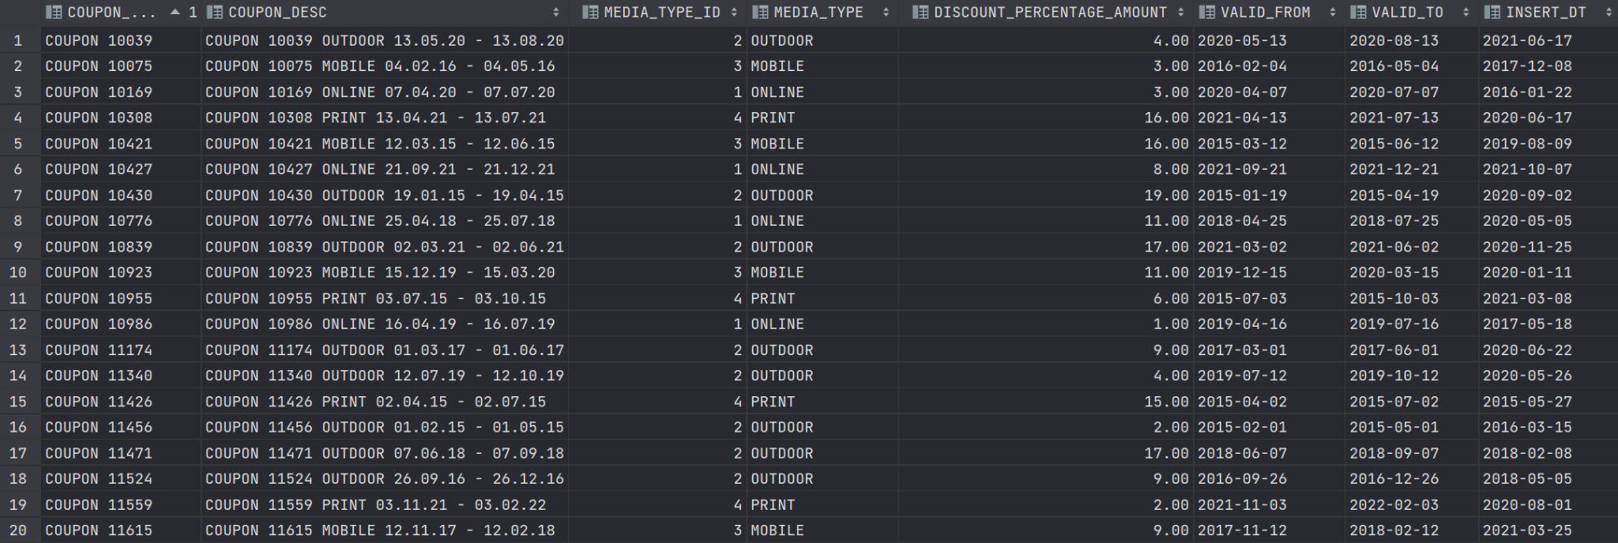

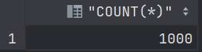

Data generation for SA_GEO_DATA:

Was loaded from the source csv file.

Result-screenshots:

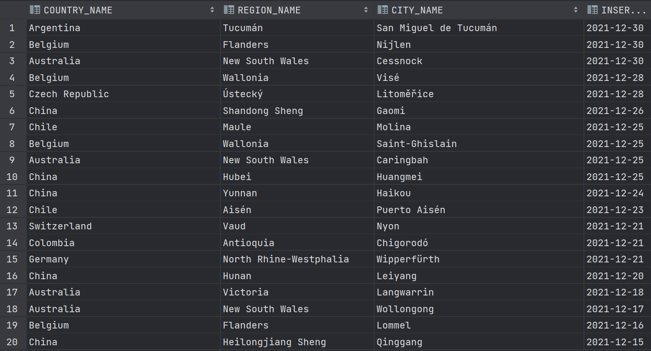

Data generation for SA_PERIODS_DATA:

Result-screenshots:

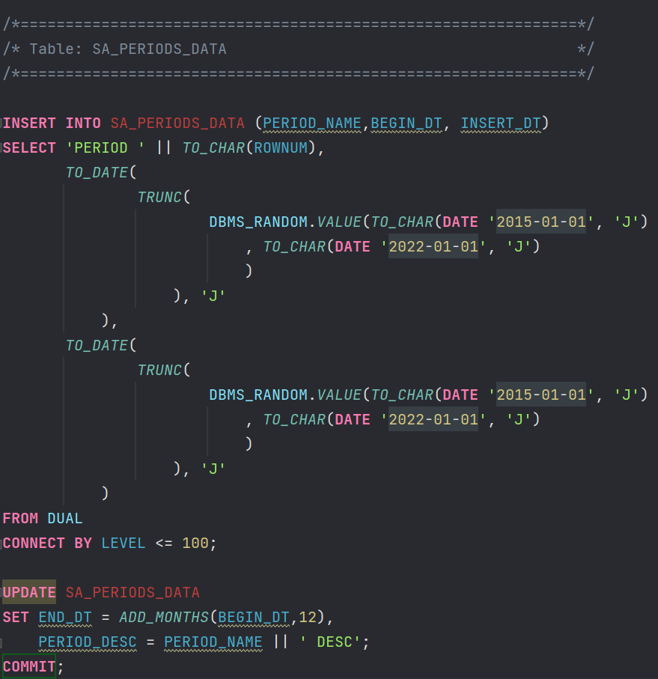

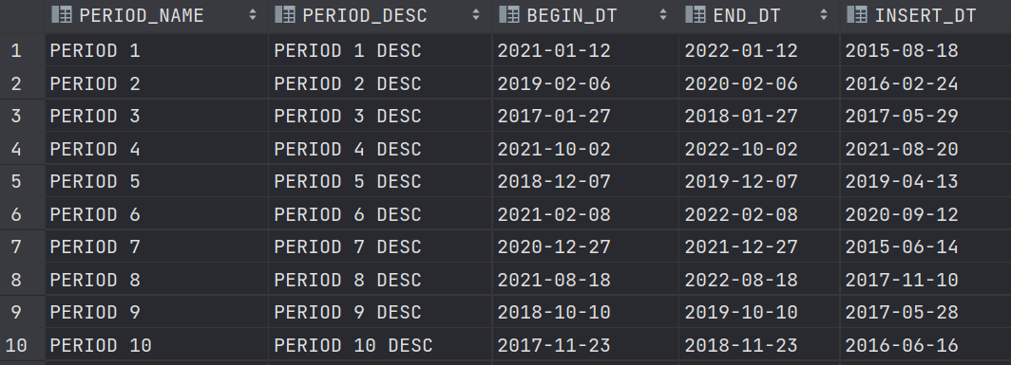

2.3. Task 03: Create Group by Plan

Transactions table structure:

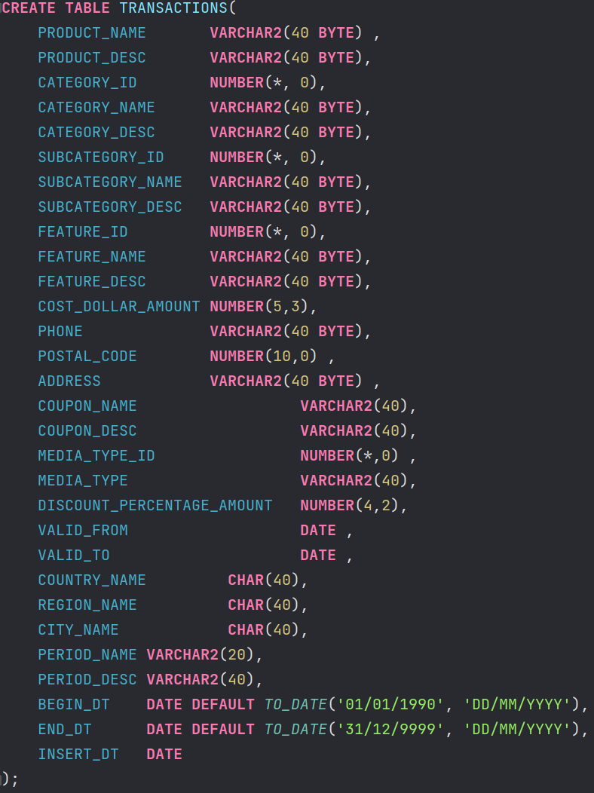

Population of the table with data:

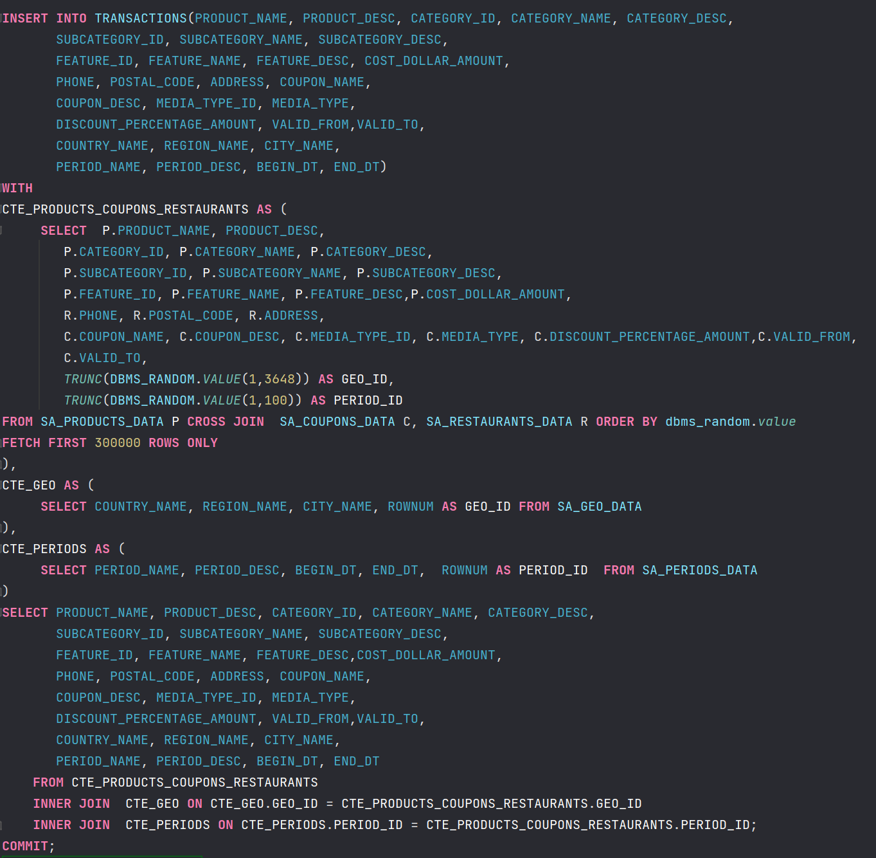

Examples of using group by plan:

