U3M3.LW.Implementing Data Flow

Mastykina Elizaveta

**1.1. Exercise 1: Creating new database for HR department**

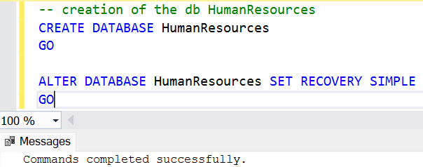

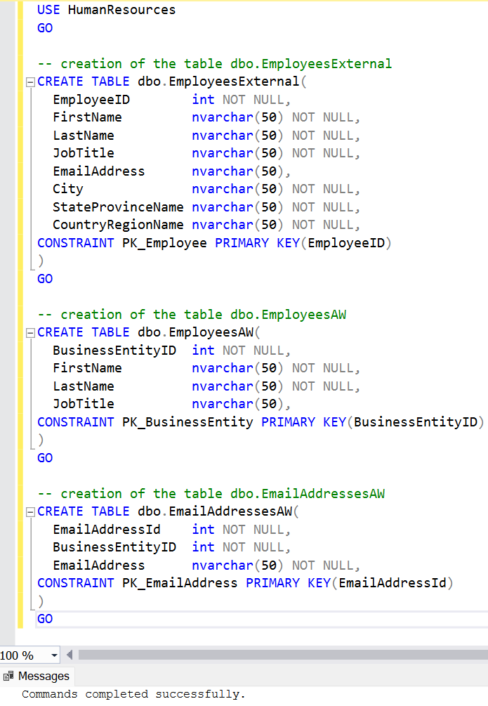

**2. Exercise 2: Creating ETL solution to import employees from different sources**

At the first step we truncate all destination tables to make our process repeatable.

To achive this goal we create Exequte SQL Task component on Control Flow with the next Query:

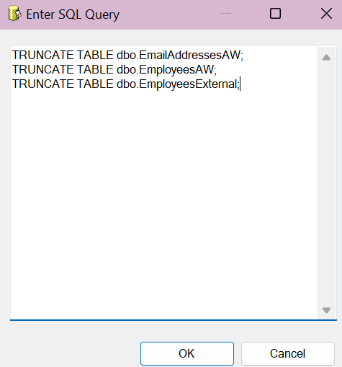

Then we organize Control Flow Logic:

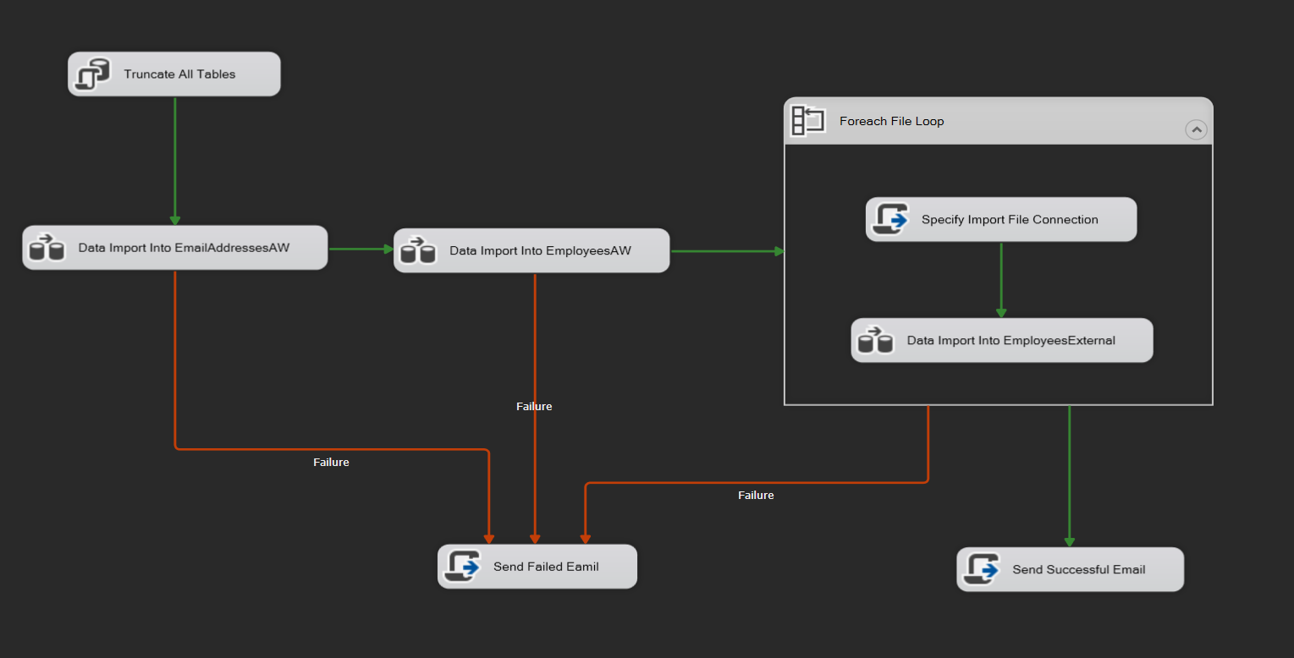

**Lets look in details on each dataflow component:**

* **Data Import Into EmailAddressesAW**

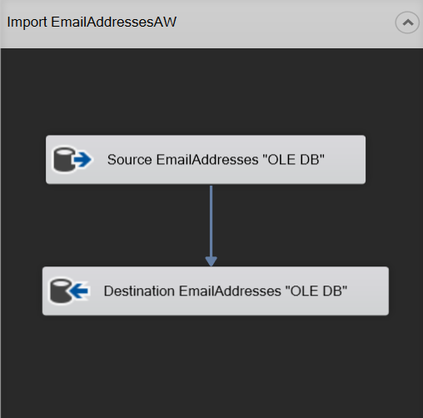

* **Data Import Into EmployeesAW**

Here we use Left Join to merge two source tables. It was nessasary to use sort, cause I receive the following error: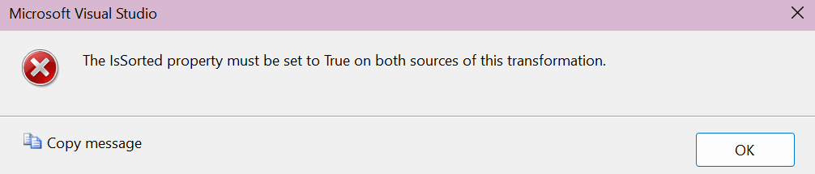

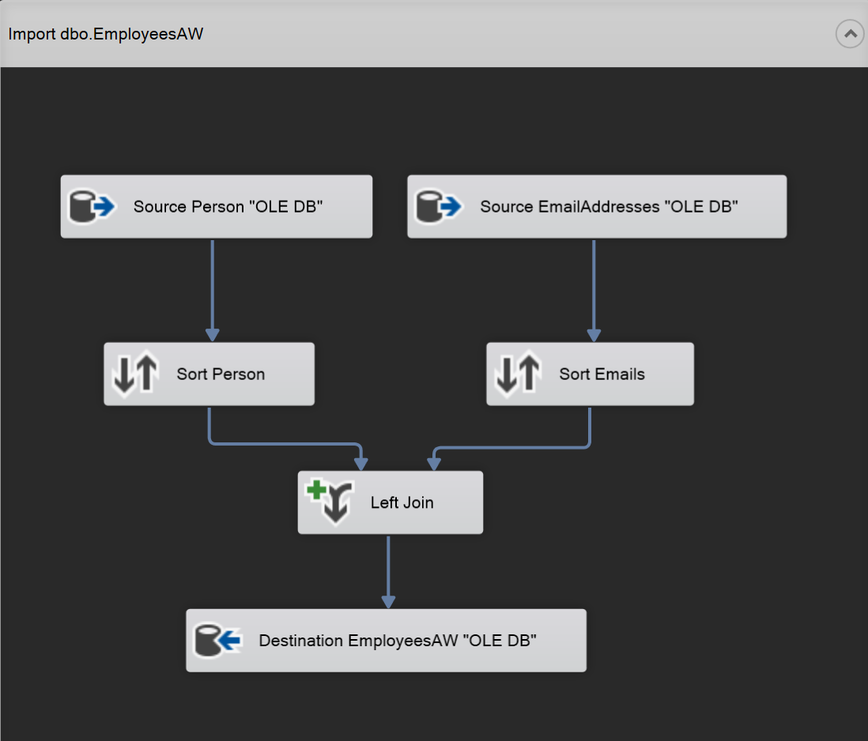

* **Data Import Into EmployeesAW**

As we can see the process is based on looping through source dirrectory, on each iteration we identify source file name:

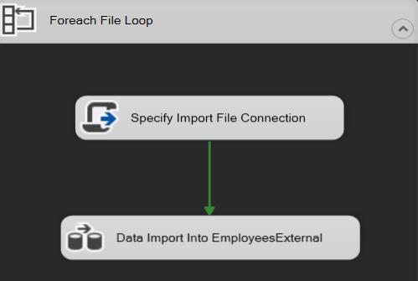

I decided to write short script to configure Input Flat File connection dinamicly:

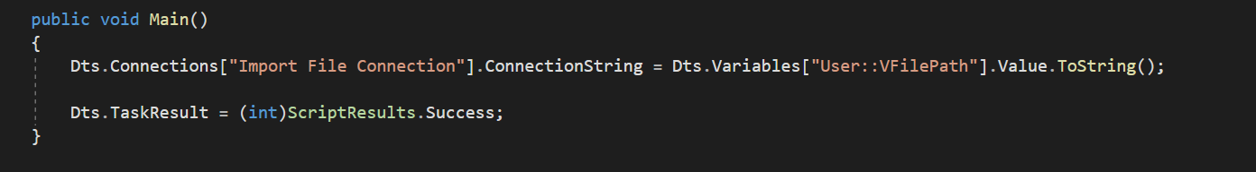

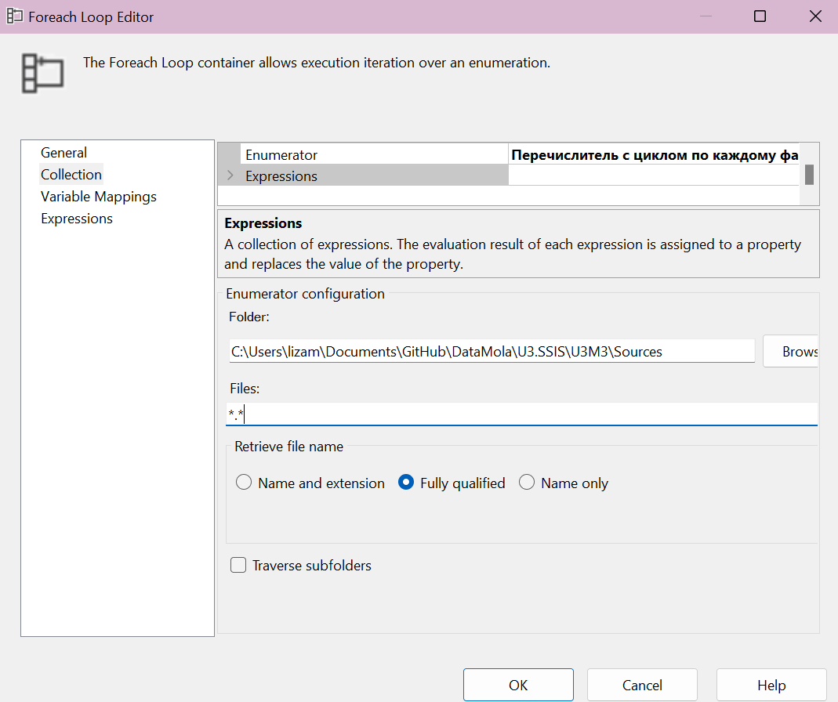

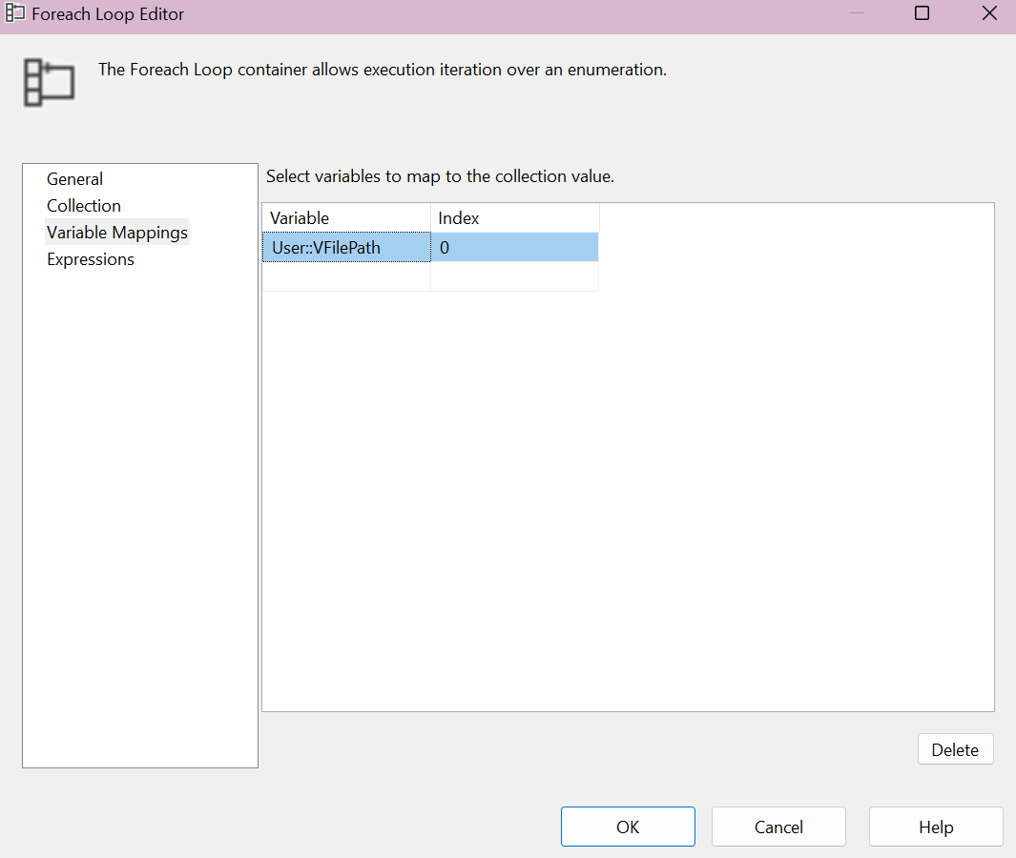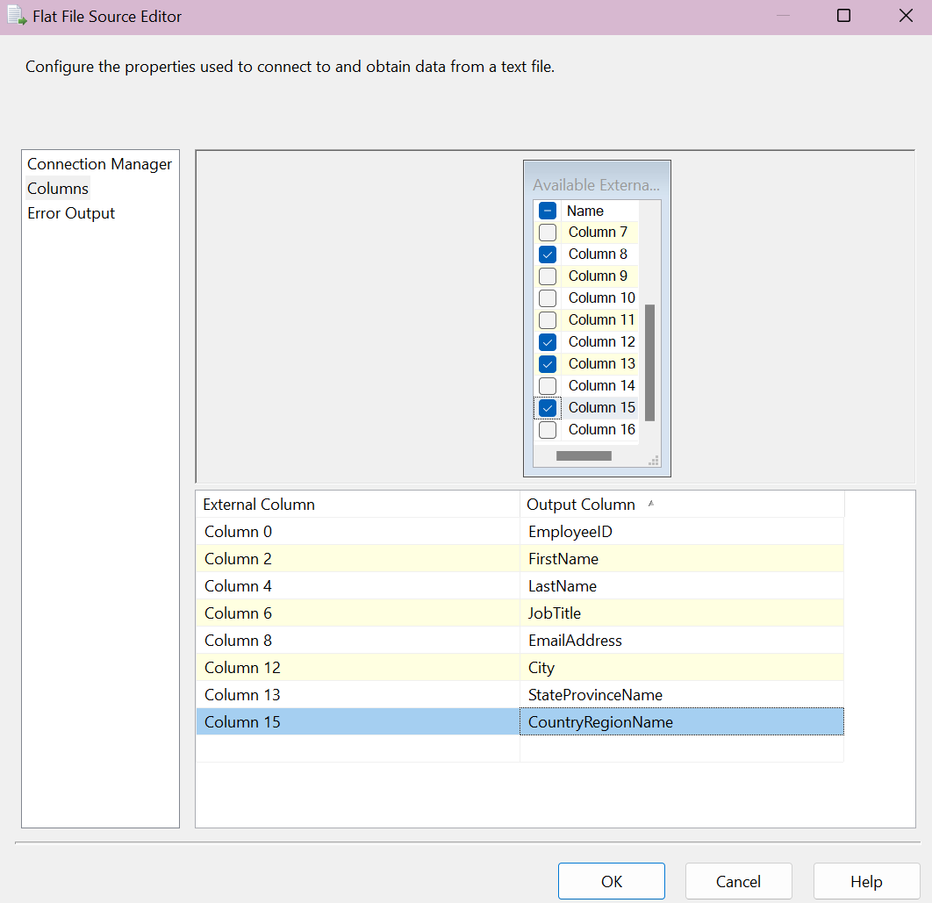

It was obligatory to configure DataType of each column to avoid encoding error:

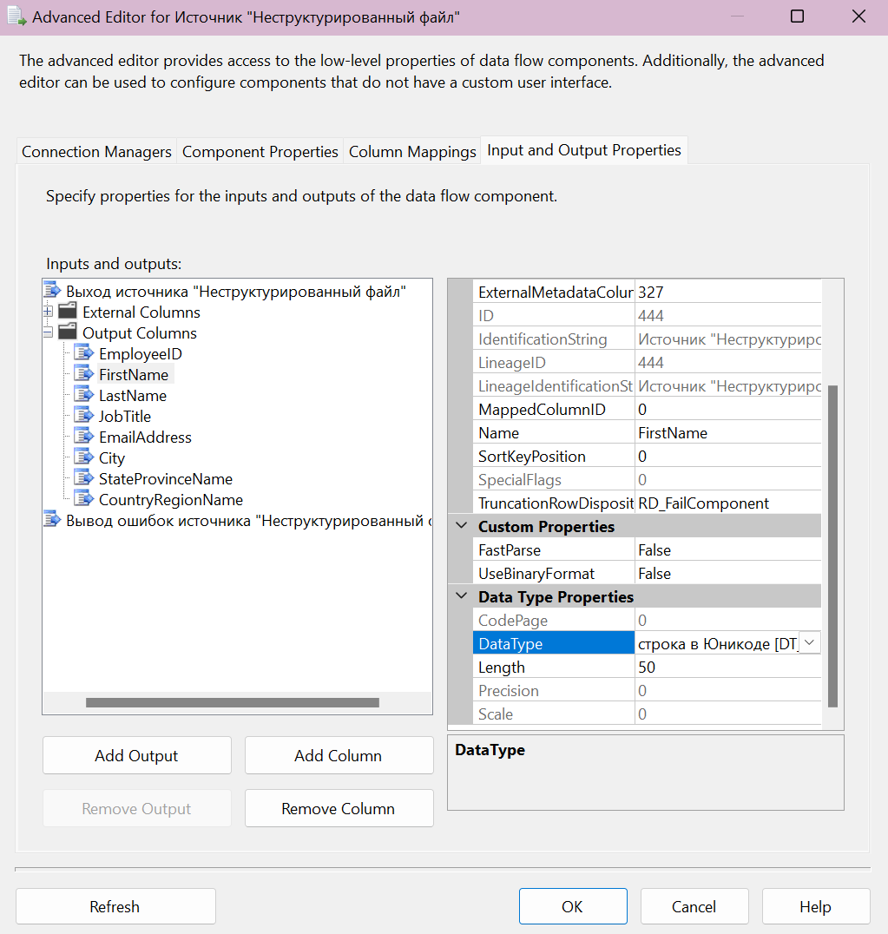

Then we config Destination Table in DB:

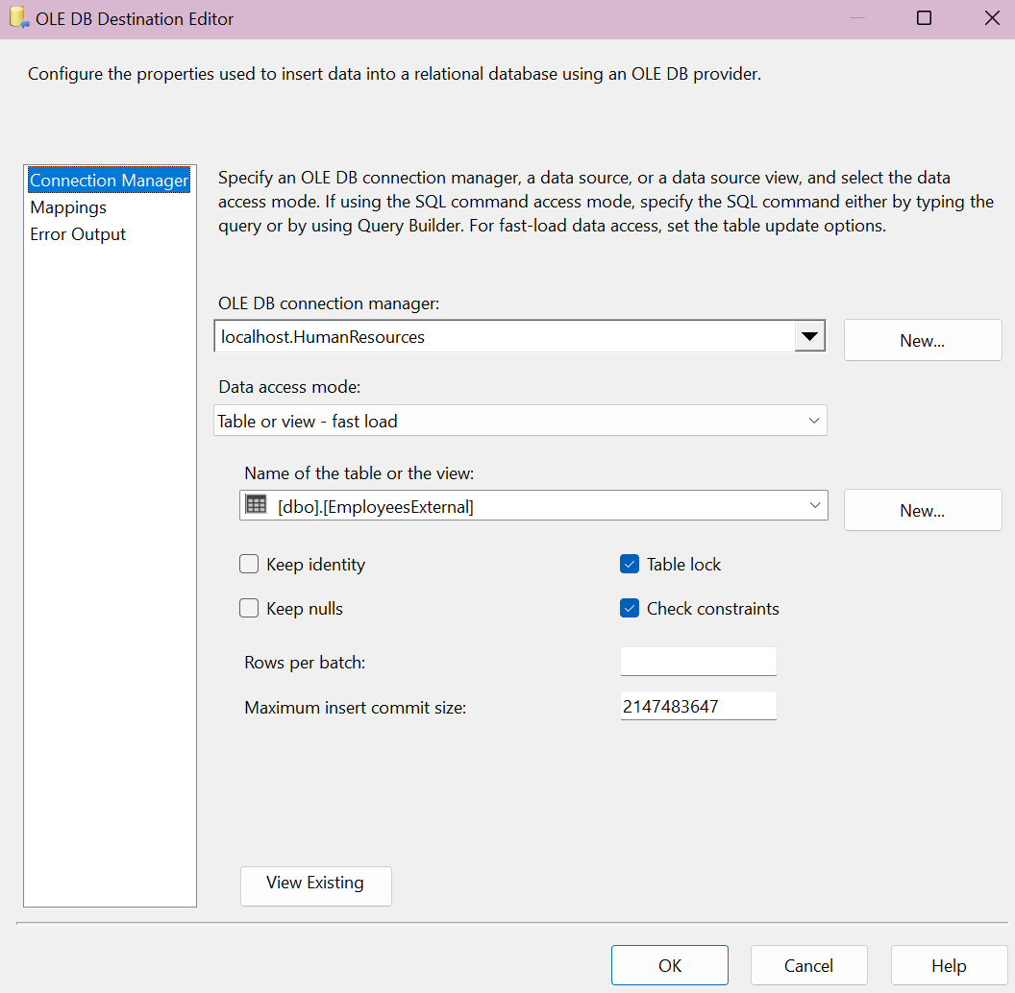

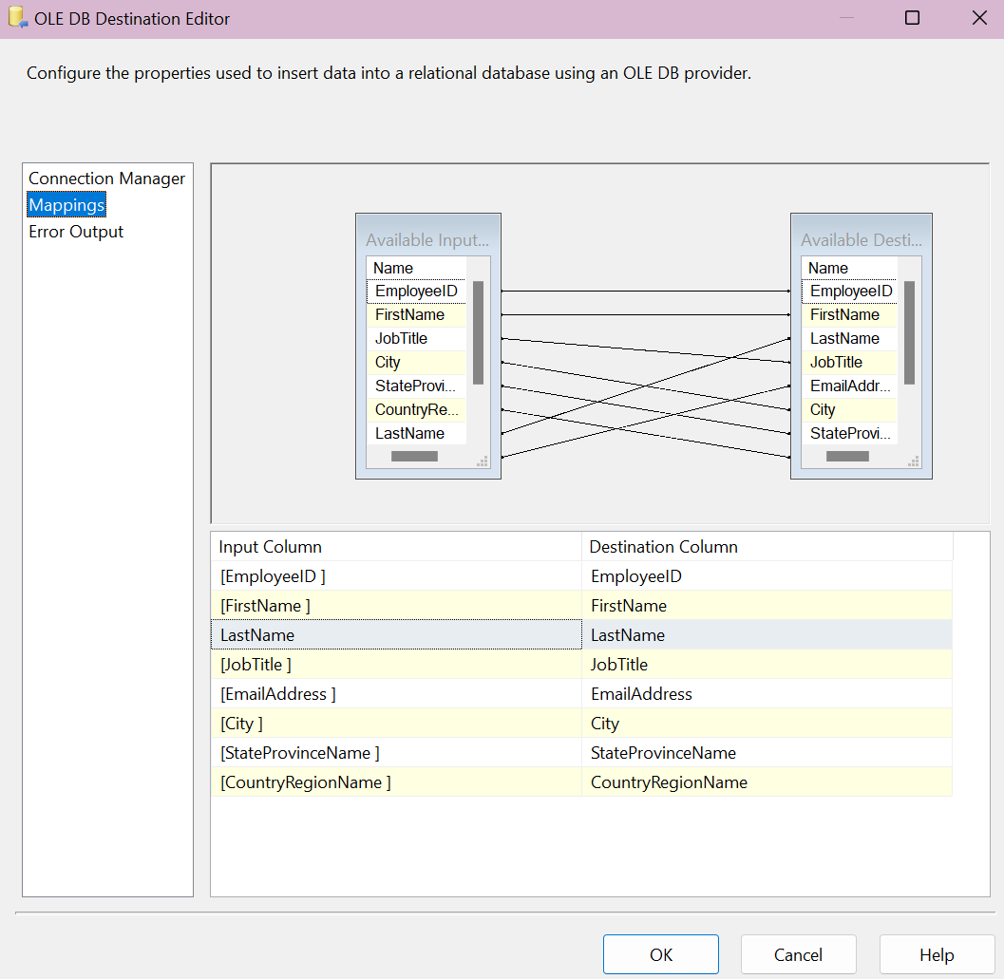

Script to send email:

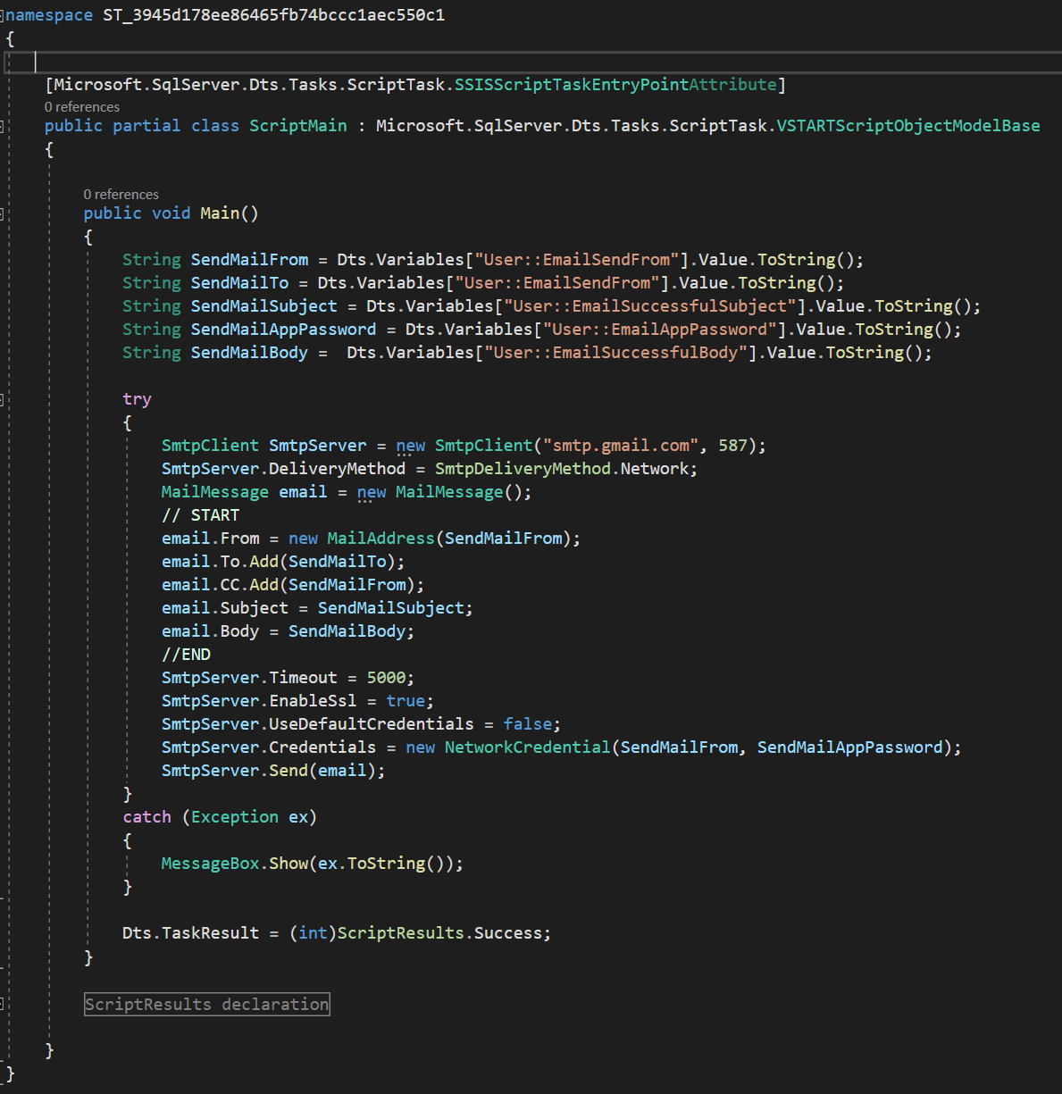

Results:



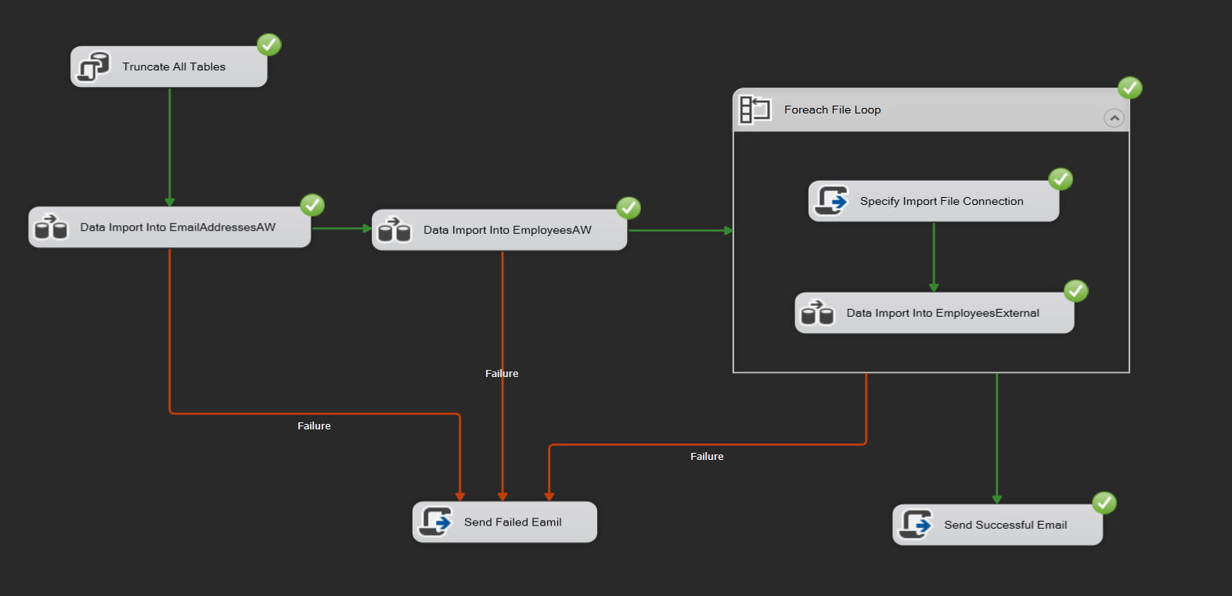

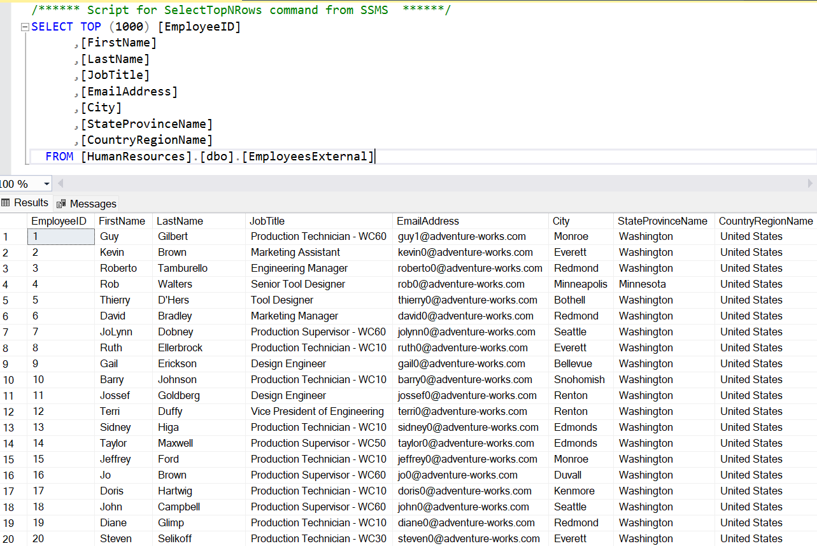

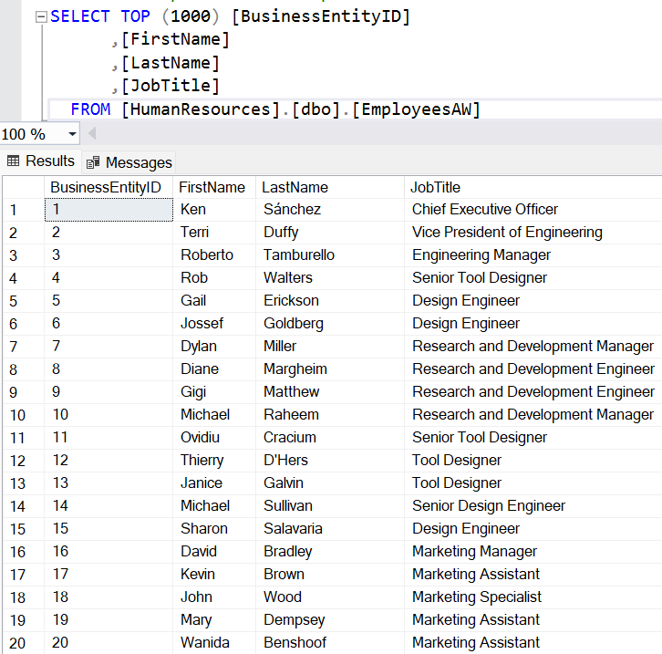

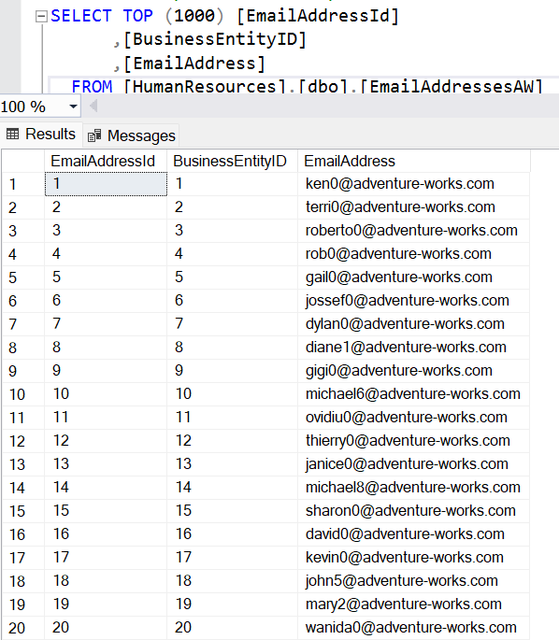

**3. Exercise 3: Creating ETL solution to export the data from HumanResourcesdb**

Here I decided to use additional Null Condition, cause In Source Table Its acceptable to have JobTitle as Null value. We load such records in file EmpNull.txt.

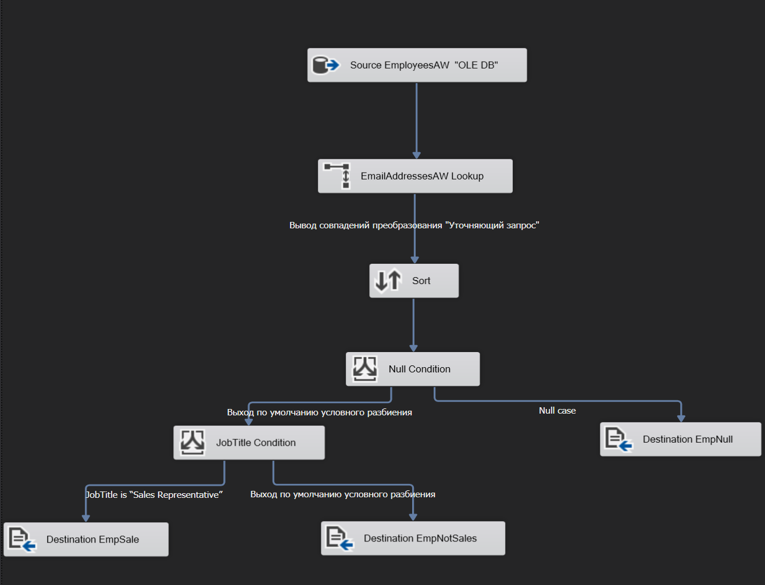

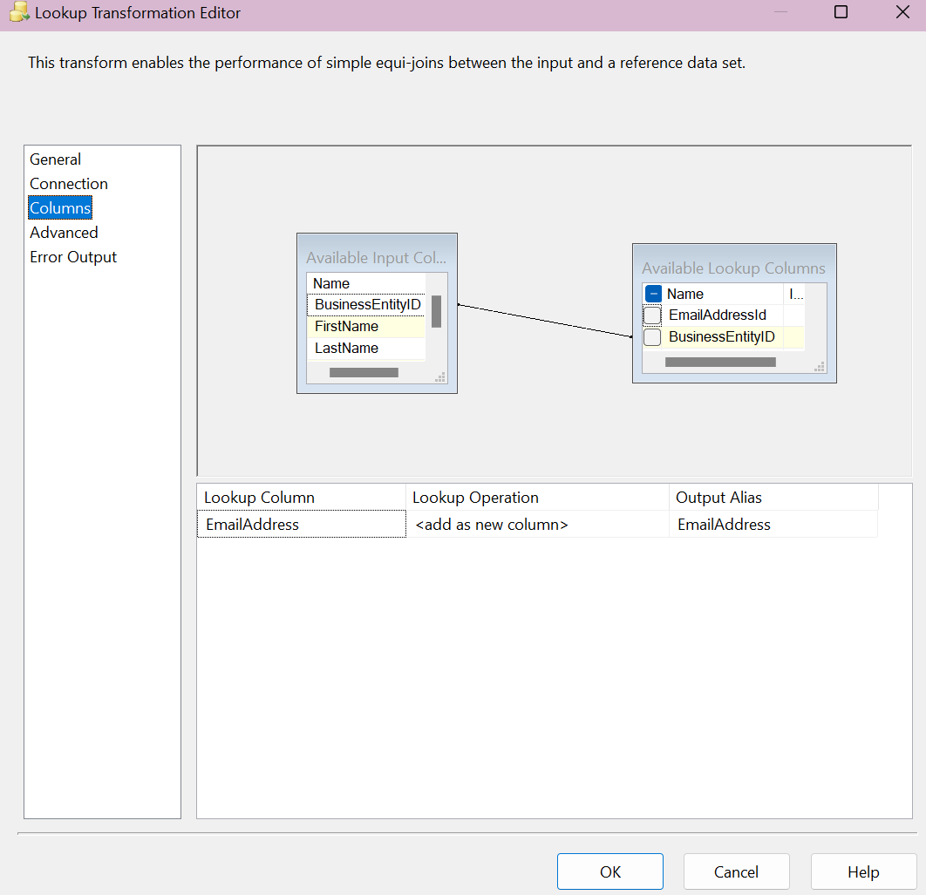

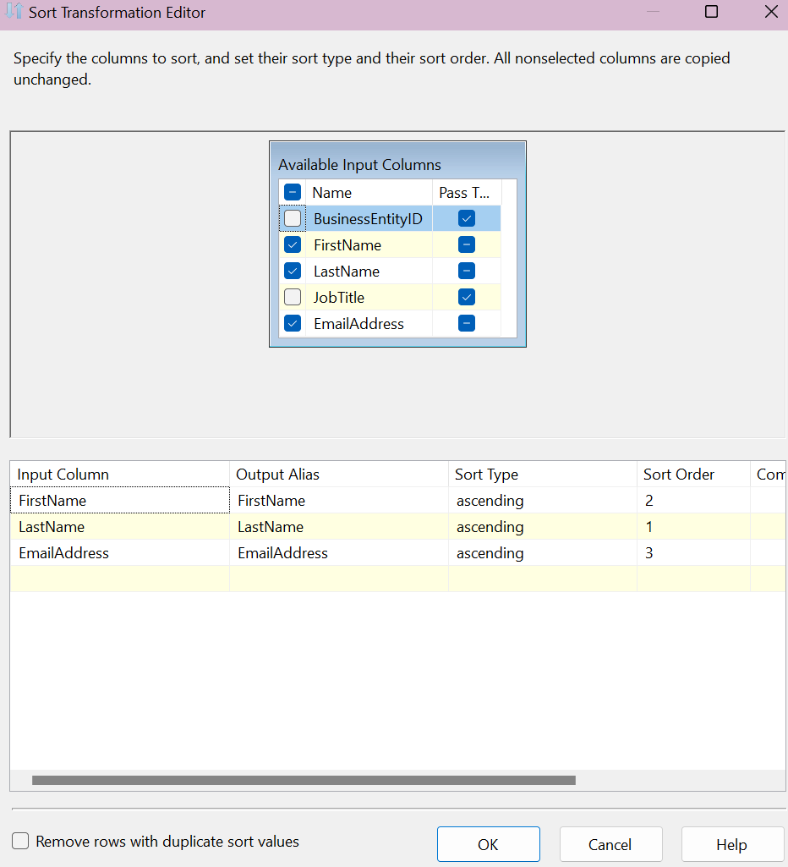

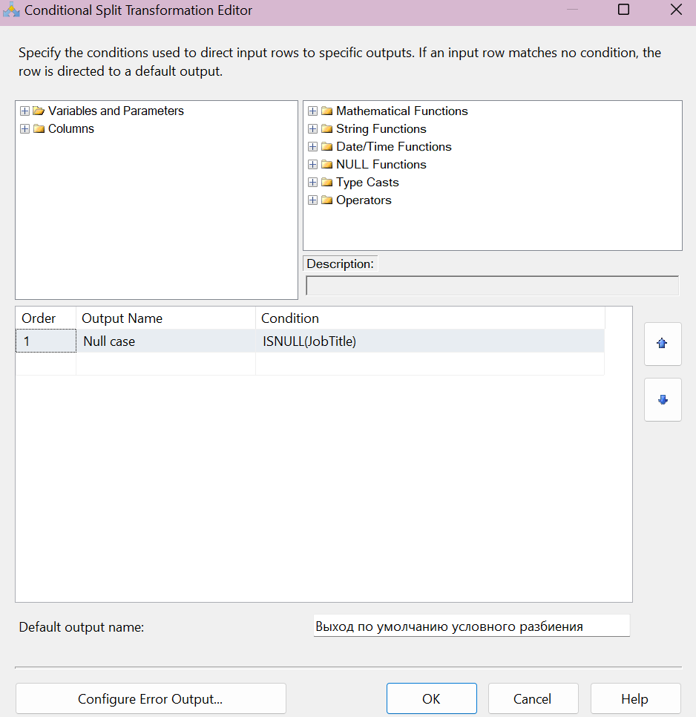

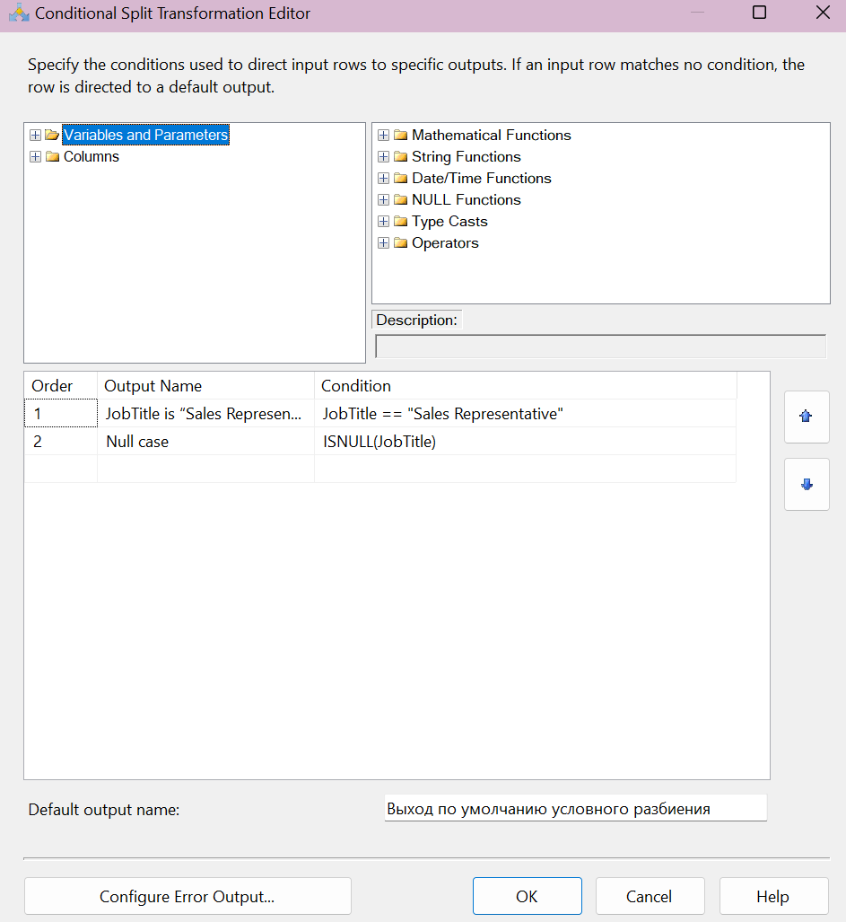

Results:

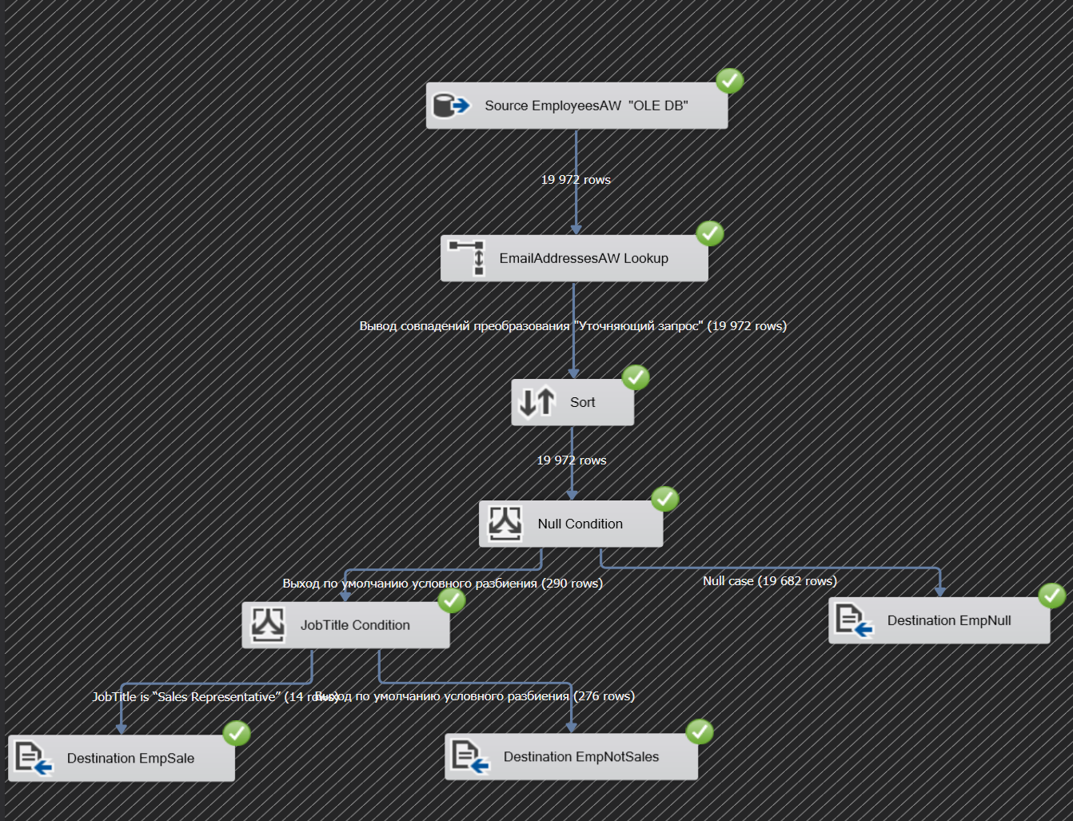

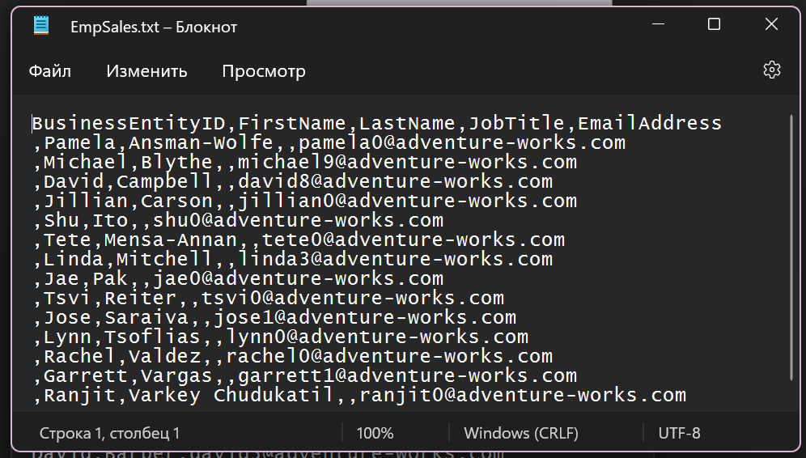

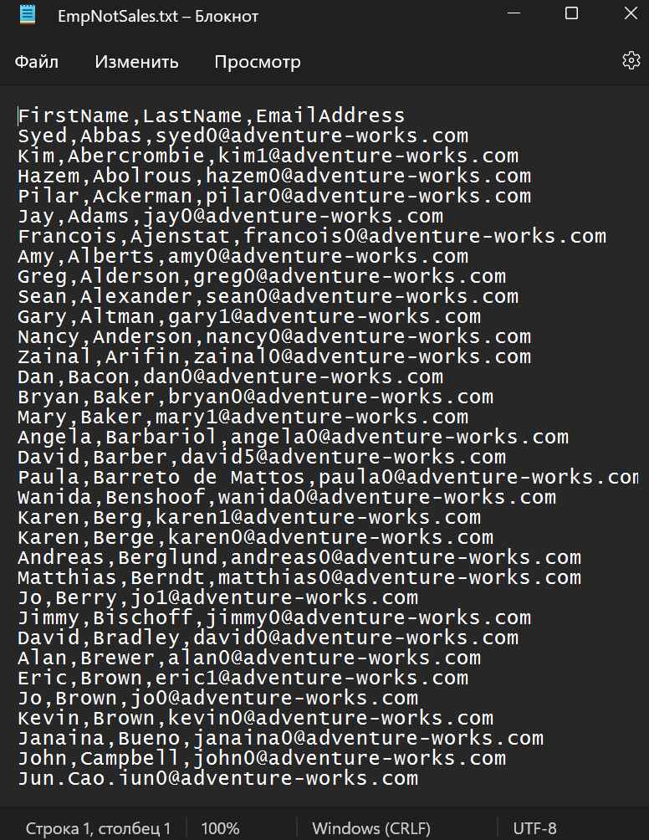

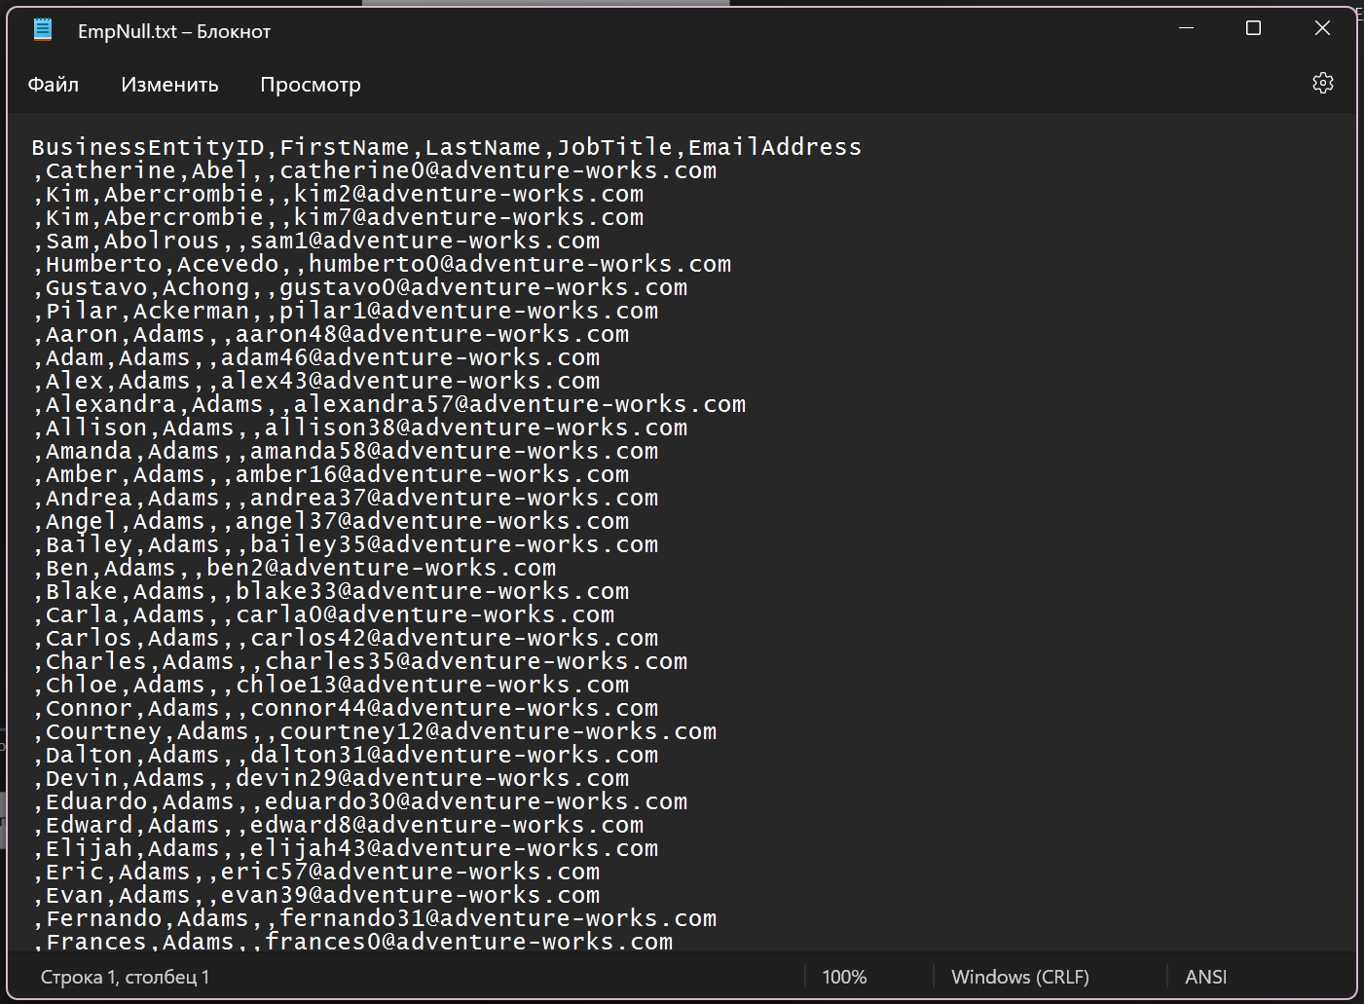

**4. Exercise 4: Using Data Viewers**

