 | UNITED REPUBLIC OF TANZANIA  MINISTRY OF TRANSPORT  TANZANIA METEOROLOGICAL AUTHORITY  Five days Severe weather impact-based forecasts | 
Issued on Saturday: 08-03-2025: 15:30 (EAT)
Saturday: 08-03-2025
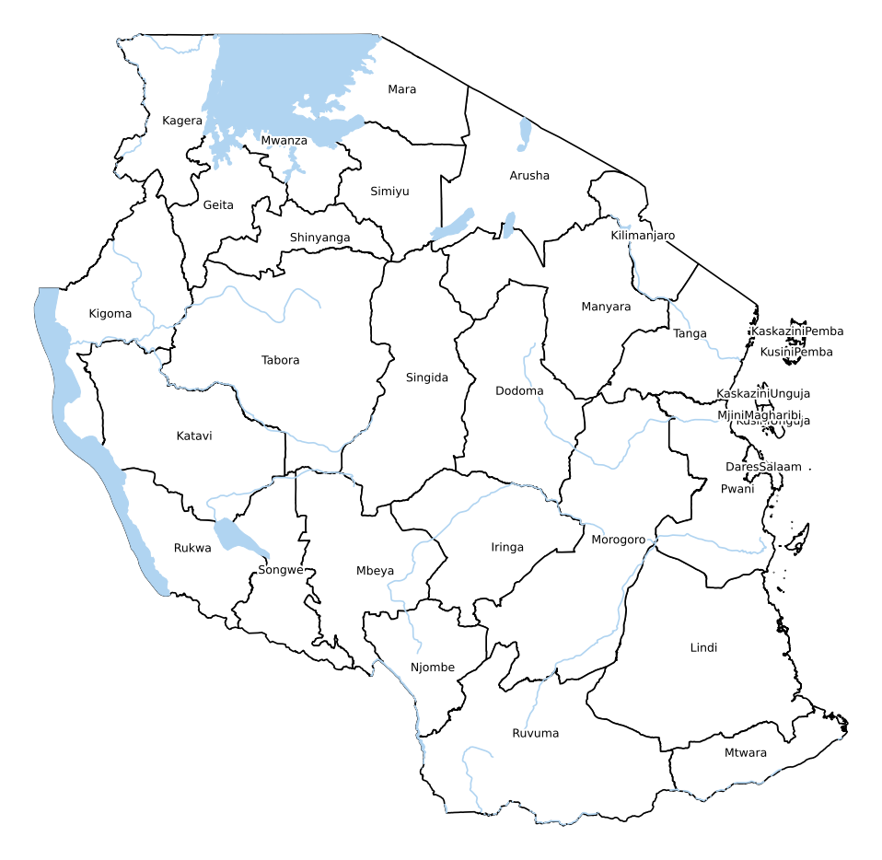  KEY:  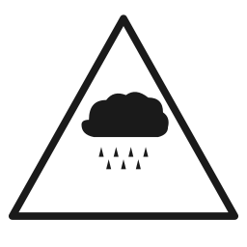 Heavy rain  ██ ADVISORY ██ WARNING ██ MAJOR WARNING | NO WARNING.

All correspondences should be directed to:
Director General, Tanzania Meteorological Authority,
University of Dodoma, Administration block, College of Informatics and Virtual Education,
1 CIVE Street, P.O. Box 27, 41218 Dodoma; Tel: + 255 26 2962610: Fax: +255 26 2962610
Email: met@meteo.go.tz; Website: www.meteo.go.tz
(ISO 9001:2015 Certified in Aviation Services)
722E-4 _ 04/2023

 | UNITED REPUBLIC OF TANZANIA  MINISTRY OF TRANSPORT  TANZANIA METEOROLOGICAL AUTHORITY  Five days Severe weather impact-based forecasts | 
Sunday: 09-03-2025 | Monday: 10-03-2025 | Tuesday: 11-03-2025 | Wednesday: 12-03-2025
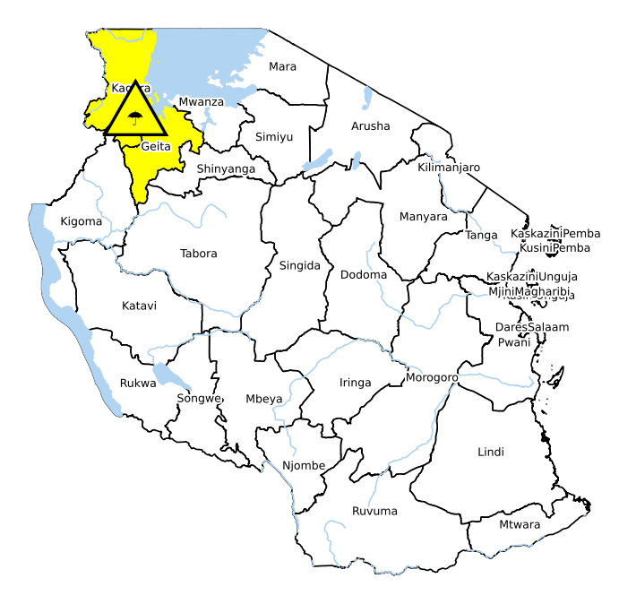 | 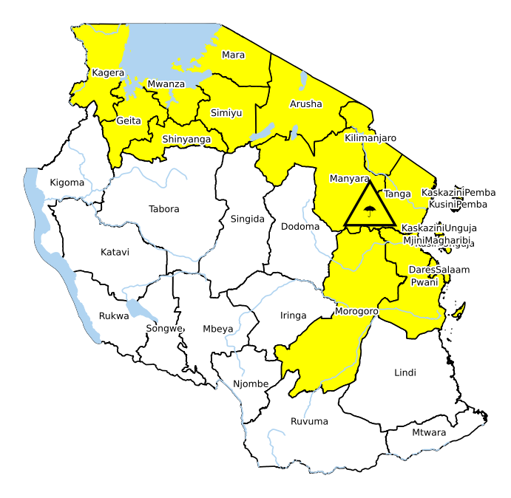 | 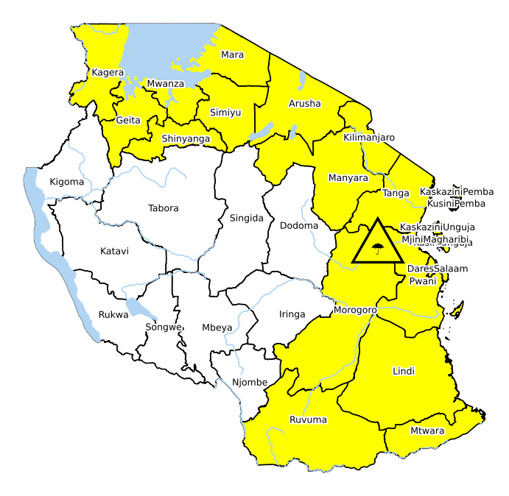 | 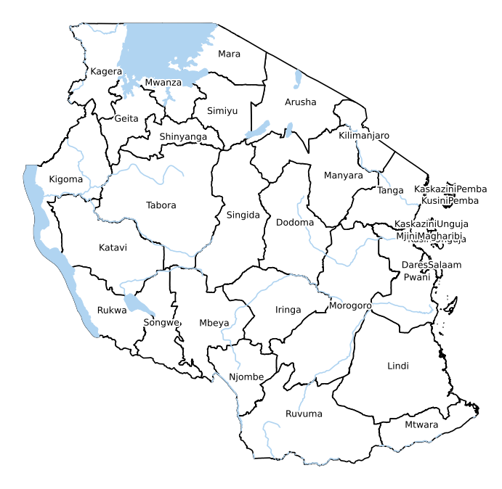
ADVISORY of heavy rain is issued over few areas of western areas of Kagera and Geita regions.  Likelihood: MEDIUM  Impact: MEDIUM  Impacts expected:  Localized floods over few areas.  Please be prepared. | ADVISORY of heavy rain is issued over few areas of Kagera, Geita, Mwanza, Simiyu, Shinyanga, Mara, Arusha, Kilimanjaro, Manyara, Tanga, Morogoro, Pwani, Dar es Salaam regions, Unguja and Pemba islands.  Likelihood: MEDIUM  Impact: MEDIUM  Impacts expected:  Localized floods and disruption of socio-economic activities over few areas.  Please be prepared. | ADVISORY of heavy rain is issued over few areas of Kagera, Geita, Mwanza, Simiyu, Shinyanga, Mara, Arusha, Kilimanjaro, Manyara, Tanga, Morogoro, Pwani, Dar es Salaam, Lindi, Mtwara and Ruvuma regions, Unguja and Pemba islands.  Likelihood: MEDIUM  Impact: MEDIUM  Impacts expected:  Localized floods and disruption of socio-economic activities over few areas.  Please be prepared. | NO WARNING.

All correspondences should be directed to:
Director General, Tanzania Meteorological Authority,
University of Dodoma, Administration block, College of Informatics and Virtual Education,
1 CIVE Street, P.O. Box 27, 41218 Dodoma; Tel: + 255 26 2962610: Fax: +255 26 2962610
Email: met@meteo.go.tz; Website: www.meteo.go.tz
(ISO 9001:2015 Certified in Aviation Services)
722E-4 _ 04/2023

