 | THE UNITED REPUBLIC OF TANZANIA  Three days impact-based forecast bulletin  No. 121 Issued on 08/03/2025 | THE PRIME MINISTER'S OFFICE  (POLICY, PARLIAMENT AFFAIRS AND COORDINATION)  DISASTER MANAGEMENT DEPARTMENT  EMERGENCY OPERATION  AND COMMUNICATION CENTER
DAY 1 - 08-03-2025
Heavy Rain  | Large Waves  | Strong Winds  | Floods 
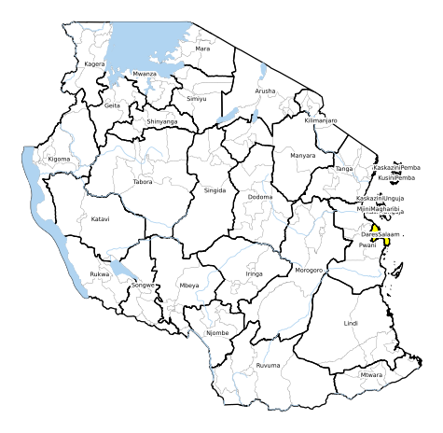 |  |  | 
Multi-hazard assessment and recommendations
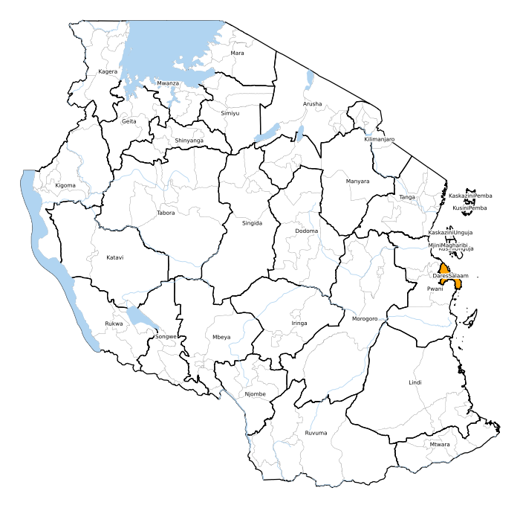 | MAJOR WARNING None  WARNING None  ADVISORY None

 | THE UNITED REPUBLIC OF TANZANIA  Three days impact-based forecast bulletin  No. 121 Issued on 08/03/2025 | THE PRIME MINISTER'S OFFICE  (POLICY, PARLIAMENT AFFAIRS AND COORDINATION)  DISASTER MANAGEMENT DEPARTMENT  EMERGENCY OPERATION  AND COMMUNICATION CENTER
Outlook DAY 1 - 08-03-2025
Comments TMA
heavy rain in Dar es Salaam
Likelihood: MEDIUM
Impact: MEDIUM
MoW Comments
DMD Comments

 | THE UNITED REPUBLIC OF TANZANIA  Three days impact-based forecast bulletin  No. 121 Issued on 08/03/2025 | THE PRIME MINISTER'S OFFICE  (POLICY, PARLIAMENT AFFAIRS AND COORDINATION)  DISASTER MANAGEMENT DEPARTMENT  EMERGENCY OPERATION  AND COMMUNICATION CENTER
DAY 2 - 09-03-2025
Heavy Rain  | Large Waves  | Strong Winds  | Floods 
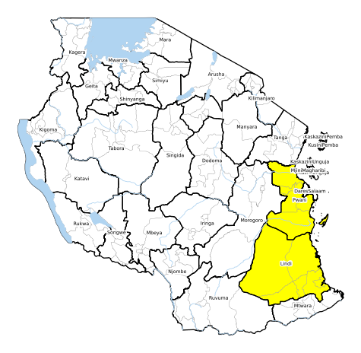 |  |  | 
Multi-hazard assessment and recommendations
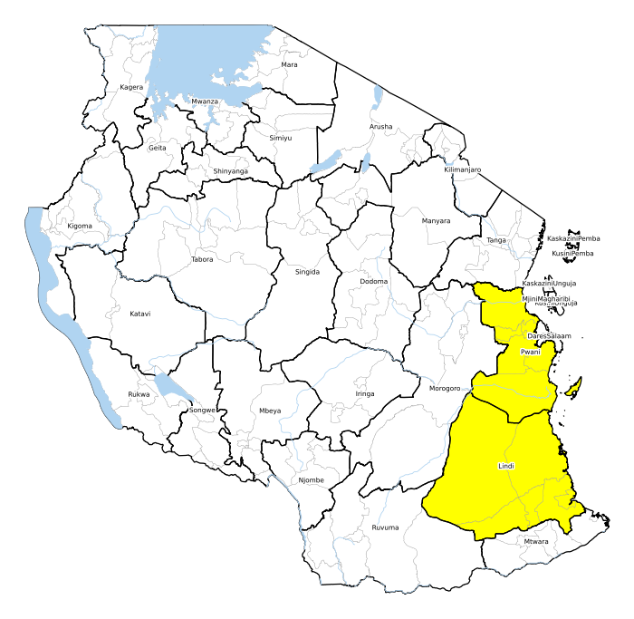 | MAJOR WARNING None  WARNING None  ADVISORY None

 | THE UNITED REPUBLIC OF TANZANIA  Three days impact-based forecast bulletin  No. 121 Issued on 08/03/2025 | THE PRIME MINISTER'S OFFICE  (POLICY, PARLIAMENT AFFAIRS AND COORDINATION)  DISASTER MANAGEMENT DEPARTMENT  EMERGENCY OPERATION  AND COMMUNICATION CENTER
Outlook DAY 2 - 09-03-2025
Comments TMA
strong wind along coast
Likelihood: MEDIUM
Impact: MEDIUM
MoW Comments
DMD Comments

 | THE UNITED REPUBLIC OF TANZANIA  Three days impact-based forecast bulletin  No. 121 Issued on 08/03/2025 | THE PRIME MINISTER'S OFFICE  (POLICY, PARLIAMENT AFFAIRS AND COORDINATION)  DISASTER MANAGEMENT DEPARTMENT  EMERGENCY OPERATION  AND COMMUNICATION CENTER
DAY 3 - 10-03-2025
Heavy Rain  | Large Waves  | Strong Winds  | Floods 
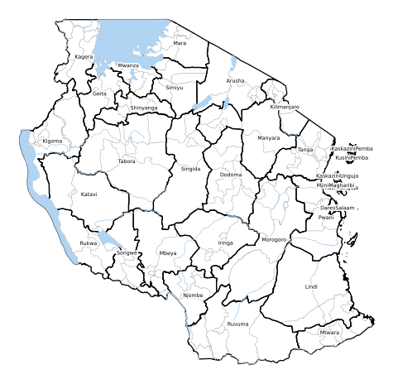 |  |  | 
Multi-hazard assessment and recommendations
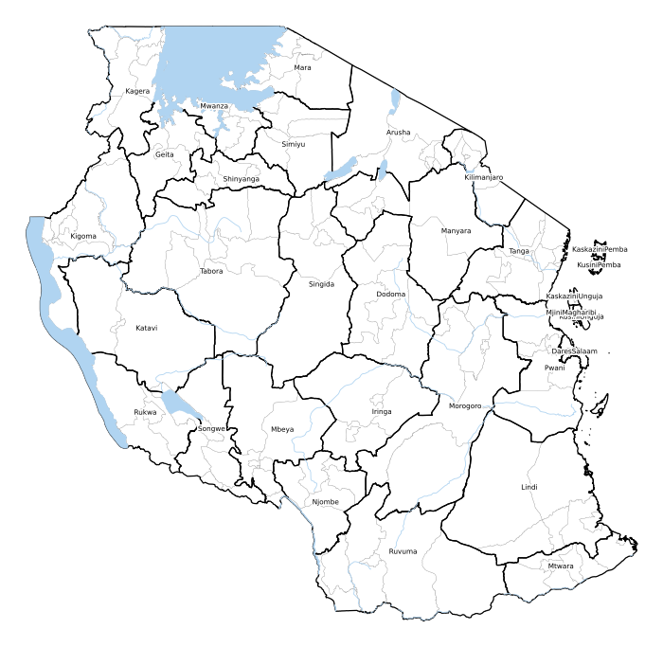 | MAJOR WARNING None  WARNING None  ADVISORY None

 | THE UNITED REPUBLIC OF TANZANIA  Three days impact-based forecast bulletin  No. 121 Issued on 08/03/2025 | THE PRIME MINISTER'S OFFICE  (POLICY, PARLIAMENT AFFAIRS AND COORDINATION)  DISASTER MANAGEMENT DEPARTMENT  EMERGENCY OPERATION  AND COMMUNICATION CENTER
Outlook DAY 3 - 10-03-2025
Comments TMA
NO WARNING.
MoW Comments
DMD Comments

 | THE UNITED REPUBLIC OF TANZANIA  Three days impact-based forecast bulletin  No. 121 Issued on 08/03/2025 | THE PRIME MINISTER'S OFFICE  (POLICY, PARLIAMENT AFFAIRS AND COORDINATION)  DISASTER MANAGEMENT DEPARTMENT  EMERGENCY OPERATION  AND COMMUNICATION CENTER
SUMMARY WARNING DAY 1
MAJOR WARNING
WARNING | Ilala, Kinondoni, Temeke
ADVISORY
SUMMARY WARNING DAY 2
MAJOR WARNING
WARNING
ADVISORY | Bagamoyo, Kibaha, Kibaha Urban, Kilwa, Kisarawe, Lindi Rural, Lindi Urban, Liwale, Mafia, Mkuranga, Nachingwea, Ruangwa, Rufiji
SUMMARY WARNING DAY 3
MAJOR WARNING
WARNING
ADVISORY
Contact us: eocctz@pmo.go.tz
This bulletin for the United Republic of Tanzania is produced by the Disaster Management Department of the Prime Minister Office with the technical and scientific assistance of the Tanzania Meteorological Authority, the Ministry of Water, UNDRR and CIMA Foundation, with support of the Italian Government.
 |  | 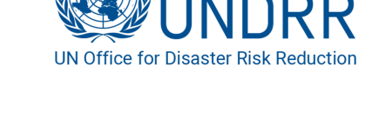 | 

