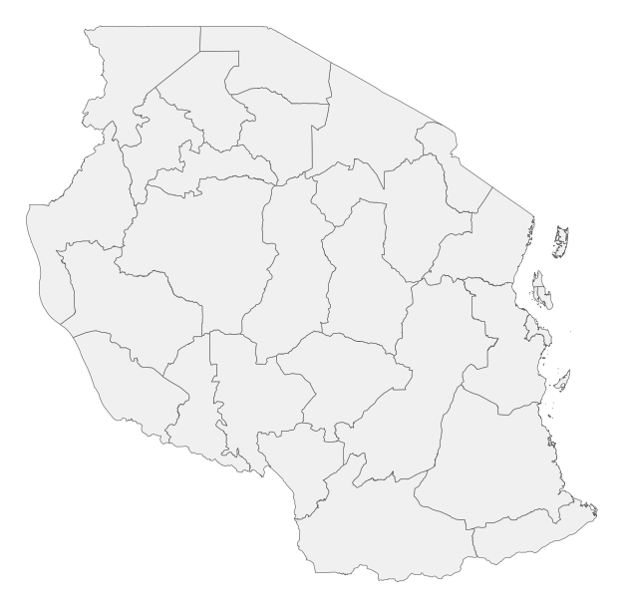  KEY: Heavy rain | NO WARNING.

