 | UNITED REPUBLIC OF TANZANIA  MINISTRY OF TRANSPORT  TANZANIA METEOROLOGICAL AUTHORITY  Five days Severe weather impact-based forecasts | 
Issued on Wednesday: 11-03-2026: 15:30 (EAT)
Wednesday: 11-03-2026
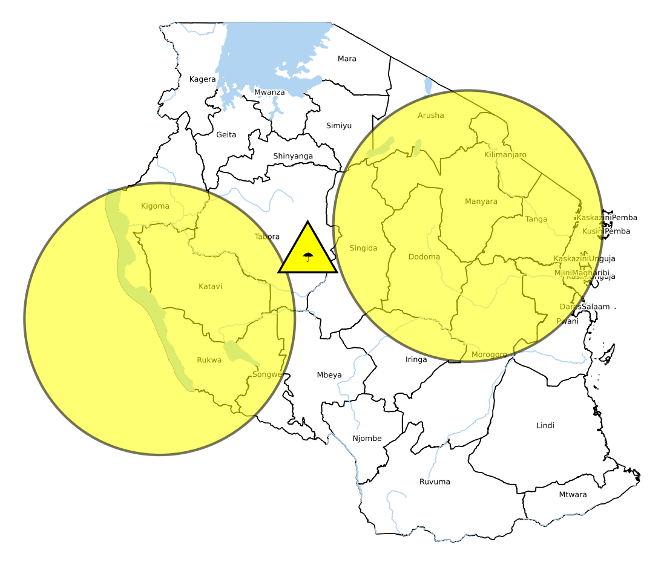  KEY:   Heavy rain  ██ ADVISORY ██ WARNING ██ MAJOR WARNING | ADVISORY jnsjsngWNV  Likelihood: MEDIUM  Impact: MEDIUM  Impacts expected:  ojujjijijioj  Please be prepared.  ADVISORY oygygbuv  Likelihood: MEDIUM  Impact: MEDIUM  Impacts expected:  hkbihshughu  Please be prepared.

All correspondences should be directed to:
Director General, Tanzania Meteorological Authority,
University of Dodoma, Administration block, College of Informatics and Virtual Education,
1 CIVE Street, P.O. Box 27, 41218 Dodoma; Tel: + 255 26 2962610: Fax: +255 26 2962610
Email: met@meteo.go.tz; Website: www.meteo.go.tz
(ISO 9001:2015 Certified in Aviation Services)
722E-4 _ 04/2023

 | UNITED REPUBLIC OF TANZANIA  MINISTRY OF TRANSPORT  TANZANIA METEOROLOGICAL AUTHORITY  Five days Severe weather impact-based forecasts | 
Thursday: 12-03-2026 | Friday: 13-03-2026 | Saturday: 14-03-2026 | Sunday: 15-03-2026
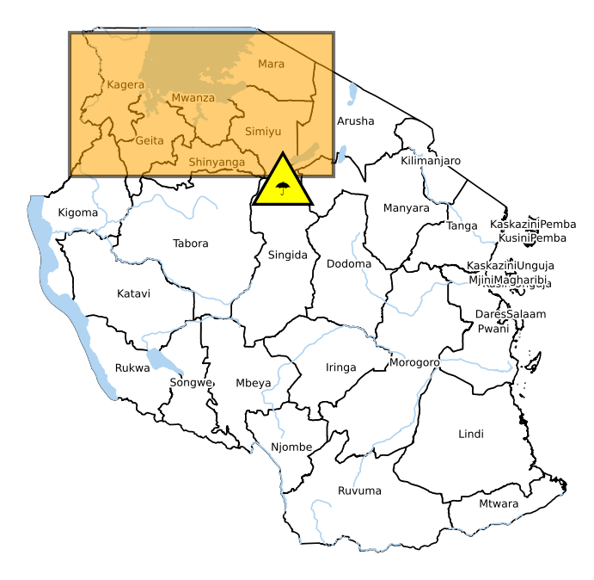 | 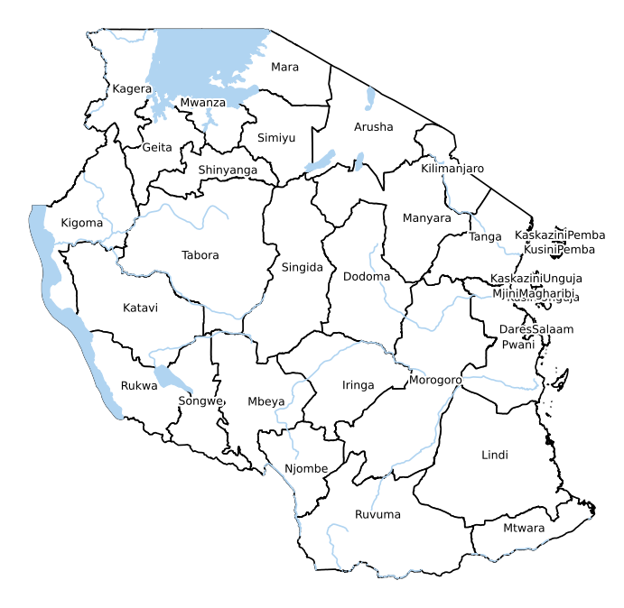 |  | 
WARNING siuhsueihfsu  Likelihood: MEDIUM  Impact: MEDIUM  Impacts expected:  hjhsruih  Please be prepared. | NO WARNING. | NO WARNING. | NO WARNING.

All correspondences should be directed to:
Director General, Tanzania Meteorological Authority,
University of Dodoma, Administration block, College of Informatics and Virtual Education,
1 CIVE Street, P.O. Box 27, 41218 Dodoma; Tel: + 255 26 2962610: Fax: +255 26 2962610
Email: met@meteo.go.tz; Website: www.meteo.go.tz
(ISO 9001:2015 Certified in Aviation Services)
722E-4 _ 04/2023

