MD. MASUD RANA  Entry-Level Java, Spring Boot & Mobile App, Full-Stack Developer | AI-Assisted Development  Mobile: 01575634380 | Email: masudrana.mwp@gmail.com  Location: Bangladesh | Training: IsDB-BISEW IT Scholarship Programme  Live Project: BestCare Health Website | Profiles: LinkedIn [add URL] | GitHub [add URL] | Portfolio [add URL] | Credly [add URL] | Coursera [add URL] | 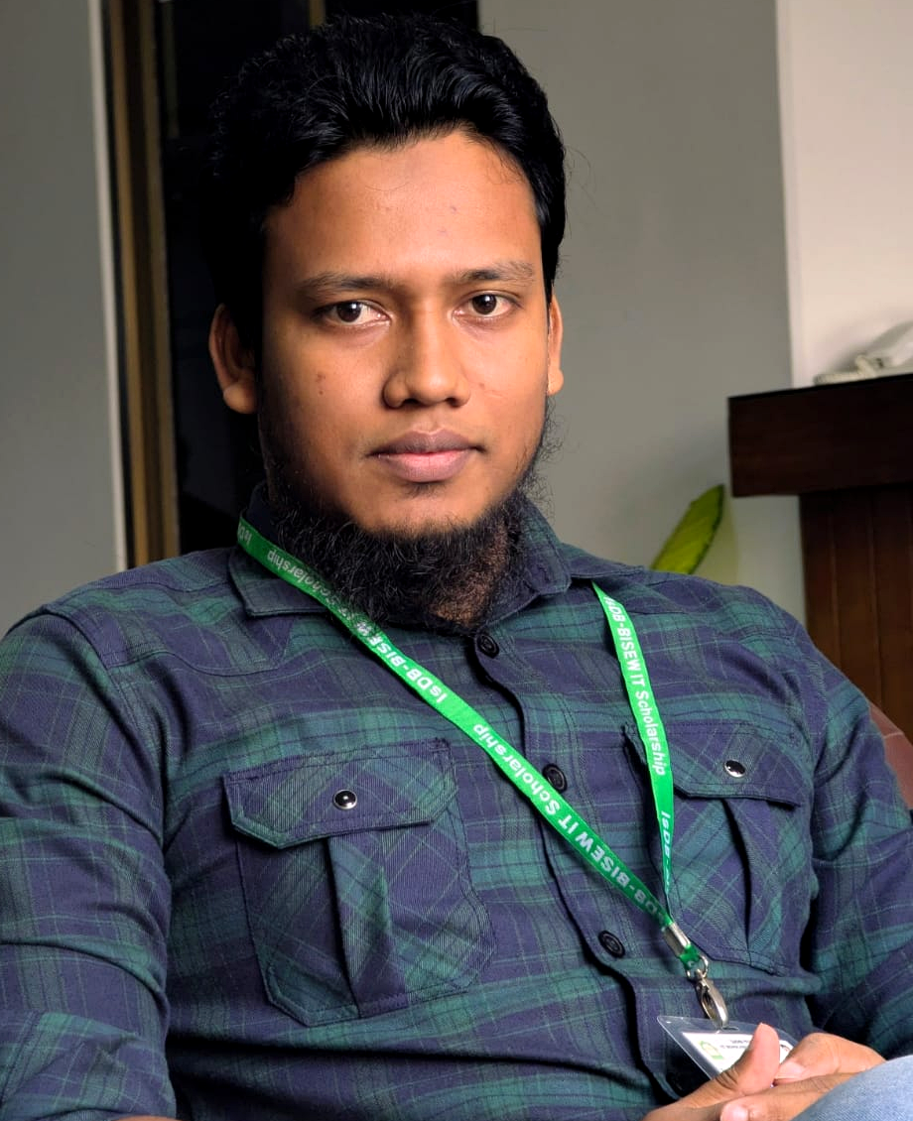
CAREER OBJECTIVE
To start my career as a software developer where I can build reliable web and mobile applications using Java, Spring Boot, Android, Flutter, databases, and AI-assisted development practices. I want to apply my Statistics, research, and software training background to deliver clean, data-driven, well-documented, and user-focused software solutions.
PROFESSIONAL SUMMARY
Entry-level developer with hands-on training in Spring Boot, Angular, Android, Flutter, Oracle 19c, Java OOP, REST API, and reporting. Completed BSc and MSc in Statistics, with an academic research paper using survey data and statistical analysis. Built projects including a live healthcare website, a Spring Boot and Angular banking system, an Android messaging app, and an ongoing Flutter mobile banking app. Experienced in AI-assisted software development workflows using Claude, Cursor Agent, Codex, Gemini, local AI agents, third-party APIs, prompt templates, repo context, code generation, refactoring, debugging, testing, and documentation.
TECHNICAL SKILLS
Programming | Java, Dart, Python, Kotlin, SQL, JavaScript, Typescript, C, C++, R, HTML5, CSS3, XML
Backend | Spring Boot, Spring, Swing, REST API, Servlet, JSP, JSF, Hibernate, Jpa, Maven, Gradel, JasperReports
Frontend & Mobile | Angular, Bootstrap, Android, Flutter, Material UI, Jetpack Compose, responsive web/mobile screens
Database & Data | Oracle 19c, SQL, PL/SQL basics, SPSS/R/Excel analysis, reporting, visualization
Tools | Git, GitHub, Postman, IntelliJ IDEA, Android Studio, VS Code, Antigravity, Eclipse, NetBeans, emulator/device testing
Concepts | OOP, UML, MVC, layered architecture, authentication, API integration, debugging
AI-assisted Development | Claude, Cursor Agent, Codex, Gemini, local AI agents, third-party APIs, prompt templates, repository context, code generation, refactoring, debugging, test generation, documentation
PROFESSIONAL TRAINING
Web and Mobile App Development using Spring Boot, Android & Flutter | Duration: 8.5/10 months | Hours: 788
Trainee ID: 1292522 | Batch: JEE/CGNT-A/68/01 | Programme: IsDB IT Scholarship Programme
- Modules: Web Publishing & Bootstrap, Oracle 19c Database, Java OOP, XML, OO System Analysis & UML, Servlet, JSP, JSF, Hibernate, Angular, Spring, Spring Boot, JasperReports, Android, and Flutter.
PROJECTS
AI-Assisted Java Developer Workflow & Coding Environment Portfolio | Claude, Cursor Agent, Codex, Gemini, Local AI Agent, Third-party API, Java/Spring Boot workflow
- Prepared developer-focused setup and usage guides/presentations for AI coding environments, IDE integration, repository context, prompt templates, code review, refactoring, debugging, testing, and documentation workflow.
- Practiced using AI tools in software development to explain code, generate boilerplate, review diffs, troubleshoot errors, write tests, and document implementation steps safely.
Portfolio/Presentation link: [add URL]
BestCare Health - Healthcare Website | HTML, CSS, Bootstrap, JavaScript, responsive website, GitHub Pages
- Designed and published a live healthcare/service website with clean sections, responsive layout, and public hosting.
Link: View Live Project
ENTERPRISE PROJECT - Banking Management System | Spring Boot, Angular, MySQL, REST API, Authentication, Reports
- Developed modules for customer, account, transaction, statements, reports, role-based access and total 22 modules.
- Worked with layered backend architecture using controller, service, repository, entity/DTO, validation, abstraction/impl and API endpoints.
Link: View Live Project

ContactMe - Android Messaging & Calling App | Android, Firebase Auth/Firestore, Firebase Storage, FCM, WebRTC foundation
- Built authentication, profile, realtime chat workflow, media/document sharing, voice messaging, notifications, navigation, permissions, and call signaling foundation.
Link: View Live Project
Dart/Flutter Mobile Banking App - bKash-like Project (Ongoing) | Flutter, Dart, Material UI, mobile banking workflow
- Building a mobile banking style app with account dashboard, transaction flow, send money/payment style screens, reusable widgets, and clean navigation.
Link: Ongoing

ACADEMIC RESEARCH
Relationship Between Study Hours and Academic Performance Among University Students in Bangladesh | Research Methodology Project | Department of Statistics, Dhaka College Under Dhaka University | Submitted: Oct 02, 2024
- Conducted a quantitative, cross-sectional survey-based research project on undergraduate university students in Bangladesh; sample size: 235 respondents.
- Applied statistical analysis including descriptive statistics, Pearson correlation, independent samples t-test, ANOVA, and multiple regression using Excel/SPSS/R/Python workflow.
- Research paper link: View Live Project
EDUCATION
MSc in Statistics | University of Dhaka | Passing Year: 2026 | Result/CGPA: Not yet published
BSc in Statistics | University of Dhaka | Passing Year: 2025 | Result/CGPA: 3.09 out of 4
HSC in Science Group | Monipur Uccha Viddalay and College | Passing Year: 2019 | Result/GPA: 4.08 out of 5
SSC in Science Group | Kathalia Pilot Model High School | Passing Year: 2016 | Result/CGPA: 5 out of 5
MICROSOFT / VENDOR CERTIFICATIONS
Certificate | Full Name | Credential Link
AZ-204 | Developing Solutions for Microsoft Azure | View Certificates
PL-400 | Microsoft Power Platform Developer | View Certificates
DP-600 | Implementing Analytics Solutions Using Microsoft Fabric | View Certificates
AI-900 | Microsoft Azure AI Fundamentals | View Certificates
RELEVANT COURSERA CERTIFICATIONS
Certification | Provider | Completed | Credential Link
Google Data Analytics Professional Certificate | Google | Feb 2023 | View Certificates
Data Science Fundamentals with Python and SQL Specialization | IBM | Jul 2023 | View Certificates
Learn SQL Basics for Data Science Specialization | UC Davis | Aug 2023 | View Certificates
Big Data Specialization | UC San Diego | Aug 2023 | View Certificates
Data Visualization with Tableau Specialization | UC Davis | Jul 2023 | View Certificates
Data Analysis and Presentation Skills: the PwC Approach | PwC | Aug 2023 | View Certificates
REFERENCES
Md. Moshaidul Islam  Organization: IsDB-BISEW IT Scholarship Programme  Designation: Consultant  Email: moshaidul@gmail.com  Phone/Mobile: +8801711071219  Relation: Academic / Consultant | Muhammad Maruf Hasan  Organization: IsDB-BISEW IT Scholarship Programme  Designation: Instructor  Email: maruf.tcl@gmail.com  Phone/Mobile: +8801825970006  Relation: Academic / Instructor
ADDITIONAL INFORMATION
Languages: Bangla, English | Strengths: Analytical problem solving, fast learning, documentation, debugging, teamwork, AI-assisted coding workflow, prompt engineering for development

