MD. MASUD RANA  FULL STACK, ANDROID & CROSS-PLATFORM DEVELOPER   +880 1575634380  github.com/masud-rana-pro  masud-rana-pro.github.io  masudrana.mwp@gmail.com  linkedin.com/in/masudmwp  Rupnagar R/A,Mirpur-2, Dhaka-1216 | 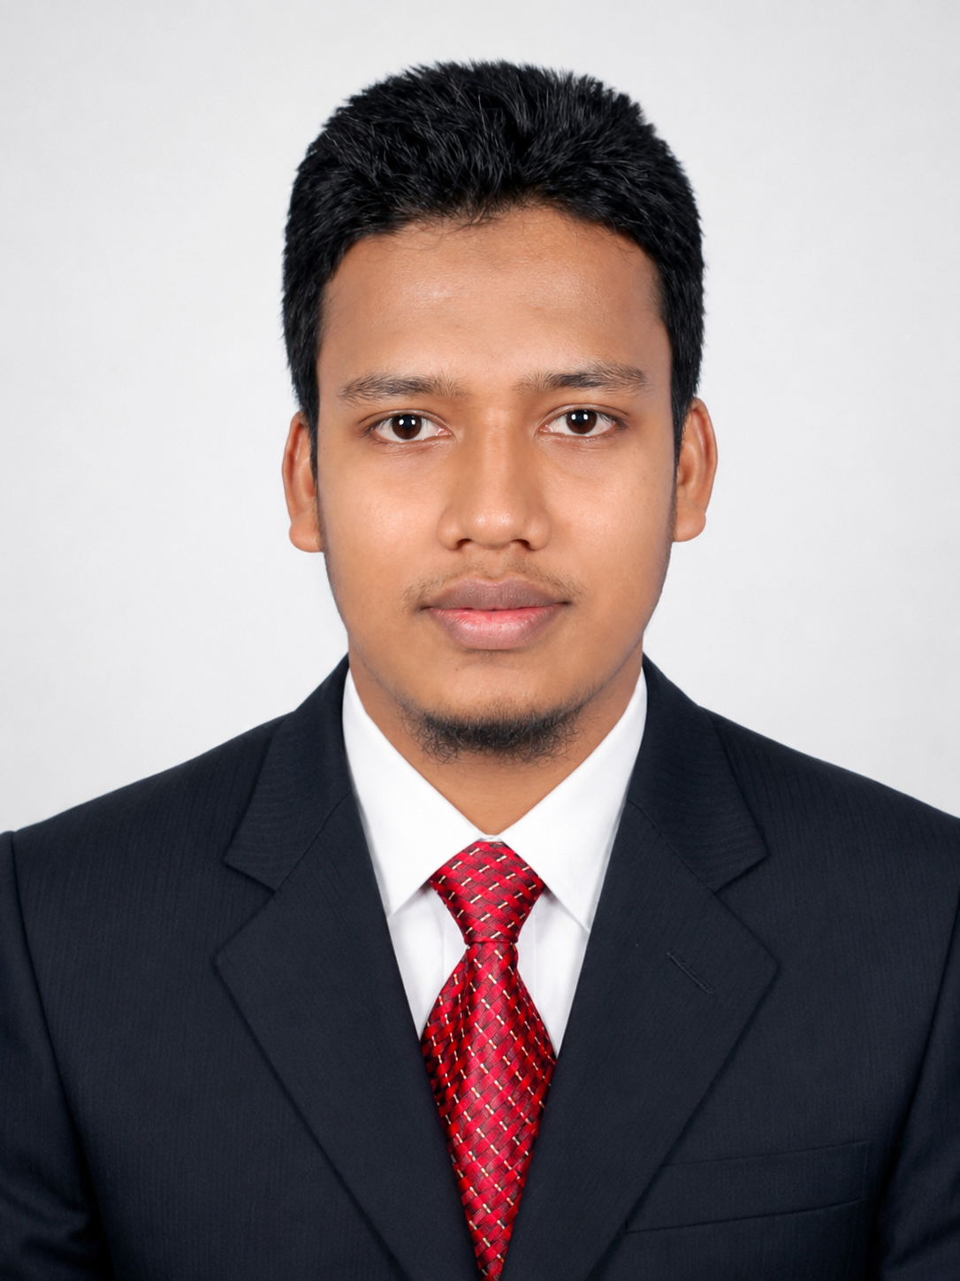
CAREER OBJECTIVE
To start my career as a software developer where I can build reliable web and mobile applications using Java, Spring Boot, Android, Flutter, databases, and AI-assisted development practices. I want to apply my Statistics, research, and software training background to deliver clean, data-driven, well-documented, and user-focused software solutions.
PROFESSIONAL TRAINING
Web and Mobile App Development using Spring Boot, Android & Flutter
Programme: IsDB IT Scholarship Programme Duration: 10.5 months | Hours: 788
- Modules: Web Publishing & Bootstrap, Oracle 19c Database, Java OOP, XML, OO System Analysis & UML, Servlet, JSP, JSF, Hibernate, Angular, Spring, Spring Boot, JasperReports, Android, and Flutter.
EDUCATION
MSc in Statistics | University of Dhaka | Passing Year: 2026 | Result/CGPA: Not yet published
BSc in Statistics | University of Dhaka | Passing Year: 2025 | Result/CGPA: 3.19 out of 4
HSC in Science Group | Monipur Uccha Viddalay and College | Passing Year: 2019 | Result/GPA: 4.08 out of 5
SSC in Science Group | Kathalia Pilot Model High School | Passing Year: 2016 | Result/GPA: 5 out of 5
VENDOR CERTIFICATIONS
Certificate | Full Name | Credential Link
AZ-204 | Developing Solutions for Microsoft Azure | View Certificates
PL-400 | Microsoft Power Platform Developer | View Certificates
DP-600 | Implementing Analytics Solutions Using Microsoft Fabric | View Certificates
AI-900 | Microsoft Azure AI Fundamentals | View Certificates
RELEVANT CERTIFICATIONS
Certification | Provider | Completed | Credential Link
Google Data Analytics Professional Certificate | Google | Feb 2023 | View Certificates
Data Science Fundamentals with Python and SQL Specialization | IBM | Jul 2023 | View Certificates
Learn SQL Basics for Data Science Specialization | UC Davis | Aug 2023 | View Certificates
Big Data Specialization | UC San Diego | Aug 2023 | View Certificates
Data Visualization with Tableau Specialization | UC Davis | Jul 2023 | View Certificates
Data Analysis and Presentation Skills: the PwC Approach | PwC | Aug 2023 | View Certificates
TECHNICAL SKILLS
Programming | Java, Dart, Python, Kotlin, SQL, JavaScript, Typescript, C, C++, R, HTML5, CSS3, XML
Backend | Spring Boot, Spring, Swing, REST API, Servlet, JSP, JSF, Hibernate, Jpa, Maven, Gradel, Reports
Frontend & Mobile | Angular, Bootstrap, Android, Flutter, Material UI, Jetpack Compose, responsive web/mobile screens
Database & Data | Oracle 19c, SQL, PL/SQL basics, SPSS/R/Excel analysis, reporting, visualization
Tools | Git, GitHub, Postman, IntelliJ IDEA, Android Studio, VS Code, Antigravity, Eclipse, NetBeans, emulator/device testing
Concepts | OOP, UML, MVC, layered architecture, authentication, API integration, debugging
AI-assisted Development | Claude, Cursor Agent, Codex, Gemini, local AI agents, third-party APIs, prompt templates, repository context, code generation, refactoring, debugging, test generation, documentation
PROJECTS
BestCare Health - Healthcare Website | HTML, CSS, Bootstrap, JavaScript, responsive website, GitHub Pages
- Designed and published a live healthcare/service website with clean sections, responsive layout, and public hosting.
Link: View Live Project
Al-Barakah Shariah Bank PLC -Shariah Banking Management System | Spring Boot, Angular, MySQL, REST API, Authentication, Reports, WebSocket, pdf generation, JPA, Hibernate, JWT, Maven
- Developed modules for customer, account, transaction, statements, reports, role-based access and total 22 modules.
- Worked with layered backend architecture using controller, service, repository, entity/DTO, validation, abstraction/impl and API endpoints.
Link: Project Video | Project GitHub
ContactMe - Android Messaging & Calling App | Android, Firebase Auth/Firestore, Claudinary Storage, Cloudflare, FCM, WebRTC, Content Provider, Camera, Voice Recording
- Built authentication, profile, realtime chat workflow, media/document sharing, voice messaging, notifications, navigation, permissions, and calling.
Link: Project Video | Project GitHub
SmartKash - Mobile Banking App | Flutter, Dart, Material UI, mobile banking workflow
- Description: Technology: Flutter, Dart, Firebase, PostgreSQL, Material UI, Mobile Banking Workflow; Project Overview: Add Money, Send Money, Cash Out, Payment, Statement, Transaction, Savings, Loan, Mobile Recharge, Pay Bill
Link: Project Video | Project GitHub
AI-Assisted Developer Workflow & Coding Environment Portfolio | Claude, Cursor Agent, Codex, Gemini, Local AI Agent, Third-party API, Java/Spring Boot workflow
Presentation link: View Presentation
ACADEMIC RESEARCH
Relationship Between Study Hours and Academic Performance Among University Students in Bangladesh | Research Methodology Project | Department of Statistics, Dhaka College Under Dhaka University | Submitted: Oct 02, 2024
- Research paper link: View Paper
ADDITIONAL INFORMATION
Languages: Bangla, English | Strengths: Analytical problem solving, fast learning, documentation, debugging, teamwork, AI-assisted coding workflow, prompt engineering for development
REFERENCES
Md. Moshaidul Islam  Organization: IsDB-BISEW IT Scholarship Programme  Designation: Consultant  Email: moshaidul@gmail.com  Phone/Mobile: +8801711071219  Relation: Academic / Consultant | Muhammad Maruf Hasan  Organization: IsDB-BISEW IT Scholarship Programme  Designation: Instructor  Email: maruf.tcl@gmail.com  Phone/Mobile: +8801825970006  Relation: Academic / Instructor

