**Plot for Soft Margin SVM (dual form) using quadprog() function:**

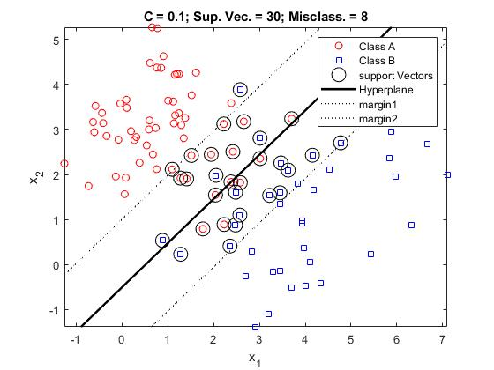

Figure 1: Plot for linearly non-separable=0.1

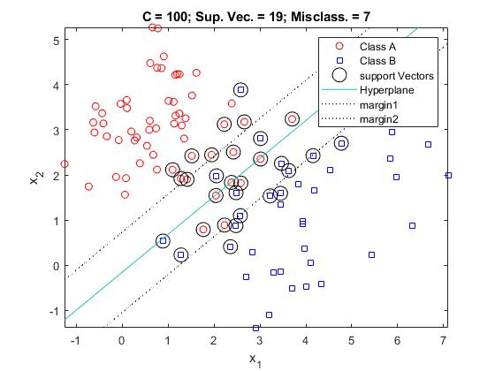

Figure 2: Plot for linearly non-separable=100

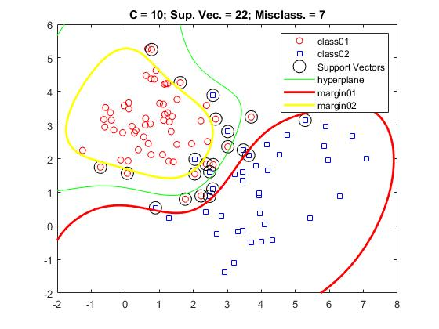

Figure 3: Plot for nonlinearly non-separable C=10

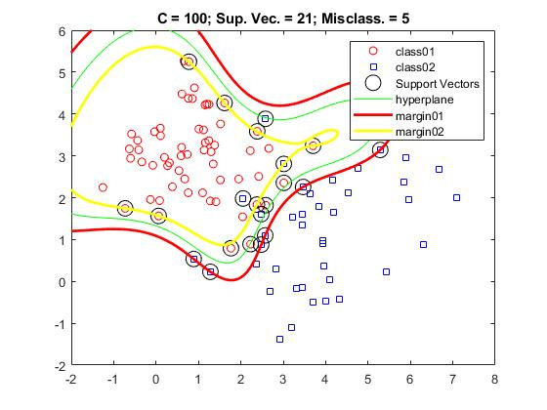

Figure 4: Plot for nonlinearly non-separable C=100

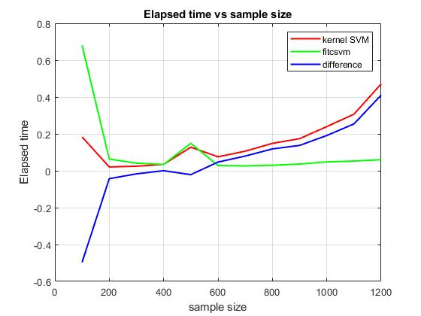

Figure 5: Comparison of computational efficiency

|  |  |  |  |
| --- | --- | --- | --- |
| **Type** | **Value of C** | **Support vectors** | **Misclassification** |
| Linearly non-separable | 0.1 | 30 | 8 |
| Linearly non-separable | 100 | 19 | 7 |
| Non-linearly Separable | 10 | 22 | 7 |
| Non-linearly Separable | 100 | 21 | 5 |

**Summary Table:**