# Education

**Secondary School Certificate 2017**

Aftabgonj B U High School

4.88

**Higher Secondary Certificate 2020**

Dinajpur Govt. College

4.89

# Skill

* Programming Languages: C, C++, Python, HTML, CSS, JavaScript
* Version Control: Git, GitHub
* Office Tools: Microsoft Office 2016(Word, PowerPoint), Google Docs
* Operating System: Windows

# Hobbies

* Music
* Traveling
* Bike Ride
* Poem Writting

# Achievement

• Take-off Programming Contest 2021

• DIU Intra University Programming Contest 2021

• Solved more than 669 problem in various online Judge

Student and Programmer

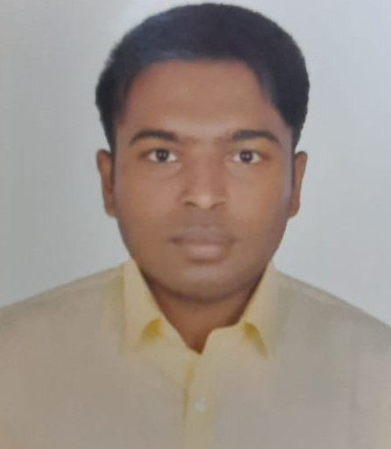

**Phone:**

01722873294

**E-Mail:**

[masud200202@gmail.com](mailto:masud200202@gmail.com)

**Adress:**

Aftabgonj,Nowabgong,Dinajpur

# Personal Details

**Date of Birth:**

03/12/2002

**Nationality:**

Bangladeshi

**Marital Status:**

Single

# Languages

Bengali

English

MOHAMMAD MASUD RANA