Vehicle Theft Detection with Remote Control Engine Locking

MD. Masud Rana, Tanjir Alam, Nayon Kar, MD. Shahjalal Raju

Abstract—Design and implementation of a system called vehicle theft detection with remote controlled engine locking was the main objective of the project. To design this system, Arduino mega, Keypad, IR Sensor, LDR, Vibration sensor, GSM module, Ultrasonic sensor, GPS module etc. have been used. Where Arduino mega was the core of the project and GSM module has been used for both way communications with the system and user phone. This system has developed strong password-based security so that it considers all the conditions other than the correct password as unwanted and notifies the car owner through GSM by sending SMS. Again, if someone can operate the engine without a correct password, then an automatic message will be sent to the user. Later, the car owner will be able to control the car engine and identify the location through cellular communication and GPS technology. In addition, an alternative protection method through ultrasonic sensors has been established in the system.

Index Terms— Arduino mega, vibration sensor, IR sensor, Ultrasonic sensor, Keypad, GSM and GPS module etc.

introduction

Insecurity is one in each of the most provocations that the entire world is facing as of now. Each country having their inquisitive security issues. The rate in each a portion of the society as of now has become a terrific issue is specified vehicle are right now used for accomplishing criminal activities over before. As the quality of human life increases, now a days the number of vehicles is rapidly increasing in a lot of developing countries. According to the survey in 1st October 2015 in Myanmar Times News, the number of vehicles on roads has been nearly doubled since 2011. It is jumping from 2,363,947 to 5,077,699 due to the Ministry of Transportation, Myanmar [1]. At the same time, with the rise within the number of vehicles robbery related to it has also risen exponentially which has become a serious issue within the society. Each year more than 10 million vehicles are stolen around the world and major it remains untracked [2]. Dhaka Metropolitan Police (DMP) sources said over 1,000 motor vehicles including car, motorbike and CNG-run auto-rickshaws were stolen in the last one year [3]. Because of this escalating phenomenon, vehicle proprietors have expressed deep concern on how to secure their cars against this serious offense. In the current market, various types of device have been created to prevent vehicle robbery, but the number of this crime isn't decreasing. Since a little price of safety system or devices in the market cannot ensure such a good quality of security and those that can ensure a little bit of good quality security are again at a higher cost which is beyond the purchasing power of the common people. As well criminals are becoming smarter day by day and have reached the stage of consummation against the existing vehicle safety framework. After considering these all reason, this framework is being introduced. If the vehicle is stolen in any way, the user can easily find out about it through GSM as well as get current location of the vehicle through GPS. After which the user is supposed to send back the message. This message gives command to the vehicle to lock the engine. If it isn't possible for user to take action that time at that point there also a backup system.

LITERATURE REVIEW

Real-time trailing and management of vehicles have been a field of interest for several analyzers. In numerous previous researches works, the authors have given some analytical see of the circuit utilized within the various projects, and whereas in some other global positioning system (GPS) is utilized. The location information is sent within the form of a message containing latitude, longitude, and speed data to the proprietor of the vehicle or area can also be traced using the internet through Google maps. A number of improvements have taken place in anti-theft systems for vehicles and some of the relevant ones are as takes after. In 2018 Shakir M. Ahmed, Hamzah M. Marhoon, and Osman Nuri did a project where the project was the implementation of a smart anti-theft car security system based on GSM. In this framework, the Arduino microcontroller, vibration sensor, GSM SIM 800L module, and Bluetooth HC-05 are utilizing to execute the framework. When the car the proprietor needs to function his car ought to be entering the mystery code to run the car motor through the 4*4 keypad conjointly requires sending particular the command from the smart versatile phone through the Bluetooth to form car motor turning “ON” and something else the car does not work. When the cheat tries to enter the watchword, more than twice the caution will be turning “ON”, all cases will show up on the screen of an extraordinary program that was chosen for this reason all these to create the framework dependable, and more secure [4]. In 2018 at Janson, a project was done by D.Gurunath, Dr. Sreeja Mole S S, Rekha about VEHICLE THEFT DETECTION BY GSM. The most reason for this paper is to prevent vehicle robbery and the functionality is accomplished by identifying vehicle status in theft mode and by sending an SMS is generated automatically. This SMS is sent to the owner of the vehicle. The proprietors can at that point send back the SMS in arrange to debilitate the ignition of the vehicle [5]. On 10, August 2019 a project wasdone by Asmita S. Udagave, S.S. Sankpal about Anti-Theft Locking for Stolen Vehicles and Canny Password Protected Access to Personalized Vehicles. The project proposes a device that tracks the location of your car anytime and anywhere. When the GPS receiver gives information about the coordinates of the vehicle to the microcontroller unit, this information will send back to the user via the GSM module. In an unfavorable situation, if someone manages to break all levels of safety and tries to steal a vehicle, then the owner can lock the vehicle from a remote location at any point [6].

Basic idea of the project

Figure 1 shows the block diagram of the whole system. Main microcontroller used in the system is the Arduino mega. The Arduino will take the input from the input devices and will generate the corresponding output for controlling the motor. Input devices like ignition key, vibration sensor, LDR, GPS module, IR sensor, Keypad, ultrasonic sensor and special key are in the left side of the diagram and output devices like LCD display, DC motor are in the right side of the diagram. For controlling the motor in normal mode, ignition key will be used. Special key will generate abnormal operating mode but in real system, status of the car engine will be used for this purpose. The GSM module will establish both way communication with the user phone. The LCD display will show the status of the system.
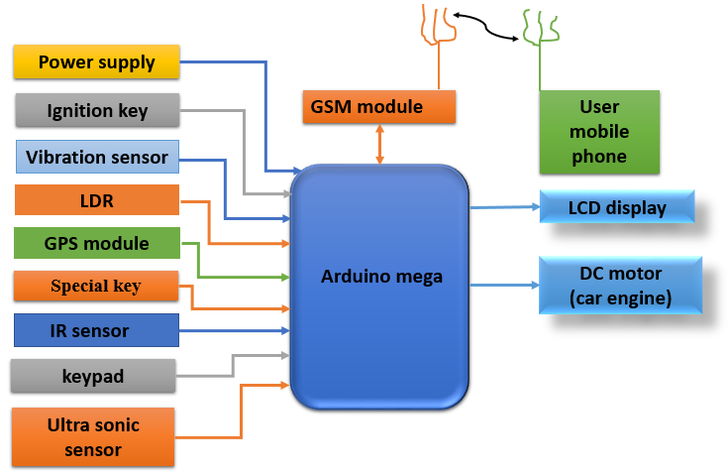

Fig 1. Block diagram

First, for user access, the IR sensor will detect the driver and then the system will request for key. Then the LDR will detect the key and the system will request for password. The keypad will be used for taking the password. If the password is correct then the DC motor can be controlled using the ignition key. There is an additional feature in the system like, if after providing correct password user leave the car putting behind the key, then the system will start counting time. If within preset time user come back in the car, then the system will work normally. However, if the user does not come back within preset time then system will notify the user with SMS that the key left behind and system will go back in lock mode.
If the password is wrong more than three times, then the user will receive SMS through GSM module with the location obtained by GPS module. The vibration sensor will detect the level of vibration. Now if without correct password the motor gets started (through special key) or system get vibrated more than a specific limit then user will receive SMS through GSM module with location obtained by GPS module. In such case, the ultrasonic sensor will be activated. Now using the GSM command from user mobile phone, the DC motor can be stopped permanently or otherwise the function of ultrasonic sensor will stop the DC motor, which is shown in figure 2 and 3. Lastly, after the recovery of the car, user need to send a specific command to the system for initializing the system and after that by providing correct password, user can use the car.

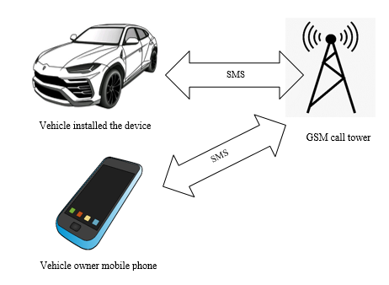

Fig. 2. Communication with user

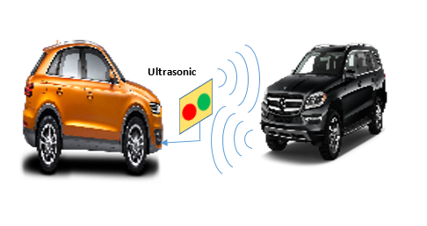
Fig 3. Function of ultrasonic sensor

implemented hardware

Figure 4. Shows the implemented hardware of the project. Here IR sensor and LDR with leaser is used for detecting the driver and key accordingly. Ignition key is used for control the DC motor in normal safe mode. Special key is used for creating the worst-case scenario and to control the motor in unsafe mode. Vibration sensor is used for detecting the vibration level and ultrasonic sensor is used for detecting the distance of any object in front of the car. GPS module is used for location tracking and GSM module is used for wireless communication with user phone. A LCD display is used for showing the status of the system. Arduino mega is used as the main microcontroller of the system.

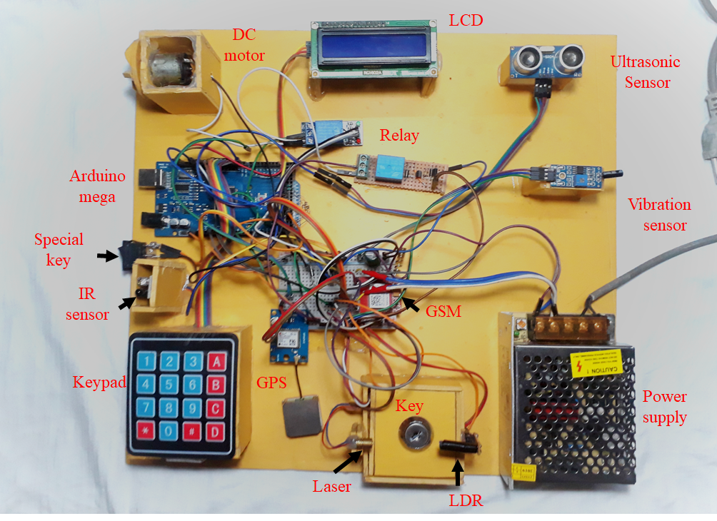
Fig 4. Implemented hardware

result analysis

  - Simulated Result

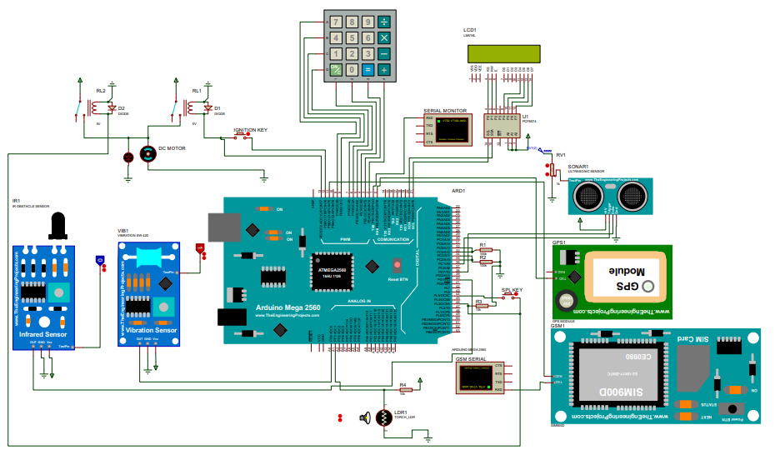
Fig 5. Complete simulated circuit

- Correct password entered
The IR sensor first identified the person and then the key was detected by the LDR. When the correct password was given, the display showed that the password was correct. The motor was then turned on via the ignition key.
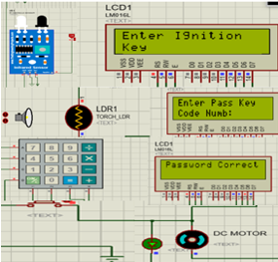
Fig 6. Correct password entered

- No driver and time counting condition
After giving the correct password, the driver left the key in the car. The driver did not arrive within four seconds (preset 4 sec for simulation) so the system went into lock mode.

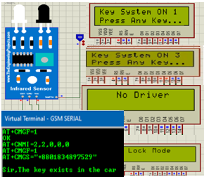
Fig 7. No driver and time counting condition.

- Three times wrong password
When the third time the wrong password was given, the display showed that access had been denied. The virtual terminal showed that the message had gone to the user's phone with the GPS location.

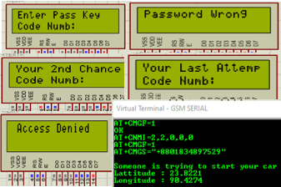
Fig 8. Enter three times wrong password.

- Vibration sensor detection
The test pin of the vibration sensor was high when the car was being moved. GSM then sent a message that someone was moving your car without using the passcode.
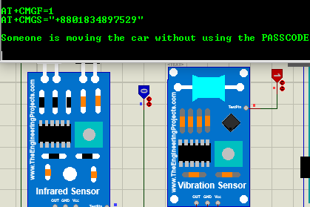
Fig 9. Vibration sensor detection.

- Turn on the motor through the special key
The special key was turned on and a message was sent to the user's phone via GSM. Here the ultrasonic sensor turned off the DC motor and it is shown in the figure.

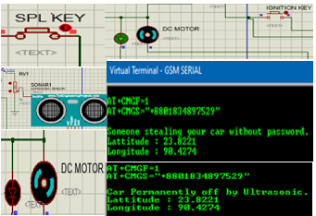
Fig 10. Turn off the motor via Ultrasonic sensor.

  - Result obtained from hardware

- Enter the correct password via keypad
When the driver was sitting in the driving seat, the IR identified the person. The LDR sensor detected the key. When the correct password was given, the display showed that the password was correct. The motor was then turned on by turning on the ignition key.

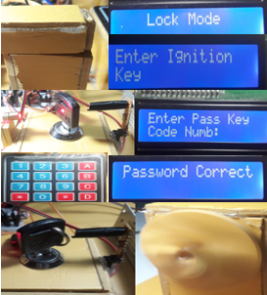
Fig 11. Enter the correct password via keypad.

- No driver and time counting condition
The driver left the ignition key in the car, 40 seconds later the system went into lock mode and notified the user via message.
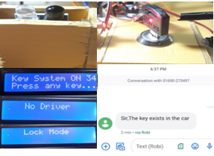
Fig 12. No driver and time counting condition.

- Three times wrong password
The third time the wrong password was entered; the display showed that access was denied. Then the message went to the user's phone via GSM.

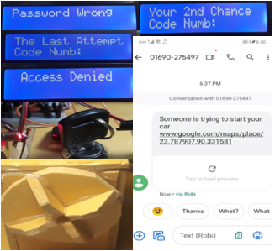
Fig 13. Enter three times wrong password.

- Vibration sensor detection
The vibration sensor was activated when the system was pushed from one place to another. A message was then sent to the user's phone with GPS location via GSM.
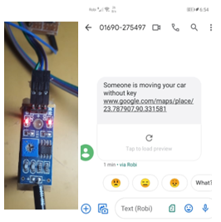
Fig 14. Detection of vibration

- Turn on the engine through the special key
To show the worst-case scenario at once, the engine was started by turning on a special key and the message was sent to the user's phone. In that case, the owner sent a car stop message and the car's engine stopped.

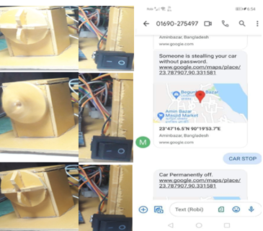
Fig 15.Turn off the engine via GSM message.

As an alternative, an ultrasonic sensor within 25 cm stopped the engine, as the user could not see the message for any reason.
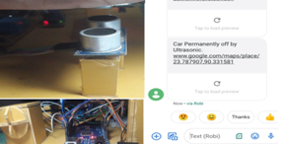
Fig 16. Turn off the engine via Ultrasonic sensor.

cost analysis.
The project device worked as expected and the cost of the project is reasonable enough to maintain its sustainability. The overall cost for this project is around 3800BDT. The proposed project is a low-cost product that is sustainable for all classes of people.

limitations and future developments
There are some limitations in the system. For detecting the person in driving seat instead of load cell, we have to use IR sensor due to the unavailability of load cell in COVID-19 pandemic. Due to the use of cheap GPS module, tracking location in blocked place was another issue. Jamming device may be a great risk for the system since it may jam the GSM module. The system provides many opportunities that can be achieved in the future. Like, the productivity of the system can be increased a lot by adding an anti-jamming system. Using the concept of image processing, a video camera can be attached to the system. In such cases, real-time video monitoring might be possible during unauthorized access. One feature can be added with the system like, if the car gets theft, then the nearest police station will get a notification with the location. For that, the concept of IOT might be used.

society impact

The system has a great impact on the society such as it can reduce fear of vehicle robbery and make people interested to purchase new car as well as this system will ensure the vehicle security. If the vehicle is stolen in any way, then the system will reduce the complexity of recovery, which will help the people of society and will save a lot of money. In addition, since the system is fast and reliable it will be beneficial for the society. Now

conclusion

The project was done during COVID-19 pandemic. Although there were several difficulties because of the pandemic but finally full simulation and hardware was finished properly and the desired result was obtained. The entire project represents a good solution to get rid of vehicle robbery. Since there is nothing perfect in the world, so with some limitation, the system will provide a relatively strong security against vehicle theft. The system has no bad impact on the society. Again, helping the society is always great and the system will help the society a lot. So at last, it can be said that the goal of the project was achieved nicely.

References
- Saw Nang Paing , May Zin Oo , Mazliza Othman and Nobuo Funabiki, “A Personal Use Vehicle Anti-Theft Tracking System Using IoT Platform”ISSN: 2456-4451, Volume 4. 2019. 143, International Journal of Computer & Software Engineering, January 30, 2019, page (2).
- ArslanHaider, AamerAnwer Hayat Khan and MouloudDenai,” A Smart Wireless Car Ignition System for Vehicle Security” ISSN: 2167-7670, Volume 6 Issue 3, Advances in Automobile Engineering, June 2017, page (1).
- The daily star website. [Online]. [Cited: September 30, 2020] Availble at: https://www.thedailystar.net/news-detail-70644
- Shakir M. Ahmed, Hamzah M. Marhoon, Osman Nuri, “Implementation of smart anti-theft car security system based on GSM” International Journal of Engineering & Technology, 2018.
- D.Gurunath1, Dr. Sreeja Mole S S2, Rekha3, “vehicle theft detection by gsm” ISSN: 2394-0697, VOLUME-5, ISSUE-2, International journal of current engineering and scientific research (IJCESR), 2018.
- Asmita S. Udagave, S. S. Sankpal, “Anti-Theft Locking For Stolen Vehicles and Canny Password Protected Access to Personalized Vehicles” ISSN: 2278-3075, Volume-8 Issue-10, International Journal of Innovative Technology and Exploring Engineering (IJITEE), August 2019, Page (3).

