**DigitalBizAds**

I want too promote my business products on my digital business card

No video only photos, Can we add referral management

Other people will sell my products, and will receive payment, I need to track who that person was,

I want this feature available for all the businesses with vcards

Yes, but others will sell the products for the companies and will get paid a referral fee

So to recap.. You will be building me a subscription site where I can offer other business the service of making their own digital cards. There was to be three layout to choose from and colors can be change by user to match their business colors! there should be a photo gallery, and three dots for account signup/ login, logos can be upload to cards, contact a the bottom should match those on sample design i shared, clients can also add their cashapp id to the card

--Sherman Bowen

Paypal Payment gateway for subscription

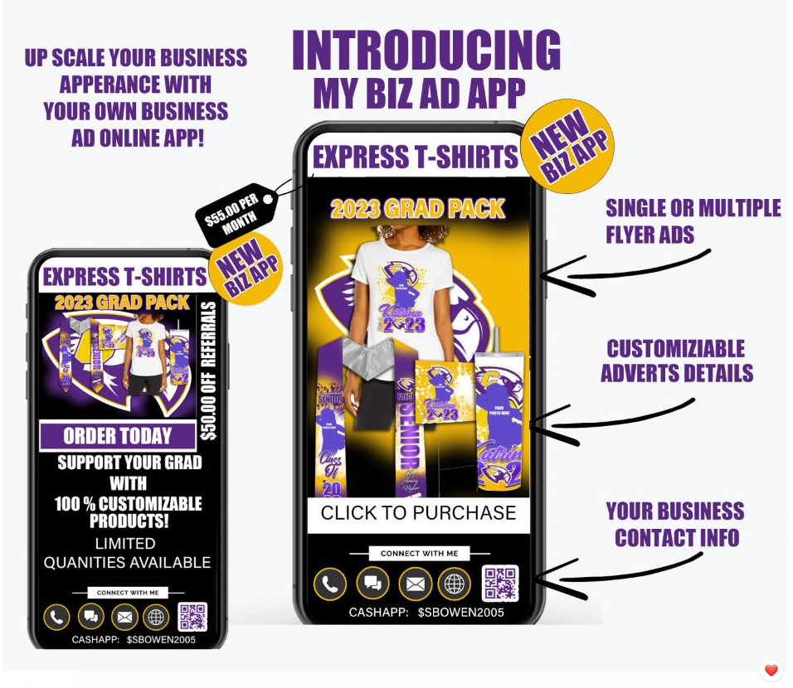

**Requirements**

**Correction 04 February, 2023**

1. Moibile device a card view hobe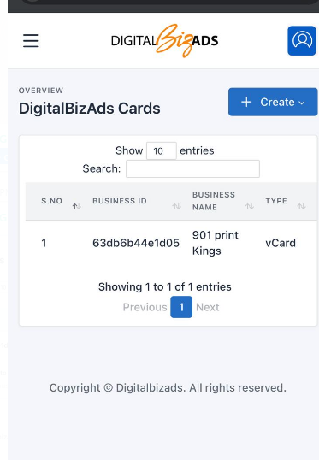
2. color need to be change able Graphical user interface

   Description automatically generated
3. site favicon
4. share icon dite hobe A picture containing text, electronics

   Description automatically generated
5. Share With Social Media 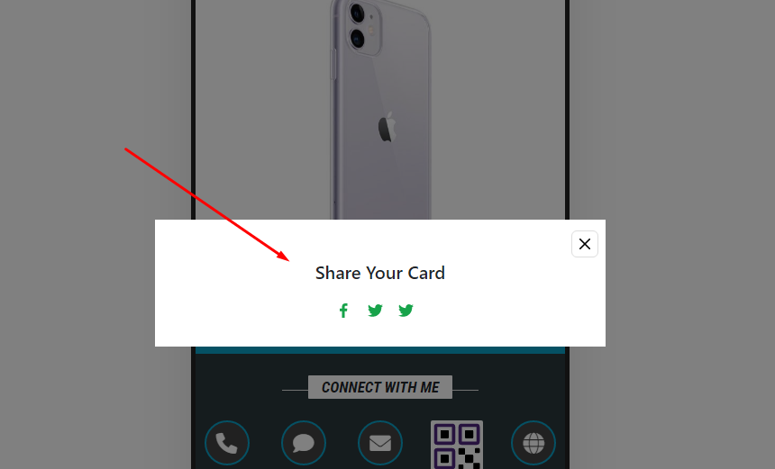
6. Card is not changing & copyright text is not coming frontendGraphical user interface, application, website

   Description automatically generated
7. Disable attribute and loader Graphical user interface, application

   Description automatically generated
8. Required fields 