Remove adname name from being a unique field. Should be possible to post same name ad Name.

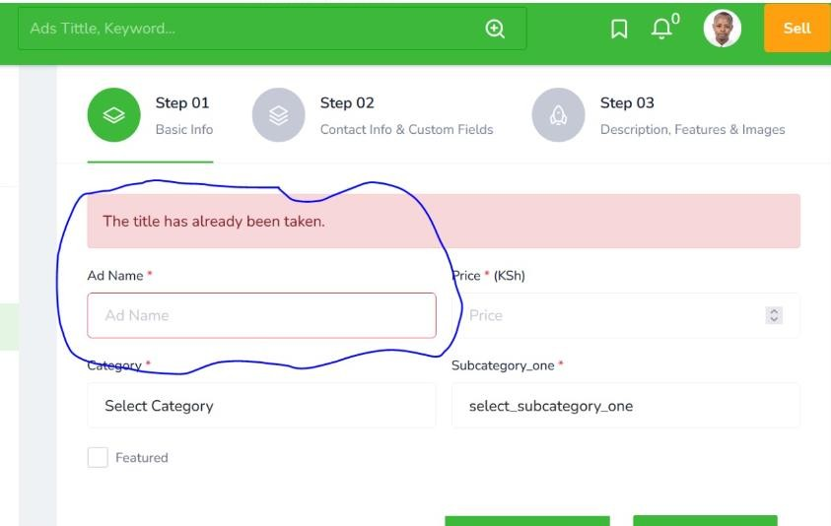

Replace the Map location with the select (Customer Field)

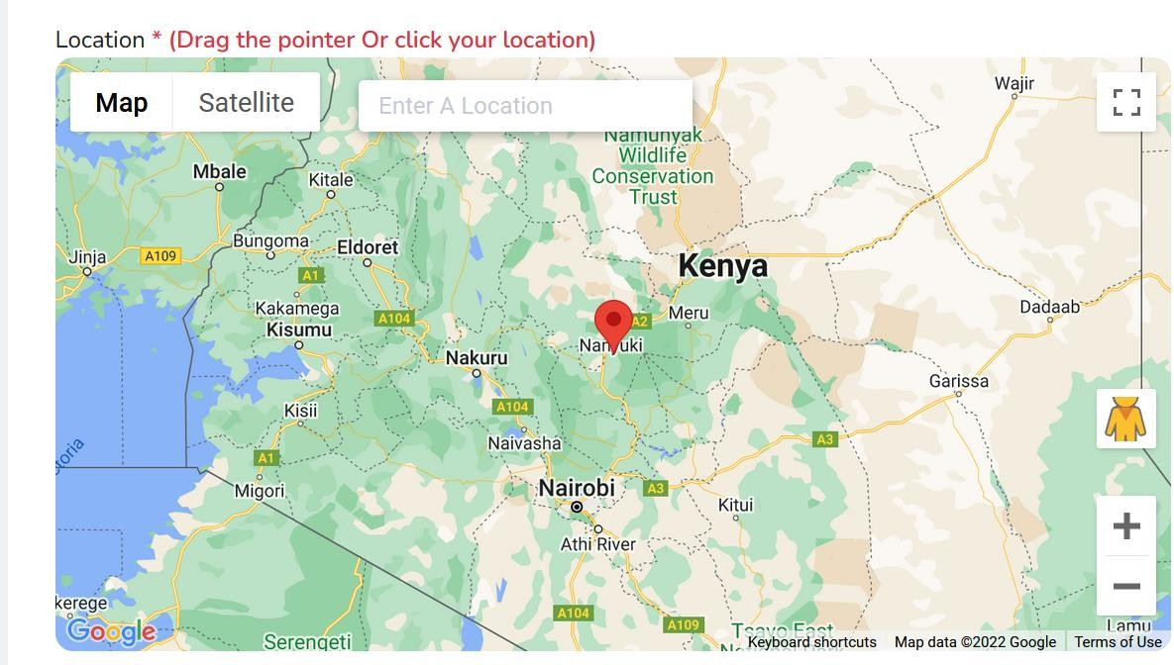

Remove Brand Field when posting Advert

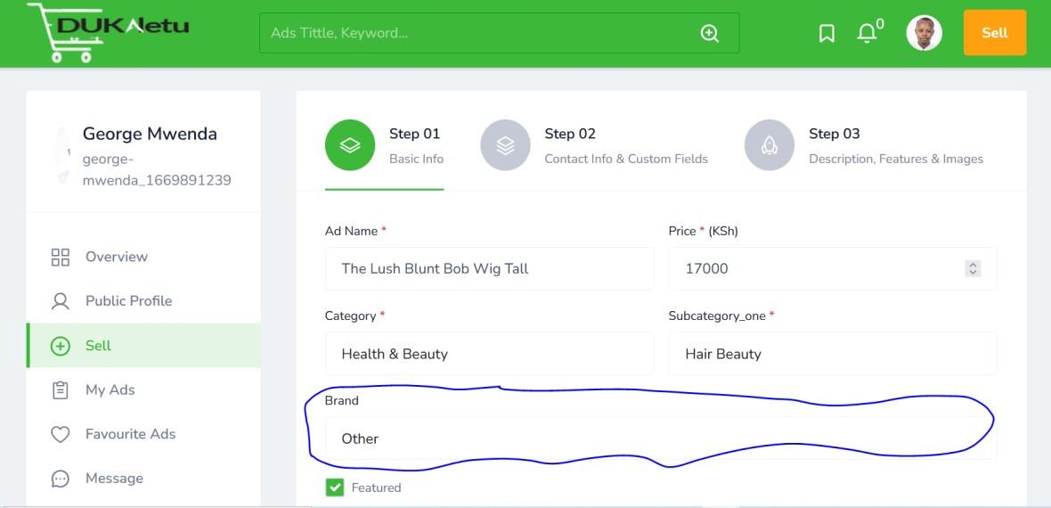

Remove the back Up Phone Number Field

Let make uploading adverts as easy as possible.

Remove the feature field

