**09 Nov, 2022**

1. Need to remove barrrter color brand 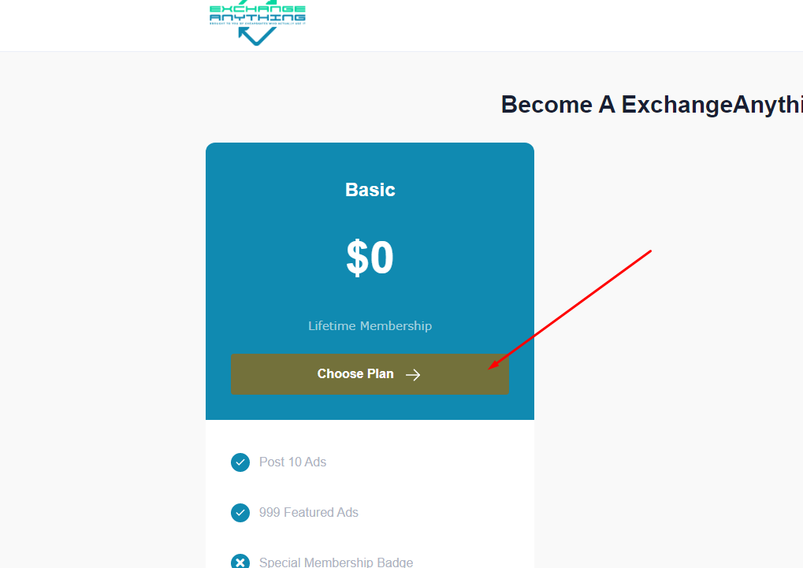
2. Color need to remove 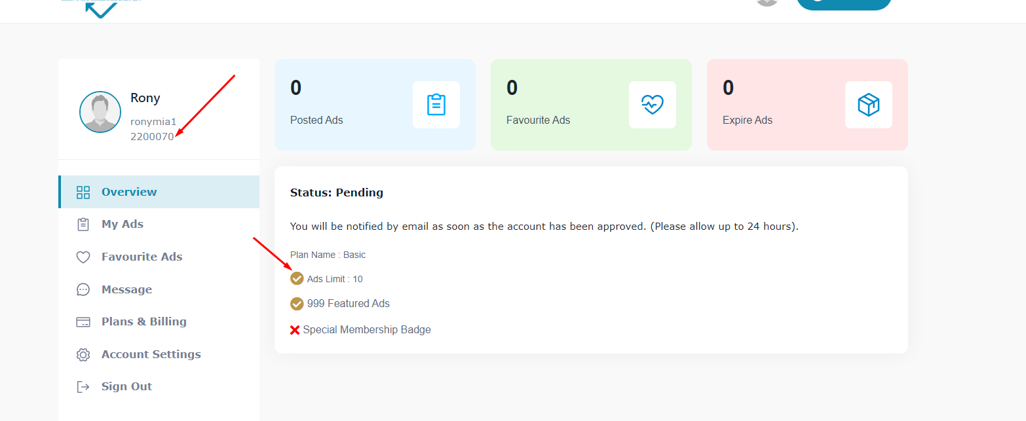also for joining date
3. Registration form ta two column a dian 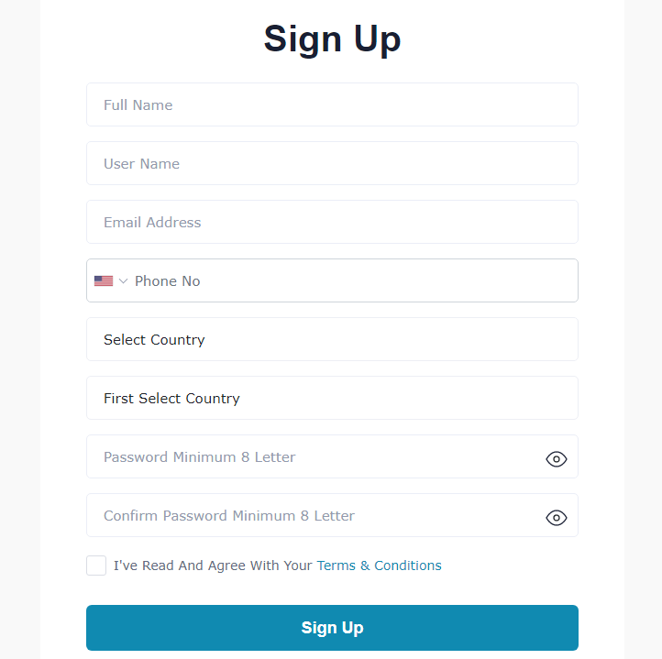
4. Country should come accending 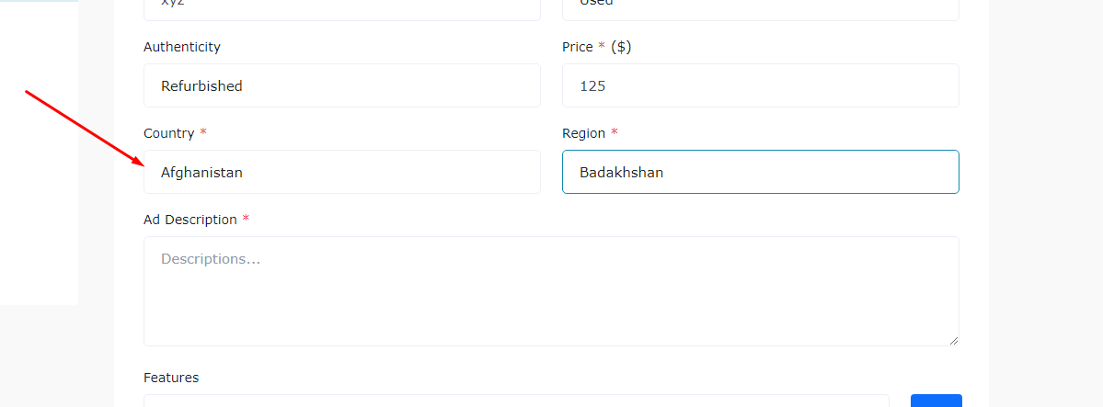
5. Space need to remove 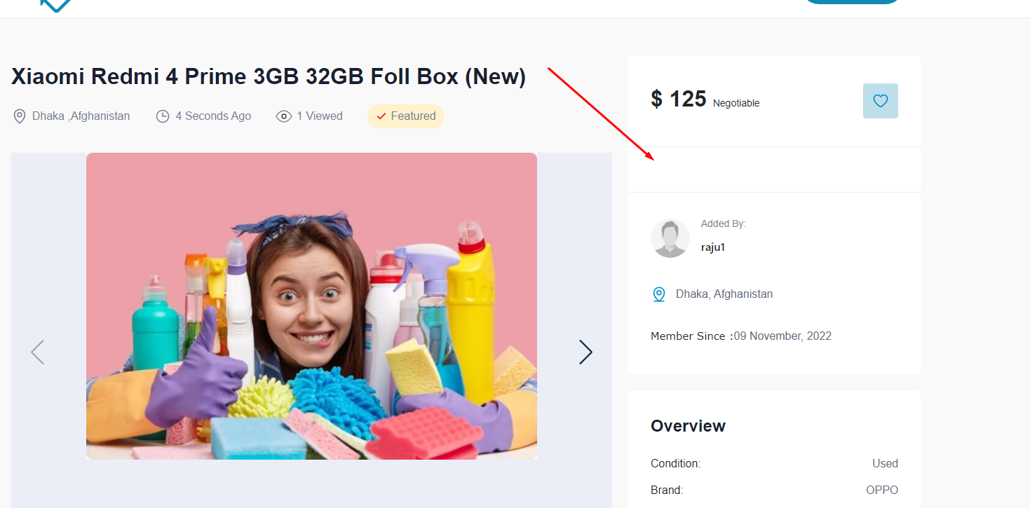
6. Ads edit a error 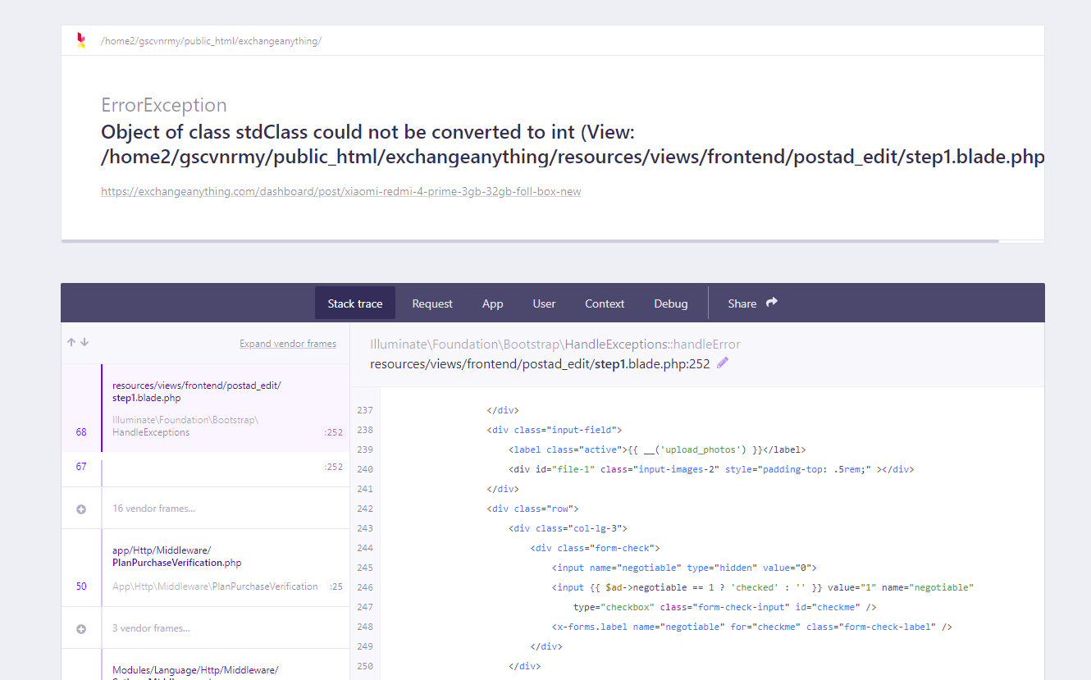
7. 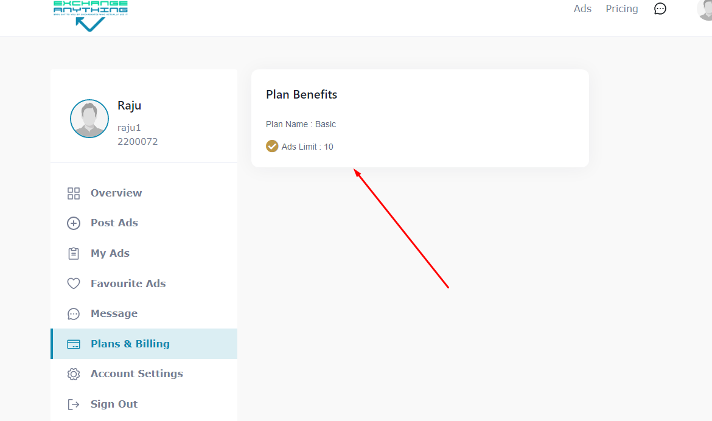has no plan benefits

**13 Nov, 2022**

1. Country, States, City
2. Review and Ratings & Seller Own page
3. On the User account I would like the ability to put an arrow over a feature and a 'bubble' explain what the feature does
4. Facebook/google login
5. Package system check