Admin panel error

1. Dashboard report overview check Graphical user interface, application

   Description automatically generated
2. User add and edit remove 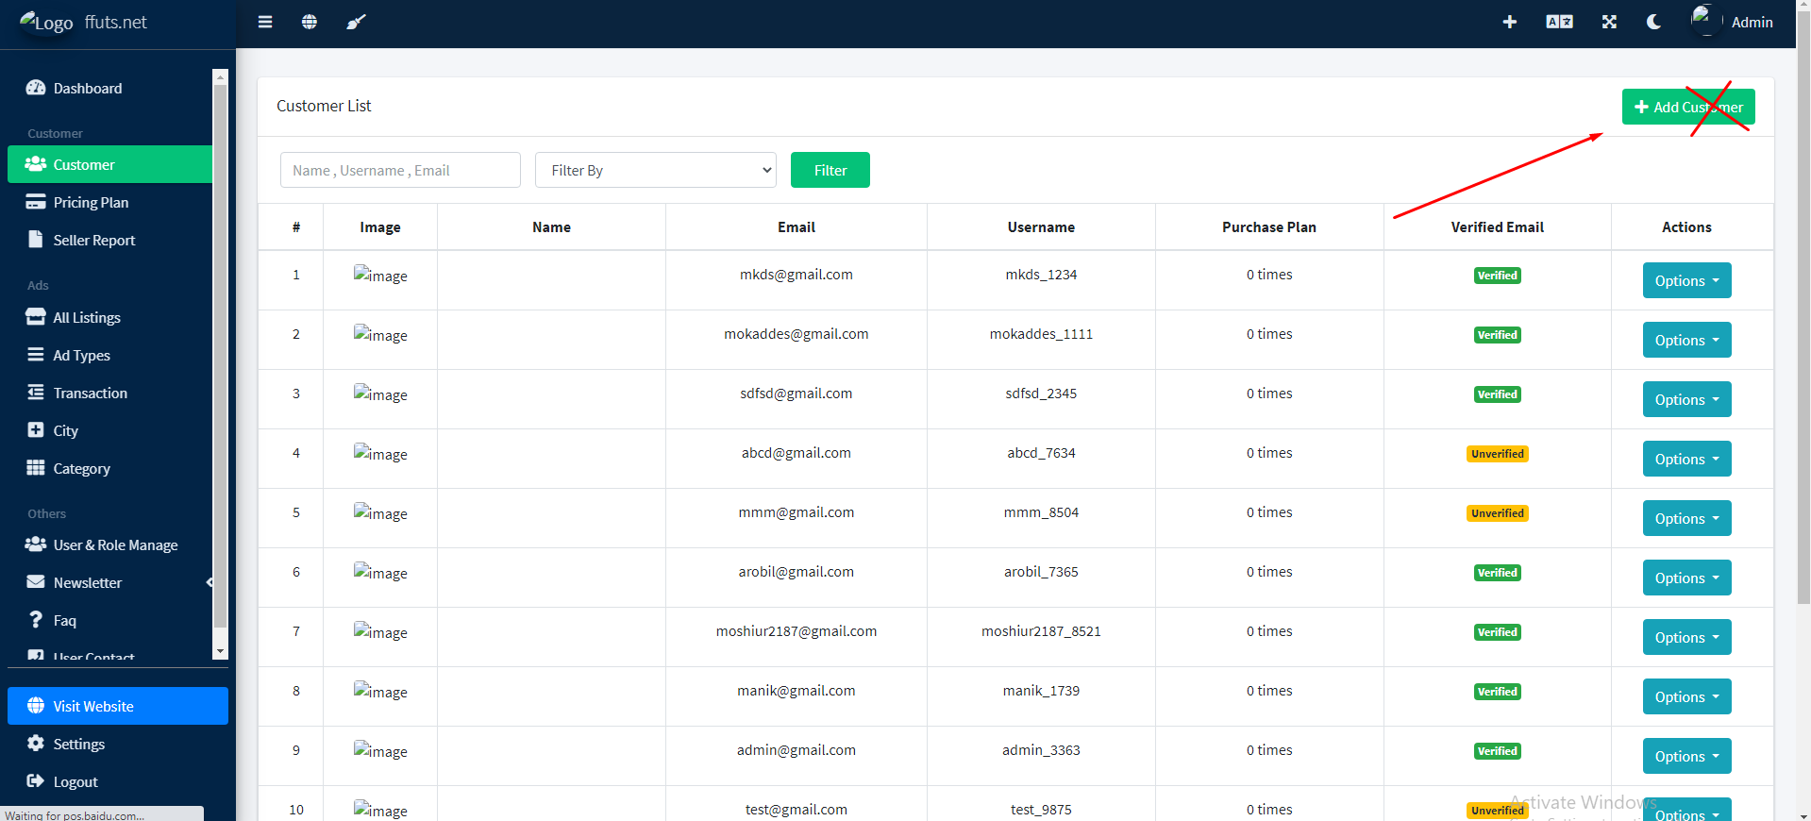
3. User details page a purchase plan section a paid category te ads dile transaction history asbeGraphical user interface, text, application, email, website

   Description automatically generated
4. Ads a add show korbe Graphical user interface, application, website

   Description automatically generated
5. Add your first add button remove Graphical user interface, application

   Description automatically generated
6. Edit customer hide Graphical user interface, application

   Description automatically generated
7. View customer ads page theke button remove Graphical user interface, text, application

   Description automatically generated
8. Remove these two menues Graphical user interface, application, Teams

   Description automatically generated
9. Text -> “Add Adtype” 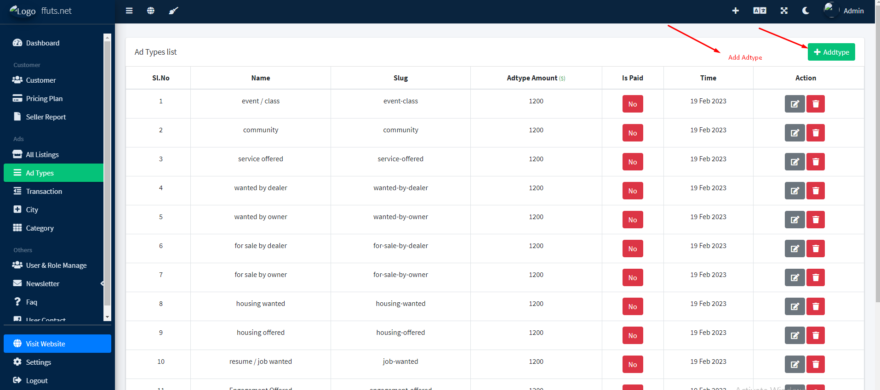
10. Menu dekhe user role golo thik korte hobe Diagram

    Description automatically generated
11. Newsletter menu comment kore rakhun 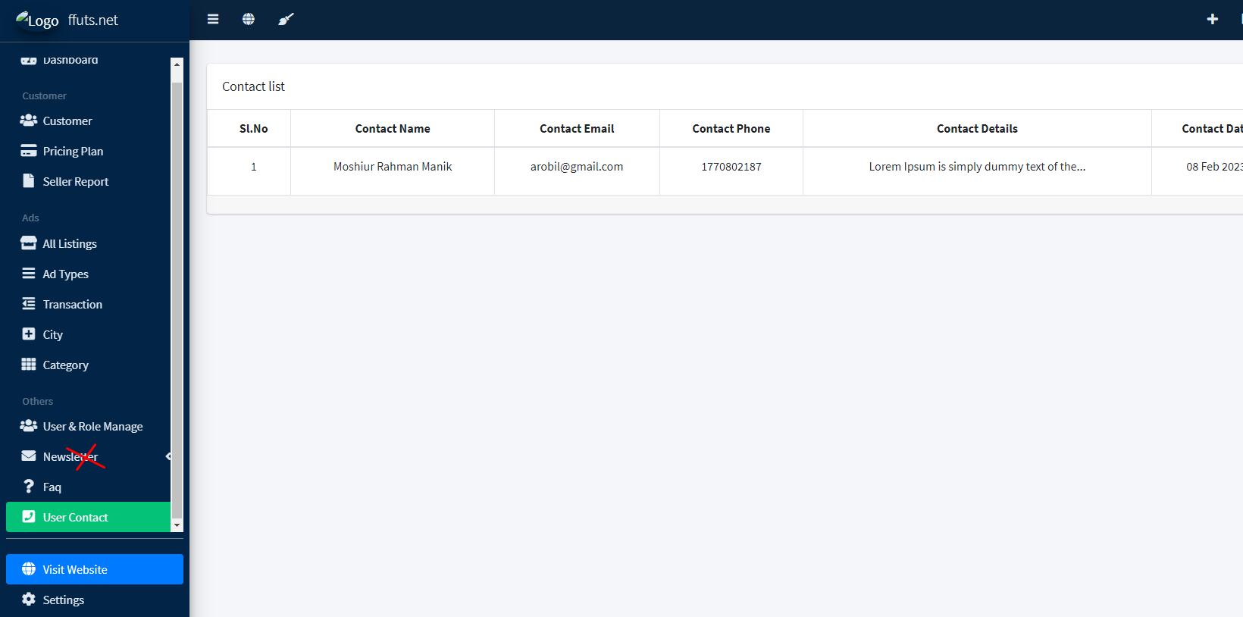
12. Whole website has no currency, currency will be $Graphical user interface, website

    Description automatically generated
13. Comment cross fields and check remaining fields functions Graphical user interface

    Description automatically generated
14. Remove offline payment & online payment will be only stripe and paypal
15. Comment kore rakhun cms menu theke cms-> **Home, posting rules, membership, price plan, blog, ads, contact, faq, dashboard, login, comming soon, maintaince, error page,** Graphical user interface, application

    Description automatically generated
16. And baki page golo te image ase ogolo remove korben
17. Seo setting theke uncecessary page remove A screenshot of a computer

    Description automatically generated
18. Menu remove A picture containing calendar

    Description automatically generated
19. Comment kore rakhun Graphical user interface, application

    Description automatically generated