Website → https://indhosnacks.com/  
We want to use this design → <https://www.7-eleven.com/>

1. Footer opening hours dynamic korte hobe
2. About page dynamic
3. Terms of user page dynamic
4. Static data
5. 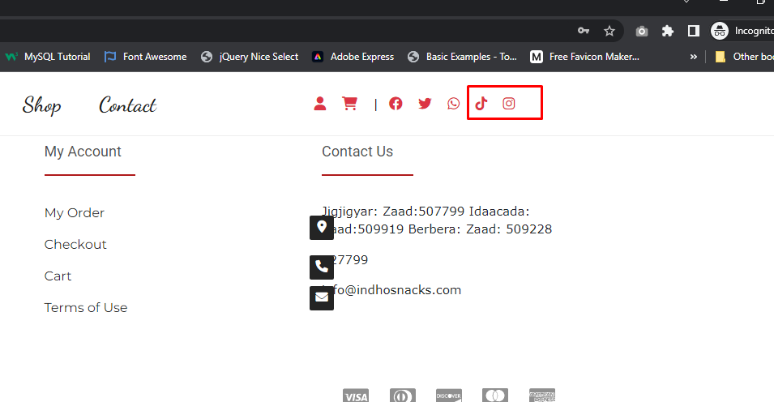
6. Social icon tiktok and Instagram
7. Padding problem 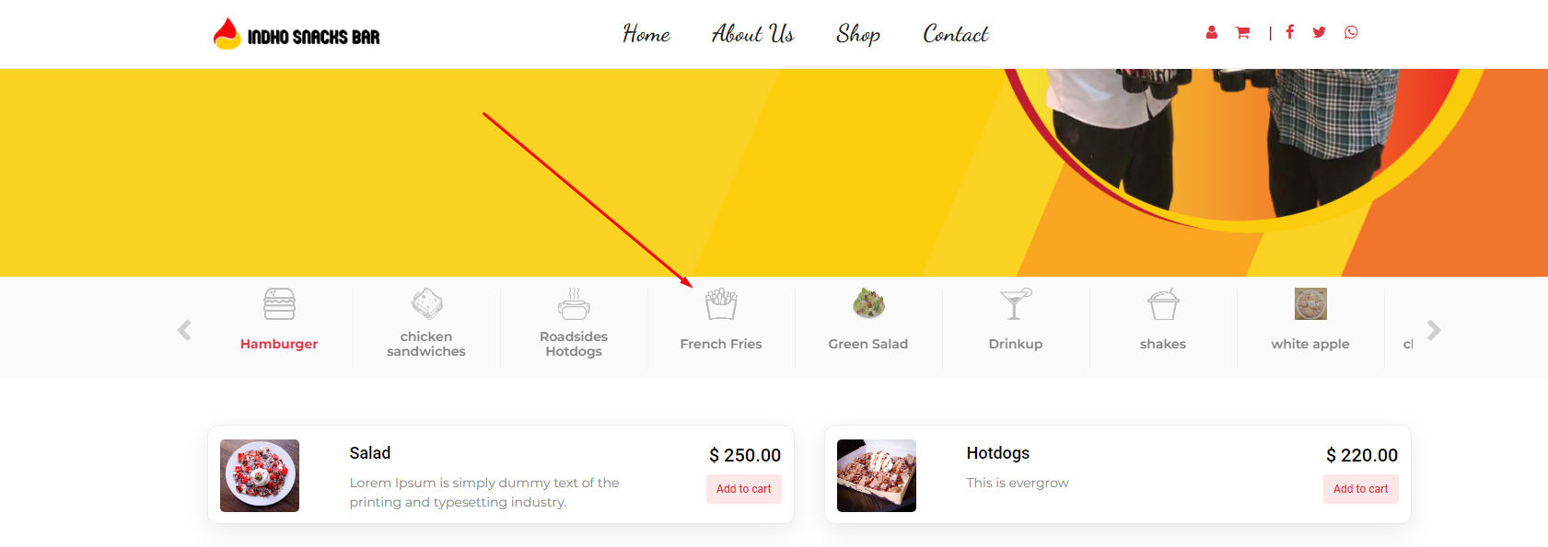
8. Center align dile valo hobe A picture containing food, dish

   Description automatically generated
9. Footer design improve 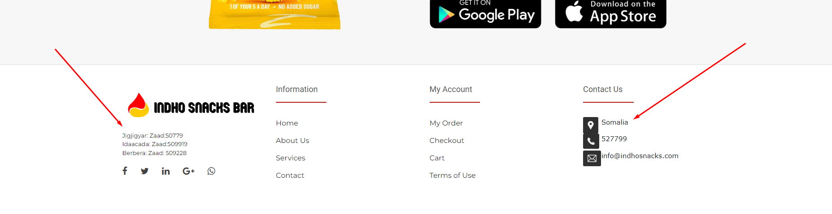
10. About page padding problem & almost all pages a padding problemGraphical user interface, text

    Description automatically generated
11. Design problem & login button problem 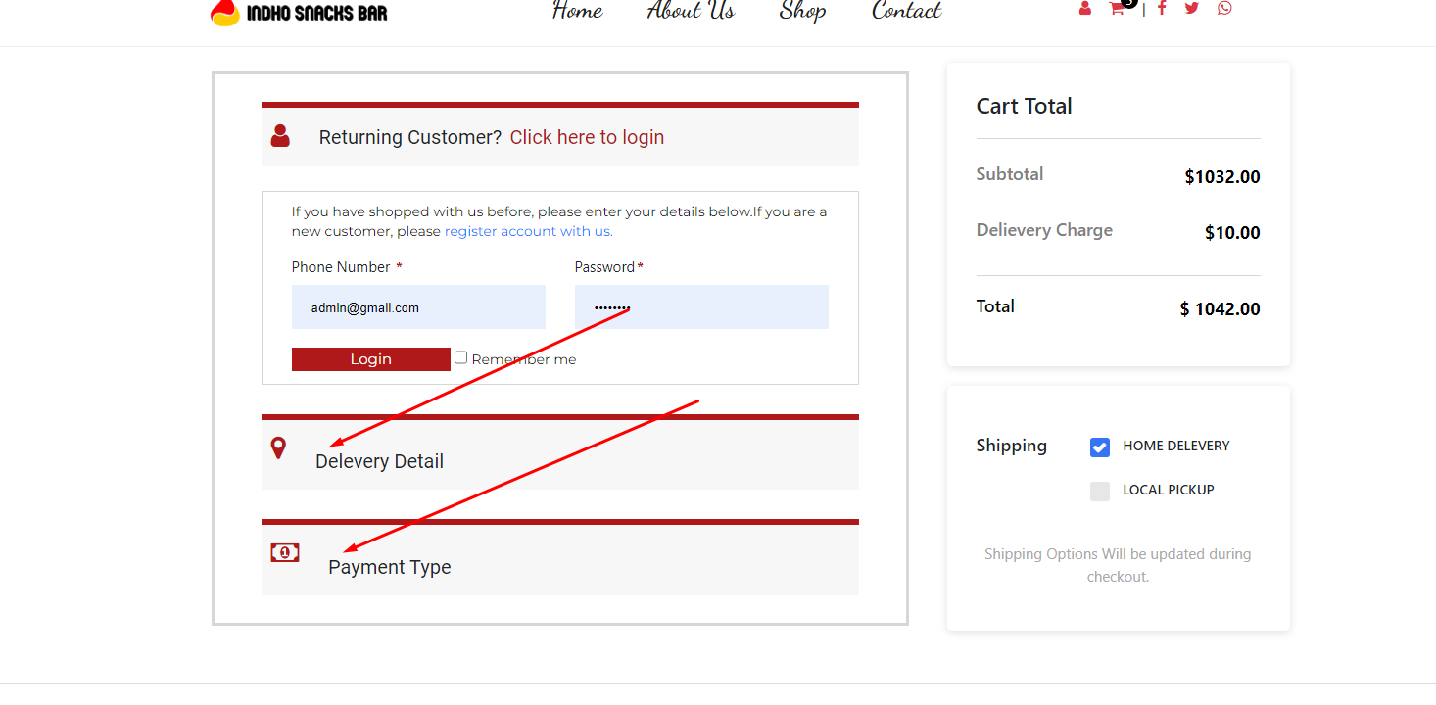
12. Login korar por o problem ase Graphical user interface, application

    Description automatically generated
13. It should be stripe icon Graphical user interface, application, Word

    Description automatically generated
14. Order page a currency nai 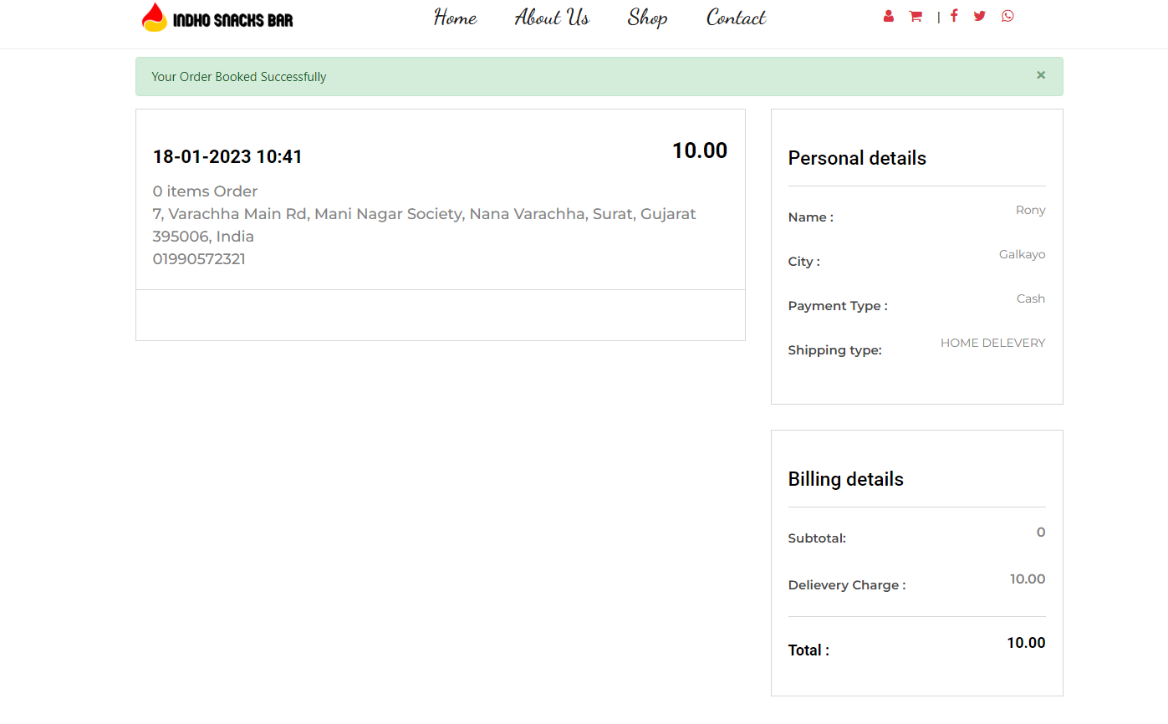
15. Admin panel a akta orders menu lagbe and orders list golo show korbe. Akhon orders list golo dashboard a show kore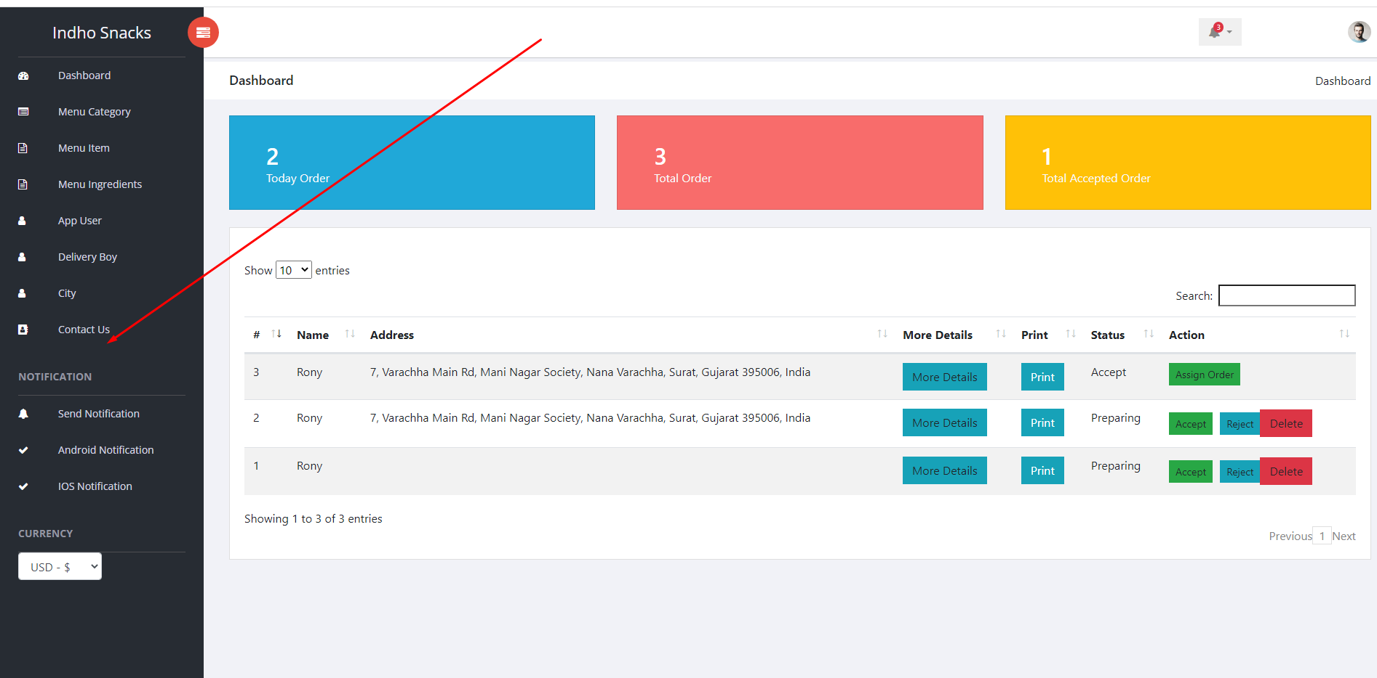
16. Delivery boy is not coming 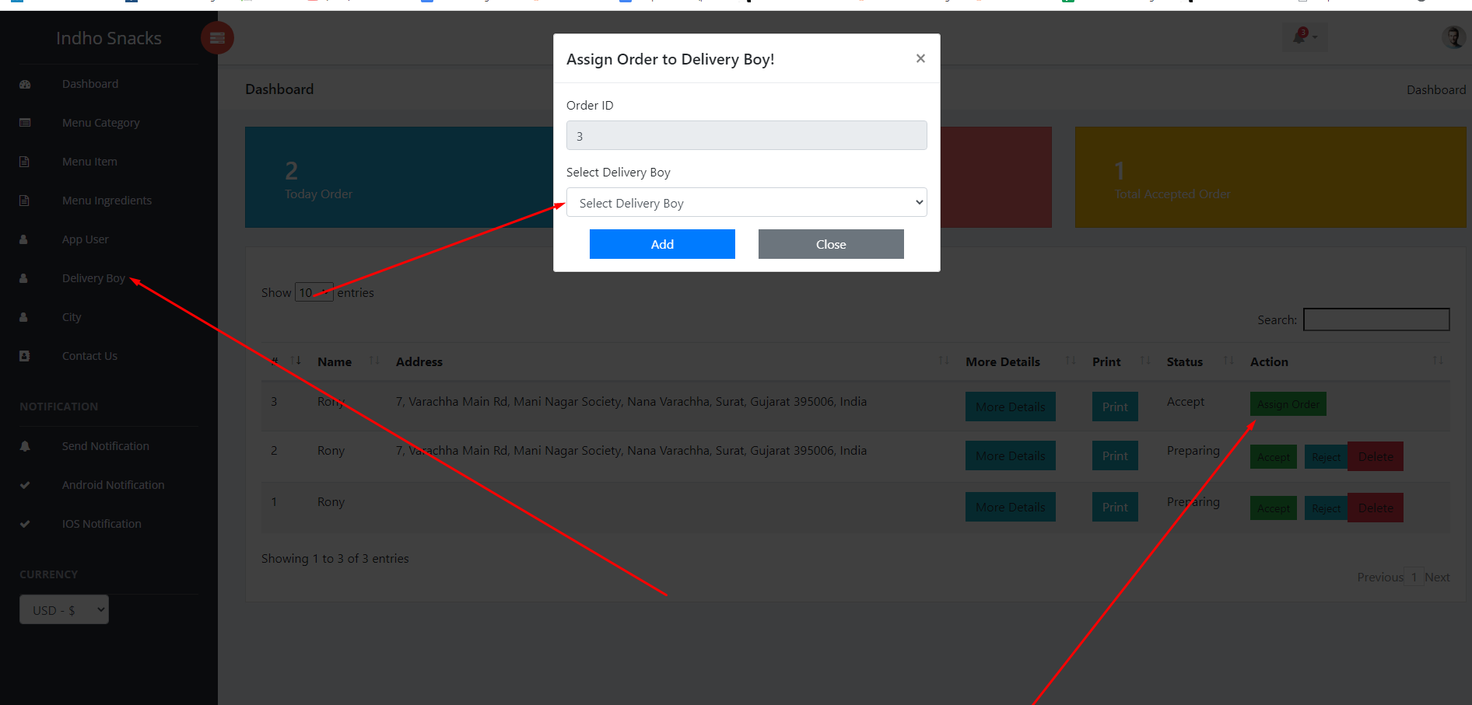
17. Full website responsive a problem ase