Req:

Pricing menu error, need to create another page

Features section needs to do dynamic.

Testimonial adding option from admin panel

Monthly word is missing and recommended flag 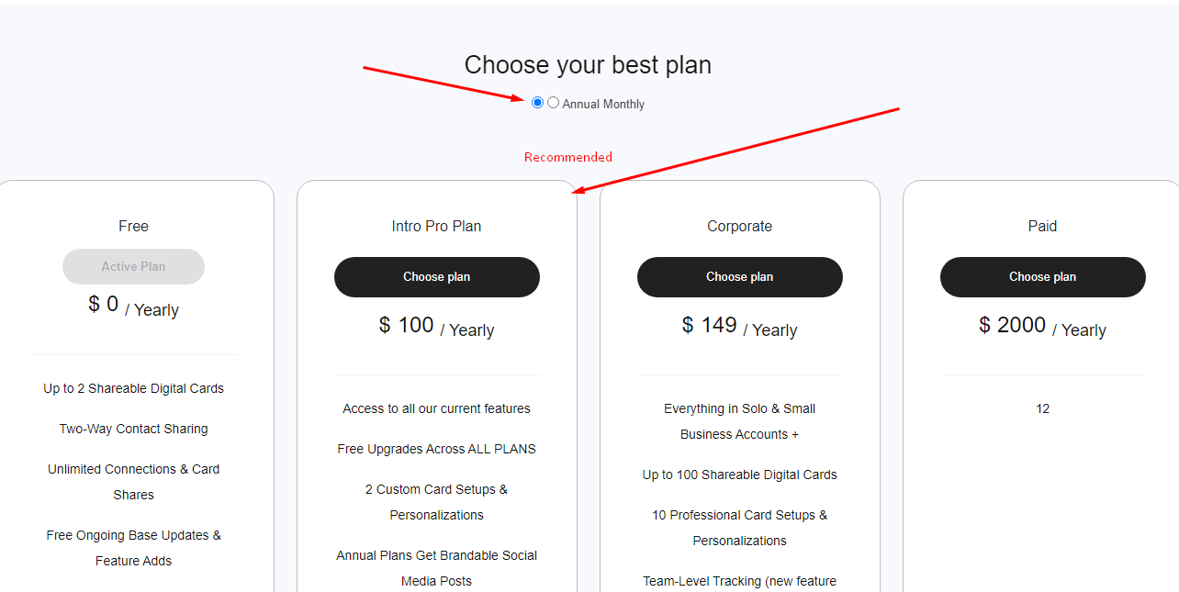

Plan Price Forever -> kindly remove it

Free select korle price option asbe na

For unlimited, enter 999 -> kindly check the condition.

Hide branding and Qr code customization will be conditional on package creation

Package condition

price

branding name

qr code customization

number of cards

Plan expired condition check

Live url of the vcard

Whatsapp is not functioning

How do I add reviews and approve reviews to be published

How do I add specific features to the annual variation of same plan

How do I create(add) and edit SMTP emails

* Can I be BCC on them

What is this?

Need show/ hide function for social url in general settings.

Need to be able to edit features on home page

Need editable home page banner at top

Is facetime app action working?

Is text action working yet?

Social profile username only (not url) feature?

How do I see a users link to their profile, not to their vcard

Where do request features emails go to

Whatapp does not open whats app it takes to phone call

Is promo code for subscription part of ecommerce?

* I want to be able to create promo code for monthly
* plan save 50% first month etc.
* Shape

  Description automatically generated with low confidence