MTGPRO.Me

1. We still don’t house equal housing logo option which was part of phase 2

2. the pre built online forms is not even started it looks like.

<https://www.neatloans.com/fast-mortgage-application>

<https://firstpremier.mymortgage-online.com/loan-app/?siteId=9621968476&workFlowId=81187>

<https://www.google.com/search?q=equal+housing+opportunity+logo&ie=UTF-8&oe=UTF-8&hl=en-us&client=safari#imgrc=rb7J_sAqH2m6AM>

<https://leadscripts.co/>

1. ChatGPT
2. Canva
3. Calculators
4. Site Security (google captcha, paid ssl, server firewall)

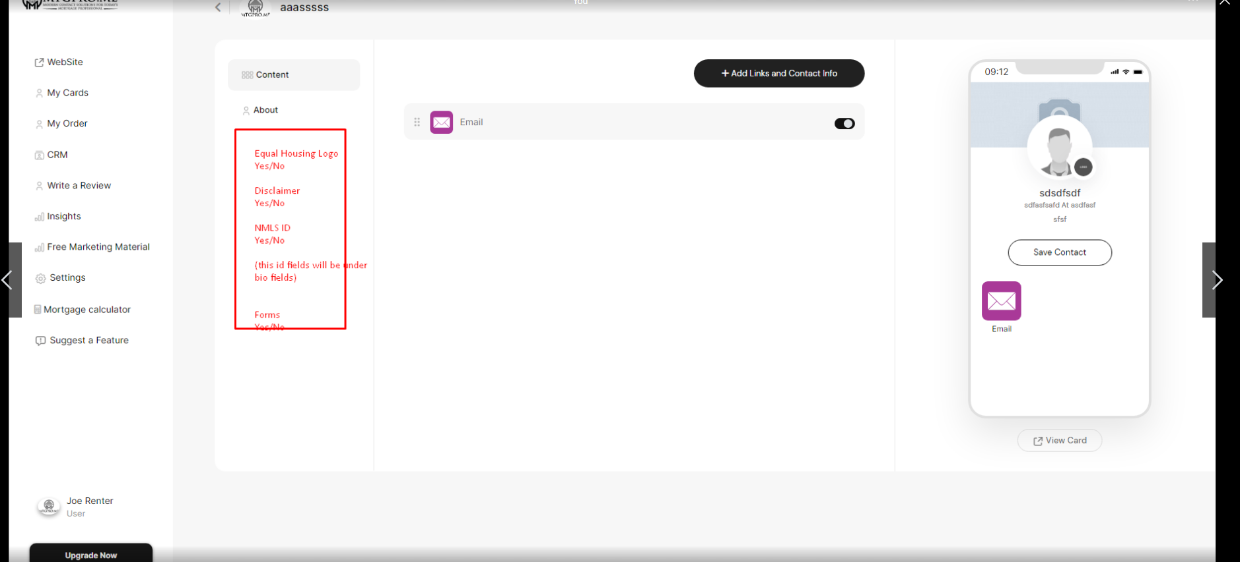

https://www.google.com/search?q=equal+housing+opportunity+logo&ie=UTF-8&oe=UTF-8&hl=en-us&client=safari#imgrc=rb7J_sAqH2m6AM



