**18 Doc, 2023**

1. Card live but still showing alert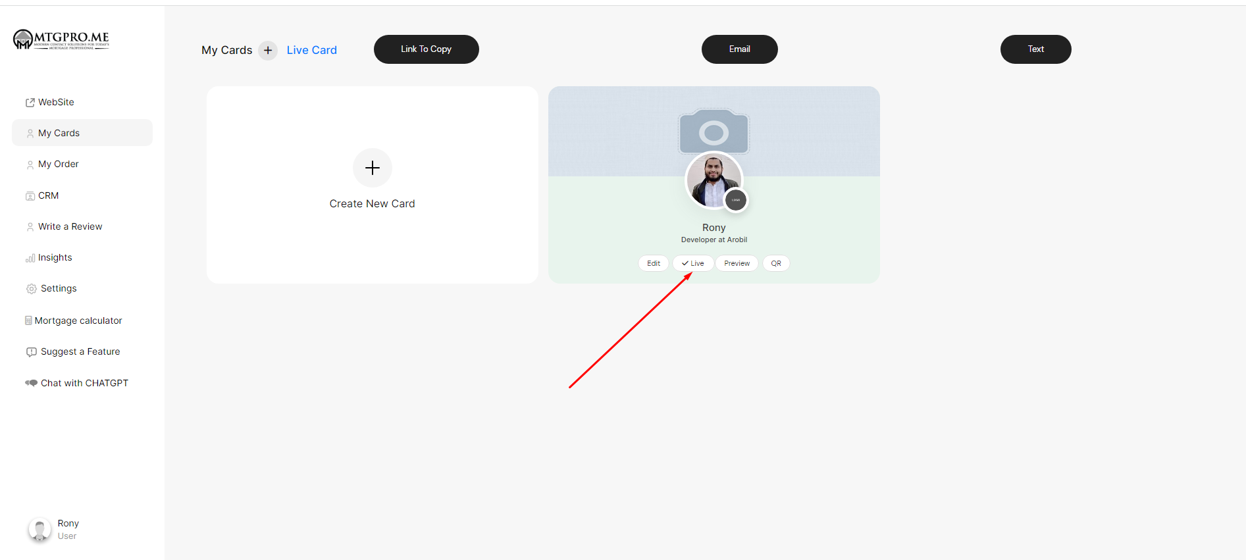
2. Invoice page mobile responsive na Graphical user interface, application

   Description automatically generated
3. Similar icon golo change korte hobe Graphical user interface, application

   Description automatically generated
4. Mobile a button design problem 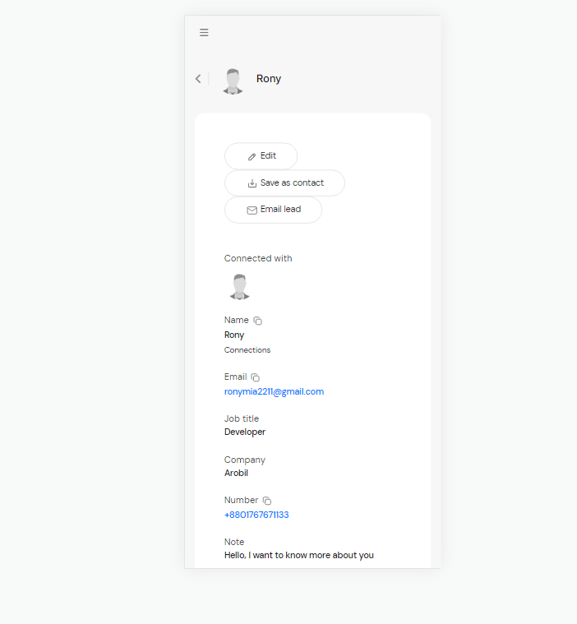
5. Subscriber jokhon connect mail ar reply dai, tokhon reply to wrong 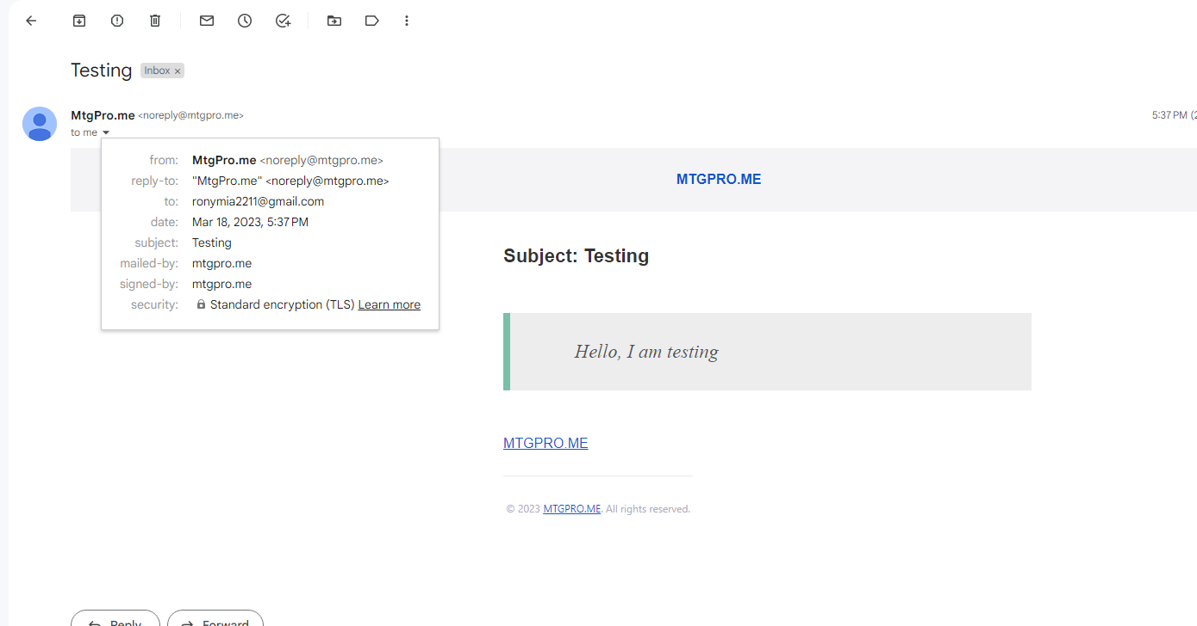
6. Responsive issue 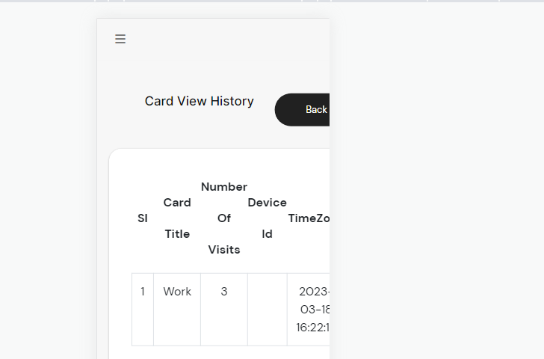
7. Card download history Graphical user interface, application

   Description automatically generated
8. Responsive issue Graphical user interface, application

   Description automatically generated
9. This page is not responsive in mobile devices, and under setting menu every pages are not responsive 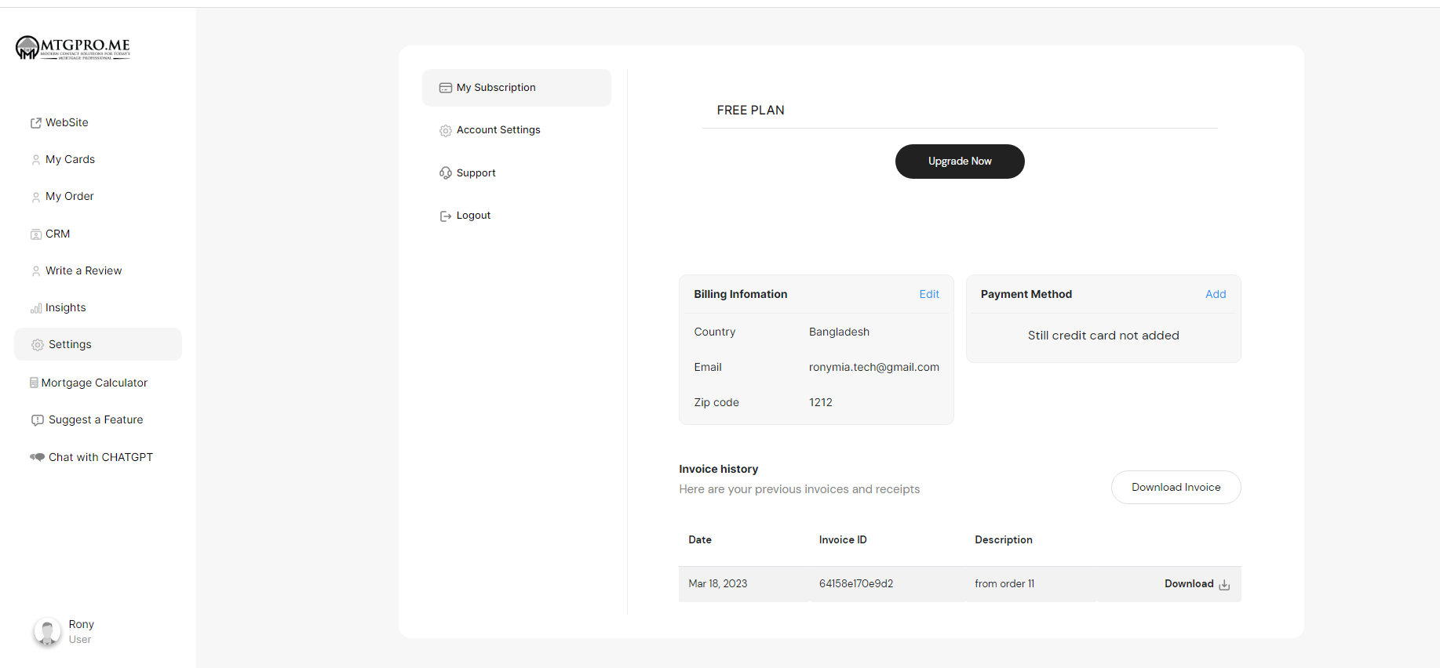
10. Card adding is not working A screenshot of a computer

    Description automatically generated
11. Subscriber support form dia query send korese but ata reply to subscriber mail hobe Graphical user interface, application

    Description automatically generated
12. Subscriber request a features mail problem