1.Color still not good on view card in mobile app

Still not back button 2. This is supposed to be to show QR code for live card

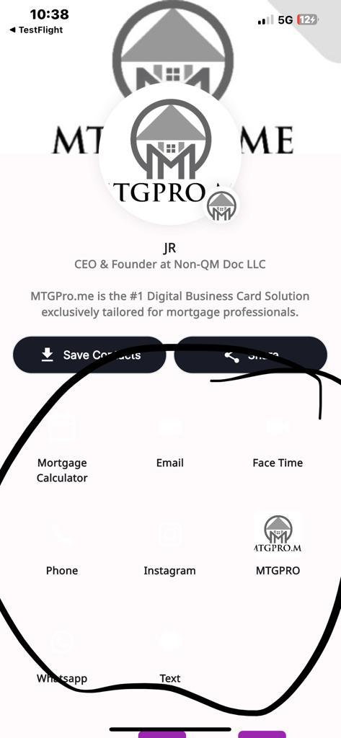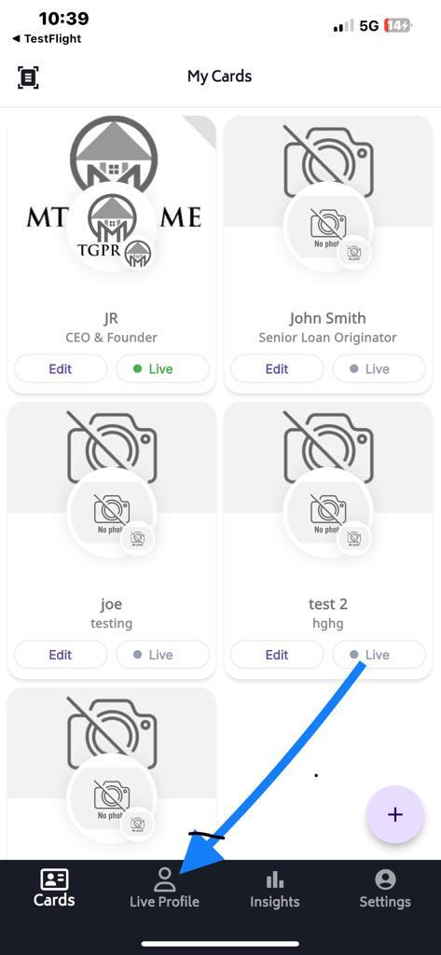

3. 3rd time - this only scans we code. It is supposed to scan a business card and out the information on the business card as a connection like Popl

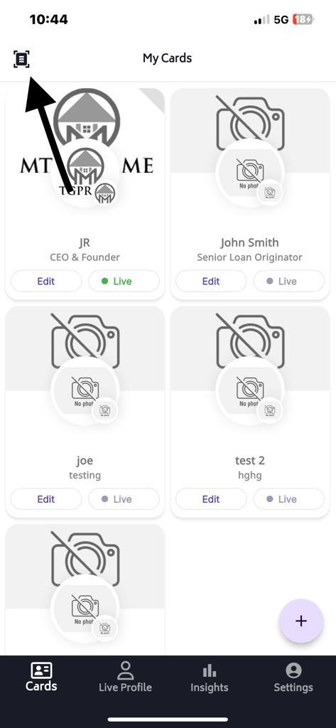

4. This is not what I asked for this will let them write to any nfc device

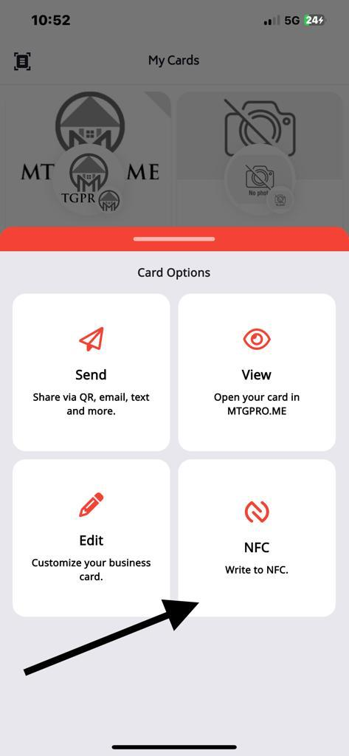

5. In insights: we code downloaded in insights is wrong. It’s supposed to be when the QR code is scanned. A visitor will never download the QR code. there’s no reason for that

6. Need logo updated to without tag line everywhere – previously sent

7. Where do I see the SMTP email log?

The emails that go to support@mtgpro.me do not make any sense. I need to be able to edit them with short codes

8. still on website said card is not active where you to go home page. Is there a user that does not have a username? That would make sense