**Comments**

1. Still the country shows Bangladesh in many places, and category description, I have already changed 1 or 2. (I have changed all to Srilanka)
2. I have given you the all sri lanka cities and divisions and not updated (Updated)

**Home page**

1. Gogoads.lk logo – size to increase (Done)
   1. 
2. All Ads fonts size/ alignment to be reviewed (Reviewed)
3. Language – two tabs not dropdown (Done)
   1. 
4. General typo/ spelling – to be reviewed (Done)
5. GogoadsThe - space (Done)
6. 
7. **Logo to change – Transparent** (Done)
8. 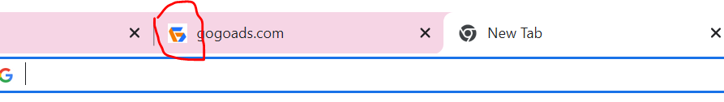
9. **Post Free Ad – tab need at below position** (Done)
10. 
11. **Icon to provide for following icons** (Done)
12. 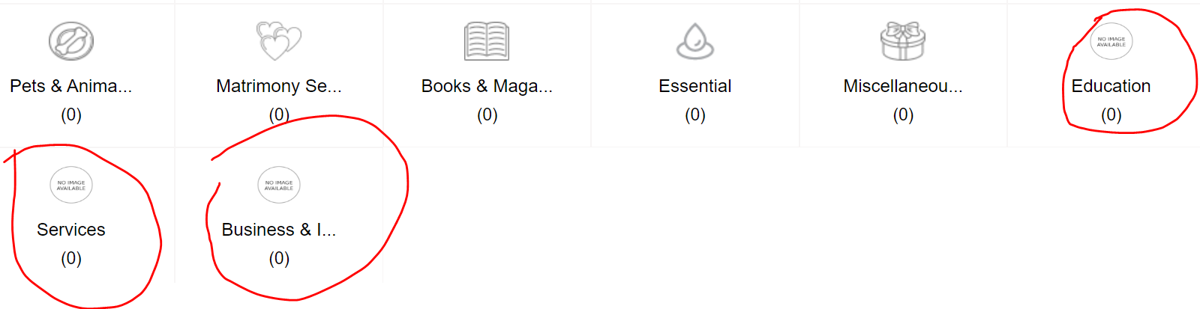
13. **There is no section to manage all footer pages/ link** (Done)
14. Quick link
15. How to sell fast
16. Social media
17. **~~Popular Categories~~, need all the categories to display, please change as “Browse items by category”** (Done)
18. Now 16 nos, to arrange in 3 rows, you have provided a limited main category, (Yes, total 16 main categories are showing which is not good for landing pages but on listing page or category modal customer will get all category list)
19. Color icons (I have used free icon from online with default color #ddd, but if you want to use specific color then you have to provide icons)
20. Ad Banners (Done)
21. Google analytics – not updated (Done)
22. Google AdSense - code provide not updated (Done)
23. Not shown – 3 ads on each page (Done)
24. Sitemap – to complete/ update/ proper organise(Done)
25. Quick link – not updated all information has been provided(Done)

**Ad Posting**

1. Admin panel doesn’t have enough details to monitor, user name, status of post (draft, posted or review, expiry date) (Done)
2. 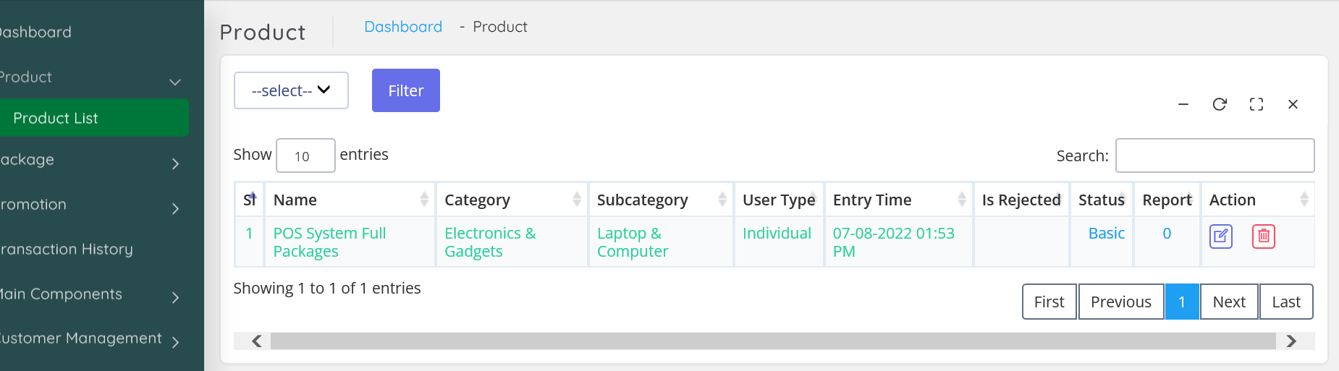
3. Admin not receiving a notification after user posting an ad. (Done)
4. Admin to review and approve the posts. (Done)
5. There is no email communication system with user, this is agreed scope. (done)
6. Provision for images to increase at least 6-8 images to be (done)
7. Paid customer a proper invoice management to be provided (currently available is very very low quality) no information provided is in sufficient (we will lose user creditability) (Done)
8. User will be able save the posts and start later time for any reason. (Done)
9. User home page to be changed as discussed in the first video call and agreed. (Done)
10. Can’t select area no result found (Done)
11. 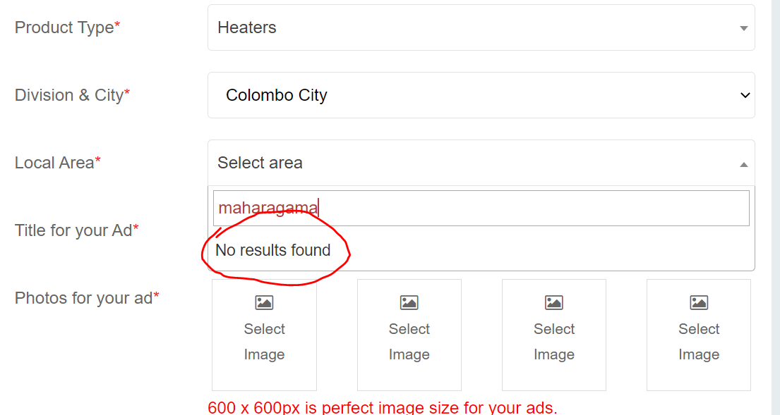 (Done)
12. 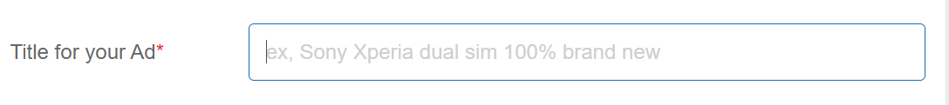(Done)

**Cities**

1. Cities limited to 20 to be expandable to 25 (Done)
2. I have entered area more than 20 but display only 10, there are some issue in (Done)

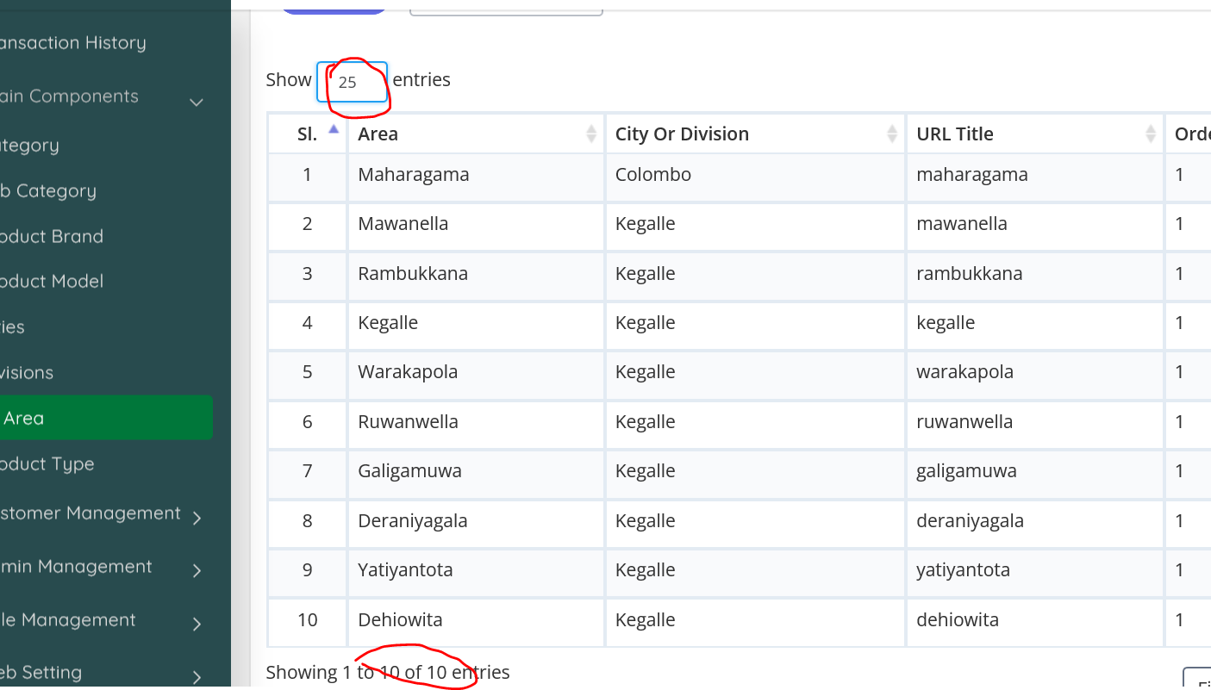

**Creating Brand** (Done)

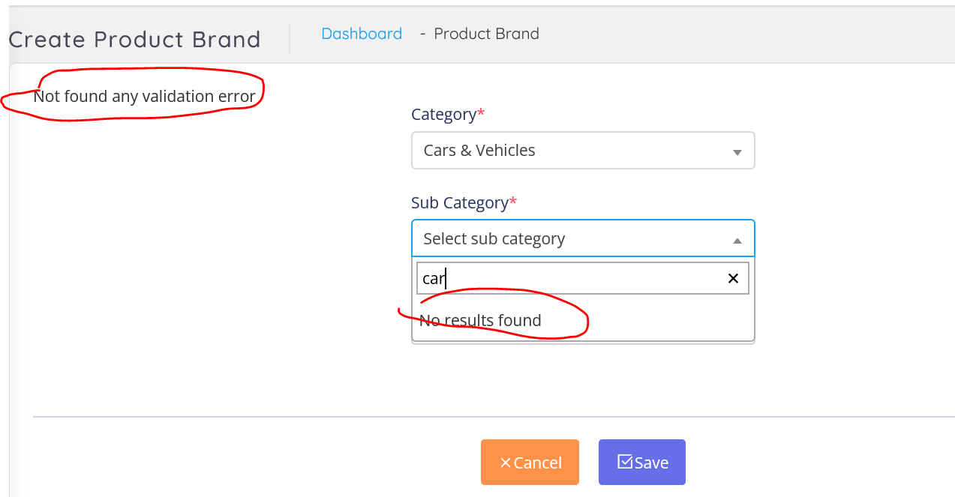

**Main Categories**

1. Property
2. Jobs & Work Overseas
3. ~~Mobiles~~
4. Home Appliances
5. Cars & Vehicles
6. Electronics
7. Fashion & Beauty
8. Pets & Animals
9. Matrimony Services
10. Books & Magazines
11. Essential
12. Miscellaneous
13. Electronics
14. Business & Industry
15. Services
16. Hobby, Sport & Kids
17. Education
18. **Property -subcategories**

* Land
* Houses For Sale
* House Rentals
* Apartment Rentals
* Room & Annex Rentals
* Commercial Property Rentals
* Holiday & Short-Term Rental
* Apartments For Sale
* Commercial Properties For Sale

1. **Home Appliances**

* Furniture
* Kitchen items
* Other Home Items
* Building Material & Tools
* Garden
* Home Decor
* Bathroom & Sanitary ware
* Refrigerators & Freezers (0)
* Living Room Furniture (0)
* Kitchen & Dining Furniture (0)
* Bedroom Furniture (0)
* Office & Shop Furniture (0)
* Children's Furniture (0)
* ACs & Home Electronics (0)
* Household Items (0)
* Home Textiles & Decoration (0)

1. **Electronics**

* Mobile Phones
* Computer Accessories
* Computers & Tablets
* Mobile Phone Accessories
* Electronic Home Appliances
* Audio & MP3
* Other Electronics
* Air Conditions & Electrical fittings
* Cameras & Camcorders
* TVs
* Video Games & Consoles
* TV & Video Accessories

1. **Cars & Vehicles**

* Auto Parts & Accessories
* Motorbikes
* Bicycles
* Cars
* Three Wheelers
* Auto Services
* Lorries & Trucks
* Rentals
* Vans
* Heavy Duty
* Tractors
* Buses
* Boats & Water Transport

1. **Business & Industry**

* Industry Tools & Machinery
* Solar & Generators
* Office Equipment, Supplies & Stationery
* Other Business Services
* Raw Materials & Wholesale Lots
* Healthcare, Medical Equipment & Supplies
* Licences & Titles

1. **Pets and Animals**

* Pets
* Animal Accessories
* Farm Animals
* Veterinary Services
* Pet Food
* Other Animals

1. **Services**

* Trade Services
* Domestic Services
* Other Services
* Events & Entertainment
* Health & Wellbeing
* Travel & Tourism

1. **Hobby, Sport & Kids**

* Musical Instruments
* Sports & Fitness
* Art & Collectibles
* Children's Items
* Other Hobby, Sport & Kids Items
* Music, Books & Movies
* Sports Supplements
* Travel, Events & Tickets

1. **Fashion & Beauty**

* Clothing
* Beauty Products
* Watches
* Jewellery
* Shoes & Footwear
* Bags & Luggage
* Sunglasses & Opticians
* Other Fashion Accessories
* Other Personal Items

1. **Education**

* Tuition
* Other Education
* Textbooks
* Vocational Institutes
* Higher Education

1. **Essentials**

* Gas
* Grocery
* Healthcare
* Fruits & Vegetables
* Household
* Other Essentials
* Baby Products
* Meat & Seafood

1. **Agriculture**

* Crops, Seeds & Plants
* Other Agriculture
* Farming Tools & Machinery

1. **Work Overseas**

* Overseas Jobs
* Study & Work Abroad

Districts and Cities

1. **Colombo**

Maharagama

Nugegoda

Dehiwala

Piliyandala

Colombo 3

Kottawa

Homagama

Kaduwela

Colombo 6

Boralesgamuwa

Battaramulla

Malabe

Moratuwa

Athurugiriya

Rajagiriya

Colombo 5

Talawatugoda

Pannipitiya

Wellampitiya

Padukka

Colombo

Meegoda

Colombo 4

Colombo 11

Colombo 10

Mount Lavinia

Kotte

Colombo 9

Ratmalana

Nawala

Colombo 14

Angoda

Kolonnawa

Colombo

Godagama

Kesbewa

Hanwella

Colombo 2

Kohuwala

Colombo 13

Avissawella

Colombo 12

Colombo 7

Colombo 1

1. **Gampaha**

Gampaha City

Negombo

Kiribathgoda

Wattala

Kadawatha

Ja-Ela

Kelaniya

Delgoda

Nittambuwa

Minuwangoda

Katunayake

Ragama

Seeduwa

Kandana

Ganemulla

Veyangoda

Divulapitiya

Mirigama

1. **Kandy**

Kandy City

Gampola

Katugastota

Peradeniya

Akurana

Pilimatalawa

Gelioya

Digana

Kundasale

Nawalapitiya

Galagedara

Wattegama

Madawala Bazaar

Ampitiya

Kadugannawa

Menikhinna

1. **[Kalutara](https://ikman.lk/en/ads/kalutara)**

Horana

Kalutara City

Panadura

Wadduwa

Matugam

Bandaragama

Alutgama

Beruwala

Ingiriya

1. **[Kurunegala](https://ikman.lk/en/ads/kurunegala)**

Kurunegala City

Kuliyapitiya

Narammala

Wariyapola

Polgahawela

Ibbagamuwa

Pannala

Mawathagama

Nikaweratiya

Alawwa

Hettipola

Giriulla

Galgamuwa

Bingiriya

1. **Galle**

Galle City

Ambalangoda

Bentota

Elpitiya

Baddegama

Hikkaduwa

Karapitiya

Ahangama

Batapola

1. **Ratnapura**

Ratnapura City

Embilipitiya

Balangoda

Pelmadulla

Eheliyagoda

Kuruwita

1. **Matara**

Matara City

Dikwella

Akuressa

Weligama

Hakmana

Deniyaya

Kamburupitiya

Kekanadurra

Kamburugamuwa

Gandara

1. **Puttalam**

Puttalam City

Chilaw

Wennappuwa

Nattandiya

Dankotuwa

Marawila

Anamaduwa

1. **Anuradhapura**

Anuradhapura City

Kekirawa

Medawachchiya

Tambuttegama

Eppawala

Mihintale

Habarana

Galnewa

Nochchiyagama

Galenbindunuwewa

Talawa

1. **Kegalle**

Kegalle City

Mawanella

Warakapola

Ruwanwella

Rambukkana

Galigamuwa

Deraniyagala

Yatiyantota

Dehiowita

Kitulgala

1. **Jaffna**

Jaffna City

Nallur

Chavakachcheri

1. **Hambantota**

Tangalla

Beliatta

Hambantota City

Ambalantota

Tissamaharama

1. **Ampara**

Akkarepattu (983)

Ampara City (926)

Kalmunai (702)

Sainthamaruthu (310)

1. **Badulla**

Badulla City

Bandarawela

Mahiyanganaya

Welimada

Haputale

Passara

Hali Ela

Diyatalawa

Ella

1. **Batticaloa**

Batticaloa City

1. **Matale**

Matale City

Dambulla

Galewela

Ukuwela

Rattota

Pallepola

Palapathwela

Yatawatta

Sigiriya

1. **Trincomalee**

Trincomalee City

Kinniya

1. **Polonnaruwa**

Polonnaruwa City

Kaduruwela

Hingurakgoda

Medirigiriya

1. **Monaragala**

Monaragala City

Wellawaya

Bibile

Buttala

Kataragama

1. **Nuwara Eliya**

Nuwara Eliya City

Hatton

Ginigathhena

Madulla

1. **Vavuniya**

Vavuniya City

1. **Kilinochchi**

Kilinochchi City

1. **Mannar**

Mannar City

1. **Mullativu**

Mullativu City

**Revision List- 20 august, 2022**

1. Ads analytics (Done)
2. 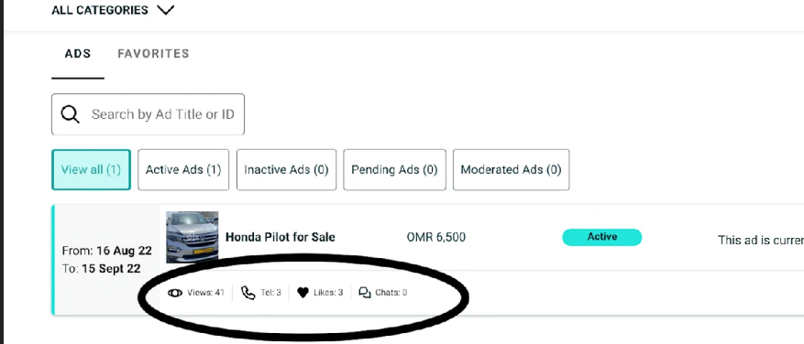(Done)
3. Favicon (Done)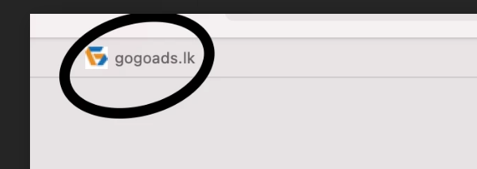
4. After ads upload we will redirect ads promotion page (Done)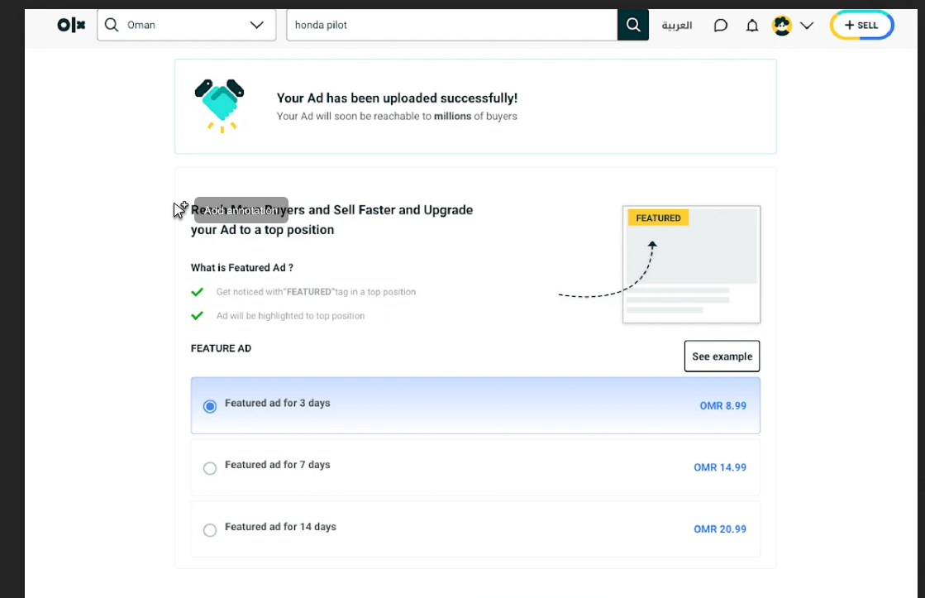
5. City delete option (Done)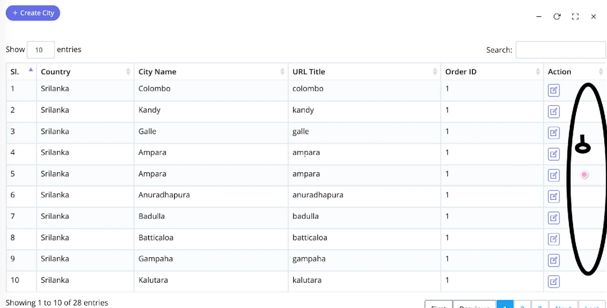
6. Add more number **(Extra Task)**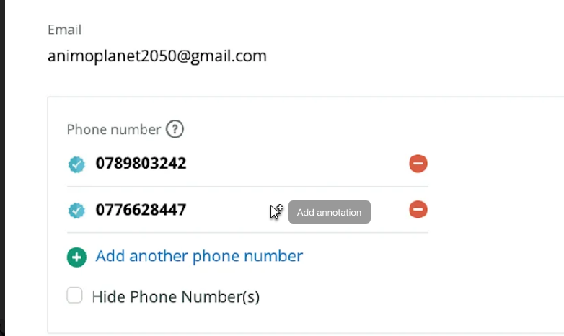
7. 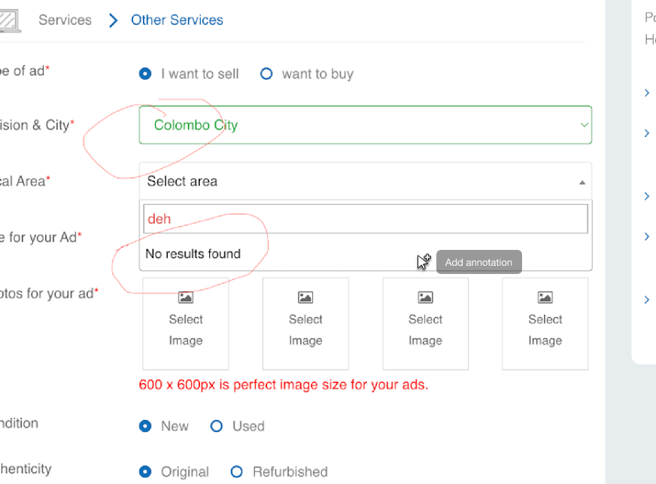 (Done)
8. 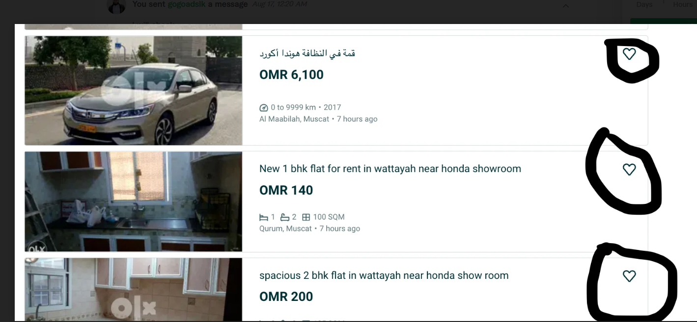
9. Need to check banner image random issues (Done)
10. 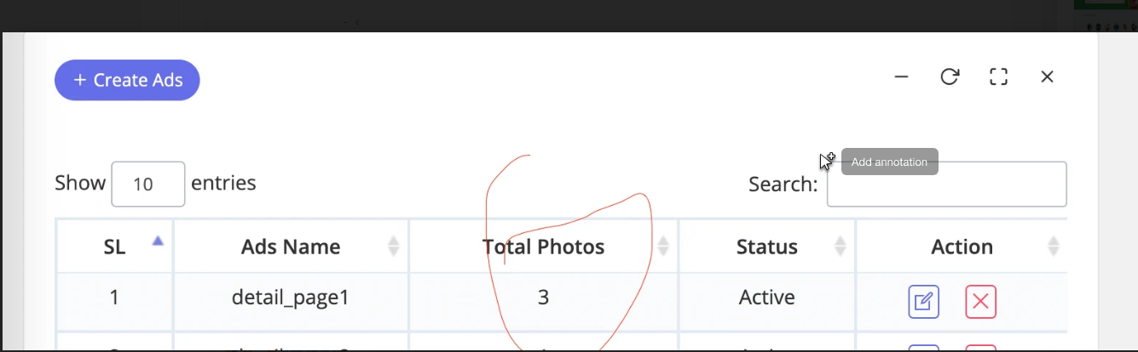
11. Breadcrumb with ads name and category & location name (Done)
12. 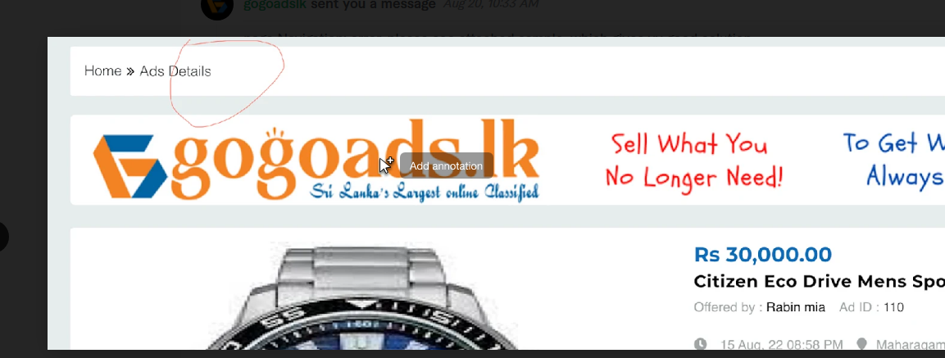
13. Mail send for Ads rejection or status change by admin (Done)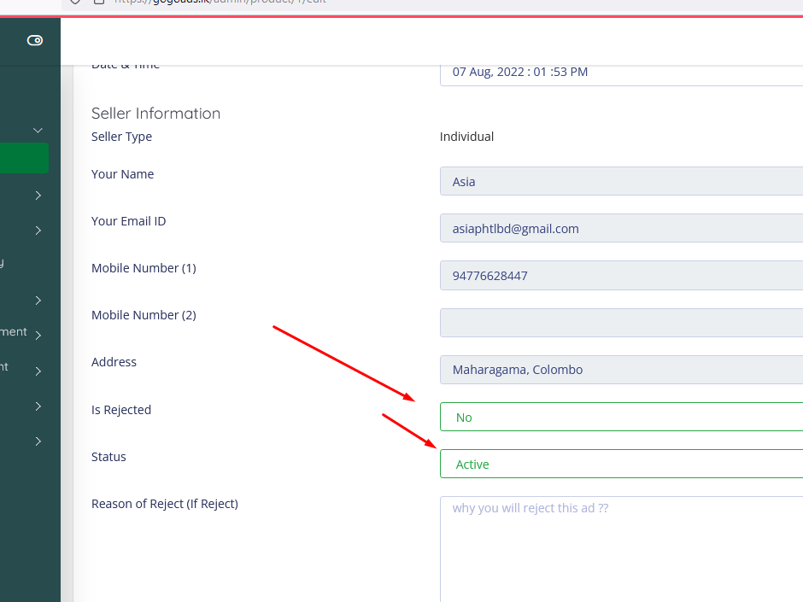
14. User wise ads listing show in admin dashboard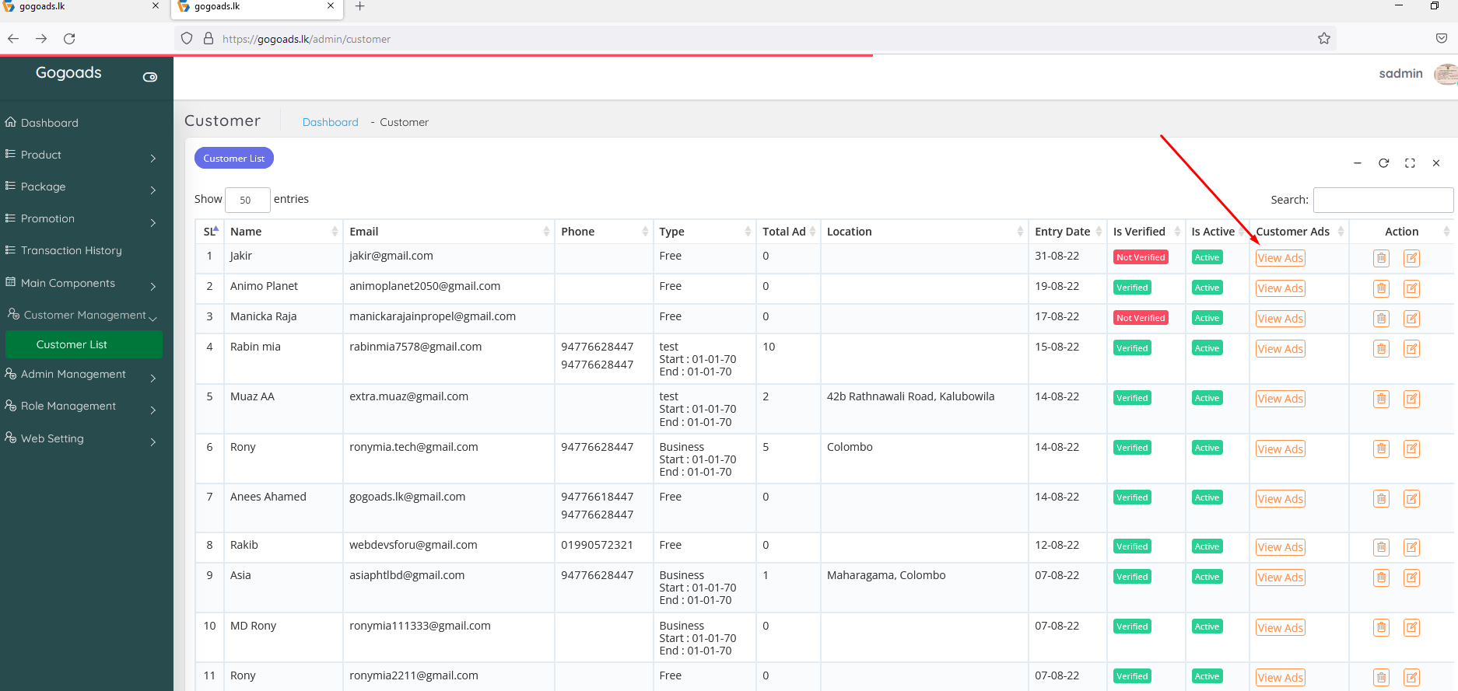

**24 August, 2022**

1. language Sinhala need to change (Done)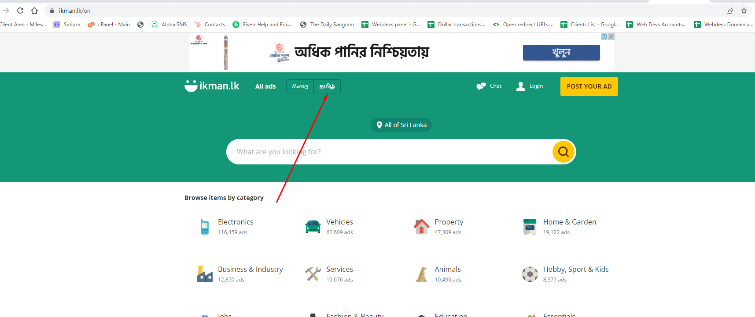
2. categories words not appearing full (Done)
3. category and location wise product is not coming (Done)
4. 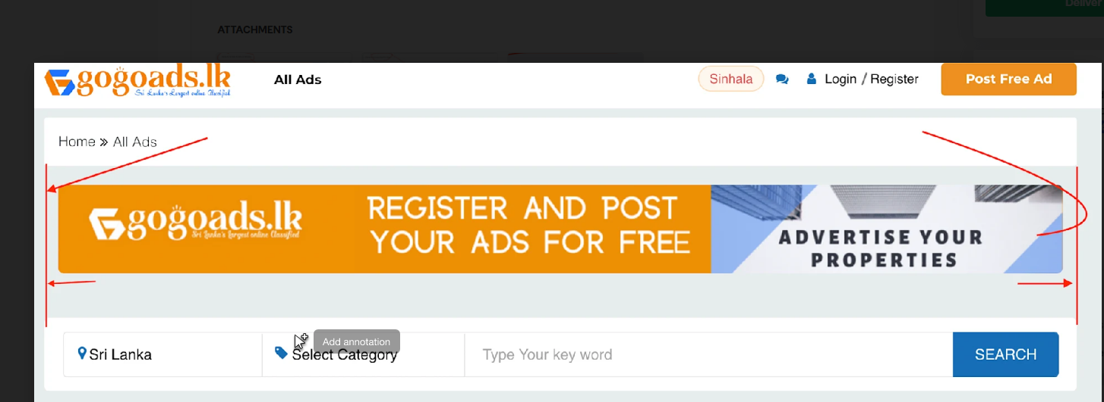page alignment (Done)
5. For services category don’t need brand, used, original (Done)
6. need to remove (Done)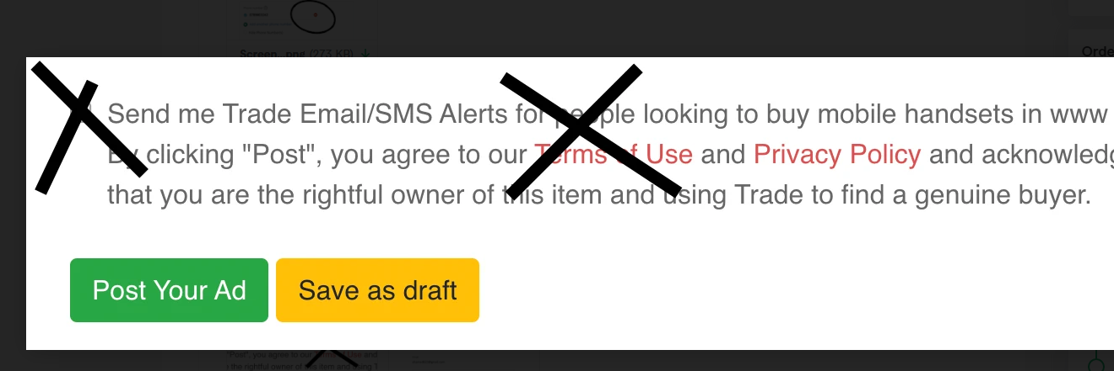
7. watermart image size (Done)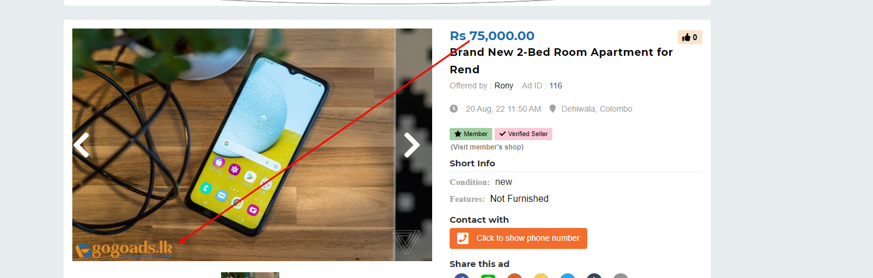
8. only two ads & design is broken (Done)